SQL Practice — Orders Table

WHERE, HAVING, GROUP BY & ORDER BY — CONCISE VERSION

Name: Ch.Srihitha
Roll No: 2520030400

Step 1 — Create Database
CREATE DATABASE orders_db; USE orders_db;
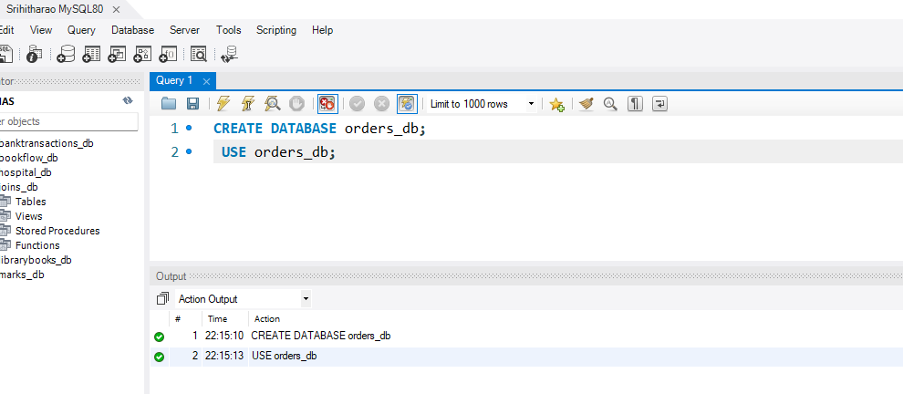

Step 2 — Create Orders Table (DDL)
CREATE TABLE orders ( ord_no INT PRIMARY KEY, purch_amt DECIMAL(10,2), ord_date DATE, customer_id INT, salesman_id INT
);

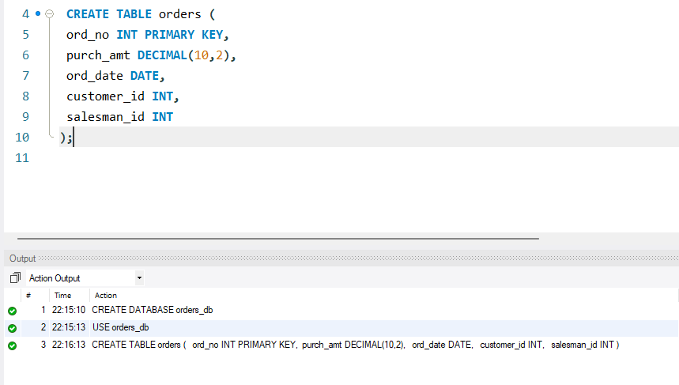

Step 3 — Insert Data into Orders and Display
INSERT INTO orders VALUES (70001,150.50,'2012-10-05',3005,5002),
(70009,270.65,'2012-09-10',3001,5005),
(70002,65.26,'2012-10-05',3002,5001),
(70004,110.50,'2012-08-17',3009,5003),
(70007,948.50,'2012-09-10',3005,5002),
(70005,2400.60,'2012-07-27',3007,5001),
(70008,5760.00,'2012-09-10',3002,5001),
(70010,1983.43,'2012-10-10',3004,5006),
(70003,2480.40,'2012-10-10',3009,5003),
(70012,250.45,'2012-06-27',3008,5002),
(70011,75.29,'2012-08-17',3003,5007),
(70013,3045.60,'2012-04-25',3002,5001);

SELECT * FROM orders;

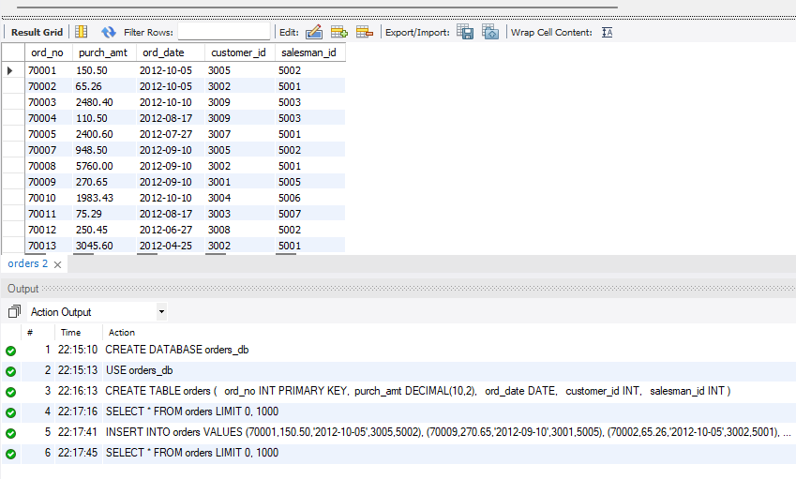

Step 4 — Question 1: WHERE Clause
SELECT *
FROM orders
WHERE purch_amt > 2000;

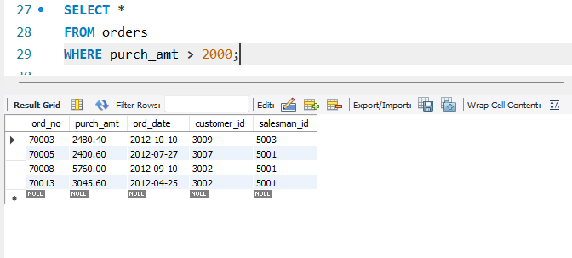

Step 5 — Question 2: ORDER BY
SELECT *
FROM orders
ORDER BY purch_amt DESC;

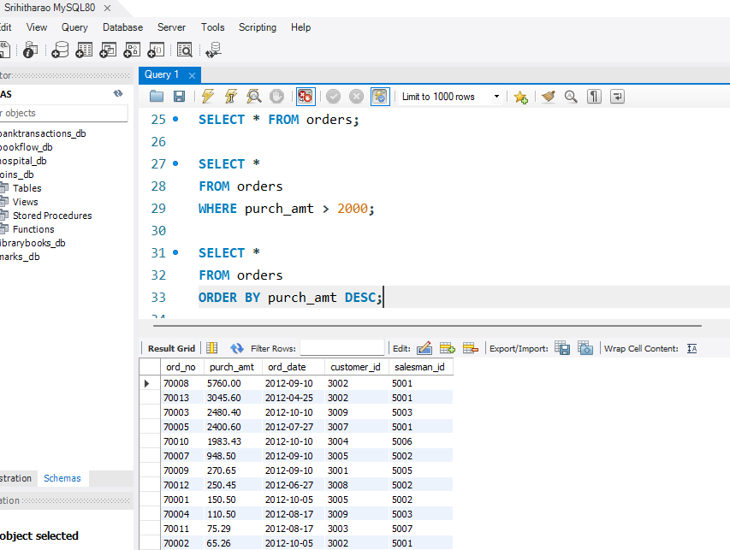

Step 6 — Question 3: SUM()
SELECT SUM(purch_amt) AS total_revenue FROM orders;

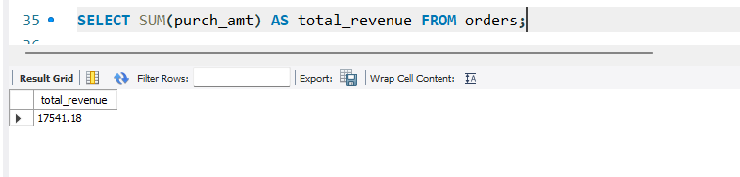

Step 7 — Question 4: AVG()
SELECT AVG(purch_amt) AS average_order FROM orders;

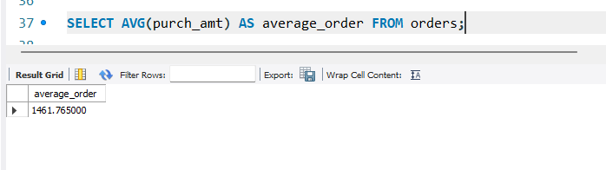

Step 8 — Question 5: MAX()
SELECT MAX(purch_amt) AS highest_order FROM orders;

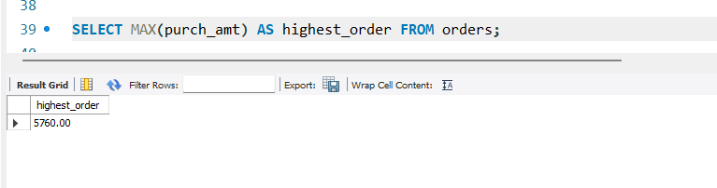

Step 9 — Question 6: MIN()

SELECT MIN(purch_amt) AS lowest_order FROM orders;

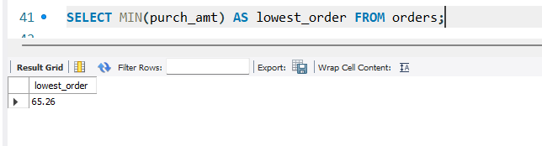

Step 10 — Question 7: COUNT()
Scenario: Find total number of orders.
SELECT COUNT(*) AS total_orders FROM orders;
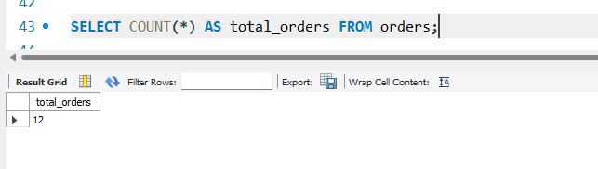

Step 11 — Question 8: GROUP BY

SELECT salesman_id,
SUM(purch_amt) AS total_sales FROM orders
GROUP BY salesman_id;

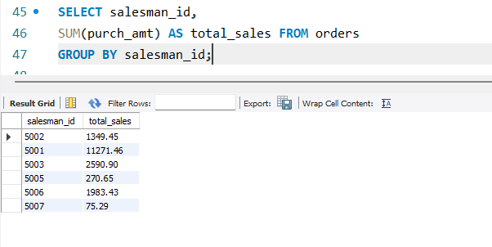

Step 12 — Question 9: GROUP BY + HAVING
Scenario: Company rewards salesmen whose total sales exceed $3,000.
SELECT salesman_id,
SUM(purch_amt) AS total_sales FROM orders
GROUP BY salesman_id
HAVING SUM(purch_amt) > 3000;

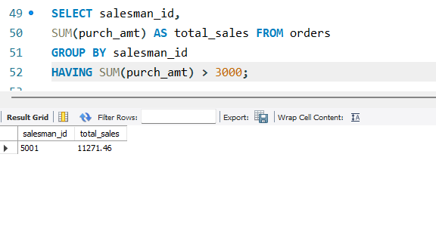

Step 13 — Question 10: GROUP BY + HAVING + ORDER BY
Scenario: Management wants top customers ranked by spending.
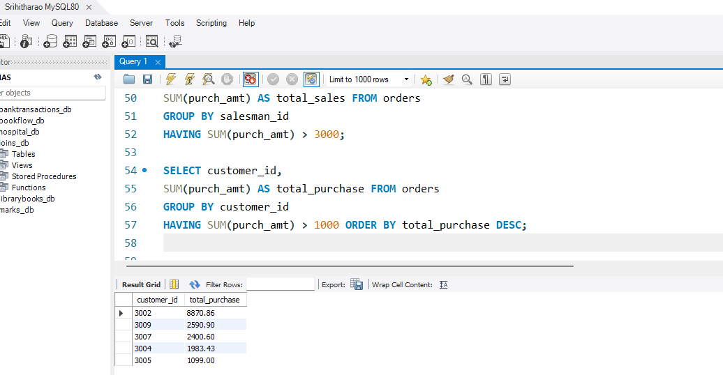
SELECT customer_id,
SUM(purch_amt) AS total_purchase FROM orders
GROUP BY customer_id
HAVING SUM(purch_amt) > 1000 ORDER BY total_purchase DESC;

Step 14 — Question 11: BETWEEN + HAVING
Scenario: Find customers whose maximum purchase is between $2,000 and $6,000.
SELECT customer_id,
MAX(purch_amt) AS max_purchase FROM orders
GROUP BY customer_id
HAVING MAX(purch_amt) BETWEEN 2000 AND 6000;
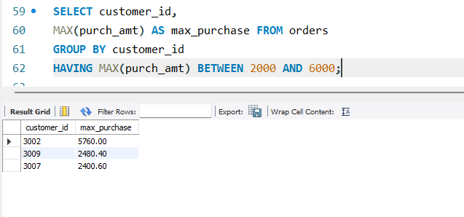

Step 15 — Question 12: MAX + GROUP BY + HAVING
Scenario: Management wants daily highest purchases above $2,000.
SELECT ord_date,
MAX(purch_amt) AS highest_purchase FROM orders
GROUP BY ord_date
HAVING MAX(purch_amt) > 2000;
