SQL Practice — Bank Management System

AGGREGATE FUNCTIONS with WHERE, GROUP BY, HAVING, ORDER BY
Name: Ch.Srihitha
Roll No: 2520030400

Step 1 — Create Database
CREATE DATABASE bank_db; USE bank_db;

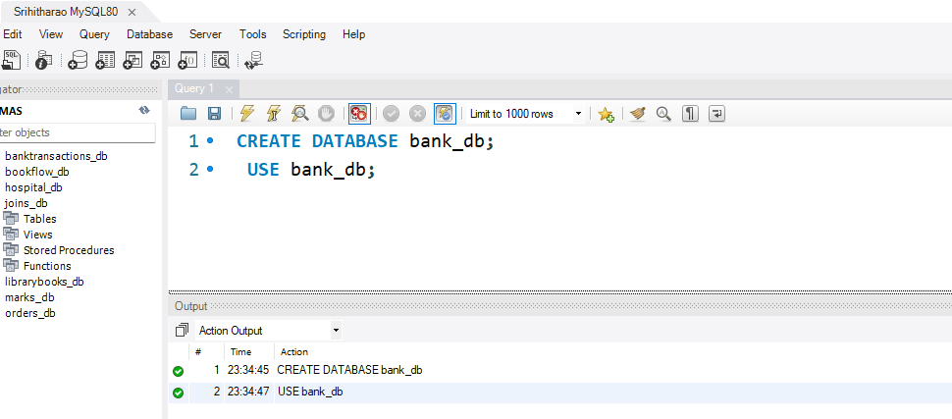

Step 2 — Create Bank_Transactions Table (DDL)
CREATE TABLE bank_transactions ( txn_id INT PRIMARY KEY, customer_name VARCHAR(50), branch_name VARCHAR(50), transaction_type VARCHAR(20), amount DECIMAL(10,2), transaction_date DATE
);

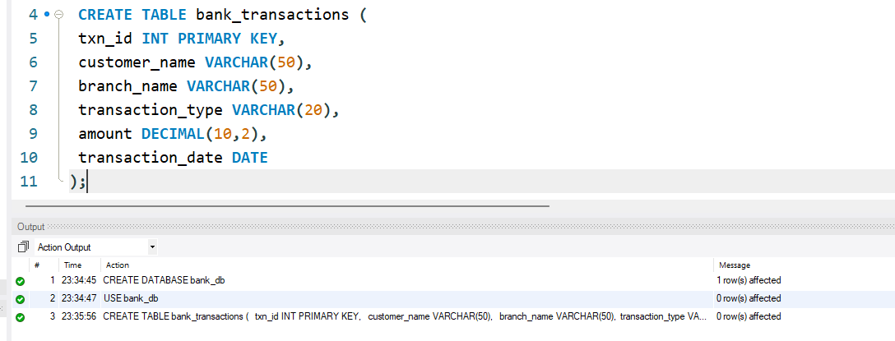Step 3 — Insert Data and Display
INSERT INTO bank_transactions VALUES (101,'Hansika','Hyderabad','Deposit',5000,'2024-01-05'),
(102,'Srihitha','Hyderabad','Withdrawal',2000,'2024-01-06'),
(103,'Manvitha','Vijayawada','Deposit',12000,'2024-01-08'),
(104,'Annanya','Vizag','Deposit',8000,'2024-01-10'),
(105,'Priya','Hyderabad','Withdrawal',3500,'2024-01-11'),
(106,'Rakesh','Vizag','Deposit',15000,'2024-01-12'),
(107,'Keerthi','Vijayawada','Withdrawal',1000,'2024-01-13'),
(108,'Rahul','Hyderabad','Deposit',9000,'2024-01-14'),
(109,'Sneha','Vizag','Withdrawal',4000,'2024-01-15'),
(110,'Madhu','Vijayawada','Deposit',11000,'2024-01-16');

SELECT * FROM bank_transactions;
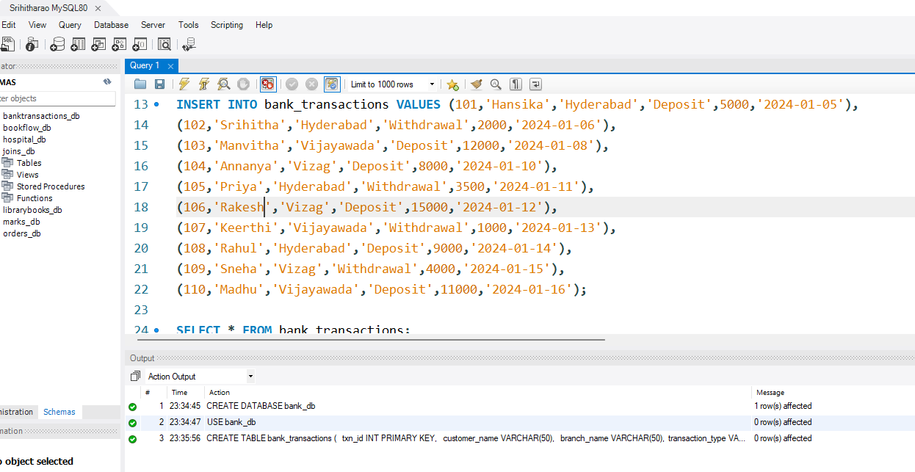

Step 4 — Question 1: SUM()
SELECT SUM(amount) AS Total_Amount FROM bank_transactions;

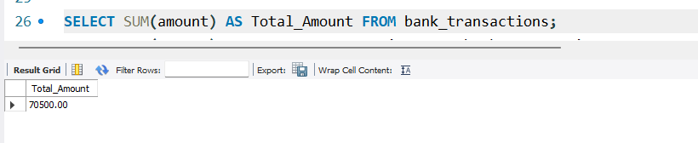

Step 5 — Question 2: AVG()
SELECT AVG(amount) AS Average_Transaction FROM bank_transactions;

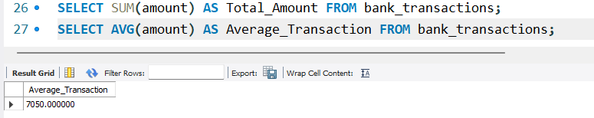

Step 6 — Question 3: MAX()
SELECT MAX(amount) AS Highest_Transaction FROM bank_transactions;
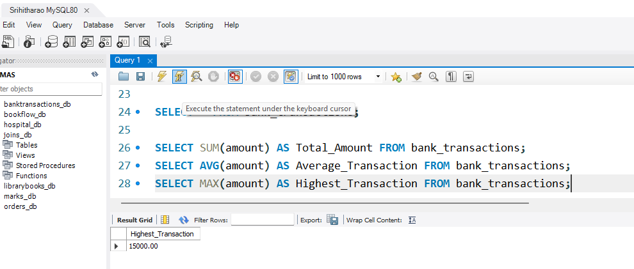

Step 7 — Question 4: MIN()

Scenario: The audit department wants to know the smallest transaction amount recorded.
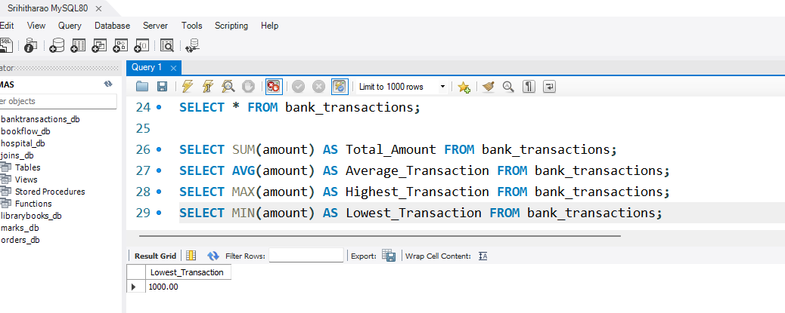
SELECT MIN(amount) AS Lowest_Transaction FROM bank_transactions;

Step 8 — Question 5: COUNT()
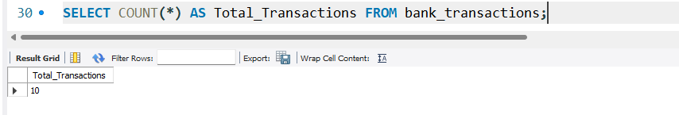
SELECT COUNT(*) AS Total_Transactions FROM bank_transactions;

Step 9 — Question 6: WHERE + SUM()
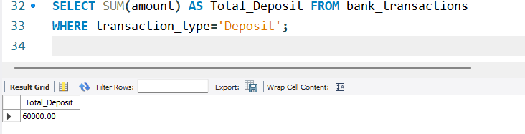
SELECT SUM(amount) AS Total_Deposit FROM bank_transactions
WHERE transaction_type='Deposit';

Step 10 — Question 7: GROUP BY
SELECT branch_name,
SUM(amount) AS Total_Amount FROM bank_transactions
GROUP BY branch_name;

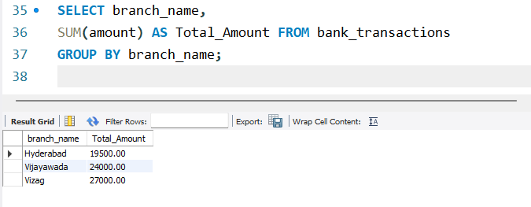

Step 11 — Question 8: GROUP BY + HAVING
SELECT branch_name,
SUM(amount) AS Total_Amount FROM bank_transactions
GROUP BY branch_name HAVING SUM(amount) > 20000;

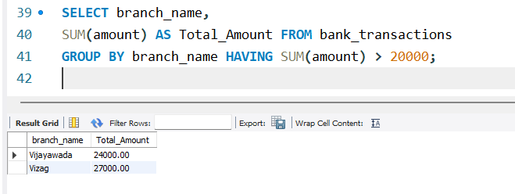

Step 12 — Question 9: GROUP BY + ORDER BY
SELECT branch_name,
SUM(amount) AS Total_Amount FROM bank_transactions
GROUP BY branch_name
ORDER BY Total_Amount DESC;

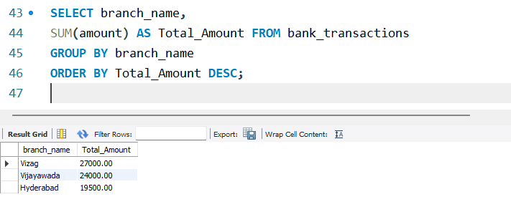

Step 13 — Question 10: GROUP BY + HAVING + ORDER BY
SELECT branch_name,
COUNT(*) AS Total_Transactions FROM bank_transactions
GROUP BY branch_name HAVING COUNT(*) >= 3
ORDER BY Total_Transactions DESC;

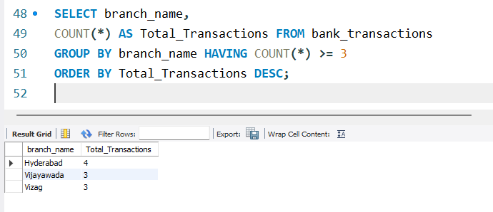
Step 14 — Question 11: WHERE + ORDER BY
Scenario: The fraud detection team wants all transactions greater than $8,000.
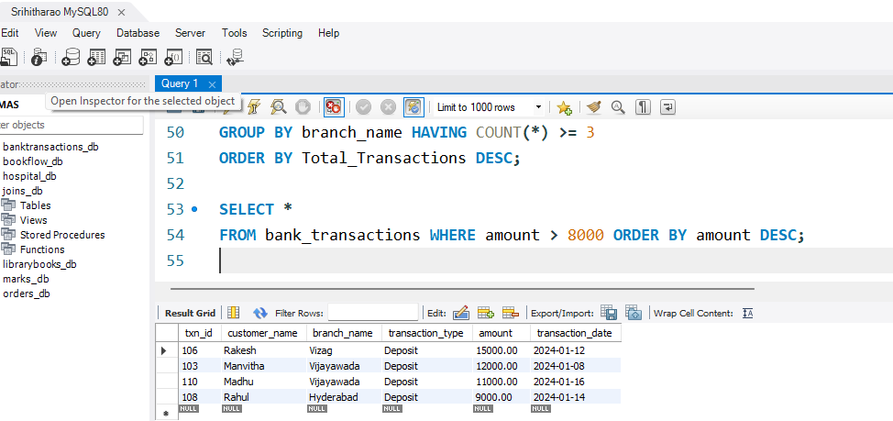
SELECT *
FROM bank_transactions WHERE amount > 8000 ORDER BY amount DESC;

Step 15 — Question 12: WHERE + GROUP BY + HAVING
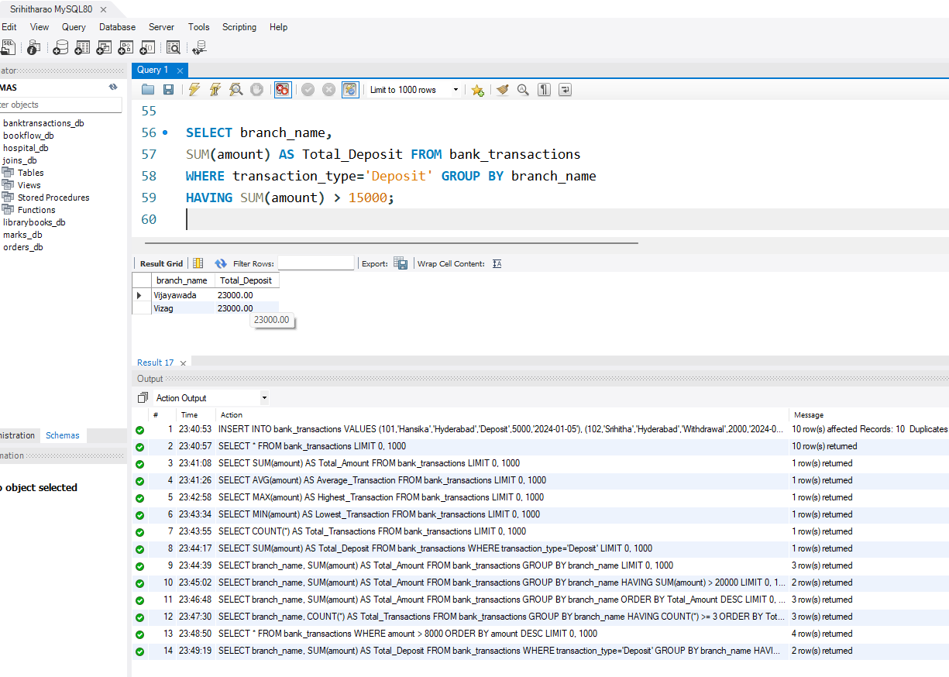
SELECT branch_name,
SUM(amount) AS Total_Deposit FROM bank_transactions
WHERE transaction_type='Deposit' GROUP BY branch_name
HAVING SUM(amount) > 15000;

