Database System Engineering and Distributed Backend Development

WEEK-3
Name: CH.Srihitha
Roll No: 2520030400
Section: 7

Step 1 — Switch to the BookFlow Database
use bookflow
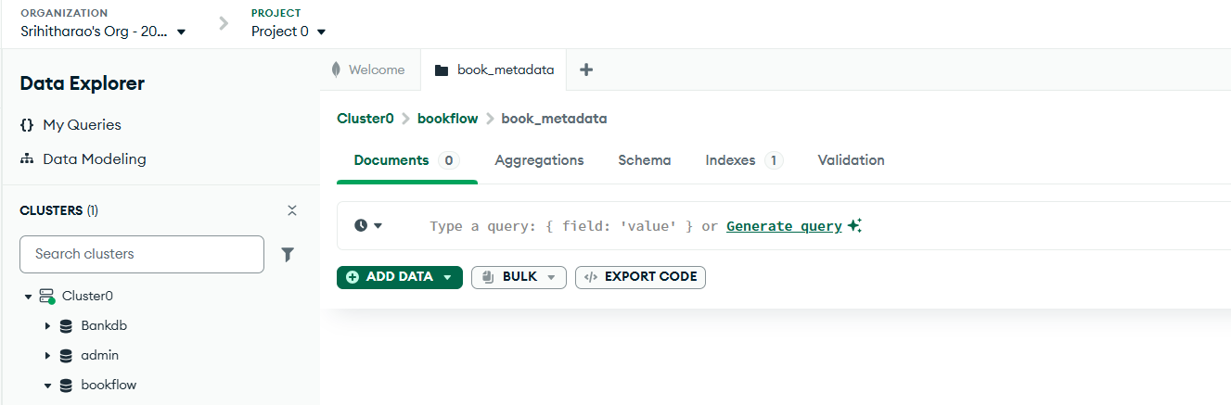

Step 2 — Create the book_metadata Collection
db.createCollection("book_metadata")
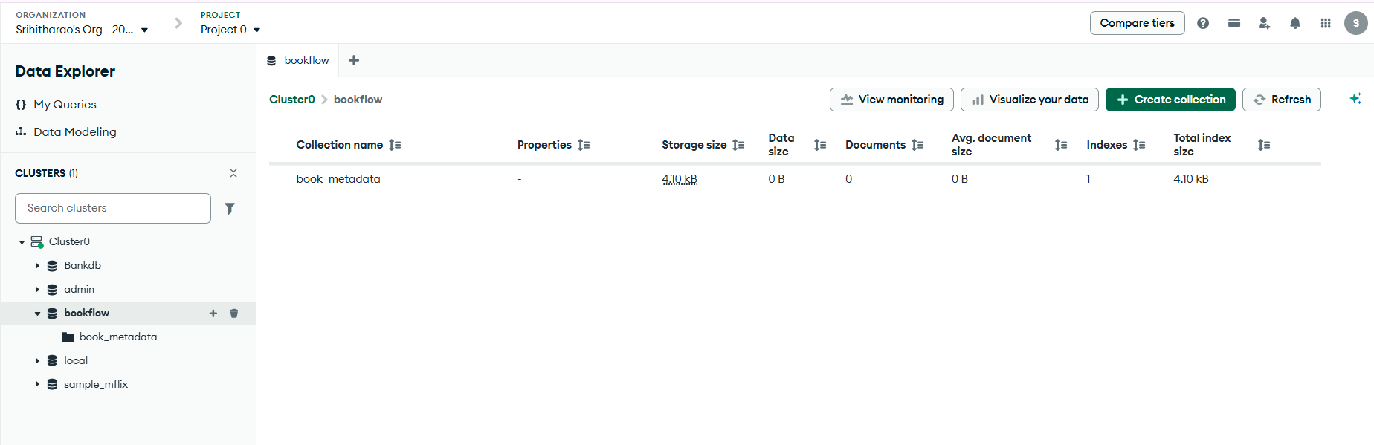

Step 3 — Insert Document 1 (Embedded + Referenced Pattern)
db.book_metadata.insertOne({ book_id: 201,
title: "The Silent Patient", author: "Alex Michaelides", published_year: 2022, category: "Thriller", format: "Digital EPUB", file_size: "2.8 MB", member_id: 101, reviews: [
{ member_id: 101, reviewer_name: "Hansika", rating: 5, comments: "Excellent psychological thriller" },
{ member_id: 104, reviewer_name: "Aditya Rao", rating: 4, comments: "Very gripping with an unexpected twist" },
{ member_id: 105, reviewer_name: "Sneha Kapoor", rating: 5, comments: "Excellent narration and pacing" }
]
})

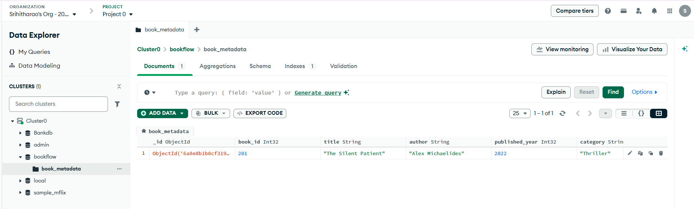

Step 4 — Insert Document 2 (Digital Format)
db.book_metadata.insertOne({ book_id: 202, title: "Atomic Habits", author: "James Clear", published_year: 2023, category: "Self Help", format: "Digital PDF", file_size: "3.4 MB", member_id: 102, reviews: [
{ member_id: 102, reviewer_name: "Hasini", rating: 5, comments: "Excellent practical habit building guide" },
{ member_id: 106, reviewer_name: "Riya Sharma", rating: 4, comments: "Good but a little repetitive later on" },
{ member_id: 101, reviewer_name: "Hansika", rating: 5, comments: "Excellent life changing concepts" }
]
})

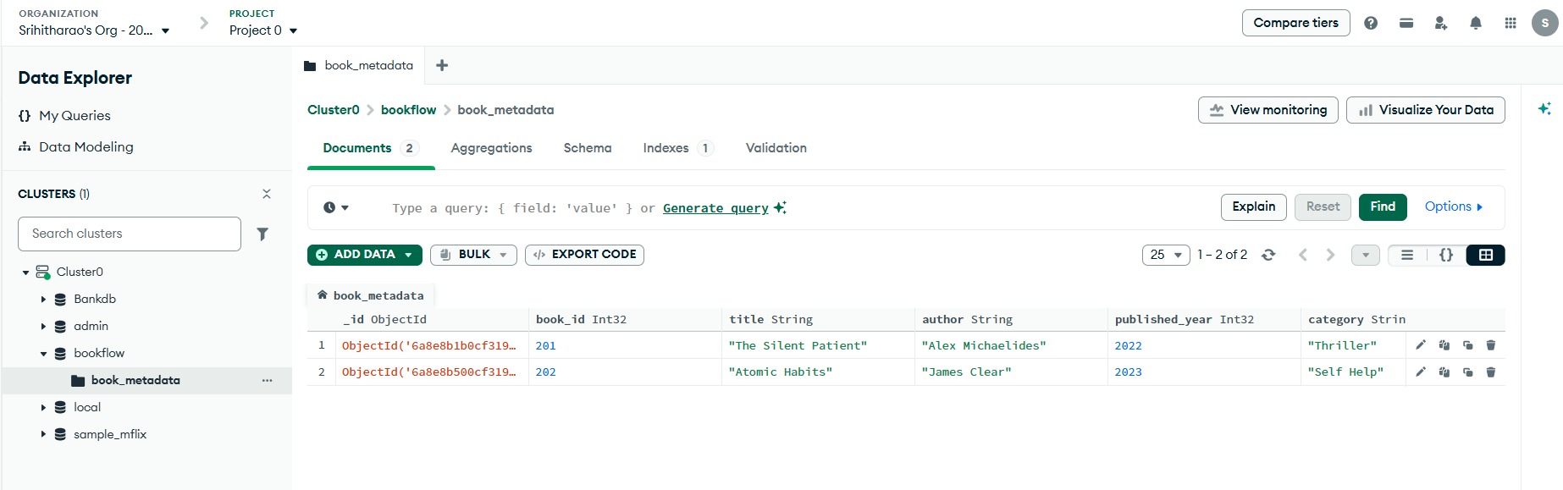

Step 5 — Insert Document 3 (Physical Format / Flexible Schema)

db.book_metadata.insertOne({ book_id: 203, title: "Wings of Fire", author: "A. P. J. Abdul Kalam", published_year: 2019, category: "Autobiography", format: "Physical",
dimensions: { height: "22 cm", width: "14 cm", weight: "350 g" }, member_id: 103, reviews: [
{ member_id: 103, reviewer_name: "Bindhu", rating: 5, comments: "Excellent inspiring autobiography" },
{ member_id: 107, reviewer_name: "Kunal Mehta", rating: 4, comments: "Very motivational read for students" }
]
})

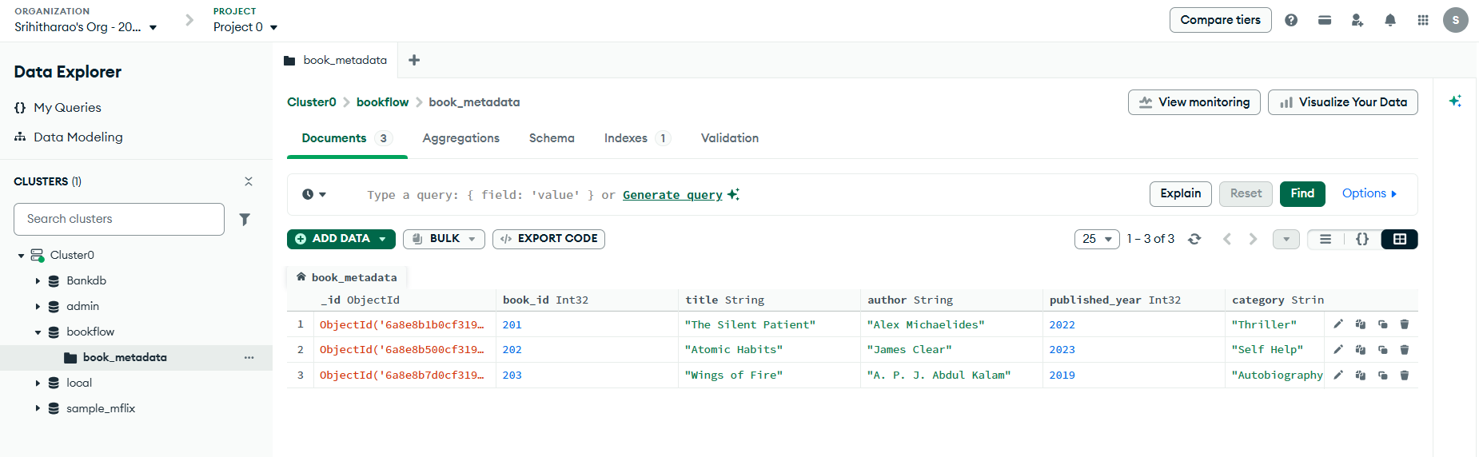

Step 6 — Verify Inserted Documents
db.book_metadata.find().pretty()
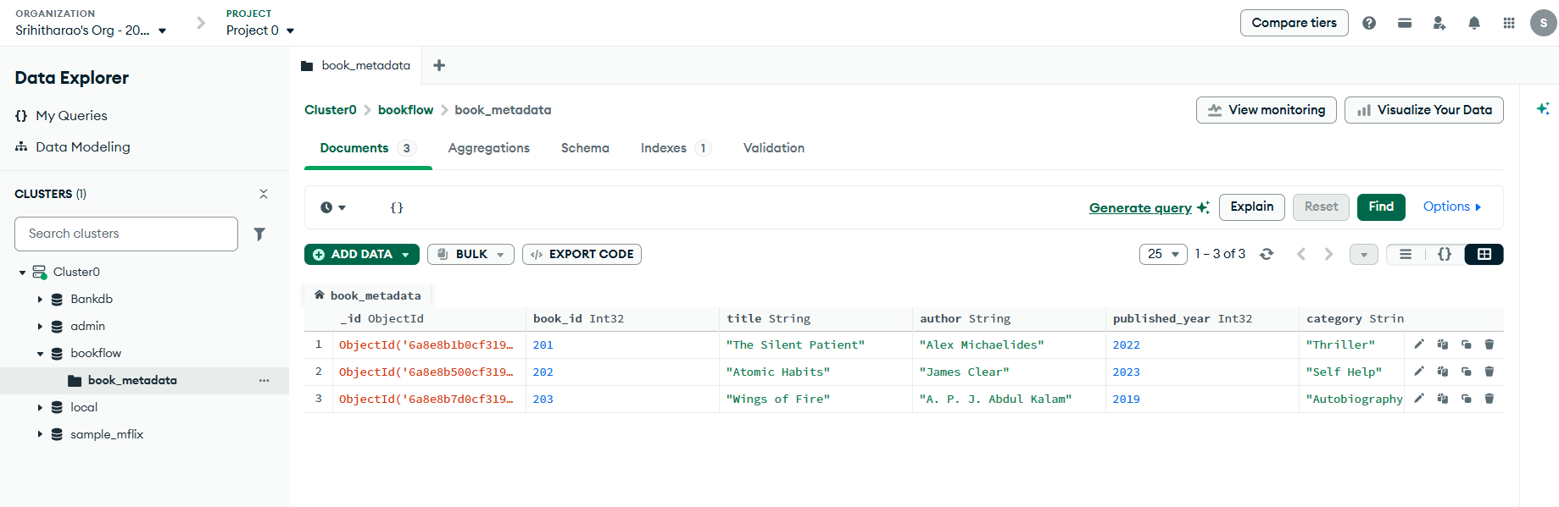

Step 7 — Comparison Query: $gt (Rating Greater Than 4)
db.book_metadata.find({ "reviews.rating": { $gt: 4 }
})

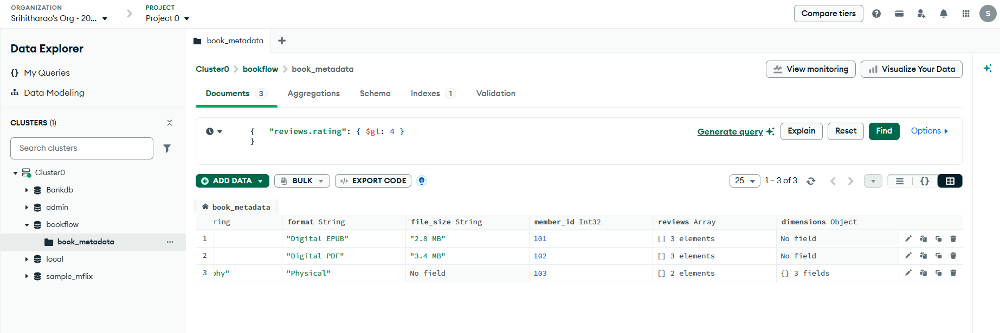

Step 8 — $in Query (Rating 4 or 5)
db.book_metadata.find({
"reviews.rating": { $in: [4, 5] } })

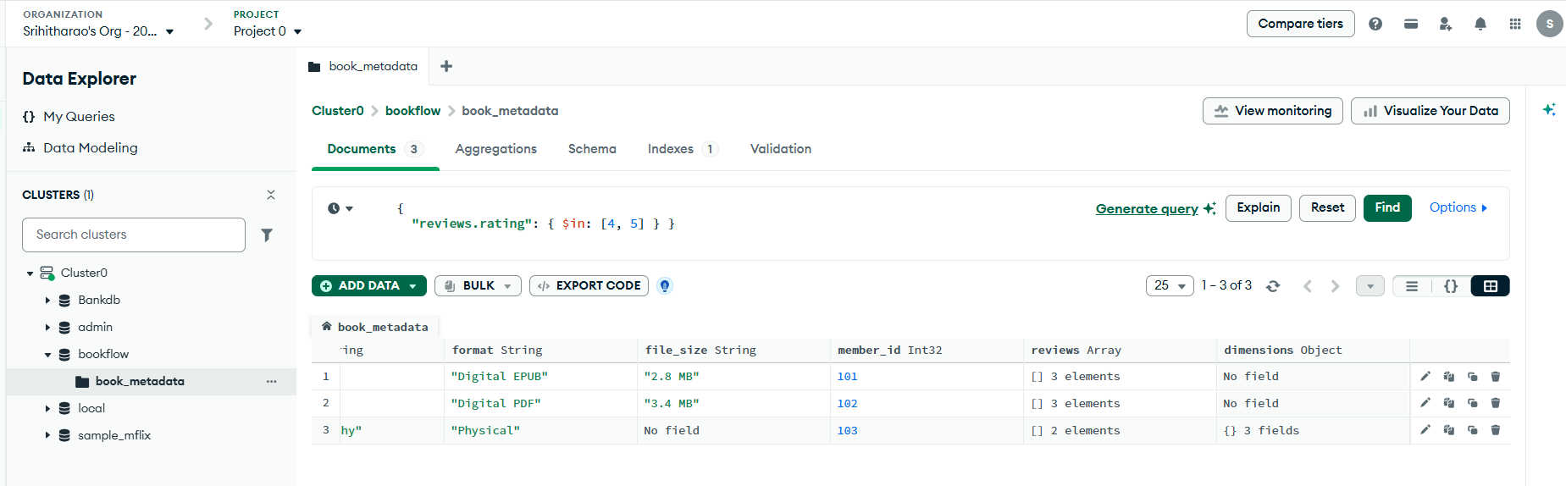

Step 9 — Regex Query (Digital Format)
db.book_metadata.find({
format: { $regex: "Digital", $options: "i" } })

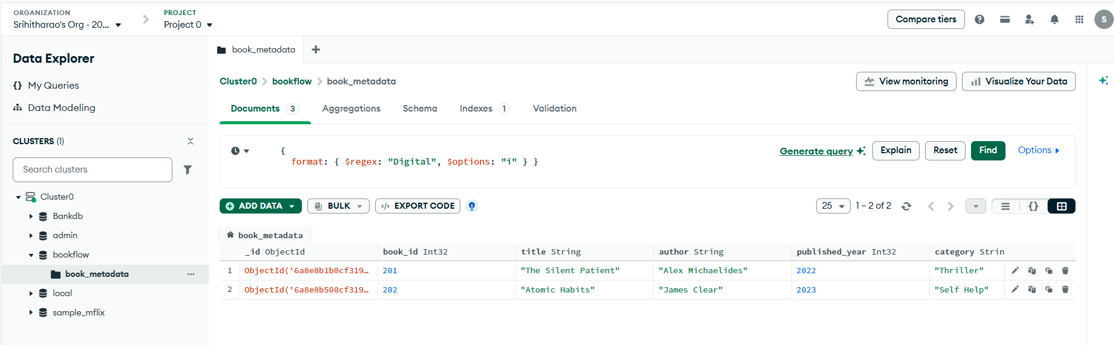

Step 10 — Aggregation Pipeline: Top Rated Books Report

db.book_metadata.aggregate([
{ $match: { published_year: { $gt: 2020 } } },
{ $unwind: "$reviews" },
{ $group: { _id: "$title",
average_rating: { $avg: "$reviews.rating" }, total_reviews: { $sum: 1 }
} },
{ $sort: { average_rating: -1 } } ])

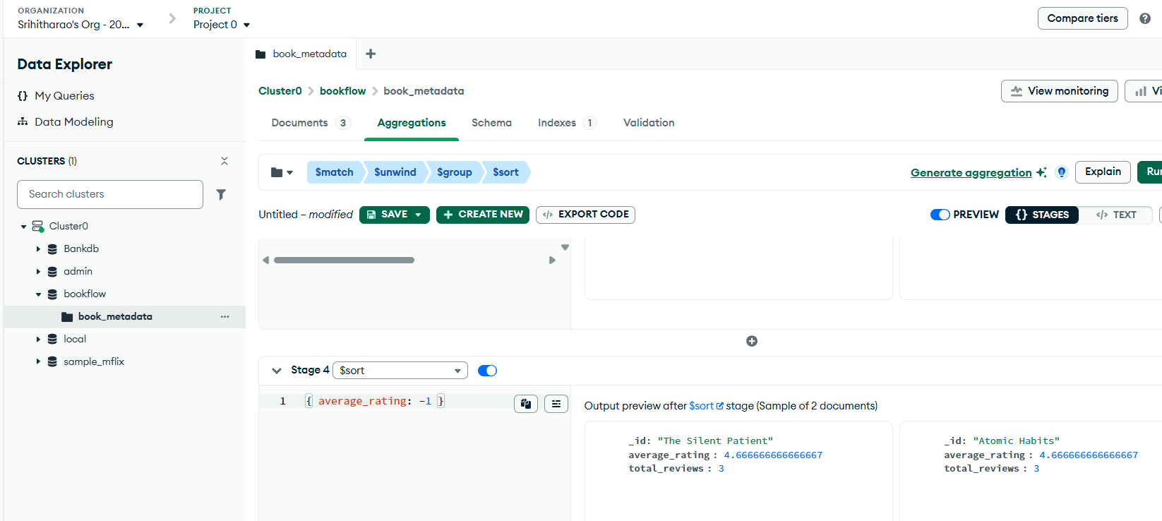

Step 11 — Create a Text Index on Review Comments
db.book_metadata.createIndex({
"reviews.comments": "text"
})

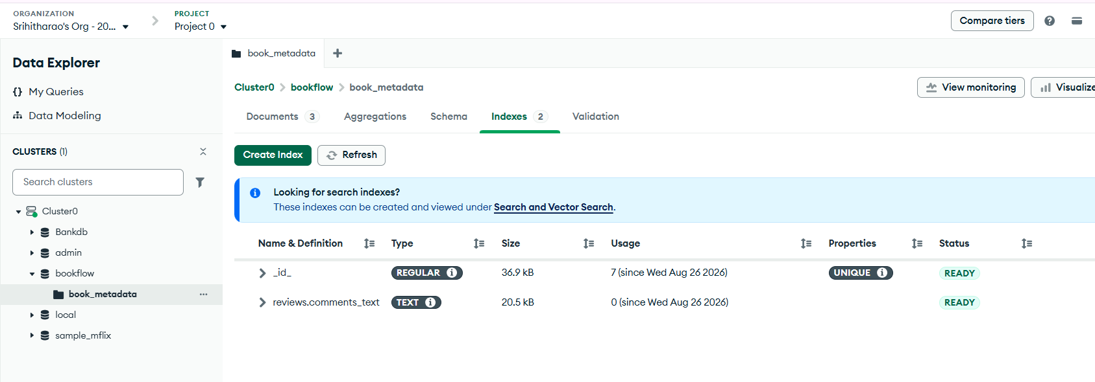

Step 12 — Text Search Query
db.book_metadata.find({
$text: { $search: "excellent" } })

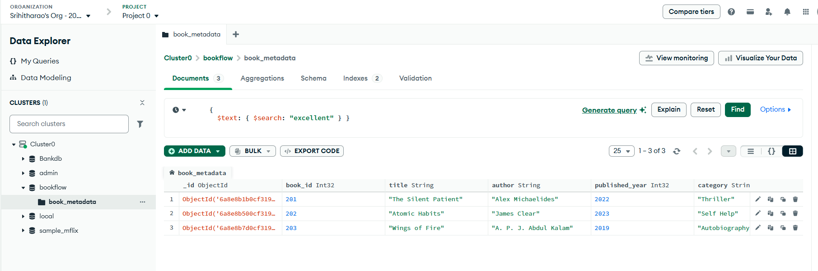

Step 13 — explain() Query Performance Analysis
db.book_metadata.find({
$text: { $search: "excellent" }
}).explain("executionStats")

