“CRM FOR SMALL BUSINESSES ”
A Project Report Submitted in the partial fulfillment of the requirements for the award of the degree of

BACHELOROFTECHNOLOGY
In
DEPARTMENT OF COMPUTER SCIENCE ENGINNERING
&
DEPARTMENT OF COMPUTER SCIENCE AND INFORMATION TECHNOLOGY By
KASIREDDY SRIHITHA | :2520030153
CHEETI SRIHITHA | :2520030400
BODDU PEMESH | :2520030388
Under the Esteemed Guidance of
Dr Spandana
Assistant Professor

Department of Computer Science and Engineering

K L (Deemed to be) University DEPARTMENT OF COMPUTER SCIENCE ENGINEERING
&

DEPARTMENT OF COMPUTER SCIENCE AND INFORMATION TECHNOL

Declaration
The Project Report entitled “CRM FOR SMALL BUISINESSES” is a record of Bonafide work of KASIREDDY SRIHITHA - 2420030153 ,CHEETI SRIHITHA – 2520030400, BODDU PEMESH - 2520030388 submitted in partial fulfillment for the award of B. Tech in Computer Science and Engineering (or) Computer Science and Information Technology to the K L University. The results embodied in this report have not been copied from any other departments/University/Institute.
KASIREDDY SRIHITHA – 2520030153
CHEETI SRIHITHA – 2520030400 BODDU PEMESH – 2520030388

K L (Deemed to be) University
DEPARTMENT OF COMPUTER SCIENCE ENGINEERING
&
DEPARTMENT OF COMPUTER SCIENCE AND INFORMATION TECHNOLOGY

CERTIFICATE
This is certify that the mini project based report entitled“CRM FOR SMALL BUISINESSES” is a
bonafide work done and submitted by KASIREDDY SRIHITHA - 2420030153 ,CHEETI SRIHITHA – 2520030400, BODDU PEMESH - 2520030388
in partial fulfillment of the requirements for the award of the degree of BACHELOR OF TECHNOLOGY in Department of Computer Science Engineering, K L (Deemed to be University), during the academic year 2025-2026.
Signature of the Guide
Signature of the Course Coordinator Signature of the HOD

ACKNOWLEDGEMENT
The success in this project would not have been possible but for the timely help and guidance rendered by many people. Our wish to express my sincere thanks to all those who has assisted us in one way or the other for the completion of my project.
Our greatest appreciation to my Course Coordinator Dr SPANDANA, and my guide Dr SPANDANA, Department of Computer Science which cannot be expressed in words for his/her tremendous support, encouragement and guidance for this project.
We express our gratitude to Dr. P Venkateshwara Roa (CSE)/Dr. Kaja Shareef (CSIT), Head of the Department for Computer Science Engineering/ Department for Computer Science and Information Technology for providing us with adequate facilities, ways and means by which we are able to complete this project-based Lab.
We thank all the members of teaching and non-teaching staff members, and also who have assisted me directly or indirectly for successful completion of this project. Finally, I sincerely thank my parents, friends and classmates for their kind help and cooperation during my work.
KASIREDDY SRIHITHA – 2520030153
CHEETI SRIHITHA – 2520030400 BODDU PEMESH – 2520030388

Abstract
The CRM for Small Businesses is a web-based application designed to simplify and organize customer relationship management activities for small-scale businesses. Managing customer information manually or through scattered records can lead to data duplication, difficulty in accessing information, and inefficient record maintenance. To address these challenges, the proposed system provides a centralized platform that enables users to securely access and manage customer information through an organized and user-friendly interface.
The application is developed using React, TypeScript, and Tailwind CSS for the frontend, while Java and Spring Boot are used for backend development. MySQL is utilized as the relational database for storing and managing application data. The system follows a REST API-based architecture, with Axios facilitating communication between the frontend and backend. Spring Data JPA and Hibernate support database operations, while Spring Security and JSON Web Tokens (JWT) are used to implement authentication and secure access. The implemented functionalities include user registration, login, dashboard access, customer record management through create, read, update, and delete operations, and login history tracking.
The primary objective of this project is to provide small businesses with a structured and accessible solution for managing customer records while demonstrating the integration of modern frontend technologies, backend services, database management, and authentication mechanisms. The developed application establishes a foundation for further CRM capabilities, including lead management, sales tracking, interaction management, follow-up scheduling, and advanced reporting. These enhancements can extend the system into a more comprehensive customer relationship management platform in the future.

Index
S.  No. | Chapters | Topics | Page.no
 |  | Acknowledgement
 |  | Abstract
1 | Introduction | 1.1 Background of the project  1.2 Problem statement  1.3 Scope of the project  1.4 Objective(s)  1.5 Importance of the application  1.6 Target users/audience | 5-15
2 | System Requirements | 2.1 Hardware requirements  2.2 Software requirements  2.3 Development tools and frameworks | 16-21
3 | Technology Stack | 3.1 Front-end (e.g., React.js, Angular, HTML/CSS)  3.2 Back-end (e.g., Node.js, Django, Spring Boot)  3.3 Database (e.g., MongoDB, MySQL, PostgreSQL)  3.4 Version Control (e.g., Git, GitHub)  3.5 APIs or External services (e.g., Firebase, Stripe) | 22-32
4 | System Architecture | 4.1 High-level architecture diagram  4.2 Description of each layer (frontend, backend, database)  4.3 Deployment architecture (e.g., cloud, local, CI/CD pipelines) | 33-36
5 | Design | 5.2 ER Diagram / Database schema | 37
6 | Implementation | 6.1 Module-wise implementation  6.2 Front-end logic (UI rendering, state management)  6.3 API integration  6.4 Authentication & Authorization | 38-47
7 | Features | 7.1 List of main features  7.2 How each feature works (user perspective + technical description) | 48-55
8 | Testing | 8.1 Postman testing (frontend/backend)  8.2 Integration testing  8.3 Tools used for testing  8.4 Test cases and results | 56-64
9 | Deployment | 9.1 Steps to deploy  9.2 Environment configuration  9.3 Hosting of frontend and backend | 65-73
10 | Challenges &  Limitations | 10.1 Issues faced during development  10.2 Solutions applied  10.3 Current limitations or known bugs | 74-82
11 | Future Enhancements | 11.1 Planned features  11.2 Possible integrations or optimizations | 83-88
12 | Conclusion | 12.1 Summary of the project  12.2 What was achieved  12.3 Skills learned during development | 89-97
13 | References | - Books, tutorials, APIs, documentation sites used | 98-99

14 | Appendices | - Screenshots of the app  - Sample code snippets  - Installation/setup instructions  - User manual or guide  -Geo Tag photos with guide  -Review forms with guide signatures | 100-105

CHAPTER -1 INTRODUCTION
1.1 Background of the Project
Customer Relationship Management (CRM) is an important aspect of business operations that focuses on maintaining customer information and managing relationships between businesses and their customers. For small businesses, maintaining accurate customer records is essential for organizing daily activities, understanding customer requirements, and providing consistent services. As businesses grow, the amount of customer information also increases, making it necessary to adopt systematic methods for storing, accessing, and updating records.
Many small businesses initially depend on manual methods such as notebooks, spreadsheets, or separate digital documents to maintain customer details. Although these methods may be sufficient when the number of customers is limited, managing information through multiple sources can become difficult over time. Business owners may face challenges in locating customer details, updating outdated information, maintaining consistency, and keeping records organized. These difficulties highlight the need for a centralized application that simplifies customer information management.
The idea behind this project emerged from the need to provide small businesses with a structured digital platform for maintaining customer records. The proposed “CRM for Small Businesses” is a web-based application developed to provide users with a centralized environment for managing customer information. It combines user authentication, customer record management, and a dashboard within a single application. The system aims to reduce dependence on scattered records and make customer information easier to access and maintain.
The application follows a full-stack development approach, with separate frontend, backend, and database components. The frontend is developed using React and TypeScript, with Vite serving as the development and build tool. The backend is implemented using Java and the Spring Boot framework, which handles application requests and business logic. MySQL is used as the relational database for storing user details, customer records, and login history. REST APIs are used for communication between the frontend and backend, while Axios facilitates HTTP requests from the frontend.
An important functionality of the system is user registration and authentication. New users can register by providing the required details and subsequently log in to access the application. Spring Security and JSON Web Tokens (JWT) are incorporated to support authentication and protect restricted API operations. Password encoding is also implemented as part of the authentication process. These mechanisms help ensure that access to customer-related operations is associated with an authenticated user.
The customer management functionality allows users to perform basic operations on customer records. Users can add new customers, view existing records, update customer information, and delete records when necessary. Each customer record contains details such as name, email address, phone number, company, and status. The backend associates customer records with the corresponding user, allowing customer information to be managed within the user's account. Spring Data JPA and Hibernate are used to handle database interactions between the application and MySQL.
The application also includes a dashboard that presents an overview of customer information. It displays the total number of customers, the number of active customers, the signed-in user's account role, and a list of customer records. This provides users with a convenient view of the information maintained in the system. In addition, the login history functionality records successful login activity and allows the authenticated user to view previous login timestamps.
From an academic and engineering perspective, the development of this project involves the integration of several important areas of computer science:
- Frontend Development: Building the user interface and application screens using React and TypeScript, supported by Vite and CSS-based styling.
- Backend Development: Implementing application logic, request handling, and REST API endpoints using Java and Spring Boot.
- Database Management: Designing and managing relational data for users, customers, and login history using MySQL.
- Authentication and Security: Implementing user authentication, password encoding, JWT generation, and protected API access using Spring Security.
- Object-Relational Mapping: Using Spring Data JPA and Hibernate to connect Java application entities with database tables and perform database operations.
- API Communication: Establishing communication between frontend and backend components through REST APIs using Axios.
The project follows a layered application structure in which controllers handle incoming requests, services manage application logic, repositories perform database operations, and entities represent the stored data. This separation helps organize the application code and makes individual components easier to understand, maintain, and extend.
The current implementation establishes the core foundation of a customer relationship management application through authentication, customer record operations, dashboard information, and login history. The project can be extended in future development phases by introducing additional modules such as lead management, account management, sales and deal tracking, customer interactions, follow-up scheduling, and reports. These proposed enhancements would expand the application beyond basic customer record management and support a wider range of business activities.
To summarize, the background of this project is based on three fundamental observations:
- Small businesses require an organized method to maintain and retrieve customer information without depending entirely on scattered manual records.
- Modern web technologies make it possible to develop centralized applications that connect user interfaces, backend services, and relational databases.
- Authentication, customer record management, and dashboard functionalities provide a foundation for developing a broader customer relationship management system.
By addressing the need for structured customer information management, the CRM for Small Businesses project demonstrates the practical application of modern web development, backend programming, database management, and authentication technologies. The developed system provides a centralized platform for managing customer records and establishes a foundation for incorporating further CRM functionalities in future development.

1.2 Problem Statement
In today's competitive business environment, maintaining organized customer information is essential for the smooth operation and growth of small businesses. Customer details such as names, contact information, company details, and customer status need to be recorded, updated, and accessed whenever required. However, many small businesses still depend on manual record-keeping methods, spreadsheets, or multiple disconnected applications to maintain this information. As the volume of customer records increases, these methods can become difficult to manage, resulting in inefficient data organization and delays in retrieving important information.
The core problem addressed by this project is the absence of a simple and centralized customer information management system that enables small businesses to maintain and manage their customer records efficiently. When customer details are stored across different files or locations, business owners may find it difficult to maintain consistency and keep information updated. Adding new records, modifying existing details, and removing outdated information can also become repetitive tasks. Without a structured system, accessing the required customer information may consume additional time and affect the overall efficiency of routine business operations.
Another significant challenge is the lack of a dedicated platform that combines customer information management with controlled user access. When customer records are maintained through shared documents or unorganized files, it may be difficult to manage who can access the information. A suitable application should provide a registration and login mechanism so that users can authenticate themselves before accessing customer-related operations. It should also maintain appropriate authentication procedures to restrict unauthorized access to protected application resources.
The organization and maintenance of customer records represent another important problem. Customer information is not limited to a name or contact number; it may also include email addresses, company details, and the current status of the customer. If these details are maintained inconsistently, retrieving and updating complete customer information becomes difficult. Therefore, a centralized system is required to support essential database operations, including creating new customer records, viewing existing records, updating customer details, and deleting records when necessary. Such functionality helps maintain customer information in a structured and consistent manner.
Business owners may also face difficulties in obtaining a quick overview of their customer records when information is stored in separate documents. Without a centralized dashboard, users may need to examine multiple records manually to understand the current state of their customer database. The absence of a consolidated view can make routine information access less convenient. A dashboard that presents customer-related information, including total customer count, active customer count, and recent customer records, can help users access important information from a single interface.
Maintaining a record of user access activity is also relevant to application management. When login activities are not recorded, users may not have an accessible history of their previous successful logins. A login history feature provides a record of authentication activity and offers additional visibility into account usage. Along with secure authentication, this functionality contributes to a more organized approach to managing access to the application.
From a technical perspective, developing a centralized customer management application involves several challenges, including connecting the frontend interface with backend services, maintaining consistent database operations, and implementing secure authentication. The application must process user requests, validate the required information, communicate with the database, and return appropriate responses to the frontend. Without a well-organized application architecture, these operations can become difficult to maintain and extend. Therefore, a structured full-stack development approach is required to establish reliable communication between the user interface, backend logic, and database.
User experience is another important consideration for small business applications. A complicated interface or an application with poorly organized navigation can make routine customer management tasks difficult for users. The system should provide a clear and accessible interface through which users can register, log in, access the dashboard, and manage customer records without unnecessary complexity. A web-based application also provides a convenient way to access these functionalities through a browser.
In this context, the project aims to address these challenges through the development of a web-based CRM for Small Businesses application. The system provides a centralized platform with user registration, login, authenticated access, customer record management, dashboard information, and login history. It uses React and TypeScript for the frontend, Java and Spring Boot for backend services, and MySQL for database management. REST APIs and Axios facilitate communication between the frontend and backend, while Spring Security and JSON Web Tokens (JWT) support authentication and protected access to application resources.
By addressing the identified problems, the project focuses on the following objectives:
- Centralized Customer Information: Provide a single platform for maintaining customer details instead of depending on scattered records and separate documents.
- Efficient Record Management: Enable users to create, view, update, and delete customer records through structured CRUD operations.
- Secure User Authentication: Implement user registration and login functionality with authentication mechanisms to control access to protected application resources.
- Dashboard-Based Information Access: Present customer statistics and recent customer records through a centralized dashboard.
- Login Activity Tracking: Maintain login history so that users can view their previous successful login activity.
- Structured Application Architecture: Establish communication between the frontend, backend, and MySQL database using REST APIs and appropriate data access components.
In summary, the problem statement identifies the difficulties small businesses may encounter when maintaining customer information through manual or disconnected methods. Challenges related to record organization, information retrieval, access control, and monitoring customer data create a need for a centralized digital solution. The proposed CRM application addresses these core requirements by providing essential customer management and authentication functionalities within a unified web-based platform. It also establishes a foundation for future enhancements that can extend the system to support additional business processes and more comprehensive customer relationship management.
1.3 Scope of the Project
The scope of this project, “CRM for Small Businesses,” extends across multiple dimensions of customer information management, web application development, database management, and application security. The primary objective is to develop a centralized, web-based platform that simplifies the process of storing, accessing, and maintaining customer records for small businesses. The system focuses on providing essential customer relationship management functionalities through a structured interface, reducing the dependency on manual record-keeping methods and disconnected data sources.
The technical scope involves the development of a database-driven web application using modern frontend and backend technologies. The frontend is developed using React and TypeScript, providing an interactive interface for user registration, login, dashboard access, and customer record management. Java and the Spring Boot framework are used to implement backend services and application logic, while MySQL serves as the relational database for storing user and customer information. The application follows a structured architecture in which the frontend, backend, and database perform separate responsibilities and communicate through REST APIs.
The functional scope of the project primarily covers user authentication and customer record management. The application provides user registration and login facilities, allowing users to access the system through authenticated accounts. After successful login, users can access the dashboard and perform customer-related operations. These operations include creating new customer records, viewing existing records, updating customer details, and deleting records when required. The customer information maintained by the system includes details such as customer name, email address, phone number, company, and customer status. This functionality establishes a centralized approach to maintaining customer information.
The project also includes a dashboard that provides users with a consolidated overview of customer-related information. It displays important statistics such as the total number of customers and the number of active customers, along with recently added customer records. By presenting these details within a single interface, the dashboard helps users access relevant information without manually examining individual records. The application also maintains login history, recording successful login activity and associated timestamps. This provides users with visibility into their previous login activity.
Another important dimension of the project is application security and controlled access. The backend uses Spring Security and JSON Web Tokens (JWT) to support user authentication and protect application resources. Password encoding is incorporated as part of the authentication process. These mechanisms help ensure that protected operations are accessible through authenticated requests. The use of Spring Data JPA and Hibernate supports database interaction by mapping application entities to relational database structures, simplifying the handling of stored information.
The scope also includes frontend and backend communication through REST-based services. Axios is used by the frontend to send requests to backend API endpoints and receive responses. The backend processes these requests, performs the required application operations, interacts with the MySQL database, and returns appropriate responses. Maven is used for managing the Java backend build and dependencies, while npm supports frontend package management and development. This combination of technologies establishes an organized full-stack development environment.
From a user experience perspective, the application focuses on providing a clear and accessible interface for performing routine customer management activities. The registration and login pages provide entry points to the system, while the dashboard presents important customer information in an organized manner. Customer management operations are made available through the application interface, enabling users to maintain records without directly interacting with database tables. The web-based nature of the application allows users to access its supported functionalities through a web browser.
From an operational perspective, the project is intended to support small businesses that require a basic digital system for maintaining customer information. A centralized database helps reduce dependence on separate spreadsheets and manual records. The ability to create, retrieve, modify, and delete customer information provides a structured method of maintaining customer records. Dashboard statistics and login history further contribute to organized access to application information and account activity.
The project also provides an academic and technical foundation for understanding the integration of different areas of computer science and software engineering. Its scope includes the following major technical areas:
- Frontend Development: Designing and developing the user interface using React and TypeScript to support registration, login, dashboard navigation, and customer management operations.
- Backend Development: Implementing application logic and REST API endpoints using Java and the Spring Boot framework.
- Database Management: Using MySQL to store and maintain user information, customer records, and relevant application data.
- Authentication and Security: Applying Spring Security, JSON Web Tokens (JWT), and password encoding to support authenticated access to protected application resources.
- Database Integration: Using Spring Data JPA and Hibernate to manage interactions between backend application entities and the MySQL database.
- API Communication: Establishing communication between frontend and backend components through REST APIs, with Axios handling HTTP requests and responses.
- Dashboard and Activity Tracking: Presenting customer statistics and recent records while maintaining a history of successful user login activity.
The architectural scope emphasizes separation of responsibilities between the application components. The frontend handles user interaction and presentation, the backend processes requests and implements business logic, and the database stores the information required by the application. This structured approach improves the organization of the codebase and provides a foundation for maintaining and extending the system.
In terms of future development, the project can be extended to include additional customer relationship management capabilities. Potential enhancements include lead management, sales and deal tracking, customer interaction history, follow-up scheduling, advanced reports, and additional dashboard analytics. These features could help transform the current customer record management application into a more comprehensive CRM solution. However, they are considered future enhancements and are not included as completed functionalities in the current implementation.
The scope of the current version also has certain limitations. The application focuses primarily on user authentication, customer record management, dashboard information, and login history. It does not currently implement complete lead management, sales tracking, automated follow-up scheduling, email or SMS notifications, payment processing, or advanced business analytics. The system is designed as a web-based application and its current functionality is limited to the features implemented within the project. These limitations provide clear areas for future development without affecting the objectives of the existing implementation.
To summarize, the scope of the project can be defined through the following key points:
- Development of a centralized, web-based CRM application for managing customer information.
- Implementation of user registration, login, and authenticated access to protected application resources.
- Provision of customer record operations, including creation, viewing, updating, and deletion.
- Development of a dashboard displaying customer statistics and recently added customer records.
- Maintenance of successful login activity through a login history feature.
- Integration of React, TypeScript, Java, Spring Boot, and MySQL through REST APIs.
- Application of authentication and database management technologies to support secure and organized data handling.
- Establishment of a foundation for future enhancements such as lead management, sales tracking, follow-up scheduling, and advanced reporting.
In conclusion, the scope of this project extends beyond the development of a basic data-entry application. It focuses on establishing a structured customer relationship management system that brings essential customer record management operations together within a single web-based platform. By integrating frontend development, backend services, relational database management, and authentication mechanisms, the project demonstrates how modern software technologies can simplify routine business activities. Although the current implementation concentrates on core CRM functionalities, its modular structure provides a foundation for incorporating additional business management features in future versions.

1.4 Objectives of the Project
The main objective of this project is to design and develop a web-based CRM for Small Businesses application that simplifies customer information management by providing a centralized platform for storing, accessing, and maintaining customer records. The system aims to reduce the difficulties associated with traditional record-keeping methods and provide small businesses with an organized digital solution for managing essential customer-related information.
In many small businesses, customer details are maintained through notebooks, spreadsheets, or separate documents. As the number of customers increases, managing these records manually becomes difficult and time-consuming. This project aims to address these challenges by providing a unified application through which users can create, view, update, and delete customer records. By bringing these operations together within a single platform, the system helps maintain customer information in a more structured and accessible manner.
One of the primary objectives is to develop a user authentication system that allows users to register and log in securely. The application provides a dedicated registration and login process, ensuring that users must authenticate themselves before accessing protected application resources. Spring Security and JSON Web Tokens (JWT) are used to support authentication and controlled access. Password encoding is also incorporated to improve the security of stored user credentials.
Another important objective is to implement efficient customer record management functionality. The system enables users to maintain essential customer details, including names, email addresses, phone numbers, company information, and customer status. Through the implementation of basic Create, Read, Update, and Delete (CRUD) operations, users can add new customer records, retrieve existing information, modify customer details, and remove records when they are no longer required. These operations form the core functionality of the proposed CRM application.
The project also aims to provide a centralized dashboard that presents important customer-related information in an organized manner. Instead of requiring users to examine individual records to understand the current state of their customer database, the dashboard displays useful statistics such as the total number of customers and the number of active customers. It also presents recently added customer records, enabling users to access relevant information conveniently from a single interface.
Maintaining visibility into user access activity is another objective of the project. The application includes a login history feature that records successful login activity along with associated timestamps. This functionality allows users to view their previous login activity and provides an organized record of account access. It complements the authentication mechanism by making relevant login information available within the application.
From a technical perspective, the project aims to demonstrate the integration of modern frontend and backend technologies in developing a complete web application. React and TypeScript are used to develop the frontend interface, while Java and Spring Boot are used to implement backend services and application logic. MySQL is used as the relational database for maintaining application information. REST APIs establish communication between the frontend and backend, while Axios handles HTTP requests and responses. This integration demonstrates how different technologies can work together to develop a database-driven application.
Database management and data consistency are also important objectives. The system uses Spring Data JPA and Hibernate to simplify database operations and establish communication between backend entities and the MySQL database. The objective is to provide a structured method of storing, retrieving, modifying, and deleting customer information while maintaining an organized relationship between application components.
Another objective is to develop an accessible and user-friendly interface that simplifies routine customer management activities. The application is designed to provide clear navigation between authentication pages, the dashboard, and customer management functionalities. By presenting the required operations through an organized web interface, the system aims to reduce unnecessary complexity and make customer information management more convenient for users.
The project also focuses on applying software engineering principles, including modular development, separation of responsibilities, and structured application design. The frontend is responsible for user interaction, the backend handles application logic and API requests, and the database maintains the required information. This separation helps organize the development process and provides a foundation for maintaining and extending the application.
In addition to the current implementation, the project aims to establish a foundation for future improvements in customer relationship management. Additional capabilities such as lead management, sales tracking, customer interaction management, follow-up scheduling, and advanced reporting can be incorporated in future versions. These enhancements can extend the system beyond basic customer record management and support a wider range of small business operations.
From an academic and educational perspective, the project aims to provide practical experience in full-stack web application development, database integration, API communication, authentication, and software engineering. It demonstrates how theoretical concepts related to programming, database systems, web technologies, and application security can be applied to develop a solution for a real-world business requirement.
To summarize, the major objectives of the project are as follows:
- Centralized Customer Management: To develop a unified web-based platform for storing, accessing, and maintaining customer information.
- User Registration and Authentication: To implement registration and login functionalities with secure authentication mechanisms using Spring Security and JWT.
- Customer Record Management: To provide CRUD operations that allow users to create, view, update, and delete customer records.
- Dashboard Development: To present important customer statistics, including total customers, active customers, and recently added records, through a centralized dashboard.
- Login Activity Tracking: To maintain a history of successful user login activity with associated timestamps.
- Database Integration: To use MySQL, Spring Data JPA, and Hibernate for structured data storage and database operations.
- Frontend and Backend Integration: To establish communication between React and TypeScript frontend components and Java Spring Boot backend services through REST APIs and Axios.
- Application Security: To support authenticated access to protected application resources and incorporate password encoding mechanisms.
- User-Friendly Interface: To provide an organized and accessible interface that simplifies customer management operations.
- Future Extensibility: To establish a structured application foundation that can be extended with additional CRM capabilities in future versions.
- Practical Application of Software Engineering: To demonstrate the integration of frontend development, backend programming, database management, API communication, and security concepts in a real-world application.
In essence, the objective of this project goes beyond developing a basic customer information storage application. It focuses on creating an organized digital platform that brings essential customer record management operations together within a single system. By integrating user authentication, customer management, dashboard information, and login activity tracking, the project aims to simplify routine business operations and reduce dependence on manual record-keeping methods. Through its structured architecture and use of modern web technologies, the application establishes a foundation for a more comprehensive customer relationship management solution for small businesses.

1.5 Importance of the Application
Customer Relationship Management (CRM) plays an important role in helping businesses maintain customer information, organize business activities, and establish long-term relationships with their customers. In today's competitive business environment, even small businesses need an organized method of managing customer details and accessing relevant information whenever required. However, many small businesses continue to depend on traditional methods such as notebooks, spreadsheets, and separate digital documents. These methods may become difficult to maintain as the number of customers increases, resulting in scattered information, repetitive work, and delays in retrieving important records. Hence, the importance of this application lies in providing a centralized digital solution that simplifies customer information management and supports more organized business operations.
The proposed “CRM for Small Businesses” application provides a unified platform for maintaining customer records through a web-based interface. Instead of depending on multiple documents or manual record-keeping methods, users can access customer information from a centralized application. The system provides essential operations such as adding new customer records, viewing existing information, updating customer details, and deleting records when required. This centralized approach reduces the effort involved in maintaining customer information and helps users manage their records in a more systematic manner.
One of the most significant aspects of the application's importance is its ability to improve the organization and accessibility of customer information. Customer details such as names, email addresses, phone numbers, company information, and customer status are maintained within a structured database. When information is stored in separate files, retrieving complete and updated customer details can become difficult. By maintaining these records in a centralized MySQL database, the application provides an organized method of storing and accessing customer-related information. This can help reduce dependence on scattered records and make routine information retrieval more convenient.
Another important aspect of the system is its dashboard functionality. In many small businesses, obtaining an overview of customer information may require manually checking individual records. The proposed application addresses this difficulty by presenting important customer statistics through a centralized dashboard. It displays the total number of customers, the number of active customers, and recently added customer records. This consolidated presentation allows users to understand the current state of their customer database more conveniently and access relevant information from a single interface.
The application is also important from the perspective of user authentication and application security. Customer information is valuable to businesses, and access to such information should be managed appropriately. The system incorporates user registration and login facilities, supported by Spring Security and JSON Web Tokens (JWT). Password encoding is also implemented as part of the authentication process. These mechanisms help protect application resources by supporting authenticated access. Additionally, the login history feature records successful login activity and associated timestamps, providing users with visibility into their previous account access activity.
From a technological standpoint, the project demonstrates the practical importance of integrating modern web development technologies to solve a real-world business requirement. React and TypeScript are used to develop the frontend interface, while Java and Spring Boot are used for backend development. MySQL provides relational database storage, and REST APIs establish communication between frontend and backend components. Axios is used to handle HTTP requests and responses, while Spring Data JPA and Hibernate support database operations. The integration of these technologies demonstrates how different software components can work together to develop a functional, database-driven web application.
The importance of the application is also associated with improving operational convenience for small businesses. Maintaining customer records manually can require repetitive effort, particularly when information needs to be added, modified, or removed regularly. The application provides dedicated operations for managing these records, helping users perform routine tasks through a single interface. By reducing dependence on separate documents and providing structured access to information, the system can support more organized day-to-day customer data management.
From a user experience perspective, the application emphasizes accessibility, clarity, and ease of navigation. A system that requires users to navigate complicated interfaces can create additional difficulties instead of simplifying their work. The proposed application provides dedicated registration and login pages, a dashboard, and customer management functionalities through an organized web interface. This allows users to perform the supported operations without directly interacting with database tables or requiring detailed knowledge of database management.
The project also holds importance in terms of future business development. Although the current implementation focuses on essential customer record management, authentication, dashboard information, and login history, it establishes a foundation for additional CRM capabilities. Future versions can incorporate modules such as lead management, sales tracking, customer interaction history, follow-up scheduling, and advanced reporting. These enhancements could provide small businesses with a broader set of tools for managing customer relationships and monitoring business activities.
From an academic and educational perspective, the application demonstrates the practical implementation of important computer science concepts. It combines frontend development, backend programming, relational database management, REST API communication, and authentication mechanisms within a single project. It also provides practical exposure to software architecture, modular development, data handling, and application security. Therefore, the project serves as an example of how theoretical knowledge can be applied to develop a software solution for an identifiable business requirement.
The project is also relevant to the broader process of digital transformation among small businesses. Adopting digital systems for maintaining customer information can help businesses move away from completely manual record-keeping methods. A centralized web-based application provides a structured way to maintain business-related information and introduces users to technology-assisted record management. By focusing on essential functionalities rather than unnecessary complexity, the application demonstrates how a basic CRM solution can support the digital organization of small business operations.
To summarize, the importance of this application can be understood through the following key points:
- Centralized Information Management: It provides a single platform for maintaining customer details instead of relying on scattered documents and manual records.
- Improved Record Accessibility: It enables users to create, view, update, and delete customer information through structured operations.
- Convenient Dashboard Access: It presents customer statistics and recently added records through a consolidated dashboard.
- Authentication and Security: It incorporates user registration, login, Spring Security, JWT-based authentication, and password encoding to support controlled access to application resources.
- Login Activity Visibility: It maintains a history of successful login activity with associated timestamps.
- Reduced Manual Effort: It simplifies routine customer record maintenance by providing dedicated operations through a web-based interface.
- Practical Technology Integration: It demonstrates the integration of React, TypeScript, Java, Spring Boot, MySQL, REST APIs, and database access technologies.
- Future Extensibility: It establishes a foundation for incorporating additional CRM capabilities such as lead management, sales tracking, follow-up scheduling, and advanced reporting.
- Academic and Technical Value: It demonstrates the practical application of software engineering, web development, database management, and application security concepts.
In conclusion, the importance of this application extends beyond simply storing customer details in a database. It lies in providing a structured and accessible platform that simplifies essential customer information management activities for small businesses. By bringing customer record operations, user authentication, dashboard statistics, and login activity tracking together within a single web application, the system helps reduce dependence on manual processes and supports organized data management. Through the integration of modern web technologies and a structured application architecture, the project demonstrates how software solutions can address everyday business challenges while providing a foundation for future improvements in customer relationship management.
1.6 Target Users / Audience
The target users of the CRM for Small Businesses application primarily include small business owners, entrepreneurs, and individuals who need an organized system for maintaining customer information. The application is designed to support users who want to move from traditional record-keeping methods to a centralized digital platform. By providing essential customer management functionalities through a web-based interface, the system aims to make customer information storage, retrieval, and maintenance more convenient.
The primary target users are small business owners and entrepreneurs who regularly interact with customers and need to maintain their details for business purposes. These users may manage customer information such as names, email addresses, phone numbers, company details, and customer status. The application allows them to create new customer records, view existing information, update details, and delete records when necessary. This helps them maintain customer information in a structured manner without depending entirely on notebooks, spreadsheets, or separate documents.
Another group of target users includes individuals managing startups and newly established businesses. Such businesses may initially maintain customer information through basic manual methods because they may not require complex enterprise-level CRM software. The proposed application provides essential customer record management facilities within a single platform. Its dashboard also displays customer statistics and recently added records, helping users obtain a consolidated overview of their customer database.
Small business employees or authorized team members who are responsible for maintaining customer information may also benefit from the application. Through the registration and login functionality, users can access the system using authenticated accounts. The application provides a structured interface for performing customer-related operations and includes a login history feature that records successful login activity with associated timestamps. These facilities support organized application usage and provide visibility into account access activity.
The application can also be relevant to service-based businesses and independent professionals who maintain customer records as part of their daily activities. Examples include consultants, freelancers, small service providers, and local business operators. These users often need to retain basic customer contact and company information for reference. A centralized customer database can make it easier to access and update such information whenever required.
From a technical and educational perspective, the project may also be useful as a learning reference for students and developers interested in full-stack web application development. The application demonstrates the integration of React, TypeScript, Java, Spring Boot, MySQL, REST APIs, and authentication mechanisms. It provides an example of how frontend development, backend services, database management, and application security can be combined to develop a functional customer management system.
In future versions, the application could also support additional user groups such as sales representatives, customer support personnel, and business managers through dedicated modules and role-based access. Features such as lead management, sales tracking, interaction history, follow-up scheduling, and advanced reporting could extend the system's usefulness to these stakeholders. However, these groups and capabilities represent potential future applications rather than separate, fully implemented user modules in the current version.
In essence, the target audience of the application includes:
- Small Business Owners: Individuals who need a centralized platform to store, access, and maintain customer information.
- Entrepreneurs and Startup Owners: Newly established business operators seeking an organized digital method for managing customer records.
- Small Business Employees: Authorized users responsible for creating, viewing, updating, and maintaining customer information.
- Service-Based Businesses: Consultants, freelancers, and independent service providers who need to maintain basic customer and company details.
- Local Business Operators: Small-scale business owners who want to reduce dependence on manual record-keeping and separate spreadsheets.
- Students and Developers: Individuals interested in understanding the practical implementation of full-stack web development, database integration, and authentication.
- Future Business Stakeholders: Sales representatives, customer support personnel, and managers who may benefit from additional CRM modules introduced in future versions.
Overall, the target audience of the CRM application consists of individuals and small business organizations that require a simple and structured approach to customer information management. By providing centralized customer records, authenticated access, dashboard information, and login activity tracking, the application aims to support the everyday information management needs of its users. Its web-based architecture also establishes a foundation for extending the system to accommodate a wider range of business roles and customer relationship management activities in future versions.

CHAPTER -2 SYSTEM REQUIREMENTS

2.1 Hardware Requirements
The hardware requirements of the CRM for Small Businesses application are modest because the system is a conventional three-tier web application: a React single-page application running in the browser, a Spring Boot REST service running on the Java Virtual Machine (JVM), and a MySQL database server. No graphics-intensive, real-time or machine-learning workload is involved. The requirements below are guideline figures derived from the tools the project depends on (JDK, Maven, Node.js, Vite, MySQL and a code editor); they were not obtained through formal benchmarking.
The project is developed and run in two kinds of environments: a development machine on which the source code is edited, built and tested, and a runtime environment in which the packaged application is executed. End users need only a device with a modern web browser. Table 2.1 summarises the requirements for each role.
Table 2.1: Hardware requirements
Component | Minimum | Recommended | Remarks
Processor | Dual-core, 2.0 GHz | Quad-core (Intel Core i5 / AMD Ryzen 5 class) | Maven compilation, the Vite dev server and MySQL run concurrently during development
Memory (RAM) | 4 GB | 8 GB or more | The IDE, JVM, Node.js and MySQL are all resident at the same time
Storage | 5 GB free | 10 GB free (SSD) | Maven repository, npm dependencies (node_modules), MySQL data files and build output
Display | 1366 x 768 | 1920 x 1080 | The application layout is responsive; the screenshots in this report were captured at 1366 x 768
Network | Required once to download dependencies | Broadband connection | After dependencies are cached, the application runs on localhost without internet access, except for the Google Fonts stylesheet referenced in index.html
End-user device | Any device with a current browser | Desktop or laptop | No client-side installation is required

For deployment, the packaged backend is a single executable JAR file (approximately 60 MB in the supplied build) that runs on any server with a Java 17 or newer runtime. A small virtual machine or a shared development server is sufficient for a small business with a limited number of concurrent users. Capacity figures for large user populations have not been measured and are therefore not claimed in this report.

2.2 Software Requirements
Software requirements describe the platform, runtime and tools needed to build and run the application. The versions listed in Table 2.2 are taken from the project's README, pom.xml and package.json files. The project documentation and build output indicate that development was carried out on Windows (PowerShell commands and Windows-style build paths); because Java, Node.js and MySQL are cross-platform, the same stack can be run on Linux or macOS. As a supplementary check made while preparing this report, the supplied backend JAR was started successfully on Ubuntu Linux with OpenJDK 21 (see Chapter 8).
Table 2.2: Software requirements
Software | Version | Purpose
Operating system | Windows 10/11 (used in development); Linux or macOS (cross-platform stack) | Host for the development and runtime tools
Java Development Kit (JDK) | 17 or newer (java.version = 17 in pom.xml; the README states that 21 also works) | Compile and run the Spring Boot backend
Apache Maven | 3.9 or newer | Backend build, dependency management and test execution
Node.js and npm | Node.js 20.19+ or 22 LTS (required by Vite 8) | Frontend dependency management, development server and production build
MySQL Server | 8.0 or newer | Relational database crm_db
Web browser | Current Google Chrome, Microsoft Edge or Mozilla Firefox | Access to the React single-page application
Postman | Any recent version | Manual API testing using the supplied collection

Functional requirements implemented
The functional requirements below were derived from the source code. Each requirement is marked as satisfied only if it is implemented in the backend, the frontend, or both.
Table 2.3: Functional requirements derived from the implementation
ID | Requirement | Implementation evidence
FR-1 | A visitor shall be able to register with name, e-mail address and a password of at least six characters. | POST /api/auth/register; RegisterRequest validation; Register page
FR-2 | A registered user shall be able to log in and receive a signed token. | POST /api/auth/login; JwtService; Login page
FR-3 | Protected API resources shall be accessible only with a valid token. | SecurityConfig, JwtAuthenticationFilter
FR-4 | An authenticated user shall be able to create, view, update and delete customer records. | CustomerController, CustomerService; Customers page
FR-5 | A user shall see only the customer records that belong to his or her own account. | CustomerRepository.findByIdAndUser, findByUserOrderByCreatedAtDesc
FR-6 | The dashboard shall show the total and active customer counts, the account role and the customer list. | Dashboard page (GET /api/customers, GET /api/auth/me)
FR-7 | Each successful login shall be recorded and displayed to the user. | LoginHistory entity; GET /api/login-history; Login History page
FR-8 | The customer list shall be searchable by name, e-mail or company and filterable by status. | Client-side filtering in Customers page
FR-9 | The system shall report the status of the API and of the database connection. | GET /api/health; BackendStatus component

Non-functional requirements
- Security: passwords are stored only as BCrypt hashes; API access is stateless and token based; secrets are read from environment variables rather than source code.
- Maintainability: the backend follows a controller, service, repository and entity layering; the frontend separates pages, layouts, services, hooks and context.
- Usability: a single-page interface with sidebar navigation, modal forms, confirmation before deletion and toast messages.
- Reliability of error reporting: all backend errors are converted to a uniform JSON body without stack traces (GlobalExceptionHandler).
- Portability: database credentials, ports, allowed origins and the JWT secret are externalised in a .env file.

2.3 Development Tools and Frameworks
Table 2.4 lists the tools and frameworks used to develop, build and test the project. Only tools that are evidenced in the supplied project files are listed.
Table 2.4: Development tools and frameworks
Tool / Framework | Category | Role in the project
Spring Boot 3.5.6 | Backend framework | Auto-configuration, embedded Tomcat, dependency management
Spring Security 6.5.5 | Security framework | Filter chain, BCrypt password encoder, stateless authorisation rules
Spring Data JPA 3.5.4 and Hibernate 6.6.29 | Persistence | Repository interfaces and object-relational mapping
JJWT 0.12.6 | Library | Creation and verification of JSON Web Tokens
React 19.3.0 and TypeScript 7.0.2 | Frontend | Component-based user interface with static typing
Vite 8.3.1 | Build tool | Development server (port 5173) and production bundle
Tailwind CSS 4.3.3 | Styling | Theme tokens and utility layer, combined with a custom stylesheet
Axios 1.20.0 | HTTP client | API requests with a request interceptor for the token
Maven and npm | Build and package managers | Backend and frontend builds
JUnit 5 and Mockito | Testing | Unit tests supplied through spring-boot-starter-test
Postman | API testing | Collection postman/CRM.postman_collection.json
MySQL Command Line / Workbench | Database tools | Execution of database/schema.sql (README)
Visual Studio Code | Editor | Referenced in the README for Java extensions

CHAPTER -3 TECHNOLOGY STACK
The technology stack was selected to provide a widely used, well-documented and maintainable foundation for a small-business web application. The frontend and backend are developed as separate projects (frontend/ and backend/) that communicate only through a REST API. This section describes each technology as it is actually used in the source code.

3.1 Front-End Design
The user interface is a single-page application (SPA) written in TypeScript using React 19.3.0. Vite 8.3.1 provides the development server (port 5173) and creates the optimised production bundle in frontend/dist. Routing between screens is handled in the browser by React Router 7.18.4, and all server communication is performed through an Axios 1.20.0 instance defined in src/services/api.ts.
Styling uses Tailwind CSS 4.3.3, integrated through the @tailwindcss/vite plug-in. In index.css the Tailwind theme and utility layers are imported, while the visual design itself is supplied by a hand-written stylesheet (styles/legacy.css) and a colour-token file (styles/tokens.css). The interface uses a dark colour theme with a sidebar, a top bar, cards, tables and modal dialogs. Google Fonts (Fraunces and Inter) are requested in index.html; this is the only external resource loaded by the page.
Table 3.1: Frontend technologies and resolved versions
Technology | Version | Usage in the project
React / React DOM | 19.3.0 | Component rendering using function components and hooks
React Router DOM | 7.18.4 | BrowserRouter, Routes, NavLink, Navigate, Outlet
Axios | 1.20.0 | Shared client with base URL, timeout (10 s) and interceptors
TypeScript | 7.0.2 | Typed pages, services and DTO-like interfaces
Vite and @vitejs/plugin-react | 8.3.1 / 6.1.1 | Development server and build pipeline (tsc -b && vite build)
Tailwind CSS and @tailwindcss/vite | 4.3.3 | Theme and utility layers; preflight reset intentionally not imported

The source code is organised as follows: pages/ contains one component per screen, layouts/AppLayout.tsx provides the sidebar and top bar, services/ holds the Axios client, hooks/useHealth.ts wraps the health check, context/ToastContext.tsx provides notification messages, config/navigation.ts defines the menu, and types/ contains TypeScript interfaces.

3.2 Back-End Design
The backend is a Spring Boot 3.5.6 application written in Java 17 (com.crm base package) and built with Apache Maven. It exposes a REST API under the /api prefix, served by the embedded Apache Tomcat 10.1 container. Request bodies are validated with Jakarta Bean Validation (Hibernate Validator 8.0.3), passwords are hashed with BCrypt through Spring Security 6.5.5, and tokens are produced and verified with JJWT 0.12.6.
Table 3.2: Backend dependencies declared in pom.xml
Dependency | Version | Purpose
spring-boot-starter-web | Managed by Spring Boot 3.5.6 | REST controllers, JSON serialisation (Jackson 2.19.2), Tomcat
spring-boot-starter-data-jpa | Managed | Spring Data JPA, Hibernate ORM 6.6.29, HikariCP 6.3.3 connection pool
spring-boot-starter-validation | Managed | @Valid, @NotBlank, @Email, @Size
spring-boot-starter-security | Managed | Security filter chain and BCryptPasswordEncoder
jjwt-api, jjwt-impl, jjwt-jackson | 0.12.6 | JWT generation and parsing
mysql-connector-j | 9.4.0 (managed, runtime scope) | JDBC driver for MySQL
spring-boot-starter-test | Managed (test scope) | JUnit 5, Mockito and Spring Test

3.3 Database Design
The application uses MySQL 8 as its relational database. The schema is created by the script database/schema.sql, which creates the database crm_db with the character set utf8mb4 and three tables: users, customers and login_history. Hibernate is configured with spring.jpa.hibernate.ddl-auto=none; it therefore never creates or alters tables and only maps the existing schema to Java entities. The connection parameters (host, port, database name, user and password) are read from environment variables with defaults of localhost, 3306, crm_db and root. The complete schema is presented in Chapter 5.

3.4 Version Control
A .gitignore file is present in the project root. It excludes the environment files (.env, .env.local), the backend build directory (backend/target/), the frontend node_modules/, dist/ and Vite cache, IDE folders and operating-system files, which is consistent with the use of Git. The ZIP archive supplied for this report does not contain a .git directory, so the commit history, branch structure and repository address could not be verified.
[TO BE CONFIRMED BY THE TEAM: repository hosting service and URL (for example GitHub), and the branching and commit practice actually followed. No such details have been assumed in this report.]

3.5 APIs or External Services
The implemented system does not integrate with any third-party API or cloud service. In particular, the code contains no payment gateway, e-mail or SMS provider, map service, external authentication provider, analytics service or object storage. All data is stored in the project's own MySQL database. The only external resource requested at run time is the Google Fonts stylesheet in index.html, and the application remains functional if it cannot be loaded (the browser falls back to default fonts).
The system does, however, define its own internal REST API, which is the sole integration point between the frontend and the backend. Its endpoints are documented in Section 6.3. The possibility of future integrations is discussed in Chapter 11 and is clearly separated from the implemented functionality.

CHAPTER -4 SYSTEM ARCHITECTURE

4.1 High-level architecture diagram
The system follows a classical layered client-server architecture, shown in Figure 4.1. The browser hosts the React single-page application. The application sends JSON requests over HTTP to the Spring Boot backend, where every request first passes through the Spring Security filter chain. Authenticated requests are dispatched to controllers, which delegate to services; services use Spring Data JPA repositories to read and write the MySQL database through Hibernate and JDBC.
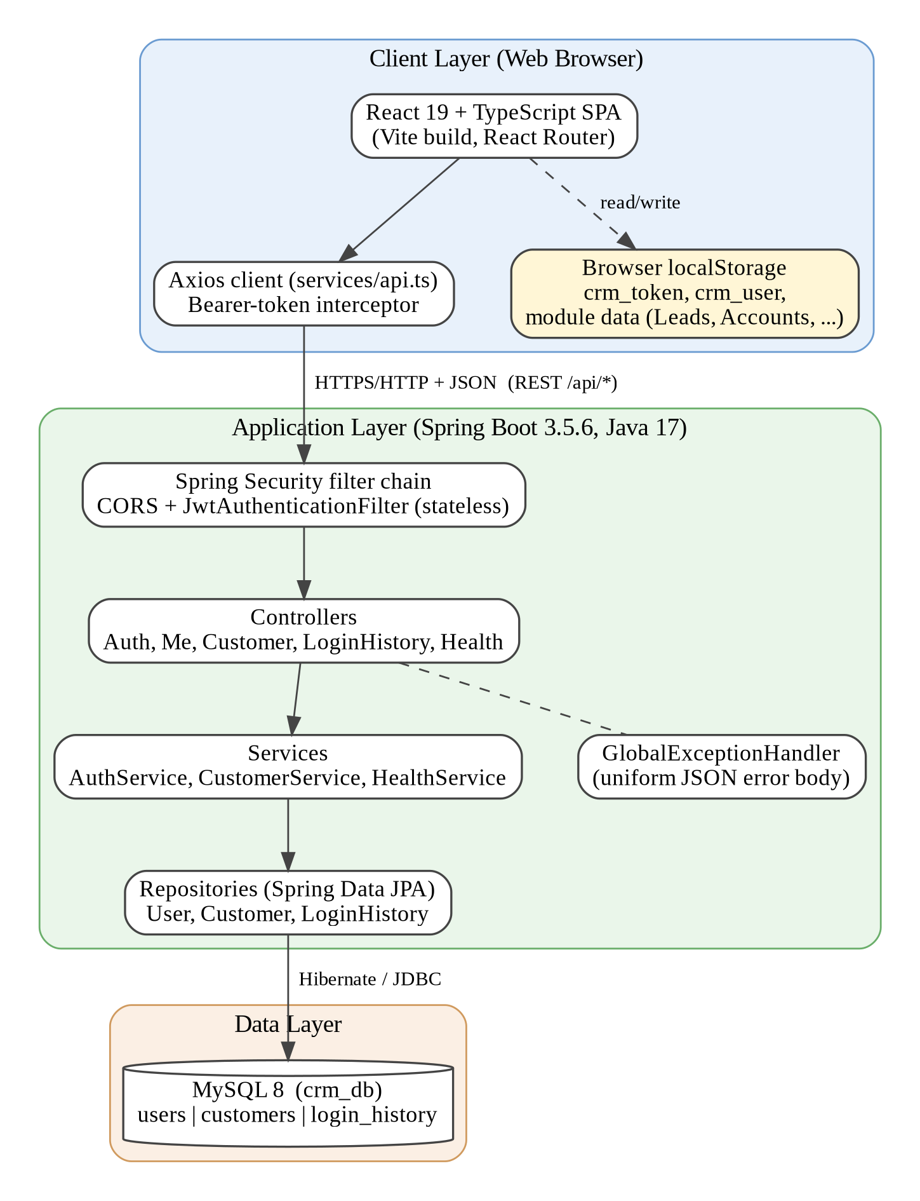
Figure 4.1: High-level architecture of the CRM for Small Businesses application

4.2 Description of Each Layer (Frontend, Backend, Database)
Presentation layer (frontend)
The presentation layer is the React SPA. main.tsx mounts the application inside BrowserRouter and ToastProvider. App.tsx defines the public routes (/login, /register) and the protected routes that are rendered inside AppLayout. The browser's localStorage holds the JWT (crm_token) and a copy of the signed-in user's profile (crm_user). The Axios client attaches the token to every request automatically. Several pages (Leads, Accounts, Sales, Interactions, Follow-ups) additionally keep their own demonstration data in localStorage; these pages do not call the backend (see Section 6.1).
Application layer (backend)
The backend is organised into the packages listed in Table 4.1. Controllers contain only HTTP concerns; services contain business rules; repositories contain data-access interfaces; DTO classes define the request and response contracts; the security package contains the JWT service and filter; and exception contains the global error handler.
Table 4.1: Backend packages and their classes
Package (com.crm.*) | Classes
controller | AuthController, MeController, CustomerController, LoginHistoryController, HealthController
service | AuthService, CustomerService, HealthService
repository | UserRepository, CustomerRepository, LoginHistoryRepository
entity | User, Customer, LoginHistory
dto | RegisterRequest, LoginRequest, AuthResponse, CustomerRequest, CustomerResponse, HealthResponse, ApiError
security | SecurityConfig, JwtService, JwtAuthenticationFilter
config | CorsConfig
exception | GlobalExceptionHandler, ResourceNotFoundException

Request life cycle
- The browser sends an HTTP request with the header Authorization: Bearer <token> (not required for /api/auth/** and /api/health).
- JwtAuthenticationFilter extracts the token, verifies its signature and expiry using JwtService, and stores an authentication object whose principal is the e-mail address from the token subject.
- The authorisation rules in SecurityConfig permit OPTIONS requests, /api/auth/** and /api/health without authentication; every other request must be authenticated.
- The controller validates the request body (@Valid) and calls the service with the authenticated e-mail address.
- The service loads the user, applies the ownership rule (findByIdAndUser) and uses the repository to access the database.
- The result is mapped to a response DTO and returned as JSON; any exception is converted by GlobalExceptionHandler into a body of the form {success, message, timestamp, status}.
Data layer
The data layer is a MySQL 8 database named crm_db. Hibernate maps the User, Customer and LoginHistory entities to the tables users, customers and login_history. The tables are linked by foreign keys, and deleting a user cascades to that user's customers and login records at database level.

4.3 Deployment Architecture (Cloud, Local, CI/CD Pipelines)
The project, as supplied, is configured for local deployment, illustrated in Figure 4.2. The React development server (port 5173), the Spring Boot service and the MySQL server run on the developer's machine; the backend reads its configuration from the .env file. In the supplied configuration the backend listens on port 8081 (SERVER_PORT=8081) and the frontend is configured with VITE_API_BASE_URL=http://localhost:8081/api; if neither variable is set, the backend defaults to port 8080.
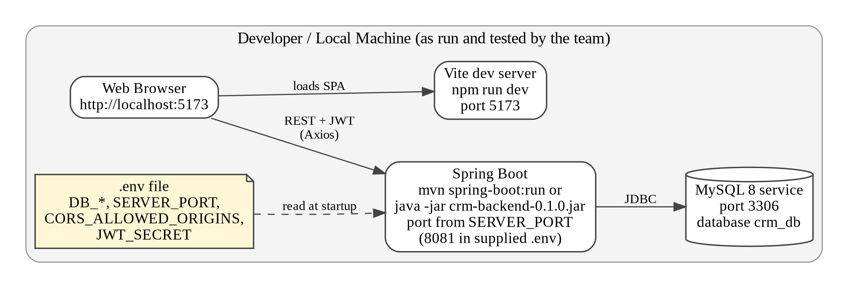
Figure 4.2: Local deployment architecture of the CRM application
The project contains no Dockerfile, container-orchestration file, cloud configuration or continuous-integration pipeline definition. Consequently, no cloud deployment or CI/CD pipeline is claimed. The build artefacts that would be used for a hosted deployment are produced by the commands in Chapter 9: an executable JAR (backend/target/crm-backend-0.1.0.jar) and a static bundle (frontend/dist).

CHAPTER -5 DESIGN

5.1 System Design Overview
The design of the system is based on three principles: separation of responsibilities between the frontend, backend and database; stateless authentication using signed tokens; and per-user ownership of business data. The only actor with access to the protected functions is the authenticated user; an unauthenticated visitor can only register, log in or query the health endpoint. The use cases supported by the implementation are listed in Table 5.1.
Table 5.1: Use cases of the implemented system
ID | Use case | Actor | Main flow
UC-1 | Register an account | Visitor | Submit name, e-mail and password; the system stores a BCrypt hash, issues a token and opens the dashboard
UC-2 | Log in | Visitor | Submit e-mail and password; the system verifies the hash, records the login and issues a token
UC-3 | View dashboard | Authenticated user | The system loads the user profile and customers and displays the counts and customer table
UC-4 | Add customer | Authenticated user | Submit the customer form; the system stores the record under the user's account with status ACTIVE
UC-5 | Edit customer | Authenticated user | Change name, e-mail, phone or company of an owned customer and save
UC-6 | Delete customer | Authenticated user | Confirm the deletion; the system removes the owned record
UC-7 | Search and filter customers | Authenticated user | Type a search term or choose All / Active / Inactive in the Customers page
UC-8 | View login history | Authenticated user | The system lists previous successful logins in descending order of time
UC-9 | Log out | Authenticated user | The frontend deletes the stored token and profile and returns to the login page

Data flow for the creation of a customer (UC-4) illustrates the design: the Customers page posts the form data to /api/customers; the security filter authenticates the token; CustomerController validates the body; CustomerService retrieves the User entity that matches the token's e-mail address, builds a Customer with status ACTIVE, and saves it through CustomerRepository; the saved entity is converted to a CustomerResponse and returned; finally the page reloads the list from GET /api/customers.

5.2 ER Diagram / Database Schema
The database consists of three tables. The entity-relationship diagram in Figure 5.1 is derived from database/schema.sql and matches the JPA entity classes. A user owns many customers and has many login-history records (one-to-many relationships); both relationships are enforced by foreign keys with ON DELETE CASCADE.
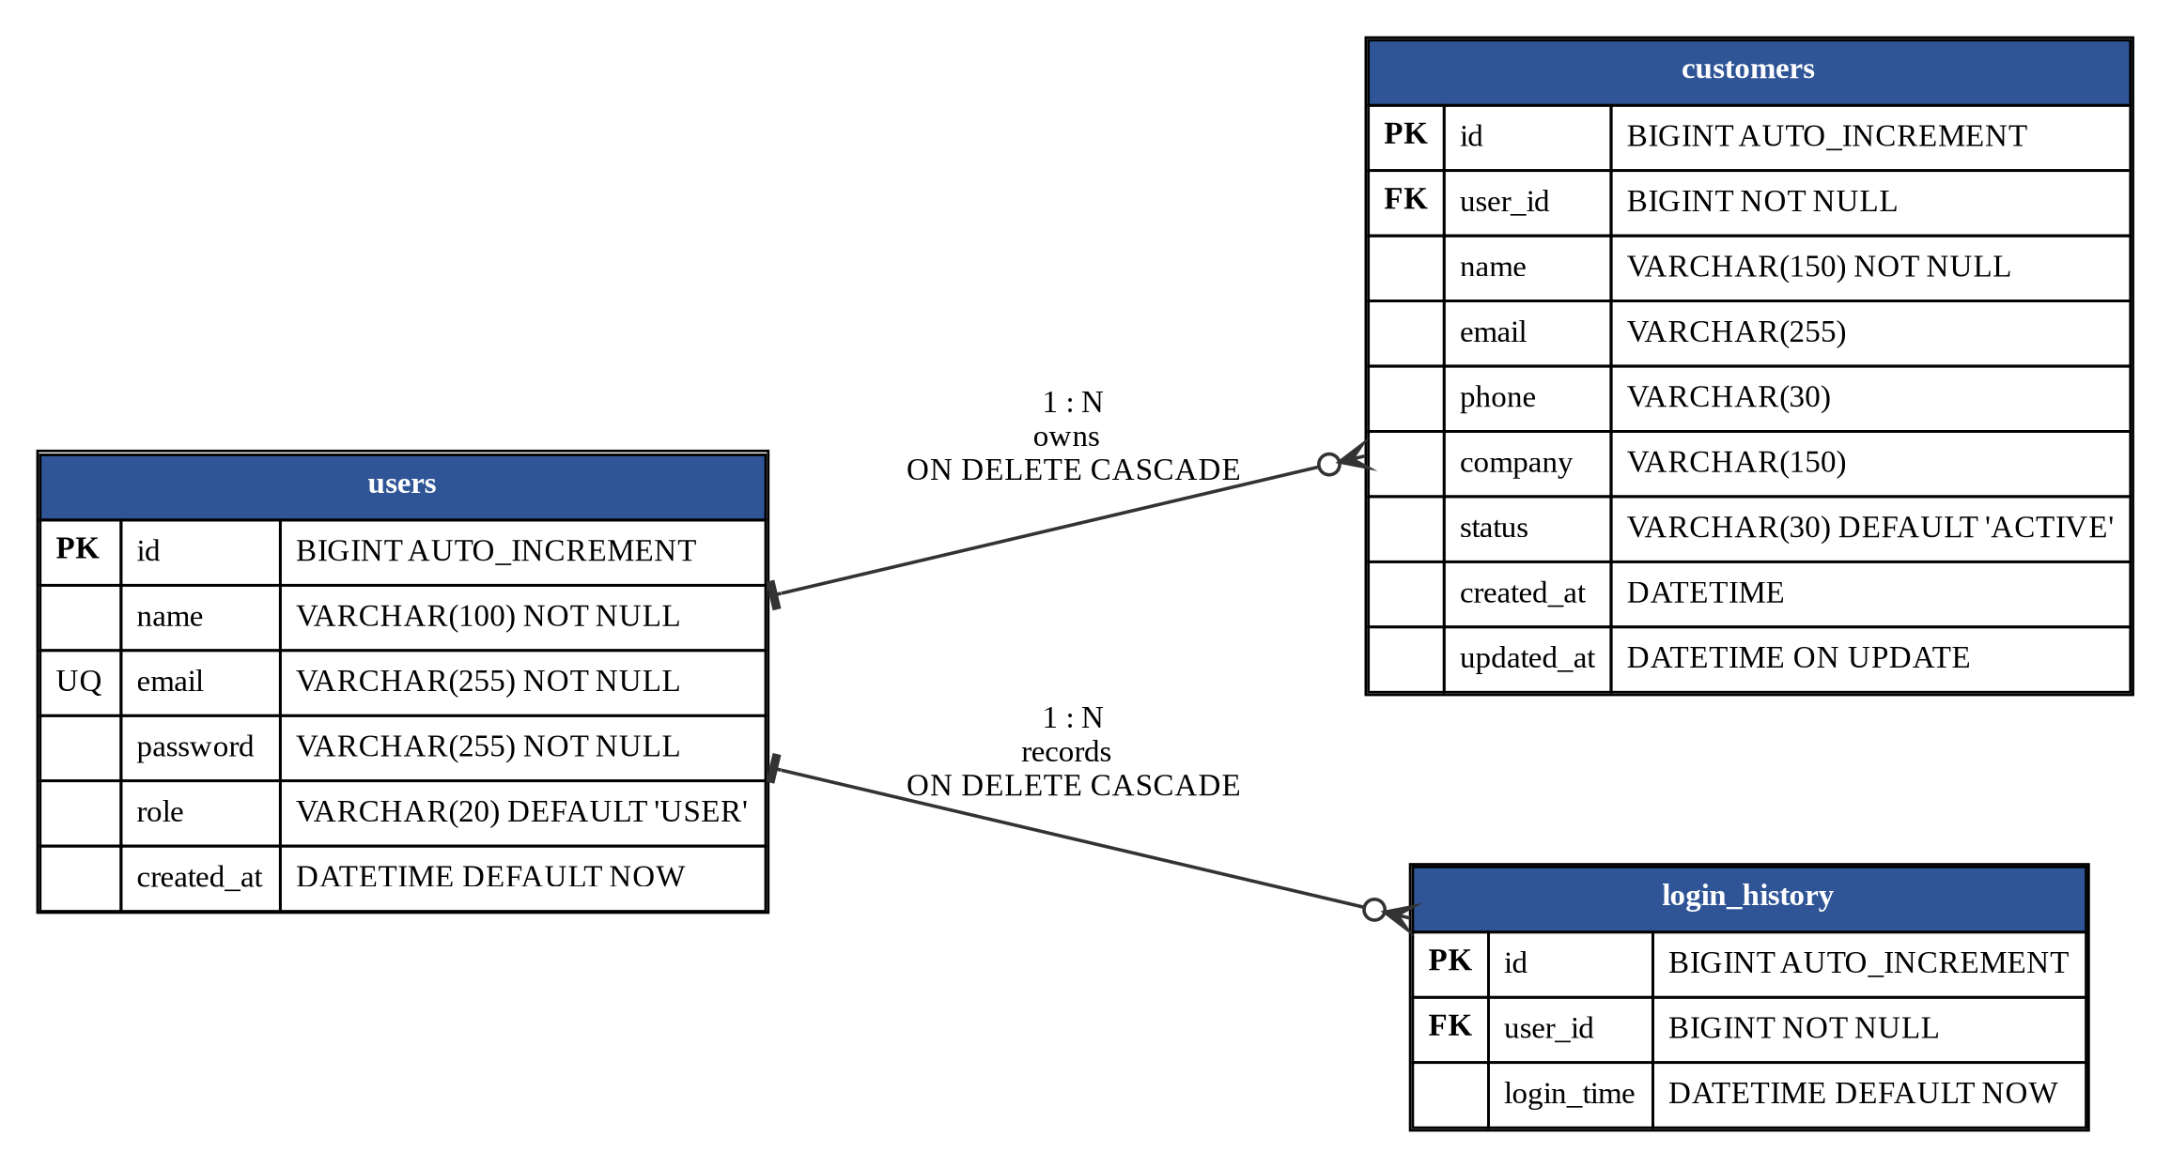
Figure 5.1: Entity-relationship diagram of the CRM database (crm_db)
Table 5.2: Structure of the users table
Column | Type | Constraints | Description
id | BIGINT | Primary key, AUTO_INCREMENT | Unique user identifier
name | VARCHAR(100) | NOT NULL | Display name
email | VARCHAR(255) | NOT NULL, UNIQUE | Login identifier
password | VARCHAR(255) | NOT NULL | BCrypt hash of the password
role | VARCHAR(20) | NOT NULL, DEFAULT 'USER' | Account role (always USER at registration)
created_at | DATETIME | NOT NULL, DEFAULT CURRENT_TIMESTAMP | Registration time

Table 5.3: Structure of the customers table
Column | Type | Constraints | Description
id | BIGINT | Primary key, AUTO_INCREMENT | Unique customer identifier
user_id | BIGINT | NOT NULL, foreign key to users(id), ON DELETE CASCADE | Owner of the record
name | VARCHAR(150) | NOT NULL | Customer name
email | VARCHAR(255) | NULL | Customer e-mail address
phone | VARCHAR(30) | NULL | Contact number
company | VARCHAR(150) | NULL | Company name
status | VARCHAR(30) | NOT NULL, DEFAULT 'ACTIVE' | Customer status
created_at | DATETIME | NOT NULL, DEFAULT CURRENT_TIMESTAMP | Creation time
updated_at | DATETIME | NOT NULL, DEFAULT CURRENT_TIMESTAMP ON UPDATE CURRENT_TIMESTAMP | Last modification time

Table 5.4: Structure of the login_history table
Column | Type | Constraints | Description
id | BIGINT | Primary key, AUTO_INCREMENT | Unique record identifier
user_id | BIGINT | NOT NULL, foreign key to users(id), ON DELETE CASCADE | User who logged in
login_time | DATETIME | NOT NULL, DEFAULT CURRENT_TIMESTAMP | Time of the successful login

The data model deliberately contains only the entities that are persisted by the current backend. The Leads, Accounts, Sales (deals), Interactions and Follow-ups screens of the frontend keep their data in the browser and have no corresponding database tables; tables for these modules have not been designed or created and are listed as future work in Chapter 11.

CHAPTER -6 IMPLEMENTATION
This chapter explains how the design was realised in code. All descriptions are based on the source files in the project archive. Wherever a screen exists in the user interface but is not connected to the backend, this is stated explicitly so that implemented and prototype functionality are not confused.

6.1 Module-Wise Implementation
The application is divided into the modules shown in Figure 6.1. The modules on the left are full-stack: they have React screens, REST endpoints, services and MySQL tables. The modules on the right are browser-only screens that keep sample or user-entered data in localStorage or in constants inside the source file; they have no backend API.
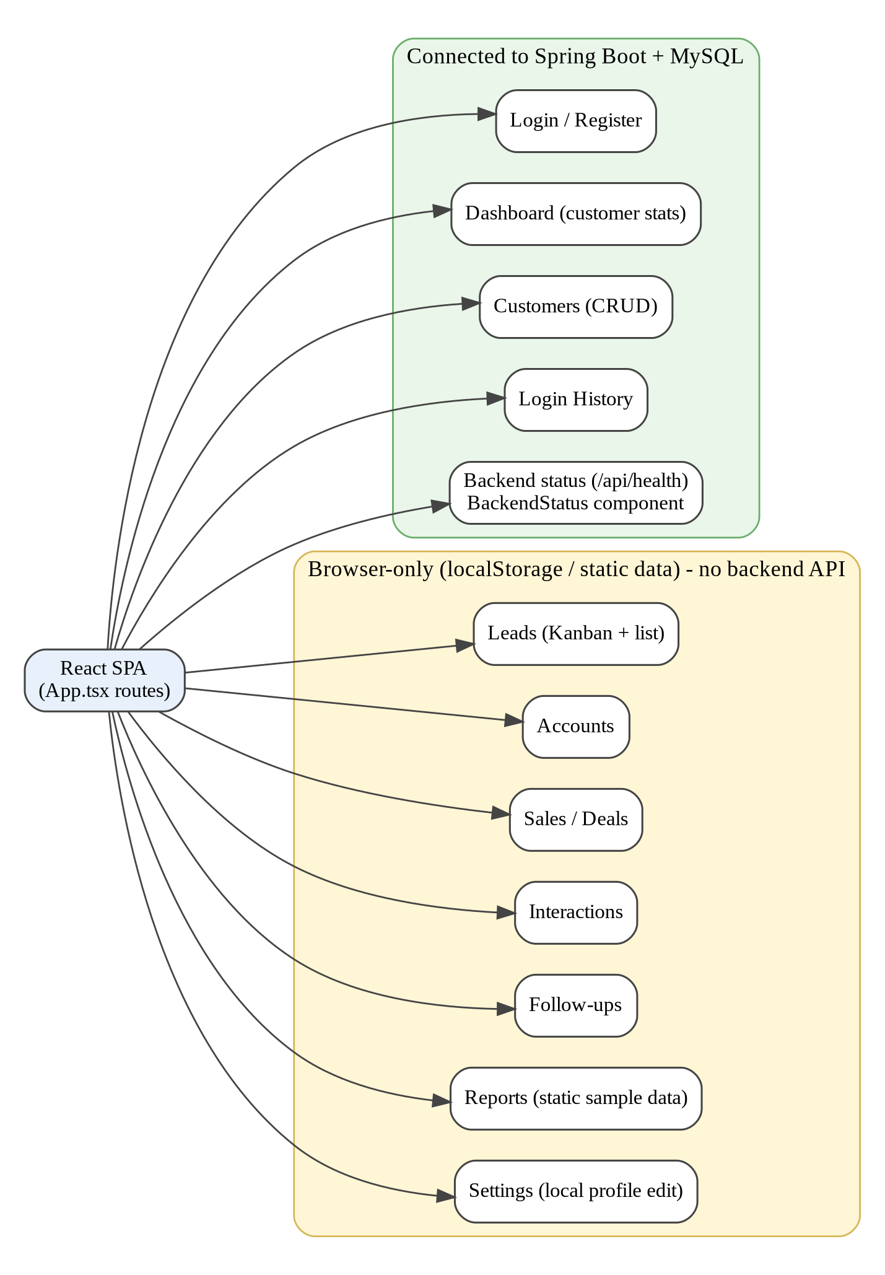
Figure 6.1: Modules of the application grouped by backend connectivity
Module 1: Authentication (registration and login)
Backend. AuthController (/api/auth) exposes POST /register and POST /login. AuthService.register rejects an e-mail address that already exists, hashes the password with the PasswordEncoder bean (BCrypt) and saves a User with the role USER. AuthService.login looks up the user by e-mail, compares the submitted password with the stored hash and, on success, saves a LoginHistory record. In both cases the controller then asks JwtService for a token and returns an AuthResponse containing the token, user id, name, e-mail and role.
Frontend. Register.tsx and Login.tsx are controlled forms that keep field values in useState, call the API through Axios, store crm_token and crm_user in localStorage and navigate to /dashboard. Errors returned by the API are displayed in an alert box through getErrorMessage.
Listing 6.1: AuthService.login (condensed from AuthService.java)
public User login(LoginRequest request) {
User user = userRepository.findByEmail(request.getEmail())
.orElseThrow(() ->
new RuntimeException("Invalid email or password"));

if (!passwordEncoder.matches(
request.getPassword(), user.getPassword())) {
throw new RuntimeException("Invalid email or password");
}

LoginHistory loginHistory = new LoginHistory(user);
loginHistoryRepository.save(loginHistory);
return user;
}

Module 2: Customer management
Backend. CustomerController (/api/customers) provides create, list, get-by-id, update and delete operations. Each method receives the Authentication object and passes authentication.getName() (the e-mail address from the token) to CustomerService. The service always resolves the User first and then queries with findByIdAndUser or findByUserOrderByCreatedAtDesc, so a user can only read, change or delete his or her own customers. New customers are created with the status ACTIVE; createdAt and updatedAt are maintained by @PrePersist and @PreUpdate callbacks in the entity.
Listing 6.2: Ownership check in CustomerService.getCustomer (condensed)
User user = userRepository.findByEmail(email)
.orElseThrow(() -> new RuntimeException("User not found"));

Customer customer = customerRepository
.findByIdAndUser(id, user)
.orElseThrow(() -> new RuntimeException("Customer not found"));

return toResponse(customer);

Frontend. Customers.tsx loads the list on mount (GET /customers), shows four statistic cards, a search box, status chips (All, Active, Inactive) and a table with Edit and Delete buttons. The same modal form is used for adding and editing: editingId determines whether the page sends POST /customers or PUT /customers/{id}. Deletion asks for confirmation with window.confirm before calling DELETE /customers/{id}. After every successful change the page reloads the list from the server.
Module 3: Dashboard
Dashboard.tsx issues two requests in parallel with Promise.all (GET /auth/me and GET /customers). It displays a welcome message, three cards (Total Customers, Active Customers, Account role) and a table of the returned customers. The counts are computed in the browser: the total is the length of the returned list and the active count is the number of customers whose status equals ACTIVE. If the request fails, the page shows the error and falls back to the user profile saved in localStorage.
Module 4: Login history
LoginHistoryController returns the logged-in user's records ordered by loginTime descending, as {id, loginTime} objects. LoginHistory.tsx formats each timestamp with toLocaleString("en-IN") and displays it in a numbered table with the status "Successful". Only successful logins are recorded; failed attempts are not stored. Registration also does not create a login-history record, although it signs the user in.
Module 5: Health check and error handling
HealthService executes SELECT 1 through JdbcTemplate; HealthController returns status, application, database and timestamp at GET /api/health. The frontend hook useHealth and the BackendStatus component can display this information. GlobalExceptionHandler converts validation errors, unknown routes, wrong HTTP methods, ResourceNotFoundException and all other exceptions into a uniform JSON error body, and writes stack traces only to the server log.
Module 6: Application shell and navigation
AppLayout.tsx renders the sidebar (menu defined in config/navigation.ts), the top bar, the signed-in user's name and role, and the Log out button. The sidebar collapses on narrow screens and is opened with a menu button. The top bar contains a Quick add menu that navigates to the Customers, Leads, Sales, Interactions and Follow-ups pages, a notifications icon and a search field. The notifications panel shows fixed sample messages and the global search field only displays a "not implemented yet" toast.
Module 7: Browser-only prototype screens
The pages Leads, Accounts, Sales, Interactions, Follow-ups, Reports and Settings were built as user-interface modules for the CRM roadmap. Leads, Accounts, Sales, Interactions and Follow-ups each define a TypeScript interface, a list of default sample records, add / edit / delete forms, statistic cards, search and filters. Their data is stored with useState and copied to localStorage (keys crm_leads_data, crm_accounts_data, crm_deals_data, crm_interactions_data and crm_followups_data). Data in these screens is therefore local to one browser, is not shared between users or devices, and is not stored in MySQL. The Reports page renders charts and tables from constants defined in the source file. The Settings page edits only the local copy of the profile.

6.2 Front-End Logic (UI Rendering and State Management)
Routing and route protection
App.tsx declares the routes in Table 6.1. Two small wrapper components implement client-side guards: ProtectedRoute redirects to /login when no crm_token exists in localStorage, and PublicRoute redirects to /dashboard when a token exists. Unknown paths are redirected to /dashboard. The guard checks only for the presence of a token; the validity of the token is verified by the backend when data is requested.
Table 6.1: Frontend routes
Path | Component | Access | Backend connection
/login | Login | Public | POST /api/auth/login
/register | Register | Public | POST /api/auth/register
/dashboard | Dashboard | Protected | GET /api/auth/me, GET /api/customers
/customers | Customers | Protected | /api/customers (CRUD)
/login-history | LoginHistory | Protected | GET /api/login-history
/leads, /accounts, /deals, /interactions, /followups | Leads, Accounts, Sales, Interactions, Followups | Protected | None (localStorage only)
/reports, /settings | Reports, Settings | Protected | None (static data / local profile)
any other path | Redirect | - | Redirects to /dashboard

State management
State is managed with React hooks inside each component. Typical pages hold the records (useState), form values, loading flag, saving flag and error message, and load data in a useEffect that runs once on mount. There is no global store such as Redux and no authentication context; the session consists of the two localStorage entries. The only React context in the project is ToastContext, which provides success, info, error and notImplemented message functions to any component. The custom hook useHealth encapsulates loading, error and refresh logic for the health endpoint.
Rendering of lists, forms and feedback
Lists are rendered with Array.map and a stable key (the record id). Search and status filtering of customers are performed in the browser by Array.filter over the list already received from the server, matching the search term against name, e-mail and company in a case-insensitive manner. Modal dialogs are shown by toggling a CSS class. Every data-loading page displays a loading message, an error alert or an empty-state message with a call-to-action button, so that the user always receives feedback.
Axios client and session handling
Listing 6.3: Axios client with request and response interceptors (condensed from services/api.ts)
export const api = axios.create({
baseURL: API_BASE_URL, // VITE_API_BASE_URL or http://localhost:8081/api
timeout: 10_000,
headers: { "Content-Type": "application/json" },
});

api.interceptors.request.use((config) => {
const token = localStorage.getItem("crm_token");
if (token) config.headers.Authorization = `Bearer ${token}`;
return config;
});

api.interceptors.response.use((r) => r, (error) => {
if (error.response?.status === 401) {
localStorage.removeItem("crm_token");
localStorage.removeItem("crm_user");
}
return Promise.reject(error);
});

6.3 API Integration
The frontend and backend communicate exclusively through JSON over HTTP. The endpoints below were verified by reading the controller classes and SecurityConfig. Status codes marked with an asterisk (*) were also observed during the tests reported in Chapter 8; the others are derived from the code.
Table 6.2: REST API endpoints
Method | Path | Authentication | Request body | Success response and notes
POST | /api/auth/register | Public | name, email, password (min. 6 characters) | 200 with token, userId, name, email, role; 400 for invalid input*
POST | /api/auth/login | Public | email, password | 200 with token, userId, name, email, role; a login record is saved; 400 for invalid input*
GET | /api/auth/me | Token expected | - | 200 with id, name, email, role; 404 if the user does not exist
GET | /api/health | Public | - | 200 with status, application, database, timestamp (DOWN if MySQL does not answer)*
GET | /api/customers | Token | - | 200 with the caller's customers, newest first
POST | /api/customers | Token | name (required), email, phone, company | 200 with the created customer; 400 if name is blank*
GET | /api/customers/{id} | Token | - | 200 with one owned customer
PUT | /api/customers/{id} | Token | name (required), email, phone, company | 200 with the updated customer (status is not changed)
DELETE | /api/customers/{id} | Token | - | 204 No Content
GET | /api/login-history | Token | - | 200 with a list of id and loginTime, newest first

Illustrative request and response bodies, constructed from the DTO classes (the values are examples, not recorded data), are shown below.
Listing 6.4: Example JSON bodies derived from the DTOs
POST /api/auth/register
{ "name": "Asha Rao", "email": "asha@example.com", "password": "secret123" }

200 OK
{ "token": "<JWT>", "userId": 1, "name": "Asha Rao",
"email": "asha@example.com", "role": "USER" }

POST /api/customers (Authorization: Bearer <JWT>)
{ "name": "Ravi Kumar", "email": "ravi@shop.in",
"phone": "9876543210", "company": "Kumar Stores" }

200 OK
{ "id": 1, "name": "Ravi Kumar", "email": "ravi@shop.in",
"phone": "9876543210", "company": "Kumar Stores", "status": "ACTIVE" }

Error format
All error responses use the structure {"success": false, "message": "...", "timestamp": "...", "status": <code>}. For validation failures the message lists each field and its constraint, for example name: must not be blank. Unexpected exceptions return the message "Something went wrong on the server." with status 500. The frontend function getErrorMessage displays message from the body when present; when no response is received it shows a message that the backend may not be running.
Cross-origin access
Because the frontend (port 5173) and the backend run on different origins, CORS is configured. The effective policy is defined in SecurityConfig.corsConfigurationSource(), which allows the origins http://localhost:5173 and http://localhost:5174, the methods GET, POST, PUT, DELETE and OPTIONS, all headers, and credentials. A second configuration, CorsConfig, reads the allowed origins from the property app.cors.allowed-origins (CORS_ALLOWED_ORIGINS) and is registered with Spring MVC. The observed response to a pre-flight request from http://localhost:5173 (Chapter 8, test T14) lists exactly the methods of SecurityConfig.

6.4 Authentication and Authorisation
Authentication is implemented with stateless JSON Web Tokens and BCrypt-hashed passwords. Figure 6.2 shows the login sequence from the form submission to the validation of the token on later requests.
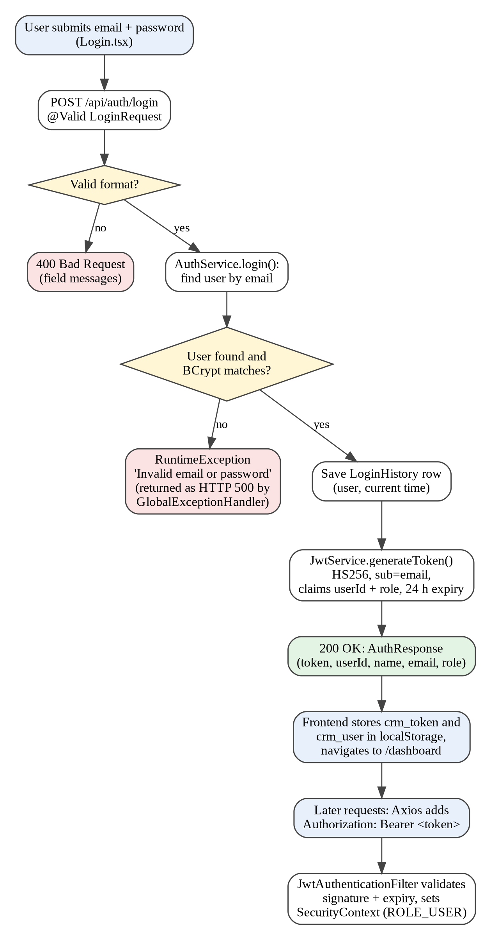
Figure 6.2: Login and token-validation flow
Table 6.3: Characteristics of the JWT implementation
Aspect | Implementation
Algorithm | HMAC-SHA with the key derived from JWT_SECRET (Keys.hmacShaKeyFor); the secret must be at least 32 characters long
Subject | The user's e-mail address
Custom claims | userId and role
Lifetime | 86 400 000 ms (24 hours) from issue time
Verification | Jwts.parser().verifyWith(secretKey); any parsing or signature error makes the token invalid
Transport | Authorization: Bearer <token> header, added by the Axios request interceptor
Storage on the client | localStorage key crm_token
Password storage | BCrypt (BCryptPasswordEncoder)

Listing 6.5: Token creation in JwtService (condensed)
public String generateToken(Long userId, String email, String role) {
return Jwts.builder()
.subject(email)
.claim("userId", userId)
.claim("role", role)
.issuedAt(new Date())
.expiration(new Date(System.currentTimeMillis() + 86400000))
.signWith(secretKey)
.compact();
}

JwtAuthenticationFilter extends OncePerRequestFilter. If the Authorization header begins with Bearer , it validates the token and, when valid, places a UsernamePasswordAuthenticationToken (principal: e-mail; authority: ROLE_USER) in the SecurityContext. If the header is missing or the token is invalid, the filter simply continues without authentication, and Spring Security then rejects access to protected URLs.
Authorisation rules
SecurityConfig disables CSRF protection (appropriate for a stateless, header-token API), sets the session policy to STATELESS, and defines the access rules summarised in Table 6.4.
Table 6.4: Access rules in SecurityConfig
URL pattern | Rule | Observed behaviour without a token
OPTIONS /** | Permitted | Pre-flight requests are answered
/api/auth/** and /api/health | Permitted for everyone | Reachable (note: includes /api/auth/me)
Any other request | Authentication required | HTTP 403 Forbidden (tests T02, T05)

Authorisation of data is enforced at the service layer: customer queries always include the authenticated user, so one user cannot access another user's records. The role value is stored in the database and in the token, but the filter assigns the fixed authority ROLE_USER and no endpoint is restricted by role. Role-based access control (for example, an administrator role) is therefore not implemented; this limitation and others found during the review are listed in Chapter 10.

CHAPTER 7- FEATURES

7.1 List of Main Features
Table 7.1 lists the features visible in the application and classifies each as Full-stack (implemented in the React frontend, the Spring Boot backend and MySQL) or Browser-only prototype (implemented in the user interface with data kept in the browser).
Table 7.1: Feature list and implementation status
No. | Feature | Description | Status
1 | User registration | Create an account with name, e-mail and password; automatic sign-in | Full-stack
2 | User login | Authenticate with e-mail and password; JWT issued | Full-stack
3 | Session handling and logout | Token kept in the browser; protected routes; log out clears the session | Full-stack (client-side logout)
4 | Dashboard | Total customers, active customers, account role and customer table | Full-stack
5 | Customer management | Add, view, edit and delete customers; search; status filter | Full-stack
6 | Login history | List of previous successful logins | Full-stack
7 | Backend health status | API and database availability via /api/health | Full-stack
8 | Leads | Kanban board and list of leads with pipeline statistics | Browser-only prototype
9 | Accounts | Company accounts with tier and status filters | Browser-only prototype
10 | Sales / Deals | Deal pipeline with stages, probability and forecast figures | Browser-only prototype
11 | Interactions | Log of calls, meetings, e-mails, notes and tasks | Browser-only prototype
12 | Follow-ups | Scheduled follow-ups with priority and completion state | Browser-only prototype
13 | Reports | Revenue, funnel, top-account and channel charts from sample constants | Static prototype
14 | Settings | Profile and workspace preferences screen | Local prototype (not saved to server)

7.2 How Each Feature Works
Feature 1: User registration
User perspective. The visitor opens /register, enters a name, an e-mail address and a password of at least six characters, and presses "Create account". On success the user is taken directly to the dashboard.
Technical description. The form posts to POST /api/auth/register. RegisterRequest is validated (@NotBlank on name; @NotBlank and @Email on e-mail; @NotBlank and @Size(min = 6) on password). AuthService.register checks existsByEmail, encodes the password with BCrypt and saves the user. The controller issues a token and the page stores the token and profile in localStorage.
Feature 2: User login
User perspective. The user enters e-mail and password on /login and presses "Log in". On success the dashboard opens; on failure an error message appears above the form.
Technical description. The request is POST /api/auth/login. After successful password verification a login_history row is written and a JWT is returned. The frontend stores crm_token and crm_user and navigates to /dashboard.
Feature 3: Session handling and logout
User perspective. A user who is not logged in is redirected to the login page when opening any protected address; a logged-in user who opens the login page is redirected to the dashboard. "Log out" in the sidebar returns the user to the login page.
Technical description. Route guards read crm_token. Logout removes crm_token and crm_user from localStorage. The token itself is not invalidated on the server and remains valid until it expires after 24 hours.
Feature 4: Dashboard
User perspective. After login the user sees a welcome message, the number of customers, the number of active customers, the account role and a table with name, e-mail, phone, company and status of the customers.
Technical description. See Module 3 in Section 6.1. The dashboard page also contains its own Logout button in addition to the one in the sidebar.
Feature 5: Customer management
User perspective. On the Customers page the user presses "+ Add Customer", fills in the form (name is mandatory) and saves. Existing customers can be edited or deleted with the buttons in each row. The search box and the All / Active / Inactive chips narrow the list immediately.
Technical description. See Module 2 in Section 6.1. Client-side validation requires a non-empty name; the backend independently enforces @NotBlank on the name. The status of a customer is created as ACTIVE; the current form and the update operation do not modify the status, so the Inactive filter shows records only if their status is changed directly in the database.
Feature 6: Login history
User perspective. The "Login History" menu item displays a numbered table of previous login times for the signed-in user, newest first.
Technical description. GET /api/login-history returns the rows of login_history for the authenticated user.
Feature 7: Backend health status
User perspective. A "Backend connection" card (component BackendStatus) can show whether the API and MySQL are reachable, together with the application name and server time.
Technical description. The component calls GET /api/health through the useHealth hook. The component is part of the codebase, but it is not mounted in any of the routed pages of the current version; the endpoint itself can be called directly or through the Postman collection.
Features 8 to 12: Leads, Accounts, Sales, Interactions and Follow-ups (browser-only prototypes)
These five screens share the same pattern: summary statistic cards, a search box, filter chips, a table or board, and a modal form for adding and editing. Each screen is seeded with sample records the first time it is opened, and every change is saved to localStorage.
Table 7.2: Behaviour of the browser-only modules
Module | Data fields | Views, filters and statistics | localStorage key
Leads | name, company, e-mail, phone, value, status (NEW, CONTACTED, QUALIFIED, PROPOSAL, WON, LOST), source | Kanban board and list view; search; "Advance" button moves a lead to the next stage; cards: Total Leads, Pipeline Value, Qualified / Proposal, Won Deals | crm_leads_data
Accounts | name, industry, website, tier (Enterprise, Mid-Market, Startup), annual revenue, phone, status (ACTIVE, PROSPECT, CHURNED), contacts count | Search and tier filter; cards: Total Accounts, Active Accounts, Enterprise Tier, Combined Portfolio Revenue | crm_accounts_data
Sales | name, company, value, stage (Discovery, Proposal, In Review, Negotiation, Closed Won, Closed Lost), probability, close date, owner | Search and stage filter; cards: Total Pipeline, Weighted Forecast, Closed Won Revenue, Average Deal Size | crm_deals_data
Interactions | type (CALL, MEETING, EMAIL, NOTE, TASK), contact, company, date, summary, outcome, sentiment | Search and type filter; cards: Total Activities, Calls Logged, Meetings Held, Emails Sent | crm_interactions_data
Follow-ups | title, contact, company, due date and time, priority (HIGH, MEDIUM, LOW), completed flag, notes | Filters All, Pending, Today, Completed; cards: Pending Tasks, Due Today, High Priority, Completed | crm_followups_data

Because these modules do not use the backend, their data is neither shared between users nor protected by authentication on the server, and it disappears if the browser storage is cleared. They demonstrate the intended user interface of the CRM roadmap rather than completed server-side features.
Features 13 and 14: Reports and Settings
The Reports page presents a monthly revenue-versus-target bar chart, a lead-conversion funnel, a table of top accounts and an acquisition-channel breakdown. All figures are constants in Reports.tsx; they are sample values and are not calculated from the customers stored in MySQL. The Settings page shows the profile from the stored user, and allows the display name to be edited and saved to localStorage; the workspace name, currency, time zone and two-factor toggle are interface elements whose values are not persisted or sent to the backend.

CHAPTER -8 TESTING

8.1 Postman Testing (Frontend/Backend)
Postman was used to test and validate the REST APIs developed for the CRM (Customer Relationship Management) system. It helps verify whether the Spring Boot backend receives requests, processes them correctly, and returns appropriate responses.
During testing, HTTP methods such as GET, POST, PUT, and DELETE can be used to check API functionality, depending on the endpoints implemented in the application.
The following activities describe the Postman testing process:
- API Endpoint Testing: Verified the availability and functionality of backend endpoints.
- GET Request Testing: Checked whether the server returns the expected information.
- POST Request Testing: Tested the submission of data to the backend.
- Response Validation: Examined HTTP status codes, response bodies, and error messages.
- Backend Connectivity: Verified that the backend server was accessible and responding to API requests.
- Error Handling: Checked how the application responds to invalid requests and missing information.
Postman primarily tests the backend APIs. Frontend functionality is checked separately through the browser, while the integration between the frontend and backend is validated by testing the complete application workflow.
8.2 Integration Testing
Integration testing was performed to verify the interaction between the different components of the CRM system. The main objective was to ensure that the frontend, backend, and database communicate correctly and work together as expected.
The CRM system consists of the following components:
- Frontend: React, TypeScript, Vite, and Tailwind CSS.
- Backend: Spring Boot and REST APIs.
- Database: MySQL, accessed through JPA/Hibernate.
The integration testing process includes the following activities:
- Frontend–Backend Integration: Verified that requests from the React frontend reach the appropriate Spring Boot API endpoints.
- Backend–Database Integration: Checked whether the backend can connect to MySQL and perform the required database operations.
- Login Workflow Testing: Tested the login process using valid and invalid credentials.
- Data Persistence Testing: Checked whether saved information remains available after refreshing the application or restarting the server, where applicable.
- User Data Isolation: Verified that information belonging to one user is not displayed to another user.
- Error Handling: Checked the application's response when the backend is unavailable or a request fails.
Integration testing helps identify communication errors, database connectivity problems, and inconsistencies between different application components.
8.3 Tools Used for Testing
The following tools and technologies were used or are applicable for testing the CRM application.
Tool | Purpose
Postman | Testing REST API endpoints and examining server responses.
Web Browser | Testing the frontend interface, navigation, login page, and dashboard.
Visual Studio Code | Editing source code and identifying development errors.
Spring Boot Logs | Checking backend startup, request processing, and runtime errors.
MySQL Workbench | Inspecting database tables and verifying stored records.
Maven | Building the backend project and identifying compilation or dependency errors.
Browser Developer Tools | Inspecting frontend errors, network requests, and API responses.
These tools help test individual components, identify errors, and verify the overall behavior of the application.
8.4 Test Cases and Results
The following test cases describe the key functional and integration checks for the CRM system. The final result for each test should be recorded after executing it in the application.
Test Case ID | Test Scenario | Expected Result | Status
TC-01 | Start the Spring Boot backend | Backend starts successfully without errors. | To be verified
TC-02 | Test the health API using Postman | Server returns the expected health response. | To be verified
TC-03 | Connect the backend to MySQL | Database connection is established successfully. | To be verified
TC-04 | Open the CRM frontend | Login page or intended application screen loads correctly. | To be verified
TC-05 | Submit valid login credentials | User is authenticated and redirected to the appropriate page. | To be verified
TC-06 | Submit invalid login credentials | Login is rejected with an appropriate error message. | To be verified
TC-07 | Submit data through an API | Valid data is processed and stored when the endpoint supports it. | To be verified
TC-08 | Retrieve stored data | The API returns the expected records. | To be verified
TC-09 | Refresh the application | Persisted data remains available. | To be verified
TC-10 | Log in using different user accounts | Each user sees only the data they are authorized to access. | To be verified
TC-11 | Test an invalid API request | The server returns an appropriate error response. | To be verified
TC-12 | Test frontend–backend communication | API requests and responses work correctly across the application. | To be verified
Testing Outcome
The testing process provides a structured way to evaluate the CRM application's functionality, database connectivity, API behavior, and integration between components. Issues identified during testing can be corrected through debugging and retesting.
The test cases listed above represent the planned validation of the application. Their status should be updated to Pass or Fail based on actual execution results. This ensures that the final project documentation accurately reflects the features that were tested and verified.

CHAPTER -9 DEPLOYMENT
9.1 Steps to Deploy
Deployment is the process of preparing and running the CRM (Customer Relationship Management) application in an environment where users can access and use its features. The CRM system is developed using React with TypeScript for the frontend, Spring Boot for the backend, and MySQL for database management.
The following steps describe the deployment process for the application.
Step 1: Prepare the Application
The frontend and backend source code are organized into separate directories. All required dependencies are installed, and the application is checked for compilation errors before deployment.
Step 2: Configure the Database
MySQL is installed and configured to store user details and CRM-related information. The required database and tables are created using SQL scripts. The backend database connection properties are configured to connect the Spring Boot application to MySQL.
Step 3: Build the Backend
The Spring Boot backend is built using Maven to check for compilation errors and generate the executable application package.
Command:
mvn clean package
Step 4: Build the Frontend
The React frontend dependencies are installed, and the production build is generated using Vite.
Commands:
npm install
npm run build
Step 5: Run and Verify the Application
The backend server is started, and the frontend is launched or hosted separately. The application is then tested to ensure that API requests, database operations, and user interactions work correctly.
Step 6: Perform Final Validation
The login functionality, dashboard, database connectivity, API responses, and user-specific data access are checked before making the application available to users.
9.2 Environment Configuration
Environment configuration is necessary to ensure that the CRM application runs correctly across different development and deployment environments. It includes configuring database credentials, server ports, application URLs, and other required settings.
The following configurations are required for the CRM system:
Component | Configuration
Frontend | React, TypeScript, Vite, and Tailwind CSS
Backend | Java JDK 17 or later and Spring Boot
Database | MySQL Server
Backend Port | 8080 by default
Frontend Development Port | Commonly 5173 with Vite
API Communication | HTTP requests to Spring Boot REST endpoints
Database Connectivity | JDBC URL, username, and password
The backend database configuration is maintained in the Spring Boot application.properties file.
Example configuration:
spring.datasource.url=jdbc:mysql://localhost:3306/crm_db
spring.datasource.username=${DB_USERNAME}
spring.datasource.password=${DB_PASSWORD}

spring.jpa.hibernate.ddl-auto=update
The values for DB_USERNAME and DB_PASSWORD should be configured through environment variables. Actual database credentials should not be committed to a public repository.
The frontend must also be configured with the correct backend API URL. During local development, the frontend can communicate with the backend running on localhost:8080. In production, the API URL must point to the deployed backend.
Environment variables help keep configuration separate from application code and make it easier to move the application between environments.
9.3 Hosting of Frontend and Backend
The CRM application consists of three major components: the frontend, backend, and database. Each component must be configured properly for the complete application to function.
Frontend Hosting
The frontend is developed using React, TypeScript, Vite, and Tailwind CSS. It provides the user interface through which users interact with the CRM system.
The production frontend can be hosted on platforms such as Vercel, Netlify, or a static web server. The generated production files are available in the dist directory after executing the build command.
npm run build
After deployment, the frontend communicates with the backend through configured REST API endpoints.
Backend Hosting
The backend is developed using Spring Boot and exposes REST APIs for handling application requests and business logic.
The backend can be hosted on a Java-compatible server or cloud platform that supports Spring Boot applications. Maven can generate an executable JAR file, which can be started using the Java command.
java -jar target/your-application.jar
The actual JAR filename depends on the project's Maven configuration. The deployed backend must be configured with the appropriate database credentials, server port, and frontend access settings.
Database Hosting
MySQL is used as the relational database for storing application data. During development, the database runs locally on the developer's system. For production deployment, it can be hosted on a managed MySQL service or a properly configured database server.
The backend connects to the deployed database using the configured connection URL and credentials. Database access should be restricted to authorized services, and regular backups should be maintained.
Deployment Architecture
The overall deployment architecture of the CRM system is represented below.
User's Web Browser
Accesses the CRM interface
Frontend Hosting
React · TypeScript · Vite · Tailwind CSS
Backend Hosting
Spring Boot · REST APIs · JPA/Hibernate
MySQL Database
Stores and retrieves CRM information
Figure 9.1: Proposed deployment architecture of the CRM application.
The frontend sends HTTP requests to the Spring Boot backend, which processes the requests and interacts with the MySQL database through JPA/Hibernate. The backend returns responses to the frontend, allowing the user interface to display the relevant information.
Deployment status: This chapter describes the deployment procedure and proposed hosting architecture. Actual public hosting should be marked as completed only after the frontend, backend, and database have been deployed and verified in the target environment.
Is this conversation helpful so far?

CHAPTER -10 CHALLENGES & LIMITATIONS
[CHAPTER IN PROGRESS - this chapter has not been written yet in this progress version. The content below is a structural placeholder only.]

10.1 Issues Faced During Development

10.2 Solutions Applied

10.3 Current Limitations or Known Bugs

CHAPTER -11 FUTURE ENHANCEMENTS
11.1 Planned Features
The CRM (Customer Relationship Management) system provides a foundation for managing customer information and business activities through a web-based application. In the future, the system can be enhanced with additional features to improve usability, automation, security, and overall performance.
The following features are planned for future development:
1. Advanced Customer Management
The system can be enhanced to support complete customer lifecycle management, including adding, updating, deleting, searching, and categorizing customer records. Additional customer details, communication history, and interaction records can also be maintained.
2. Lead and Sales Management
A lead management module can be introduced to track potential customers, sales opportunities, follow-up activities, and deal progress. A visual sales pipeline can help users monitor leads at different stages of the sales process.
3. Role-Based Access Control
Different access levels can be provided for administrators, managers, and regular users. This will ensure that each user can access only the features and information permitted by their assigned role.
4. Dashboard Analytics and Reports
The dashboard can be enhanced with interactive charts, graphs, and summary reports. These visualizations can help users understand customer growth, sales performance, lead conversion rates, and other important business metrics.
5. Task and Reminder Management
A task management module can be added to schedule customer follow-ups, meetings, and important activities. Automated reminders can help users complete tasks on time and maintain better customer relationships.
6. Search, Filtering, and Sorting
Advanced search and filtering options can be introduced to help users locate customer records quickly. Records can be filtered by category, date, status, or other relevant attributes.
7. Improved User Experience
The interface can be further improved with enhanced navigation, mobile responsiveness, accessibility support, customizable dashboards, and additional user preferences.
8. Data Export and Backup
The application can support exporting customer information and reports into formats such as CSV, Excel, or PDF. Automated database backups can also be implemented to reduce the risk of data loss.
11.2 Possible Integrations or Optimisations
In addition to introducing new features, the CRM system can be improved through integrations with external services and optimizations to its existing architecture.
A. Possible Integrations
1. Email Integration
Integration with email services can allow users to send customer communications, track follow-ups, and maintain a history of important interactions directly within the CRM application.
2. Calendar Integration
Integration with calendar services can help users schedule meetings, organize appointments, and receive reminders for upcoming customer interactions.
3. Notification Services
Email notifications or other notification mechanisms can be implemented to alert users about new leads, assigned tasks, upcoming deadlines, and important updates.
4. Cloud Storage Integration
Cloud storage services can be integrated to store customer-related documents, contracts, and attachments securely, subject to appropriate access controls.
5. AI-Based Customer Insights
Artificial intelligence and machine learning can be introduced to analyze customer activity, identify potential sales opportunities, predict lead conversion probabilities, and provide useful business insights.
B. Possible Optimisations
1. Database Optimization
Database performance can be improved through suitable indexing, optimized SQL queries, efficient table relationships, and pagination for large datasets.
2. Backend Performance Improvement
Spring Boot services can be optimized by reducing unnecessary database queries, improving exception handling, and using efficient data-access methods.
3. Frontend Performance Optimization
The React frontend can be improved through code splitting, lazy loading, reusable components, and efficient state management to reduce loading time and improve responsiveness.
4. Enhanced Security
Additional security measures can include secure password hashing, token-based authentication using JWT, role-based authorization, input validation, HTTPS, and protection against common web application vulnerabilities.
5. Scalability and Cloud Deployment
The application can be deployed on cloud infrastructure to support a larger number of users and increasing amounts of customer data. Monitoring, logging, and automated deployment pipelines can also be introduced to simplify maintenance.
6. Automated Testing
Automated unit, integration, and end-to-end tests can be implemented to detect errors early and ensure that new features do not affect existing functionality.
7. Data Privacy and Recovery
Data access restrictions, regular backups, secure configuration management, and recovery procedures can be introduced to improve the reliability and protection of customer information.
Conclusion
The proposed future enhancements will help transform the CRM system into a more comprehensive and scalable customer management platform. By introducing advanced customer management, analytics, automation, external integrations, and improved security, the application can better support business operations and customer relationships.
These enhancements can be implemented in phases based on user requirements, available resources, and project priorities. The existing React, Spring Boot, and MySQL architecture provides a foundation for gradually expanding the system into a more feature-rich CRM solution.

CHAPTER -12 CONCLUSION
12.1 Summary of the Project
The CRM (Customer Relationship Management) system was developed to provide a centralized platform for managing customer-related information and business activities efficiently. The project combines a modern web-based frontend with a secure backend and a MySQL database to provide an organized and user-friendly CRM solution.
The frontend was developed using React with TypeScript, Vite, and Tailwind CSS, providing an interactive and responsive user interface. The backend was implemented using Spring Boot, with JPA/Hibernate used for database communication and REST APIs used to connect the frontend and backend. MySQL was used as the relational database for storing user and CRM-related information.
The system was designed with a focus on usability, data management, authentication, and maintaining separate data for individual users. Overall, the project demonstrates how modern web technologies can be integrated to develop a practical CRM application.
12.2 What Was Achieved
The following major objectives were achieved during the development of the CRM system:
- Developed a responsive and user-friendly CRM web application.
- Created a structured React-based frontend with reusable components.
- Implemented a Spring Boot backend to handle application logic and REST API requests.
- Integrated MySQL for persistent data storage.
- Used JPA/Hibernate for communication between the backend and database.
- Implemented a login and authentication mechanism for users.
- Designed a dashboard to provide users with an overview of CRM information.
- Established communication between the frontend and backend through REST APIs.
- Maintained separate user-related data to avoid mixing information between different accounts.
- Organized the project into separate frontend, backend, and database components.
- Tested the application using development and API-testing tools.
- Created a foundation that can be extended with additional CRM features in future versions.
12.3 Skills Learned During Development
The development of this project provided practical experience in several areas of software development. The major skills learned include:
Frontend Development
- Learned React and TypeScript for developing interactive web applications.
- Gained experience with Vite for setting up and running modern React projects.
- Learned Tailwind CSS for designing responsive and consistent user interfaces.
- Understood component-based development and frontend project organization.
Backend Development
- Gained practical knowledge of Spring Boot and its application structure.
- Learned how to create and work with REST APIs.
- Understood backend request handling, controllers, services, and data access layers.
- Learned the role of JPA and Hibernate in connecting Java applications with relational databases.
Database Management
- Gained experience working with MySQL.
- Learned how to create databases and tables and manage stored data.
- Understood how backend applications interact with databases.
- Learned the importance of maintaining proper relationships and user-specific data.
Integration and Testing
- Learned how to connect a React frontend with a Spring Boot backend.
- Gained experience in identifying and resolving frontend, backend, database, and configuration errors.
- Used API testing tools such as Postman to test backend endpoints.
- Learned basic debugging techniques using browser and backend console logs.
Software Development Skills
- Improved problem-solving and debugging abilities.
- Learned how to organize a full-stack project into separate modules.
- Gained experience in configuring development environments and managing dependencies.
- Developed a better understanding of the complete frontend → API → backend → database workflow.
- Improved understanding of how real-world web applications are designed, developed, tested, and maintained.

CHAPTER -13 REFERENCES

Books

Tutorials and Learning Resources

APIs and Tools Used

Documentation and Research References

CHAPTER -14 APPENDICES

Screenshots of the app

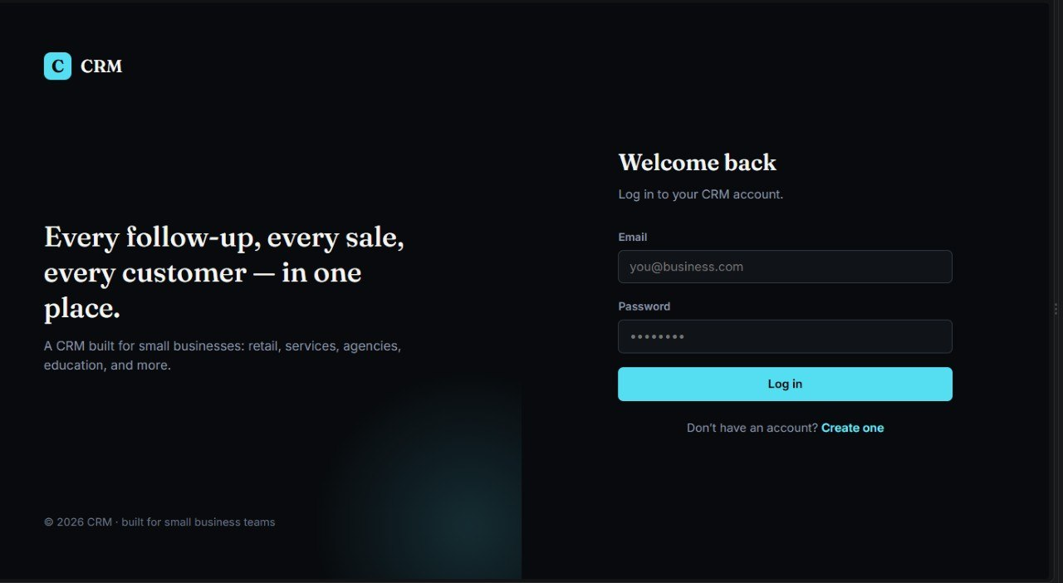

Geo Tag photos with guide
