
Date :
Course Title and Course Code : 25CS1302E DATABASE SYSTEMS ENGINEERING AND DISTRIBUTED BACKEND DEVELOPMENT
Course Coordinator/Instructor : Spandana Shivanadhuni
Department : CSE
Section : 07
Review : 1/2/3/4
Total Number of batches : 23
Number of batches given review : 23
Number of batches not given review : 0
List of batch members not given review: 0

Comments/Observations/Challenges:

Course Coordinator/Instructor: Signature

Geo-Tag pictures of Reviews Taken:
Review1:
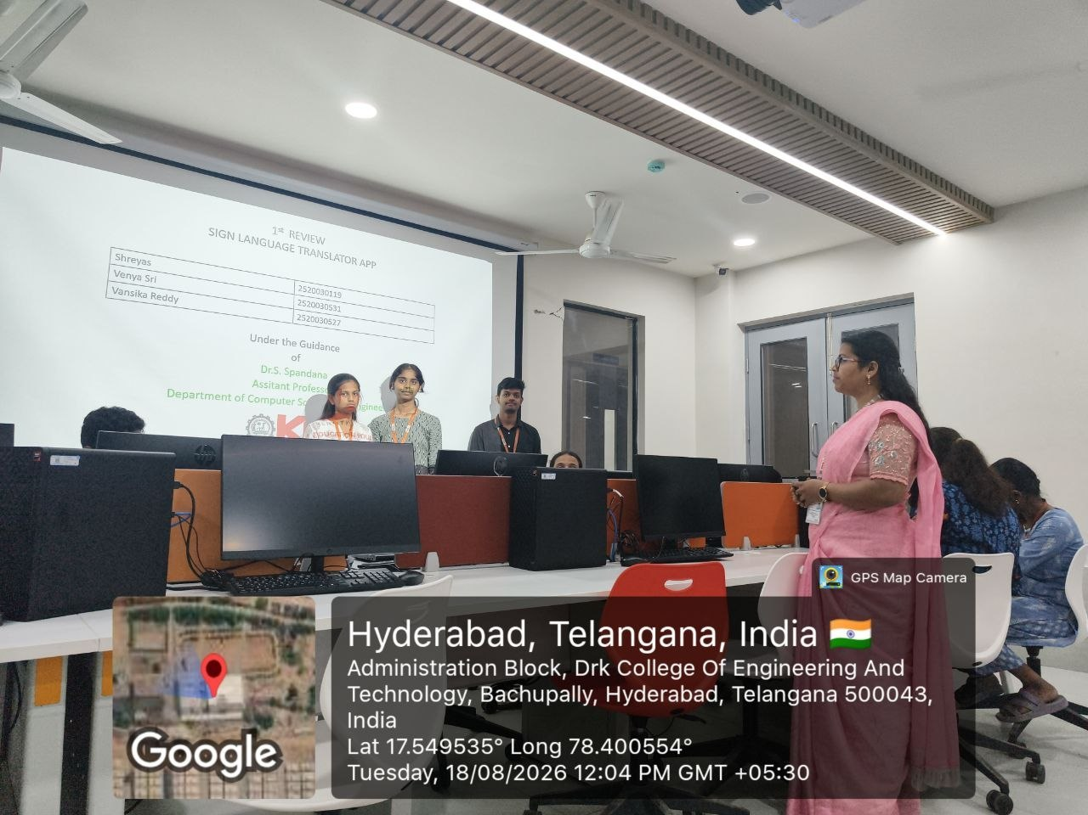
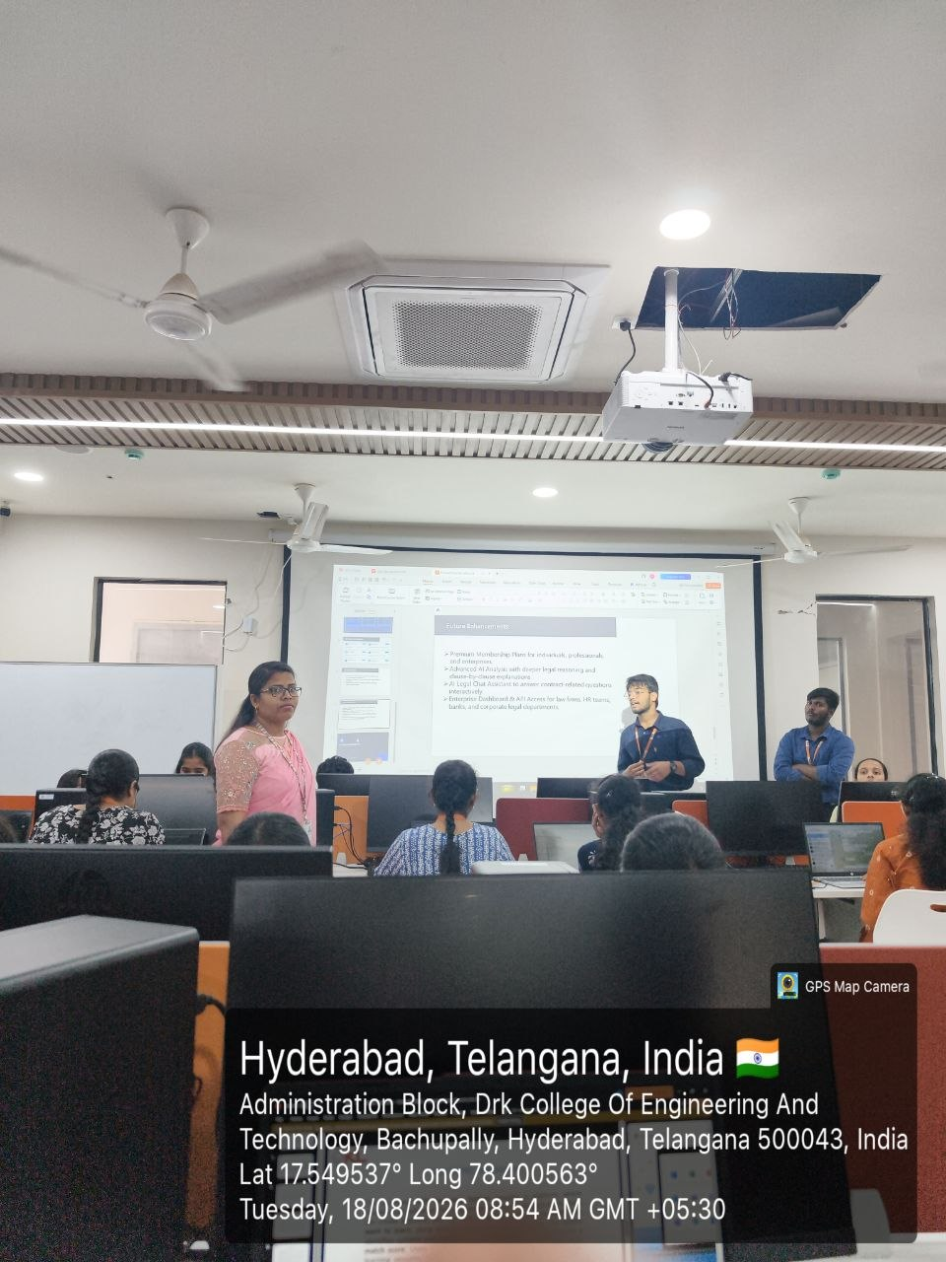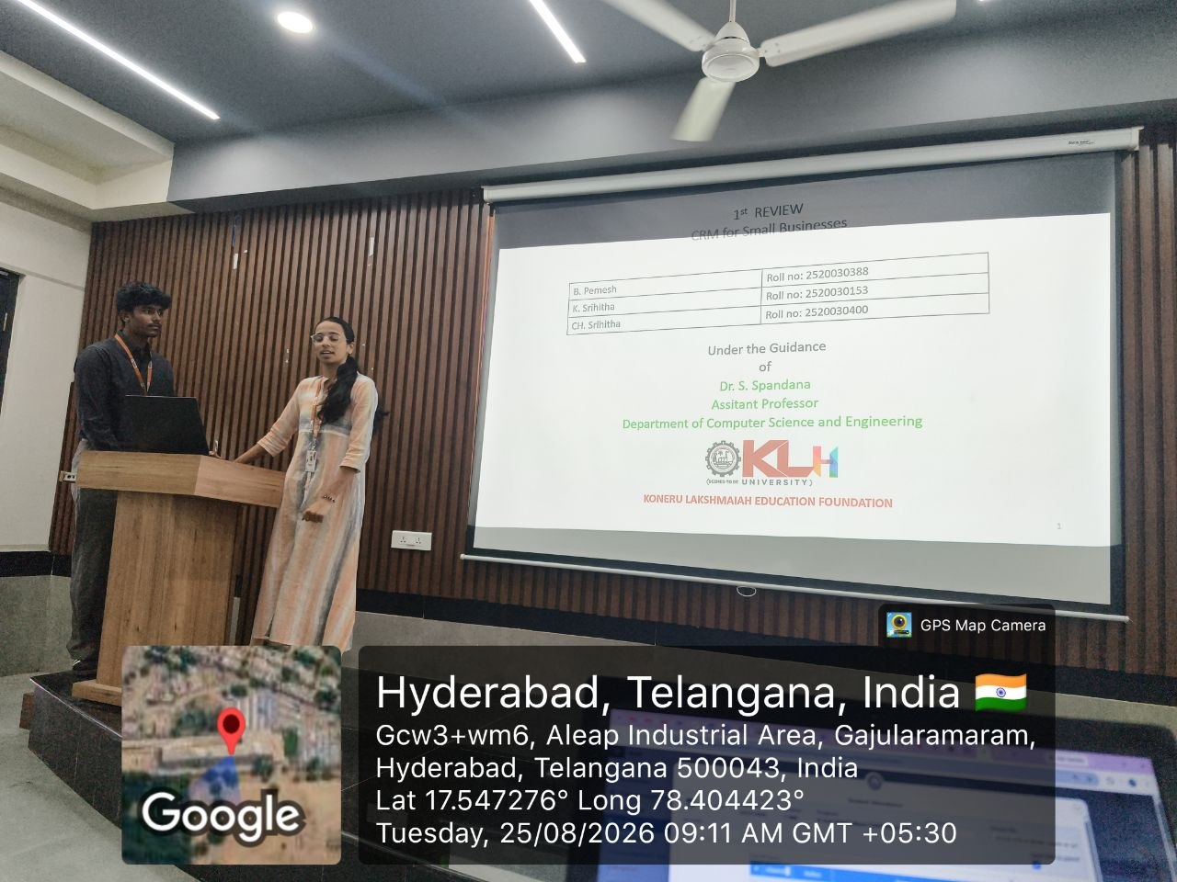
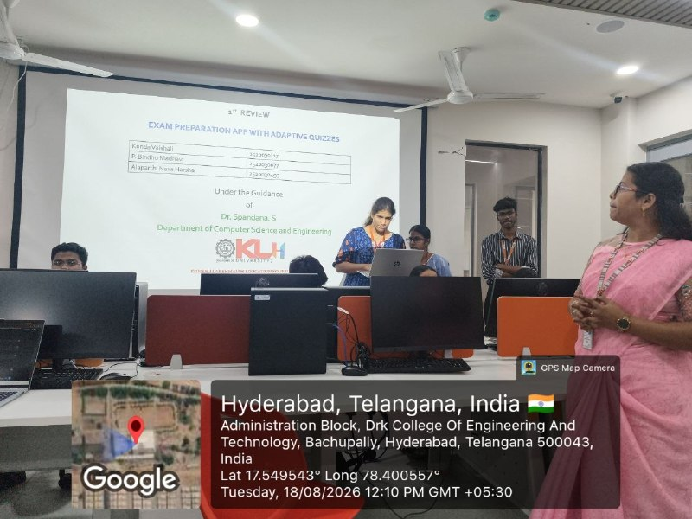
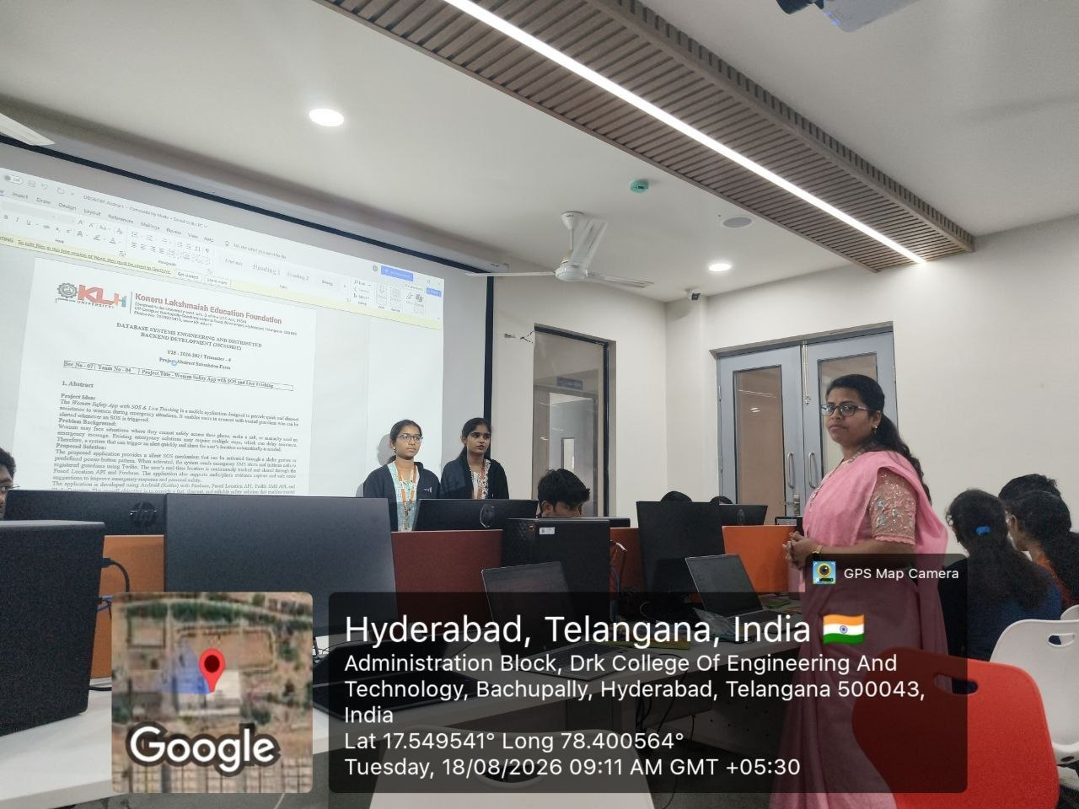

Review2: 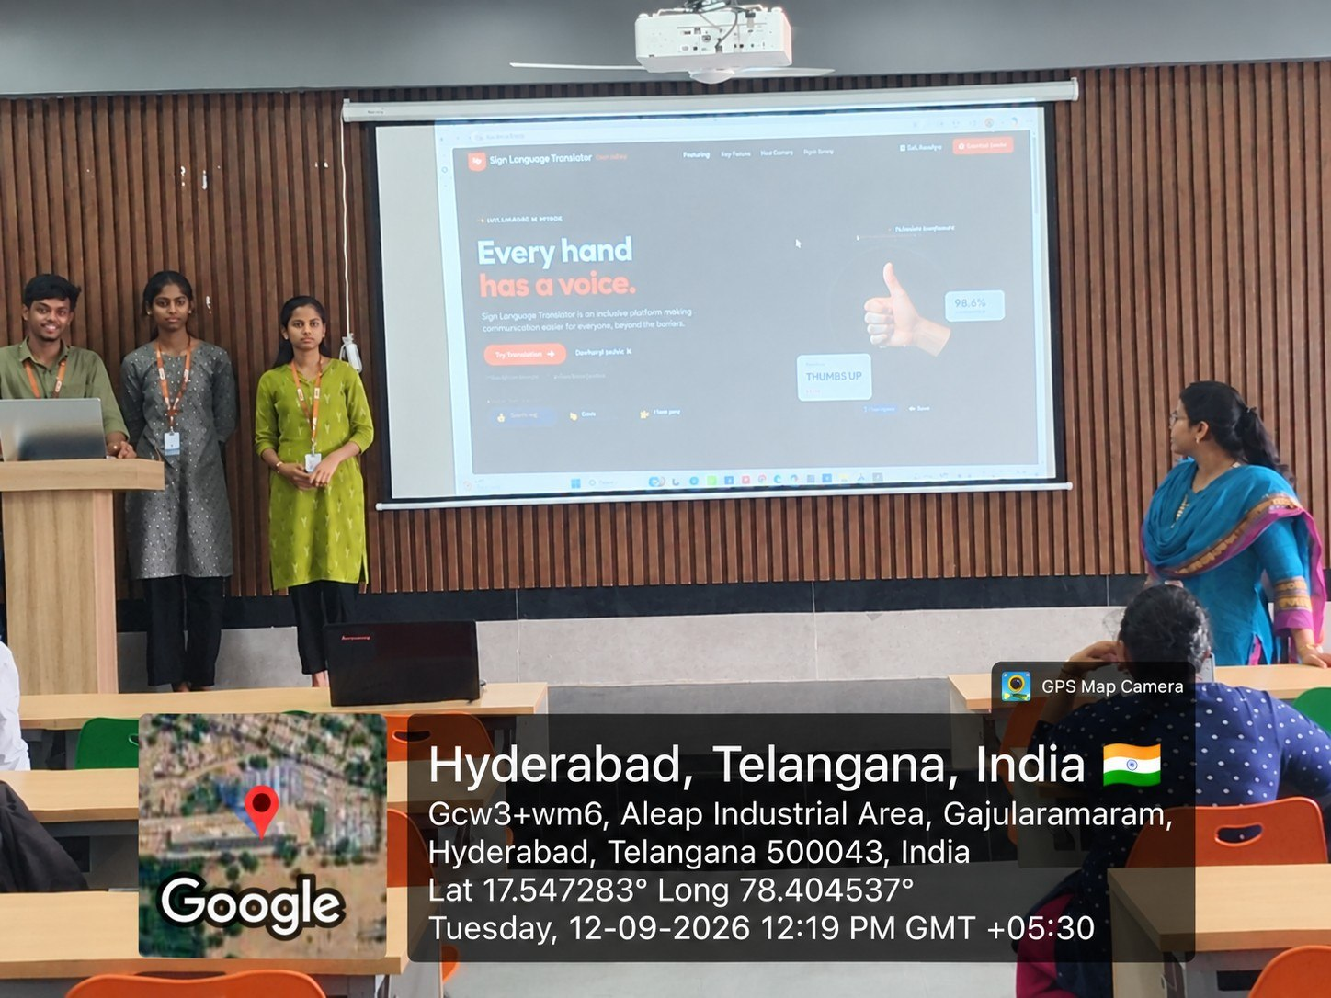
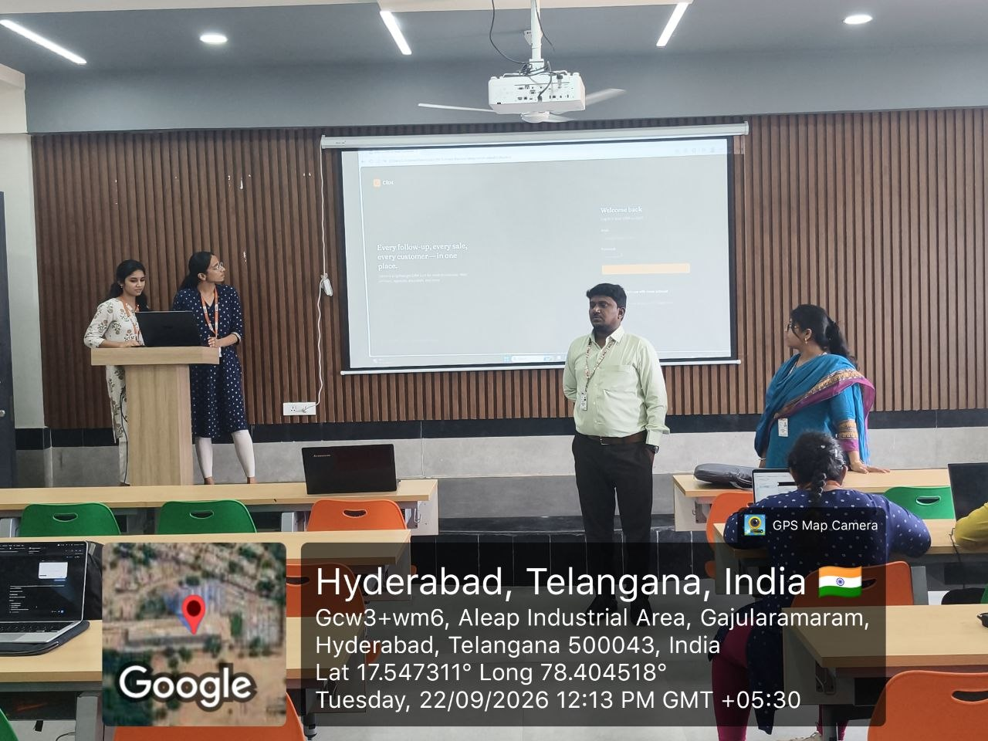
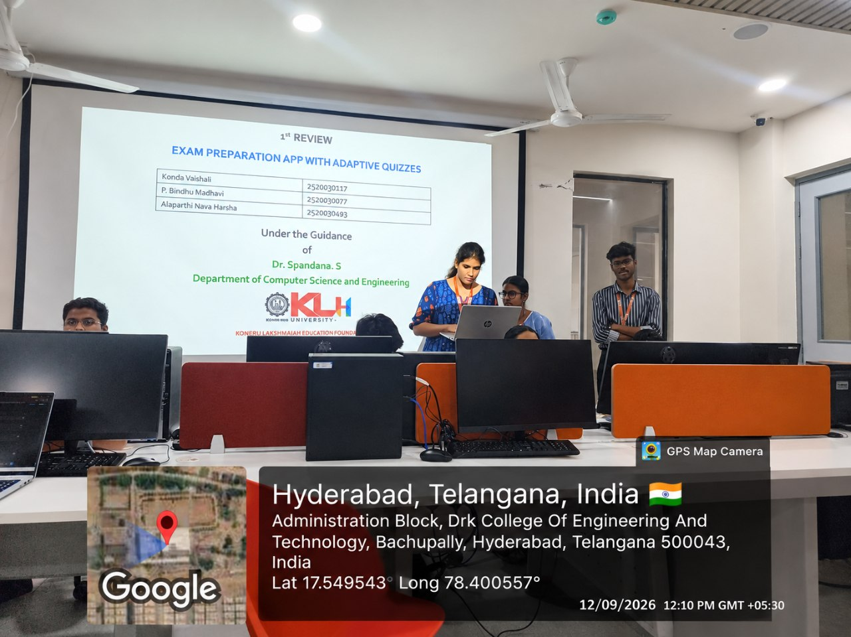
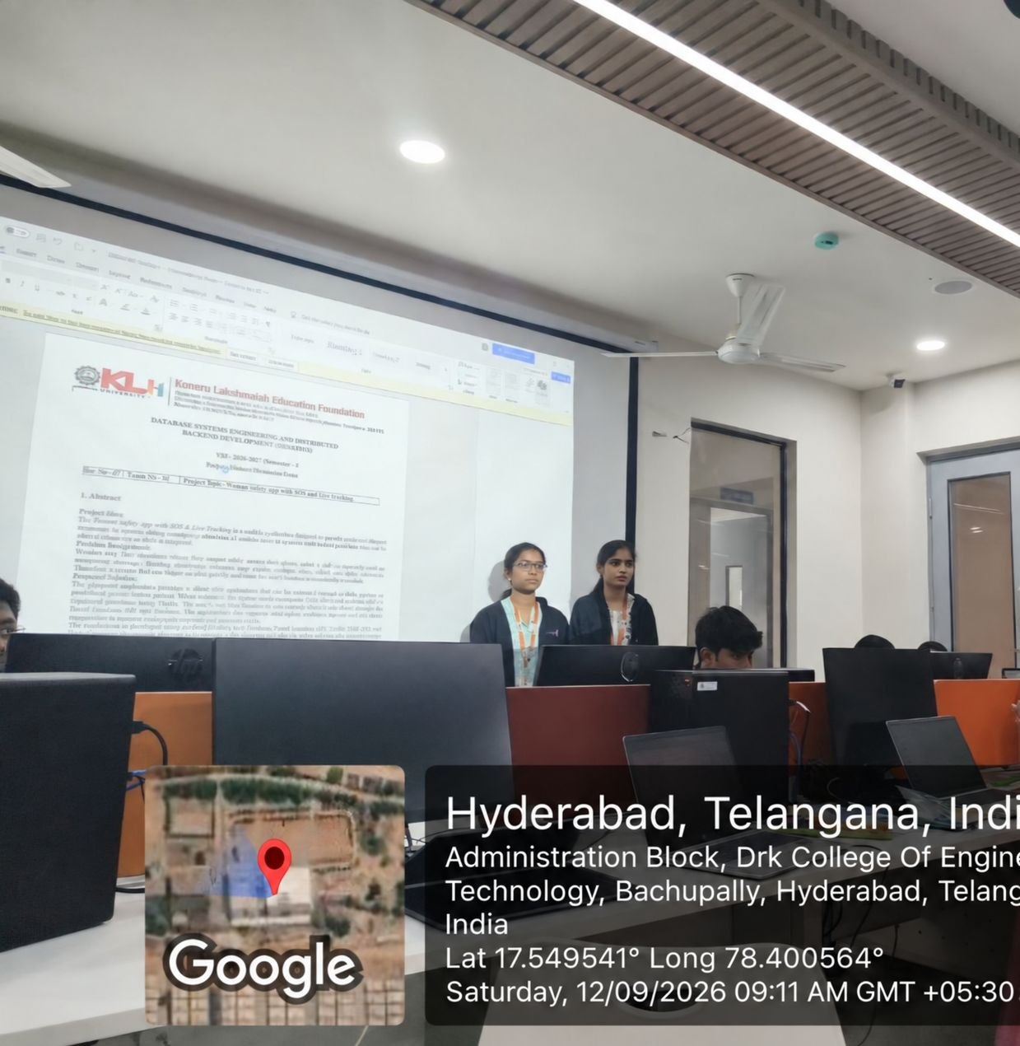

Review3:
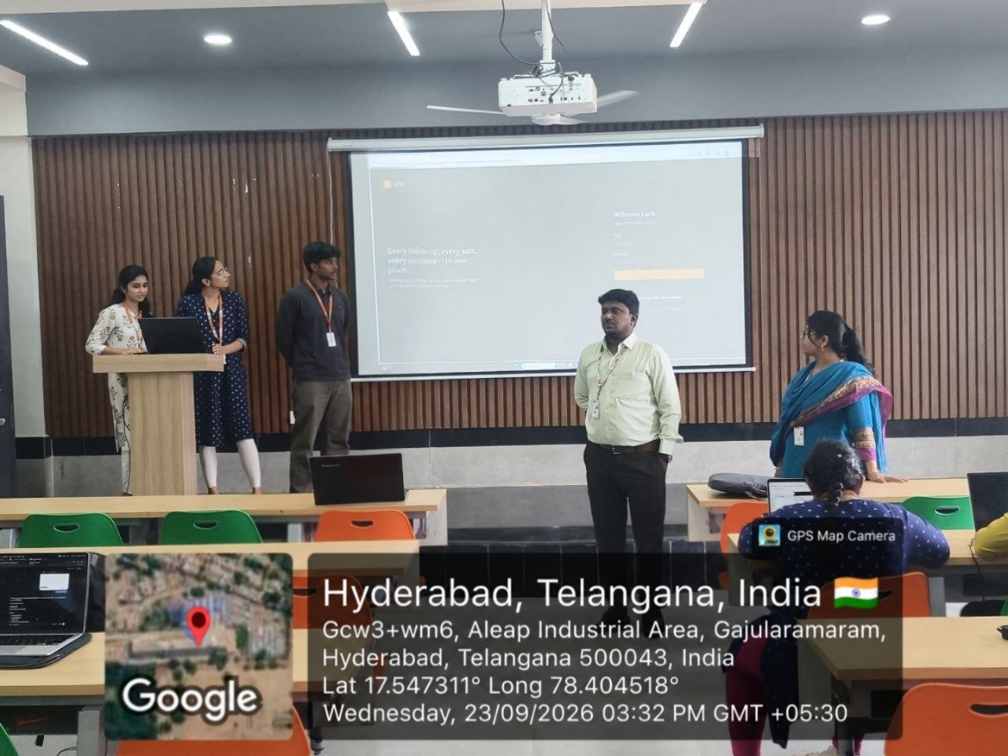
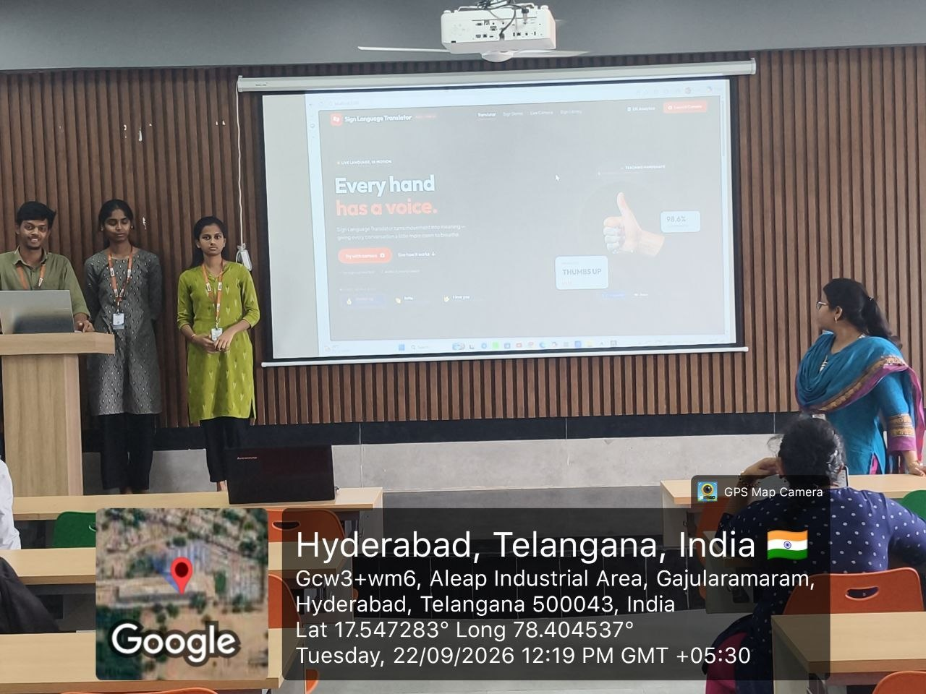
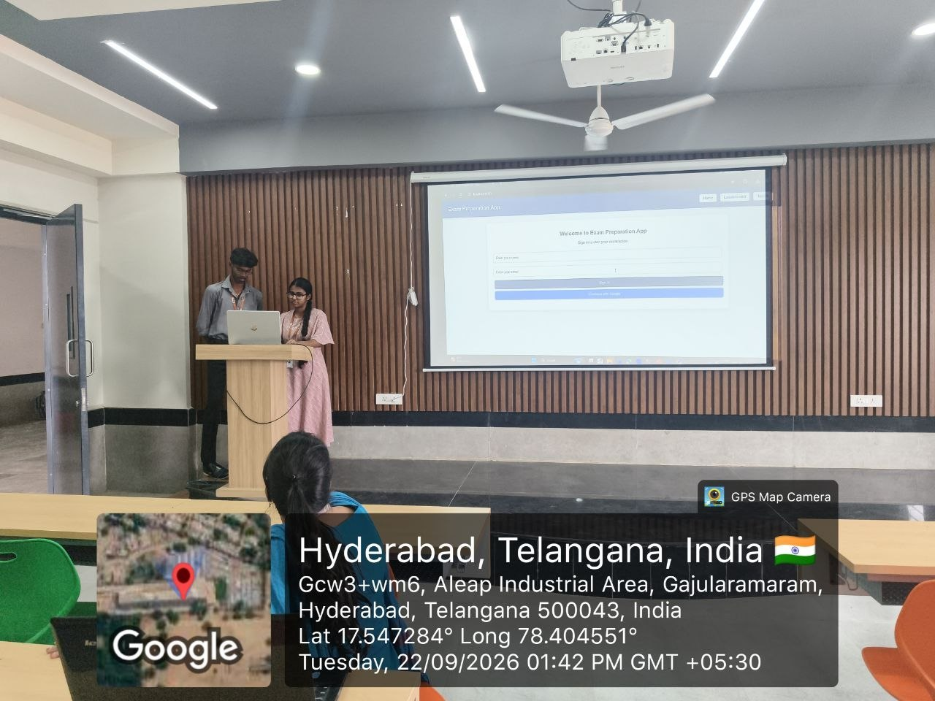

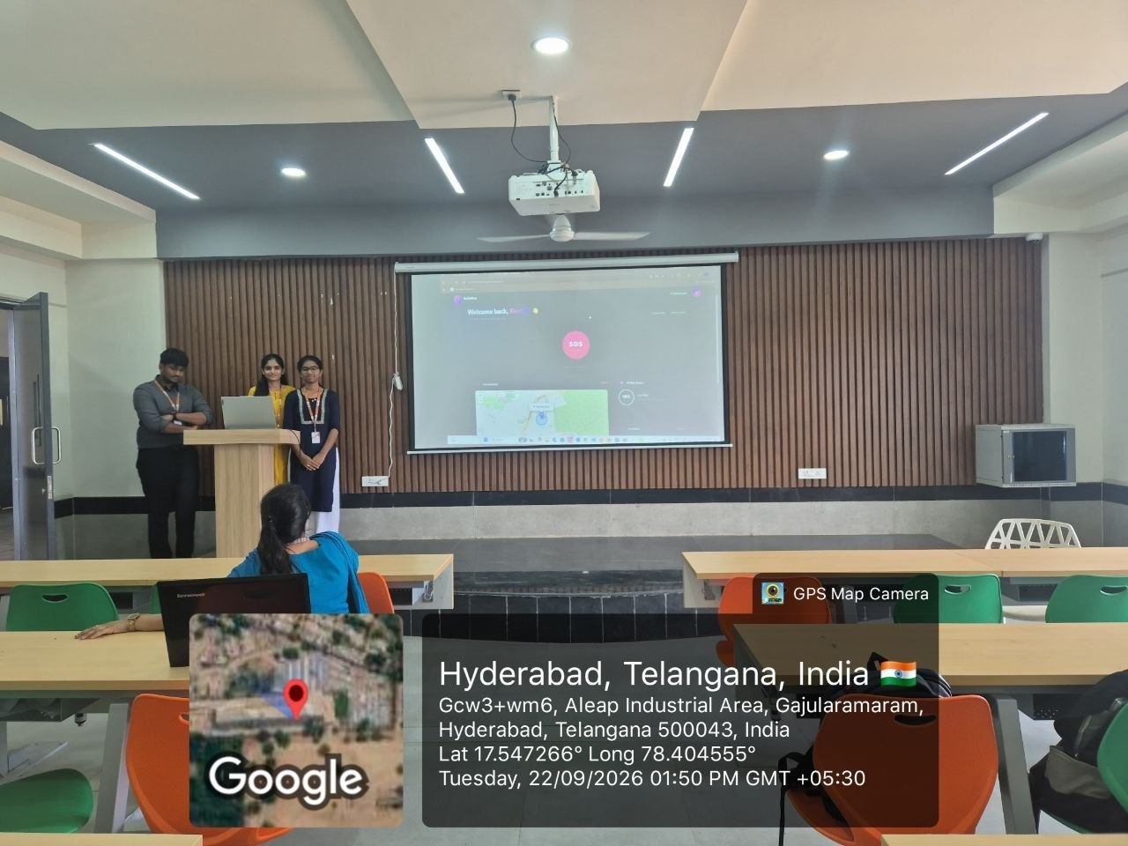

Geo-Tag pictures of Reviews Taken:
Review1:
Review2:

Geo-Tag pictures of Reviews Taken:
Review3:

