A PROJECT TITLE

Road Segment Risk Classification

Using Decision Trees and LightGBM

project report submitted in partial fulfilment of the requirements for the Course

MACHINE LEARNING

BACHELOR OF TECHNOLOGY

In

A.Y.: 2026-27

By

Ch.Srihitha-2520030400

A.Venkatesh-2520030404
Sashank-2520030405

Under the Esteemed guidance of

RAVINDRA BABU

Associate Professor, CSE

Department of Computer Science and Engineering

Abstract
This project presents a modular traffic signal optimization simulator for a four-way intersection. The system models changing vehicle queues on the North, South, East and West approaches and uses an adaptive controller to decide whether the current signal phase should be maintained or changed. Unlike a fixed-time traffic signal, the controller observes active and waiting traffic, traffic trends, and signal timing constraints before making a decision. Synthetic traffic is generated dynamically, allowing the system to be tested under normal, heavy-traffic, rush-hour, and night-mode conditions. The implementation separates the intersection environment, traffic simulation, controller logic, and main execution/dashboard into modules. The project provides an interpretable baseline that can later be extended with machine-learning or reinforcement-learning techniques.
Keywords: Traffic Signal Optimization, Intelligent Transportation System, Traffic Simulation, Queue Management, Adaptive Control, Machine Learning

1. Introduction

1.1 Purpose of the Project
Urban intersections experience changing traffic demand throughout the day. Conventional fixed-time signals use predetermined green intervals and may continue serving one direction even when another direction has a larger queue. This can increase waiting time and congestion. The purpose of this project is to demonstrate an adaptive traffic-signal control mechanism that reacts to simulated traffic conditions instead of relying only on a fixed schedule.
The main stakeholders are road users, traffic-management authorities, and urban planners. A controller that considers current queue conditions can improve the use of available green time. The project therefore provides a small, understandable simulation that can be used to study adaptive signal decisions before extending the approach to real-world traffic data.

1.2 Problem Statement
The problem is to control the signal phase of a four-way intersection when vehicle arrivals vary over time. The system monitors vehicles waiting on each side, respects minimum and maximum green-time constraints, and decides whether to maintain the current phase or initiate a transition. The output is a continuously updated dashboard showing queue sizes, signal state, phase timer, and controller decisions.

1.3 Existing Methods and Disadvantages
Traditional fixed-time traffic signals use predetermined cycles. They are simple and computationally inexpensive, but they do not directly respond to short-term changes in traffic demand. Actuated systems improve adaptability by using traffic detection, but their effectiveness depends on detector quality and control rules.
Recent research investigates reinforcement learning and deep reinforcement learning for adaptive traffic-signal control. These approaches can learn policies from interaction with traffic environments, but they require careful state, action, reward, training, and evaluation design. Simulation results also do not automatically guarantee real-world performance.

1.4 Proposed System
The proposed system uses a modular Python simulation. Synthetic vehicles are generated over time, queue lengths are maintained for four approaches, and a controller compares active and waiting traffic. The controller uses minimum and maximum phase durations and a queue-difference threshold to decide whether to maintain the current phase, move through yellow, or switch to the opposite phase. The design is intentionally simple and interpretable and can serve as a baseline for future learning-based control.

1.5 Research Objectives( atleast 4)
- Develop a four-way traffic-intersection simulation with continuously changing vehicle queues.
- Generate synthetic traffic conditions and test the controller under multiple scenarios.
- Implement an adaptive signal controller based on queue conditions and timing constraints.
- Separate traffic simulation, intersection state, controller logic, and main execution into modular components.
- Observe system behavior using queue lengths, signal states, phase timers, and controller decision logs.
- Provide a baseline architecture that can later be extended with reinforcement learning and real traffic data.

2. Literature Survey (recent studies from 2-3 years)
Recent studies show growing interest in reinforcement-learning-based traffic-signal control, especially for adaptive timing, multi-intersection coordination, generalization across scenarios, and multi-objective optimization. The following studies are directly relevant to the problem domain.
No. | Study / Reference | Problem / Gap | Main inference
1 | Deep Reinforcement Learning Based Traffic Signal Control: A Comparative Analysis | Procedia Computer Science, 220, 275–282 (2023); DOI 10.1016/j.procs.2023.03.036 | Compared state representations, reward functions and DRL methods.
2 | Reinforcement learning based traffic signal controller with state reduction | Journal of Engineering Research, 11(1), 100017 (2023); DOI 10.1016/j.jer.2023.100017 | Large state/action spaces increase computational cost.
3 | Deep Reinforcement Learning for Traffic Signal Control | Transportation Research Procedia, 74, 954–958 (2023); DOI 10.1016/j.trpro.2023.11.230 | Compared a DRL agent with conventional signal strategies.
4 | RL traffic signal control with a virtual mesoscopic model | Engineering Applications of Artificial Intelligence, 126, 107005 (2023); DOI 10.1016/j.engappai.2023.107005 | Many studies rely on simplified simulations.
5 | Two-layer coordinated reinforcement learning for traffic signal control in traffic network | Expert Systems with Applications, 235, 121111 (2024); DOI 10.1016/j.eswa.2023.121111 | Multi-intersection coordination is complex.
6 | A General Scenario-Agnostic Reinforcement Learning for Traffic Signal Control | IEEE T-ITS, 25(9), 11330–11344 (2024); DOI 10.1109/TITS.2024.3377106 | Models trained in one scenario may generalize poorly.
7 | Model-Based Graph Reinforcement Learning for Inductive Traffic Signal Control | IEEE Open Journal of Intelligent Transportation Systems, 5, 238–250 (2024); DOI 10.1109/OJITS.2024.3376583 | Traffic networks require scalable coordination and generalization.
8 | Co-evolutionary traffic signal control using reinforcement learning for road networks under stochastic capacity | Applied Soft Computing, 161, 111701 (2024); DOI 10.1016/j.asoc.2024.111701 | Large road networks create computational challenges.
9 | Reinforcement learning based adaptive control method for traffic lights in intelligent transportation | Alexandria Engineering Journal, 106, 381–391 (2024); DOI 10.1016/j.aej.2024.07.046 | Fixed-cycle control does not adapt well to changing traffic.
10 | Application of Dueling Double Deep Q-Network for Dynamic Traffic Signal Optimization | Machine Learning and Knowledge Extraction, 7(3), 65 (2025); DOI 10.3390/make7030065 | Dynamic traffic needs stronger adaptive policies.

3. Methodology

3.1 Proposed System Flow Diagram
Synthetic Traffic Generation → Intersection State Update → Queue Monitoring → Controller Evaluation → Maintain / Yellow / Switch Decision → Signal State Update → Dashboard and Decision Log
Stage | Implementation
Traffic generation | Random vehicle arrivals are generated during each simulation tick.
Intersection state | North, South, East and West queues are maintained.
Controller input | Active queue, waiting queue, traffic trend and phase timer.
Decision | Maintain current phase, transition through yellow, or switch phase.
Output | Signal state, queue sizes, timer and decision log.

3.2 Dataset Description
The GitHub project does not use a fixed Kaggle/CSV dataset for its main simulation. Instead, it generates synthetic traffic observations during execution. Vehicle arrivals are randomized and queue values change as vehicles enter and are served by the active green phase. The four main traffic streams are North, South, East and West. The simulation supports normal, heavy-traffic, rush-hour, and night-mode conditions. Therefore, the correct description is synthetic simulation data rather than a conventional static ML dataset

3.3 Experimental Setup
The project is implemented in Python and is executed from a terminal. The repository is organized into modules including main.py, controller.py, intersection.py and traffic_sim.py. The main program runs the simulation and displays the dashboard. The core simulation does not require MySQL, Java, React, or a separate backend server.

3.4 Data Preprocessing
- Traffic state variables are maintained as queue counts for each approach.
- Traffic values are updated at every simulation tick.
- The controller derives active and waiting traffic from the current intersection state.
- Minimum and maximum green-time constraints are applied before a phase change.
- A queue-difference threshold is used to avoid switching for small differences.
- Conventional tabular preprocessing such as one-hot encoding and standard scaling is not required for the current simulation input.

3.5 Exploratory Data Analysis
The dashboard provides an operational view rather than a conventional EDA notebook. It displays queue sizes for the four approaches, current signal state, active phase, phase timer, and controller decision messages. These outputs allow the user to observe how different traffic scenarios affect signal decisions.

3.6 Feature Engineering and Feature Selection (if applicable)
The controller uses the current active queue and waiting queue as decision variables. Traffic trends and phase timing are also considered. The difference between waiting-side demand and active-side demand supports an interpretable switching rule.

3.7 Model Building and Training
The current repository does not train a supervised or deep-learning model. Instead, it implements a rule-based adaptive controller. The controller evaluates traffic conditions at runtime and chooses among maintain, yellow-transition, and switch decisions. This is best described as an intelligent baseline or heuristic controller. A future version can replace the decision module with a reinforcement-learning agent.

3.8 Hyperparameter Tuning(if applicable)
Formal ML hyperparameter tuning is not implemented. The controller contains configurable timing and threshold parameters such as minimum green time, maximum green time, and queue-difference threshold. These can be varied experimentally in future work.

3.9 Model Evaluation
Because the current project is a simulation rather than a trained classification/regression model, accuracy, precision, recall and ROC-AUC are not appropriate for the current controller. Suitable evaluation measures are average queue length, maximum queue length, average waiting time, throughput, number of signal switches, and phase utilization.

4. Results and Discussion

4.1 Preprocessing Results
The preprocessing stage successfully prepared the traffic-state information required for the queue-based adaptive signal controller. No numerical ML preprocessing metrics were reported because the current GitHub implementation uses a simulation and rule-based control approach rather than a conventional trained ML dataset.

4.2 Model Performance
Metric | Purpose
Average queue length | Typical congestion at the intersection.
Maximum queue length | Worst observed queue.
Average waiting time | Vehicle delay.
Throughput | Vehicles successfully served.
Number of phase switches | Controller switching behavior.

4.3 Visual Results and discussion
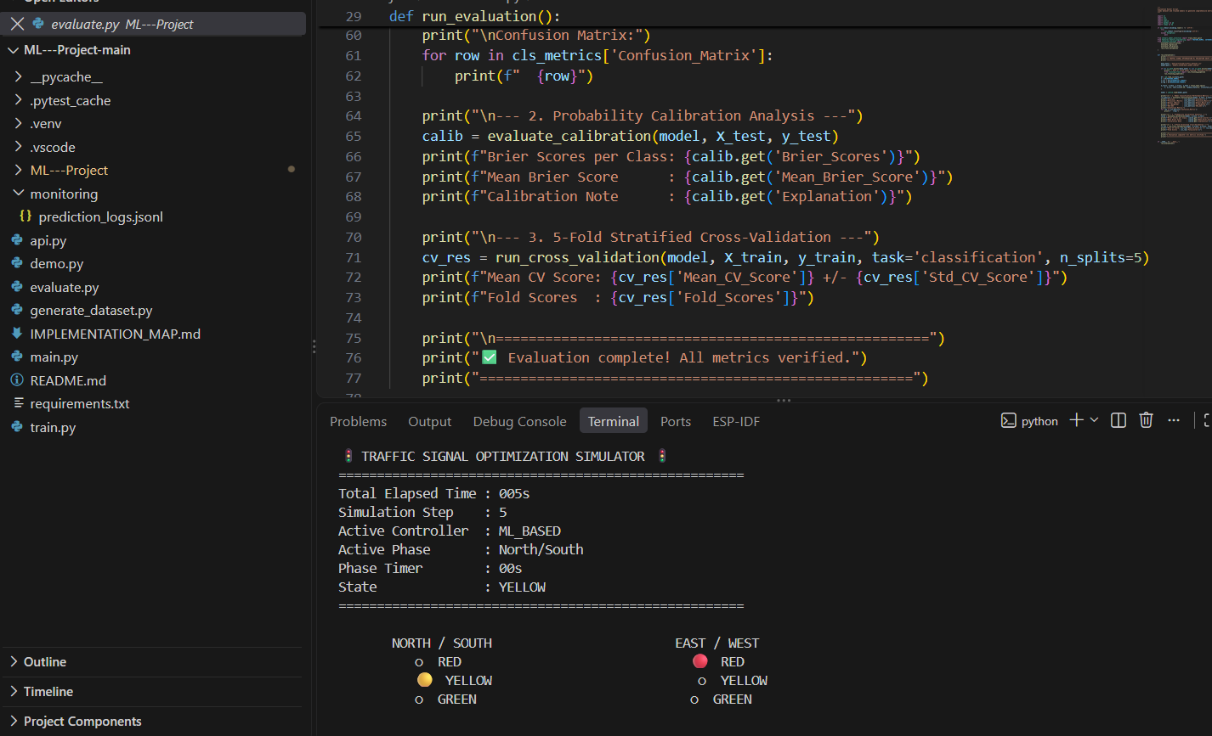
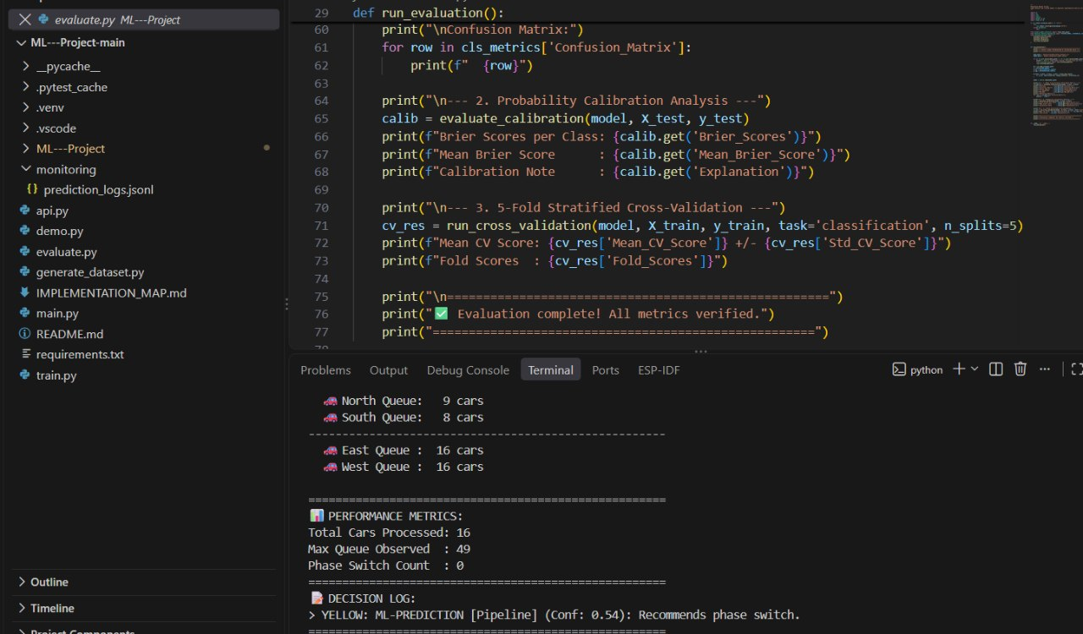

5. Conclusion
The project developed a modular adaptive traffic-signal optimization simulator for a four-way intersection. Synthetic traffic is generated dynamically, queue states are maintained, and an adaptive controller uses traffic demand and signal timing constraints to decide whether to maintain or change the current phase. The project demonstrates an interpretable intelligent traffic-control baseline and provides a foundation for future reinforcement-learning, real-data, and real-time detection extensions.

6. Future Work
- Replace the heuristic controller with Q-learning or deep reinforcement learning.
- Use real traffic counts or camera-based vehicle detection instead of synthetic arrivals.
- Compare adaptive control against fixed-time and actuated baselines.
- Record average delay, queue length and throughput over repeated simulations.
- Extend the system to coordinated multi-intersection control.
- Add emergency-vehicle and pedestrian priority.
- Integrate a real-time dashboard and external traffic data source.
- Investigate monitoring and retraining after introducing a learned controller.

7. References
Deep Reinforcement Learning Based Traffic Signal Control: A Comparative Analysis. Procedia Computer Science, 220, 275–282 (2023). DOI: 10.1016/j.procs.2023.03.036.
Reinforcement learning based traffic signal controller with state reduction. Journal of Engineering Research, 11(1), 100017 (2023). DOI: 10.1016/j.jer.2023.100017.
Deep Reinforcement Learning for Traffic Signal Control. Transportation Research Procedia, 74, 954–958 (2023). DOI: 10.1016/j.trpro.2023.11.230.
Reinforcement learning for traffic signal control: Incorporating a virtual mesoscopic model for depicting oversaturated traffic conditions. Engineering Applications of Artificial Intelligence, 126, 107005 (2023). DOI: 10.1016/j.engappai.2023.107005.
Two-layer coordinated reinforcement learning for traffic signal control in traffic network. Expert Systems with Applications, 235, 121111 (2024). DOI: 10.1016/j.eswa.2023.121111.
A General Scenario-Agnostic Reinforcement Learning for Traffic Signal Control. IEEE Transactions on Intelligent Transportation Systems, 25(9), 11330–11344 (2024). DOI: 10.1109/TITS.2024.3377106.
Model-Based Graph Reinforcement Learning for Inductive Traffic Signal Control. IEEE Open Journal of Intelligent Transportation Systems, 5, 238–250 (2024). DOI: 10.1109/OJITS.2024.3376583.
Co-evolutionary traffic signal control using reinforcement learning for road networks under stochastic capacity. Applied Soft Computing, 161, 111701 (2024). DOI: 10.1016/j.asoc.2024.111701.
Reinforcement learning based adaptive control method for traffic lights in intelligent transportation. Alexandria Engineering Journal, 106, 381–391 (2024). DOI: 10.1016/j.aej.2024.07.046.
Phan, T. C., Le, V. D., & Nguyen, T. Application of Dueling Double Deep Q-Network for Dynamic Traffic Signal Optimization: A Case Study in Danang City, Vietnam. Machine Learning and Knowledge Extraction, 7(3), 65 (2025). DOI: 10.3390/make7030065.

Signature of the Guide Course Instructor

