***Table x:*** *DH Parameter Algorithms*

|  |  |  |  |  |
| --- | --- | --- | --- | --- |
| $$i$$ | $$θ_{i}$$ | $$d_{i}$$ | $$a_{i}$$ | $$α_{i}$$ |
| 1 | $$θ_{1}$$ | 7.75 | 0 | $$90°$$ |
| 2 | $$θ_{2}$$ | 0 | 8 | 0 |
| 3 | $$0$$ | 10 | 0 | 0 |

1. **Forward Kinematic**

${}_{1}^{0}A=\left[\begin{matrix}\cos{θ_{1}} & 0 & sinθ_{1} & 0 \\ \sin{θ_{1}} & 0 & -\cos{θ_{1}} & 0 \\ 0 & 1 & 0 & 7.75 \\ 0 & 0 & 0 & 1\end{matrix}\right]$

${}_{2}^{1}A=\left[\begin{matrix}\cos{θ_{2}} & -{\sin{θ_{2}}} & 0 & 8\cos{θ_{2}} \\ \sin{θ_{2}} & \cos{θ_{2}} & 0 & 8\sin{θ_{2}} \\ 0 & 0 & 1 & 0 \\ 0 & 0 & 0 & 1\end{matrix}\right]$

$${}_{3}^{2}A=\left[\begin{matrix}1 & 0 & 0 & 0 \\ 0 & 1 & 0 & 0 \\ 0 & 0 & 1 & 10 \\ 0 & 0 & 0 & 1\end{matrix}\right]$$

$${}_{3}^{0}T={}_{1}^{0}A{}_{2}^{1}A{}_{3}^{2}A$$

= $\left[\begin{matrix}\cos{θ_{1}} & 0 & sinθ_{1} & 0 \\ \sin{θ_{1}} & 0 & -\cos{θ_{1}} & 0 \\ 0 & 1 & 0 & 7.75 \\ 0 & 0 & 0 & 1\end{matrix}\right]\left[\begin{matrix}\cos{θ_{2}} & -{\sin{θ_{2}}} & 0 & 8\cos{θ_{2}} \\ \sin{θ_{2}} & \cos{θ_{2}} & 0 & 8\sin{θ_{2}} \\ 0 & 0 & 1 & 0 \\ 0 & 0 & 0 & 1\end{matrix}\right]\left[\begin{matrix}1 & 0 & 0 & 0 \\ 0 & 1 & 0 & 0 \\ 0 & 0 & 1 & 10 \\ 0 & 0 & 0 & 1\end{matrix}\right]$

$$=\left[\begin{matrix}c_{1 }c_{2} & -c_{1 }s_{2} & s_{1 } & 10s_{1 }+ 8{c_{1 }c}_{2 } \\ s_{1 }c_{2} & {-s}_{1 }s_{2} & -c_{1 } & 8{s_{1 }c}_{2 }- 10c_{1 } \\ s_{23 } & c_{23 } & 0 & 8s_{2 }+7.75 \\ 0 & 0 & 0 & 1\end{matrix}\right]$$

$$∴ {\left(P_{x},P_{y}, P_{z}\right)}^{T}= \left[\begin{matrix}10s_{1 }+ 8{c_{1 }c}_{2 } \\ 8{s_{1 }c}_{2 }- 10c_{1 } \\ 8s_{2 }+7.75\end{matrix}\right]$$

1. **Inverse Kinematic**

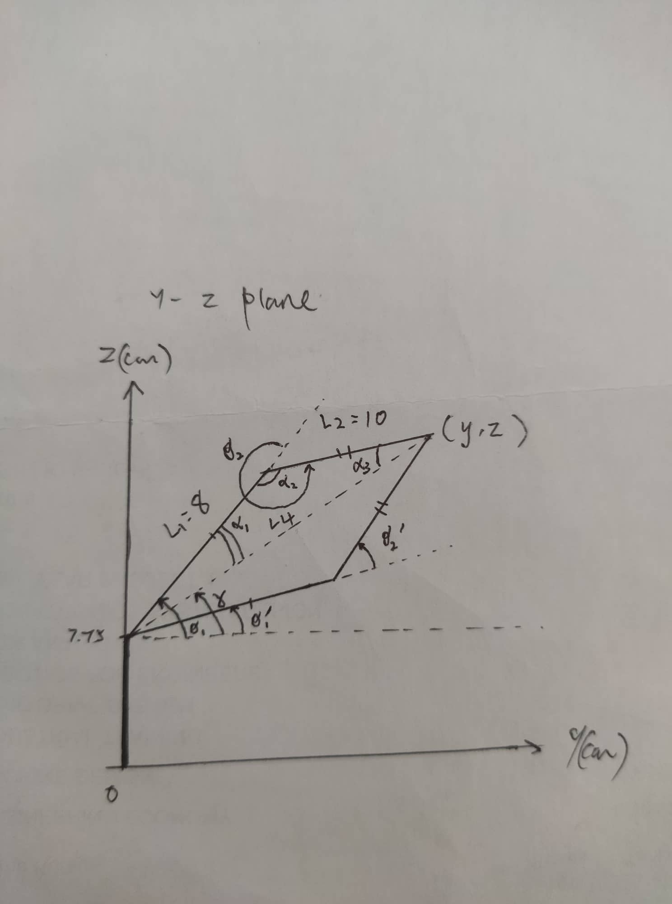

***Figure x:*** *Free body diagram for inverse kinematics*

$$L_{4}=\sqrt{{\left(x\right)}^{2}+{\left(y-7.75\right)}^{2}}:$$

$γ=atan2\left(z,y\right)$

$θ_{1}=γ+α_{1}$

$$θ_{2}=π+α_{2}$$

$θ_{1}^{'}=γ-α_{1}$

$$θ_{2}^{'}=π-α_{2}$$

Where $α_{1},α_{2}$ can be calculated as shown by using cosine rule:

$${L_{2}}^{2}={L_{1}}^{2}+{L_{4}}^{2}-2L_{1}L_{4}(cosα_{1})$$

$$α_{1}=\frac{{L_{1}}^{2}+{L_{4}}^{2}-{L_{2}}^{2}}{2L_{1}L_{4}}$$

$$α_{1}=\frac{8^{2}+{L_{4}}^{2}-{10}^{2}}{16L_{4}}$$

$${L_{4}}^{2}={L_{1}}^{2}+{L_{2}}^{2}-2L_{1}L_{2}(cosα_{2})$$

$$α_{2}=\frac{{L_{1}}^{2}+{L_{2}}^{2}-{L_{4}}^{2}}{2L_{1}L_{2}}$$

$$α_{2}=\frac{8^{2}+{10}^{2}-{L_{4}}^{2}}{160}$$

$${L_{1}}^{2}={L_{2}}^{2}+{L_{4}}^{2}-2L_{2}L_{4}(cosα_{1})$$

$$α_{3}=\frac{{L_{2}}^{2}+{L_{4}}^{2}-{L_{1}}^{2}}{2L_{2}L_{4}}$$

$$α_{1}=\frac{{10}^{2}-8^{2}+{L_{4}}^{2}}{20L_{4}}$$