

TPR2251: PATTERN RECOGNITION

*MELAKA CAFÉ RECOGNITION SYSTEM*

\*\*\*\*\*\*\*\*

Trimester 2, 2017/2018

LECTURER: DR. TEE CONNIE

GROUP: SE1A

|  |  |  |
| --- | --- | --- |
| NAME | ID | SIGNATURE |
| Phuah Chee Woei | 1141128570 |  |
| Sia Chun Wai | 1141128429 |  |
| Do Chen Hao | 1141128675 |  |

Table of Contents

[Introduction 1](#_Toc506170566)

[Overview 1](#_Toc506170567)

[Mori Café 1](#_Toc506170568)

[Ice Town 2](#_Toc506170569)

[The Alley 3](#_Toc506170570)

[Design and Implementation 3](#_Toc506170571)

[Flow chart 3](#_Toc506170572)

[Methods used for segmentation 3](#_Toc506170573)

[Feature extraction and Classification 3](#_Toc506170574)

[Highlights of special features 3](#_Toc506170575)

[Input Data 4](#_Toc506170576)

[Mori Café 4](#_Toc506170577)

[Ice Town 4](#_Toc506170578)

[The Alley 4](#_Toc506170579)

[Tyj 4](#_Toc506170580)

[Experiment Setup 5](#_Toc506170581)

[Performance Evaluation 6](#_Toc506170582)

[Conclusion 6](#_Toc506170583)

# Introduction

## Overview

The Melaka Café Recognition System is intended to recognize a café given an image as input.

The purpose of this project is to expose us with pattern recognition system gain knowledge on solving practical problems by applying the knowledge and tools learned in this course. We are required to choose at least 3 cafés to be our subject.

## Mori Café

* Location: Bukit Beruang

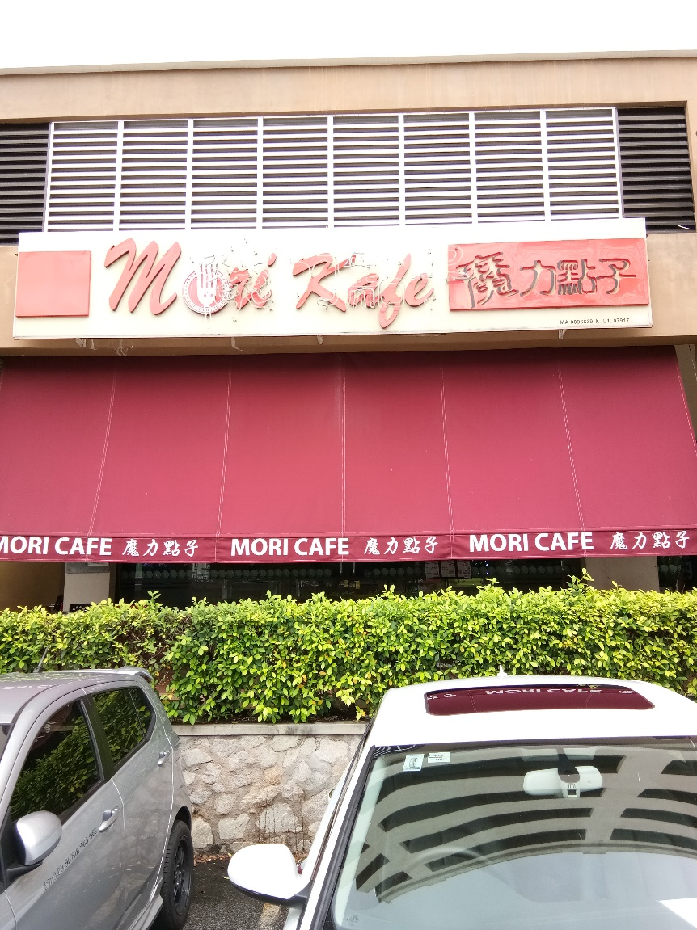

## Ice Town

* Location: Bukit Beruang

**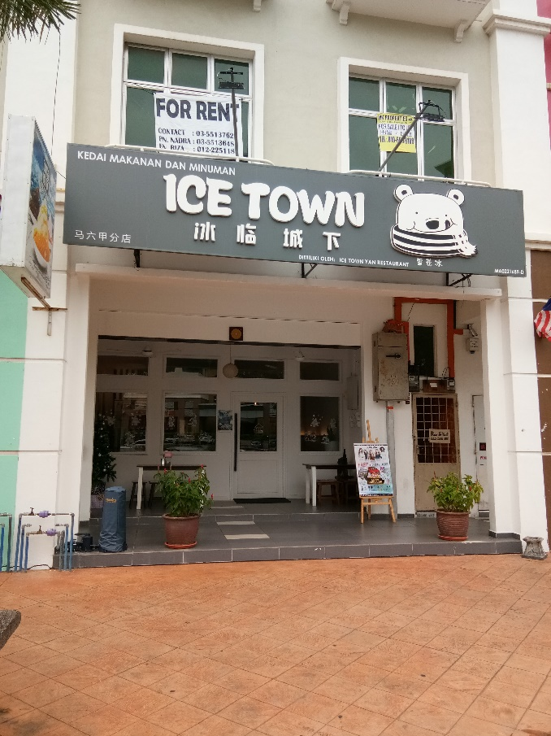**

## The Alley

* Location: Kota Laksamana

# C:\Users\Chun Wai\Downloads\IMG_20180107_102422.jpg

# Design and Implementation

## Flow chart

## Methods used for segmentation

## Feature extraction and Classification

## Highlights of special features

# Input Data

## Mori Café

## Ice Town

## The Alley

# Experiment Setup

# Performance Evaluation

# Conclusion

Throughout the entire project many discussions and changes took place. There were problems in preparing the train and test data. Writing the code to convert an image into a text was not easy and there were problems like missing pixel. We have managed to solve it only after few days of struggle and experimenting. Once we have those data, we used PCA to find the principal components of each café (mean image).