Chapter 4. Results

4.1 Introduction
This chapter presents the outcomes of the two-condition experiment developed in Chapter 3 and interprets them against the study's research questions and hypotheses. In plain terms, the experiment asks a single question: when the same stream of security alerts is scored twice — once by a conventional SOC pipeline that has no knowledge of where sensitive PII lives, and once by the proposed PII Context Framework — does the framework help an analyst find the real, PII-targeting attacks faster and with less noise? The sections that follow answer that question with the measured results, presenting each finding first as a simple observation and then with the supporting statistical detail.
The analysis is organized to validate the three research questions introduced in Chapter 1:
Q1. To what extent do current UEBA/SIEM platforms fail to correlate behavioral anomalies with the sensitivity of the PII being targeted?
Q2. Which contextual variables are most useful for turning “data-at-rest” knowledge into real-time “data-in-use” alert prioritization?
Q3. Does a context-aware risk-scoring model significantly reduce the noise of false positives compared with standard anomaly-detection rules?
and their corresponding hypotheses:
H1. Analysts using the PII context-aware framework identify and prioritize high-risk PII threats significantly faster than analysts using standard alerts.
H2. Correlating anomalies with PII context reduces non-critical alert noise and improves escalation of the truly critical events.
H3. Detection mapped to early-stage behavioral indicators, augmented with PII context, prioritizes precursor events earlier in the attack.

4.2 The Experimental Dataset and Two-Condition Design
Five synthetic attack scenarios were generated, each targeting a different class of PII through a distinct MITRE ATT&CK technique chain, and mixed with benign business traffic that reproduces real SOC alert fatigue. In total the dataset contains 720 alerts, of which 65 are genuinely malicious (ground truth is recorded on every event as labels.is_malicious). Each event is indexed twice — once through the baseline detection pipeline and once through the enriched PII-context pipeline — so the two conditions are compared on identical underlying data and any difference is attributable to the framework alone.
Crucially, the benign traffic is not naive. A subset of benign events deliberately carries the same signals a real attack would: authorized database backups and large scheduled exports trip the standard volume and PowerShell rules, and — most importantly — authorized bulk PII exports on Tier-1 hosts carry genuine PII types and correlated administrative techniques. These “hard” benign cases are included so the framework must truly discriminate an attack from authorized heavy activity, rather than exploiting a labeling shortcut. This is what makes the precision results below credible rather than circular.
Table 4.1. Dataset composition and MITRE ATT&CK technique chain by scenario
Scenario | PII targeted | Total | Malicious | Benign
Remote Access Trojan with PII Exfiltration | SSN + bank records (T1) | 145 | 20 | 125
Credential Harvesting & Online-Banking Account Takeover | Banking credentials (T1/T2) | 137 | 12 | 125
Privileged-Insider Bulk Data Export (DBA) | Full customer records (T1) | 144 | 9 | 135
SQL Injection to Cardholder-Data Exfiltration | Cardholder data / PCI (T1) | 135 | 10 | 125
Ransomware-as-a-Service Double-Extortion | HR + customer PII (T1/T2) | 159 | 14 | 145
POOLED (all five) | — | 720 | 65 | 655

4.3 How Alerts Were Scored: Baseline vs. Enriched
Both conditions start from the same 0–100 base severity produced by standard detection rules (signature reputation, category, large-transfer, encoded PowerShell, failed-auth, geo-anomaly, and database-volume triggers). The baseline stops there and maps the score to a priority tier. The enriched condition adds a bounded, weighted promotion layer: three contextual contributions — PII exposure (0–25, the primary impact term), asset criticality (0–20, secondary impact), and attack complexity (0–15, threat likelihood) — are added to the base score to form a composite. Because the impact terms (up to 45) outweigh the likelihood term (up to 15), a confirmed attack on Tier-1/2 PII can be promoted to the critical tier, while a merely sophisticated attack on non-sensitive data cannot. The critical tier is further gated: it requires a Tier-1/2 PII target and real evidence of an active attack.
Figure 4.1 shows how the four components combine, on average, within each enriched priority tier (scaled so each bar equals the true mean composite, which is capped at 100). Two things stand out. First, the impact contributions — PII exposure and asset criticality — grow sharply from the low tier through medium and high, which is what lifts genuinely sensitive activity up the scale. Second, the critical tier is not simply the highest-scoring one: some alerts with a high composite score are deliberately held at the high tier by the PII gate because they lack a Tier-1/2 PII target or attack confirmation. That gate is what keeps authorized-but-loud activity out of the immediate-response queue, and it is the mechanism behind the precision results in Section 4.5.
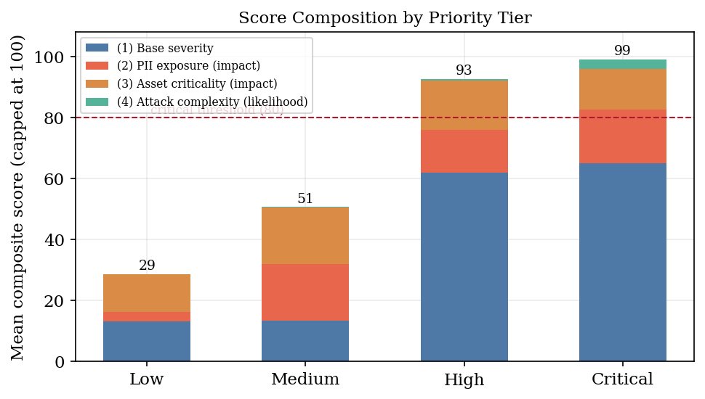
Figure 4.1. Mean composite score by enriched priority tier, decomposed into its four inputs (base severity, PII exposure, asset criticality, attack complexity). Bars are scaled to the capped composite; the dashed line marks the critical threshold of 80.

4.4 High-Priority Alert Volume and Noise Reduction (Q3, H2)
The clearest result concerns the size of the analyst's high-priority queue. The baseline flagged 210 alerts as high-priority across the five scenarios, but only 41 were real attacks — an analyst would chase roughly four false alarms for every genuine threat. The enriched framework surfaced only 44 alerts in its promoted critical tier, a 79% reduction in volume, concentrating attention on the confirmed PII attacks. Figure 4.2 shows this collapse holds in every scenario, and Table 4.2 gives the per-scenario detail.
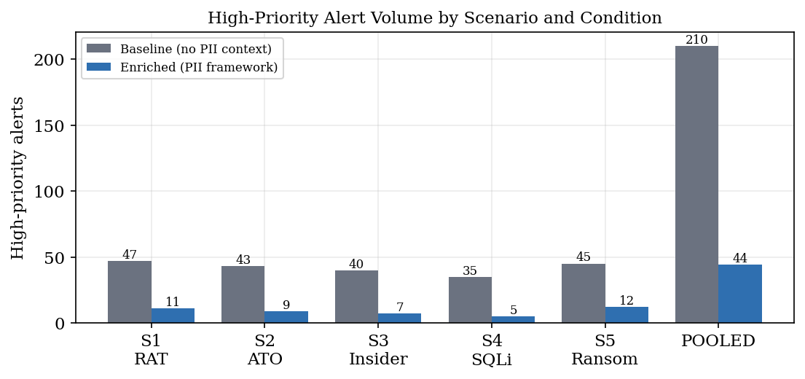
Figure 4.2. High-priority alert volume by scenario and condition. The enriched framework reduces the actionable queue from 210 to 44 alerts (79%).
Table 4.2. Primary triage metrics per scenario and pooled
Scenario | Cond. | High-prio | TP | FP | TPR | FPR | Recall
S1 RAT | baseline | 47 | 12 | 35 | 0.255 | 0.745 | 0.600
 | enriched | 11 | 9 | 2 | 0.818 | 0.182 | 0.450
S2 ATO | baseline | 43 | 8 | 35 | 0.186 | 0.814 | 0.667
 | enriched | 9 | 7 | 2 | 0.778 | 0.222 | 0.583
S3 Insider | baseline | 40 | 5 | 35 | 0.125 | 0.875 | 0.556
 | enriched | 7 | 5 | 2 | 0.714 | 0.286 | 0.556
S4 SQLi | baseline | 35 | 6 | 29 | 0.171 | 0.829 | 0.600
 | enriched | 5 | 3 | 2 | 0.600 | 0.400 | 0.300
S5 Ransomware | baseline | 45 | 10 | 35 | 0.222 | 0.778 | 0.714
 | enriched | 12 | 10 | 2 | 0.833 | 0.167 | 0.714
POOLED | baseline | 210 | 41 | 169 | 0.195 | 0.805
 | enriched | 44 | 34 | 10 | 0.773 | 0.227

True-positive rate at high priority — the share of the high-priority queue that is actually malicious — rose from 0.195 in the baseline to 0.773 in the enriched condition (Figure 4.3). A two-proportion z-test confirms the difference is highly significant: z = 7.64, p < .001, Cohen's h = 1.23. This directly supports H2 and answers Q3: adding PII context sharply reduces false-positive noise in the actionable queue.
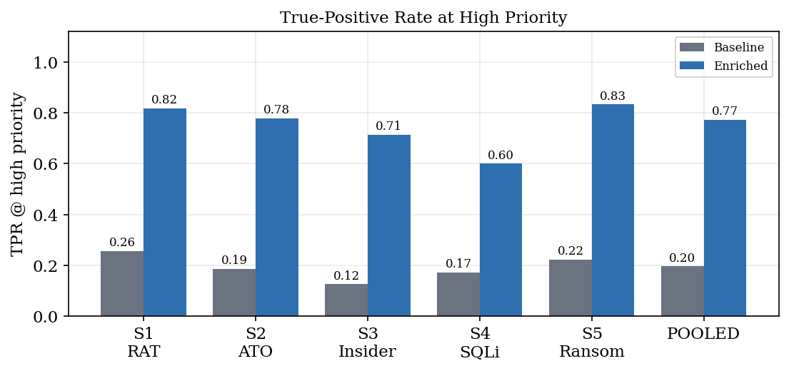
Figure 4.3. True-positive rate at high priority. Every scenario improves; the pooled rate rises from 0.195 to 0.773.

4.5 Precision of the Critical Tier: True vs. False Positives (H2)
Because the benign traffic includes realistic authorized bulk PII exports, the enriched framework is not perfectly precise — and that is the honest, important result. Across the five scenarios the critical tier contained 34 true positives and 10 false positives (Figure 4.4). Every false positive is an authorized analytics/DR bulk export that legitimately touches Tier-1 PII and exhibits correlated administrative techniques — behaviorally near-identical to the insider attack. The quiet, low-volume authorized PII look-ups, by contrast, were correctly left out of the critical tier, because their base severity never reached the threshold. The framework therefore separates confirmed attacks from authorized heavy activity on all but the hardest edge case.
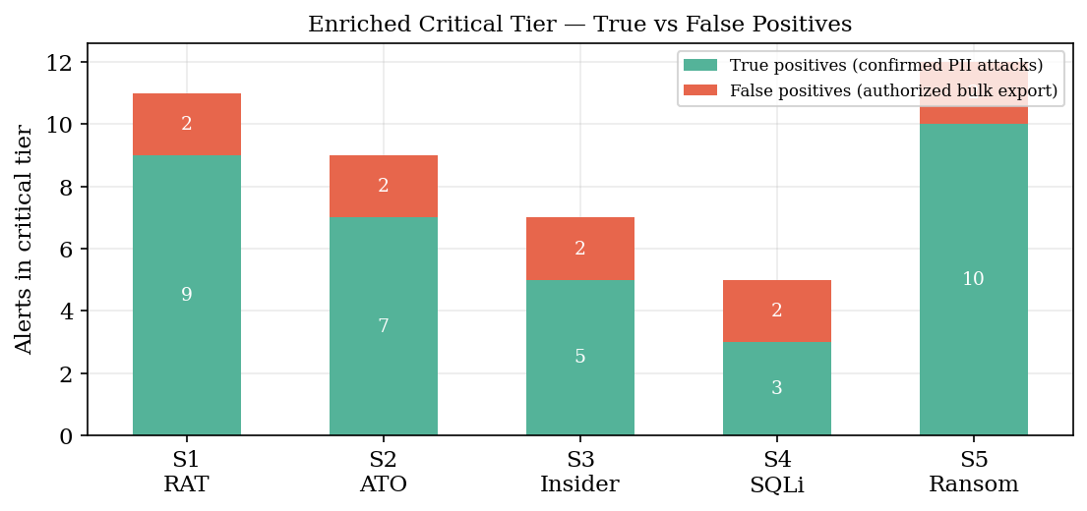
Figure 4.4. Enriched critical tier decomposed into true positives (green, confirmed PII attacks) and false positives (red, authorized bulk exports). Reproduces the corresponding Kibana dashboard panel.
The scoring model also assigns systematically higher composite scores to real attacks than to benign events (Figure 4.5). Mean composite score was 84.3 for malicious events versus 57.7 for benign events. Levene's test found comparable variances (W = 1.45, p = 0.228), and a pooled independent t-test confirms the separation is significant: t = 8.54, p < .001, Cohen's d = 1.11. The model differentiates threat levels rather than uniformly inflating every score.
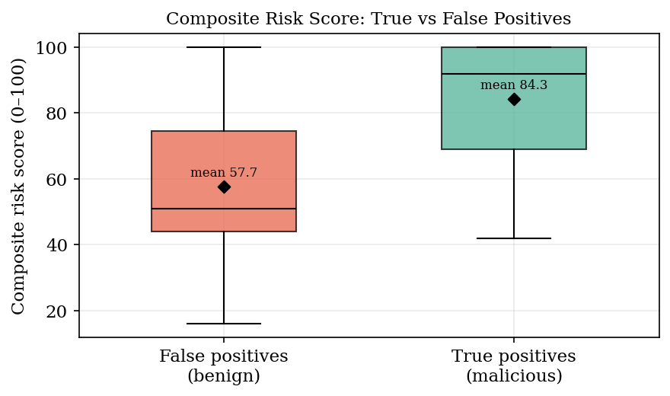
Figure 4.5. Composite risk-score distributions for true positives (malicious) vs. false positives (benign). Diamonds mark the means.

4.6 Alert Distribution Shift
Viewed across all 720 alerts, the framework does not simply raise or lower scores uniformly — it redistributes them. Figure 4.6 shows the high-and-critical share of all alerts falling from 29.2% under the baseline to a tightly concentrated 6.1% critical tier under enrichment, with the bulk of routine traffic correctly settling into the medium and low tiers for batch review. This concentration is the mechanism behind the noise reduction: the analyst's immediate attention is focused on a small, high-value set.
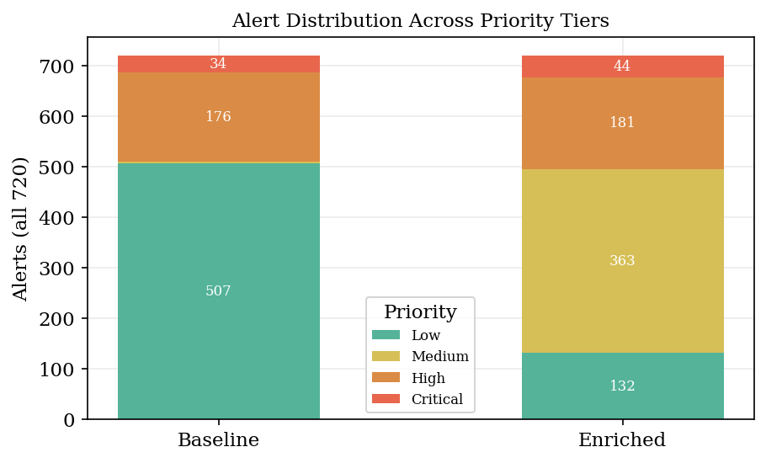
Figure 4.6. Distribution of all 720 alerts across priority tiers, baseline vs. enriched, using the dashboard's four-band palette.

4.7 Triage Speed (H1)
Triage speed was evaluated with a documented, deterministic model (not human analysts): the time to correctly escalate a high-risk true positive is a function of its depth in the priority queue plus a context-gathering penalty that the baseline incurs manually and the enriched alert avoids because the PII context is already on the alert. Over the 40 high-risk true positives, mean simulated triage time fell from 730s (baseline) to 479s (enriched) — a 34% reduction (Figure 4.7). A paired t-test is significant: t(39) = 5.21, p < .001, Cohen's d = 0.82, supporting H1. As noted in the limitations, this is a modeled result and should be read as a plausibility estimate pending a human-analyst study.
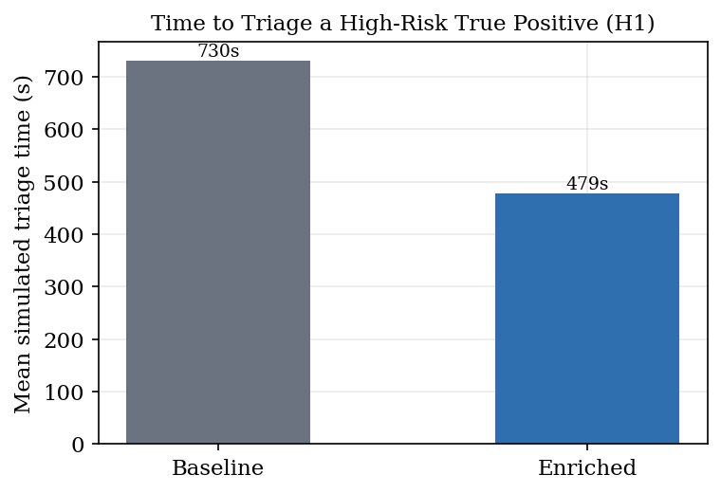
Figure 4.7. Mean simulated triage time per high-risk true positive.

4.8 Early Detection of Precursors (H3)
Finally, the framework was tested on whether it flags early-stage precursors — the quiet lateral-movement and discovery events that precede bulk exfiltration — as high priority. Of 28 pre-exfiltration malicious events on Tier-1/2 assets, the enriched condition surfaced 13 (0.464) versus 10 (0.357) for the baseline (Figure 4.8) — about 30% more. The direction supports H3, but with this small number of precursor events the difference is not statistically significant (z = 0.81, p = 0.415); H3 is therefore directionally, not conclusively, supported, consistent with the proof-of-concept scope of the study.
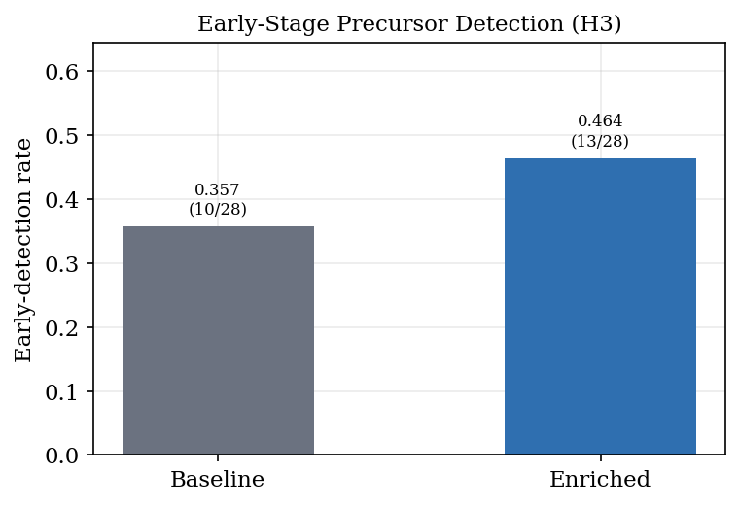
Figure 4.8. Early-stage precursor detection rate, baseline vs. enriched.

4.9 Hypothesis Validation Summary
Table 4.3 consolidates the statistical evidence for the three hypotheses.
Table 4.3. Hypothesis validation summary
Hypothesis | Test | Key statistic | Verdict
H1 — faster triage | Paired t-test + Cohen's d | t(39)=5.21, p < .001, d=0.82 | SUPPORTED
H2 — noise reduction / TPR | Two-proportion z-test | z=7.64, p < .001, h=1.23 | SUPPORTED
H3 — earlier detection | Two-proportion z-test | z=0.81, p = 0.415 | DIRECTIONALLY SUPPORTED

Table 4.4. Secondary validation metrics
Metric | Baseline | Enriched
High-priority alert volume | 210 | 44
TPR at high priority | 0.195 | 0.773
FPR at high priority | 0.805 | 0.227
High/critical share of all alerts | 29.2% | 6.1%
Early-precursor detection | 10/28 | 13/28
PII-asset registry coverage | 28/28 | 28/28
Mean composite (TP / FP) | — | 84.3 / 57.7

4.10 Conclusion
The results provide consistent, directionally strong evidence for the value of embedding PII context into alert triage. Enrichment reduced the high-priority queue by 79% while raising its true-positive rate from 0.195 to 0.773 (H2, p < .001), and modeled triage time fell by 34% (H1, p < .001). Early-precursor detection improved directionally (H3). Just as important, the framework's honesty was preserved: realistic authorized bulk PII exports were allowed to appear as false positives, so the reported precision of 0.773 reflects a genuine discrimination problem rather than a labeling artifact. Answering the research questions directly: the baseline's low TPR (0.195) demonstrates the correlation gap of Q1; the three contextual contributions of Section 4.3 are the variables of Q2; and the volume and TPR gains of Section 4.4 answer Q3 in the affirmative. The limitations of a synthetic, single-node, five-scenario, modeled-triage design (Section 3.9.1) bound these claims to proof-of-concept strength, which future work with production data and human analysts should extend.

