Workstation Setup
Windows:-
- Start > All Programs > Administrative Tools > Server Manager > 'Configure IE ESC' > Disable IE Enhanced Security Configuration
- Turn off Enabled Protected mode in IE (IE Options --> Tools --> Uncheck “Enable Protected mode”
- Configure Powershell (Enable QuickEdit Mode, Set Height buffer to 9999)
Install Chef http://www.getchef.com/chef/install
Or on Mac OS X or Linux:
$ curl -L http://www.opscode.com/chef/install.sh | sudo bash

Create a new Chef account and download Starter Kit http://www.getchef.com
(Do not use an existing account. Generating a Starter Kit will re-create your user pem.)

PS\> cd c:\Users\You\chef-repo
PS\> knife --version
PS\> knife help list
PS\> dir
PS\> dir .chef

View c:\Users\You\chef-repo\.chef\knife.rb
current_dir = File.dirname(__FILE__)
log_level :info
log_location STDOUT
node_name "USERNAME"
client_key "#{current_dir}/USERNAME.pem"
validation_client_name "ORGNAME-validator"
validation_key "#{current_dir}/ORGNAME-validator.pem"
chef_server_url "https://api.opscode.com/organizations/ORGNAME"
cache_type 'BasicFile'
cache_options( :path => "#{ENV['HOME']}/.chef/checksums" )
cookbook_path ["#{current_dir}/../cookbooks"]

PS\> knife help list
PS\> knife client list
$ git init
$ git status
$ git add .
$ git commit -m "add the starter kit from Chef"

Organization Setup
Click the "Administration" tab,
Select the appropriate Organization
Click "Invite User" from the left menu
Enter your classmate's 'Chef Username' and click Invite

Click the notification, select the Organization and click 'Accept'

Select your classmate's organization from the drop down list and peruse their org

Now either 'Leave Organization' you've been invited into, or remove your classmate from your organization

Test Node Setup
PS\> gem install knife-windows
PS\> knife bootstrap windows winrm <EXTERNAL_ADDRESS> -x chef -P chef -N "node1"

rdp <EXTERNAL_ADDRESS>
Open Powershell as Administrator

remote@PS\> dir c:\chef
remote@PS\> gc c:\chef\client.rb
edit /etc/chef/client.rb
Set log_level to :info
remote@PS\> gc c:\chef\first-boot.json

View Node on Chef Server
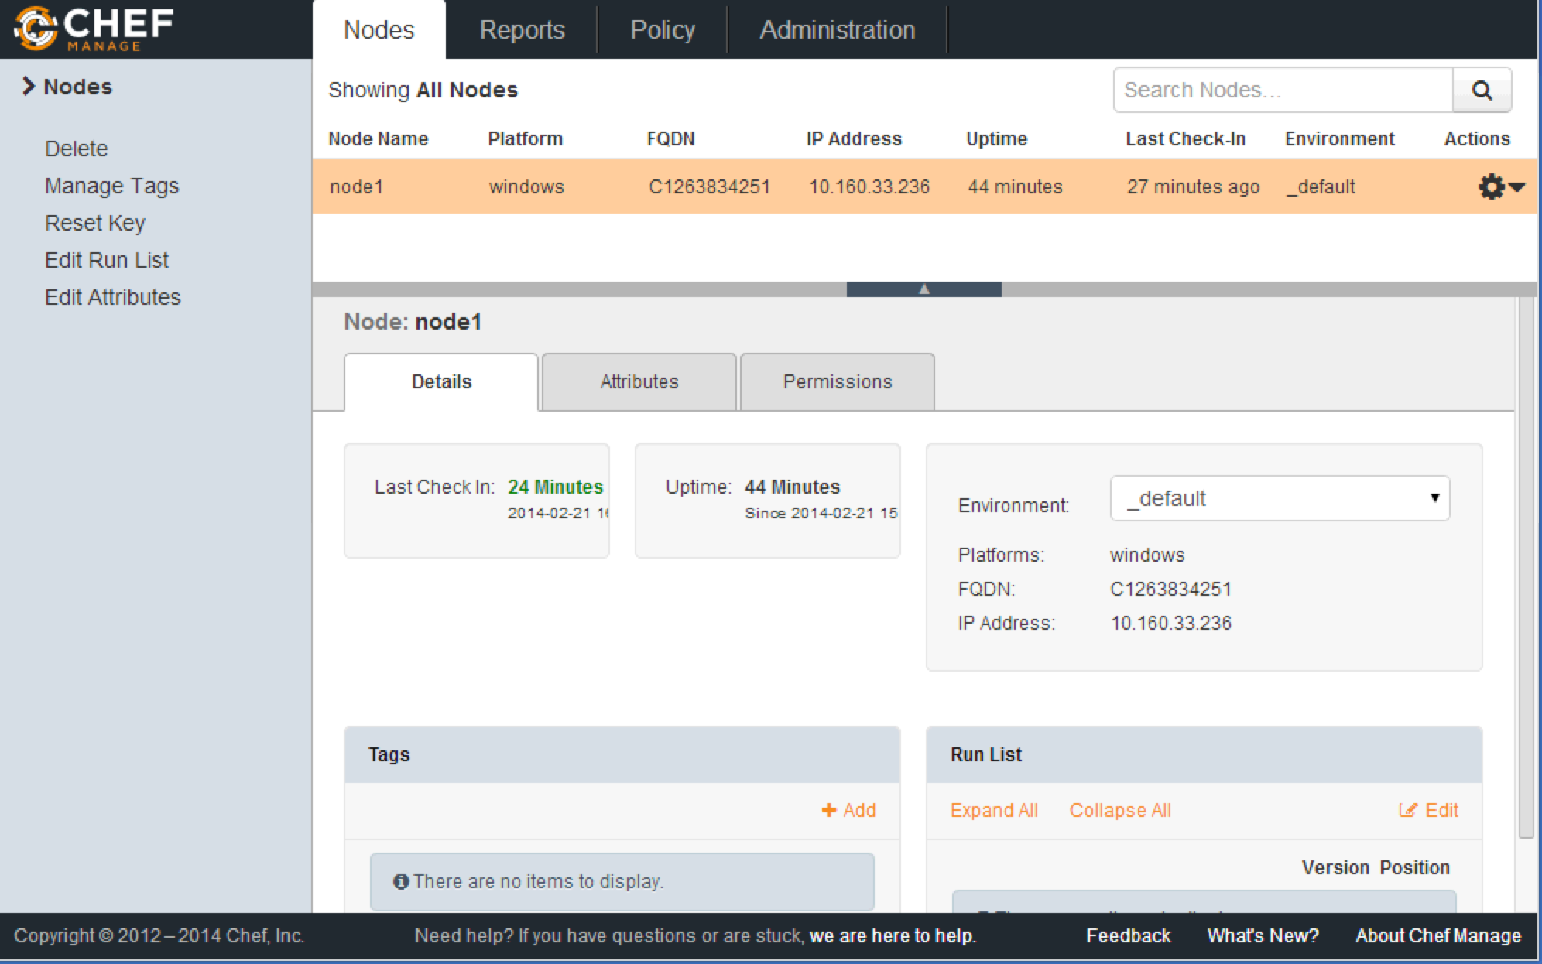
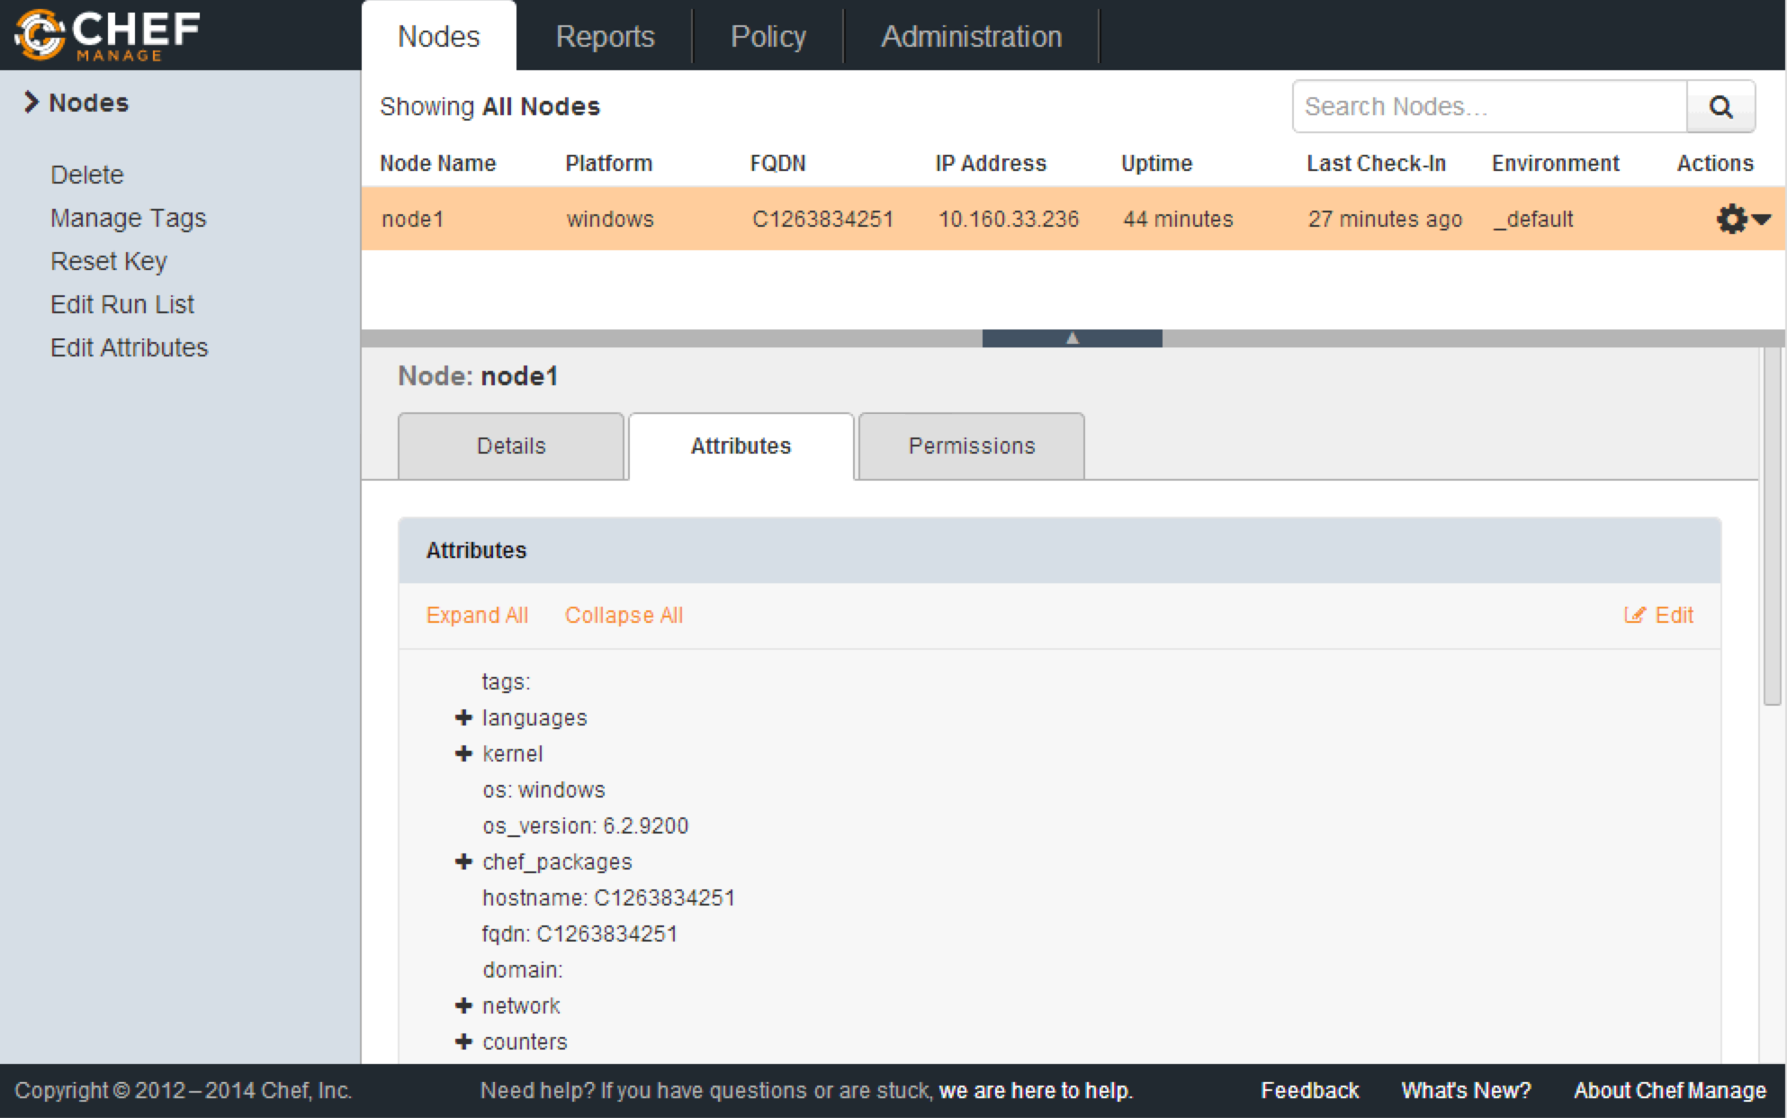

Chef Resources and Recipes

PS\> knife cookbook create iis_demo
PS\> dir cookbooks\iis_demo

cookbooks\iis_demo\recipes\default.rb
powershell_script "Install IIS" do
action :run
code "add-windowsfeature Web-Server"
end

service "w3svc" do
action [ :enable, :start ]
end

template 'c:\inetpub\wwwroot\Default.htm' do
source "Default.htm.erb"
rights :read, "Everyone"
end

cookbooks\iis_demo\templates\default\Default.htm
<html>
<body>
<h1>Hello, world!</h1>
</body>
</html>

PS\> knife cookbook upload iis_demo
PS\> knife node run_list add node1 'recipe[iis_demo::default]'
remote@PS\> chef-client

Introducing the Node Object
PS\> knife node list
PS\> knife client list
PS\> knife node show node1
remote@PS\> ohai | oh -Paging
PS\> knife node show node1 -l
PS\> knife node show node1 -Fj
PS\> knife node show node1 -a fqdn
PS\> knife search node "*:*" -a fqdn

Setting Node Attributes

Cookbooks\iis_demo\attributes\default.rb
default["iis_demo"]["indexfile"] = "Default1.htm.erb"

cookbooks\iis_demo\templates\default\Default1.htm.erb
<html>
<body>
<h1>Hello, world!</h1>
<h2>This is Default1.htm</h2>
<p>We configured this in the attributes file</p>
</body>
</html>

cookbooks\iis_demo\recipes\default.rb
template 'c:\inetpub\wwwroot\Default.htm' do
source node["iis_demo"]["indexfile"]
rights :read, "Everyone"
end

PS\> knife cookbook upload iis_demo
remote@PS\> chef-client

cookbooks\iis_demo\recipes\default.rb
node.default["iis_demo"]["indexfile"] = "Default2.htm.erb"
template 'c:\inetpub\wwwroot\Default.htm' do
source node["iis_demo"]["indexfile"]
rights :read, "Everyone"
end

cookbooks\iis_demo\files\default\Default2.htm.erb
<html>
<body>
<h1>Hello, world!</h1>
<h2>This is Default2.htm</h2>
<p>We configured this in the recipe</p>
</body>
</html>

PS\> knife cookbook upload iis_demo
remote@PS\> chef-client

PS\> knife node show node1 -l | more

Attributes, Templates, and Cookbook Dependencies
PS\> knife cookbook create datacenter

cookbooks\datacenter\attributes\default.rb
default["datacenter"]["location"] = "china"

PS\> knife cookbook upload datacenter
PS\> knife cookbook create hosts

cookbooks\hosts\recipes\default.rb
template "#{ENV['windir']}\\System32\\drivers\\etc\\hosts" do
source "hosts.erb"
end

cookbooks\host\templates\default\hosts.erb
#This file is managed by the server <%= node["fqdn"] %>
<% case node["datacenter"]["location"] -%>
<% when "china" -%>
0.0.0.0 nytimes.com
<% end -%>

PS\> knife cookbook upload hosts
PS\> knife node run_list add node1 'recipe[hosts]'
remote@PS\> chef-client

\cookbooks\hosts\metadata.rb
depends 'datacenter'

PS\> knife cookbook upload hosts
remote@PS\> chef-client

remote@PS\> gc C:\Windows\System32\drivers\etc\hosts
remote@PS\> gci C:\chef\backup\Windows\System32\drivers\etc
PS\> knife search node "*:*" -a datacenter

cookbooks\datacenter\attributes\default.rb
default["datacenter"]["location"] = "russia"

PS\> knife cookbook upload datacenter
remote@PS\> chef-client
remote@PS\> gc C:\Windows\System32\drivers\etc\hosts
PS\> knife node show node1 -a datacenter

Template Variables, Notifications, and Controlling Idempotency

\cookbooks\iis_demo\metadata.rb
name 'iis_demo'
maintainer 'YOUR_COMPANY_NAME'
maintainer_email "YOUR_EMAIL"
license "All rights reserved"
description "Installs/Configures hosts"
long_description IO.read(File.join(File.dirname(__FILE__), 'README.md'))
version "0.2.0"

\cookbooks\iis_demo\attributes\default.rb
default["iis_demo"]["sites"]["clowns"] = { "port" => 80 }
default["iis_demo"]["sites"]["bears"] = { "port" => 81 }

cookbooks/iis_demo/recipes/default.rb
(See https://gist.github.com/ae9187fb8a5fcedc5ee2 )

powershell_script "Install IIS" do
code "add-windowsfeature Web-Server"
action :run
end

service "w3svc" do
action [:enable, :start ]
end

powershell_script "disable default site" do
code 'get-website "Default Web Site*" | where {$_.state -ne "Stopped"} | Stop-Website'
end

node['iis_demo']['sites'].each do |site_name, site_data|
site_dir = "#{ENV['SYSTEMDRIVE']}\\inetpub\\wwwroot\\#{site_name}"
directory site_dir

powershell_script "create app pool for #{site_name}" do
code "New-WebAppPool #{site_name}"
not_if "C:\\Windows\\System32\\inetsrv\\appcmd.exe list apppool #{site_name}"
end

powershell_script "new website for #{site_name}" do
code <<-EOH
Import-Module WebAdministration
if (-not(test-path IIS:\\Sites\\#{site_name})){
$NewWebsiteParams = @{Name= '#{site_name}';Port= #{site_data["port"]};PhysicalPath= '#{site_dir}';ApplicationPool= '#{site_name}'}
New-Website @NewWebsiteParams
}
elseif ((Get-WebBinding -Name #{site_name}).bindingInformation -ne '*:#{site_data["port"]}:') {
$CurrentBinding = (Get-WebBinding -Name #{site_name}).bindingInformation
$BindingParameters = @{Name= '#{site_name}';Binding= $CurrentBinding;PropertyName= 'Port';Value = #{site_data["port"]} }
Set-WebBinding @BindingParameters
}
Get-Website -Name #{site_name} | Where {$_.state -like 'Stopped'} | Start-Website
EOH
end

template "#{site_dir}\\Default.htm" do
source "Default.htm.erb"
rights :read, "Everyone"
variables(
:site_name => site_name,
:port => site_data['port']
)
notifies :restart, "service[w3svc]"
end
end

cookbooks\iis_demo\templates\default\Default.htm.erb
<html>
<body>
<h2>We love <%= @site_name %></h2>
<%= node["ipaddress"] %>:<%= @port %>
</body>
</html>

PS\> knife cookbook upload iis_demo
remote@PS\> chef-client

Search

PS\> knife search node "*:*"
PS\> knife search node "ipaddress:10.*"
PS\> knife search node "*:*" -a ipaddress
PS\> knife search node "ipaddress:10.*" -a ipaddress
PS\> knife search node "ipaddress:10* AND platform:windows"
PS\> knife search node "ipaddress:[10.0.* TO 10.2.*]"

cookbooks\iis_demo\recipes\ip-logger.rb
search("node","platform:windows").each do |server|
log "The Windows servers in your organization have the following FQDN/IP Addresses:- #{server['fqdn']}/#{server['ipaddress']}"
end

PS\> knife cookbook upload iis_demo
PS\> knife node run_list add node1 'recipe[iis_demo::ip-logger]'
remote@PS \> chef-client

PS\> knife node run_list remove node1 'recipe[iis_demo::ip-logger]'

Recipe Inclusion, Data Bags, and Search
PS\> md data_bags
PS\> md data_bags\users
PS\> knife data_bag create users

data_bags\users\bobo.json
{
"id": "bobo",
"comment": "Bobo T. Clown",
"password": "iAm@Cl0wN!!!"
}

PS\> knife data_bag from file users bobo.json

data_bags\users\frank.json
{
"id": "frank",
"comment": "Frank Belson",
"password": "sP3nC3r4Hire!"
}

Use knife to upload the data_bag item 'frank.json' (command hidden)
PS\> knife data_bag from file users frank.json

PS\> knife search users "*:*"
PS\> knife search users "comment: Bobo T. Clown" -a id

Create a data_bag called 'groups' (2 commands hidden)
PS\> mkdir data_bags\groups
PS\> knife data_bag create groups

data_bags\groups\clowns.json
{
"id": "clowns",
"members": [ "bobo", "frank" ]
}

Use knife to upload the data_bag item 'clowns.json' (command hidden)
PS\> knife data_bag from file groups clowns.json

Use knife to search the data bag 'groups' (command hidden)
PS\> knife search groups "*:*"

Create a cookbook called 'users' (command hidden)
PS\> knife cookbook create users

Edit the 'user' cookbook's default recipe and add the following
cookbooks\users\recipes\default.rb
search(:users, "*:*").each do |user_data|
user user_data["id"] do
comment user_data["comment"]
password user_data["password"]
end
end
include_recipe "users::groups"

cookbooks\users\recipes\groups.rb
search(:groups, "*:*").each do |group_data|
group group_data["id"] do
members group_data["members"]
end
end

Upload the 'users' cookbook (command hidden)
PS\> knife cookbook upload users

Add the 'users' cookbook's default receipt to node1's run list (command hidden)
PS\> knife node run_list add node1 'recipe[users]'

Use rerun 'chef-client' (command hidden)
remote@PS\> chef-client
remote@PS\> net users
remote@PS\> net localgroup

Roles
PS\> md roles

Roles\webserver.rb
name "webserver"
description "Web Server"
run_list "recipe[iis_demo]"
default_attributes({
"iis_demo " => {
"sites" => {
"admin" => {
"port" => 8000
}
}
}
})

PS\> knife role from file webserver.rb
PS\> knife role show webserver

PS\> knife search role "run_list:recipe\[iis_demo\]"

Replace recipe[iis_demo] with role[webserver] in run list
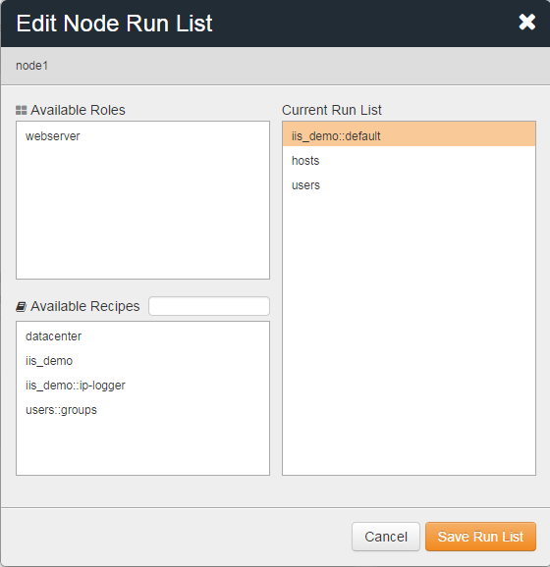

remote@PS\> chef-client
PS\> knife search node "role:webserver" -a iis_demo.sites

roles\webserver.rb
name "webserver"
description "Web Server"
run_list "recipe[iis_demo]"
default_attributes({
"iis_demo" => {
"sites" => {
"admin" => {
"port" => 8000
},
"bears" => {
"port" => 8081
}
}
}
})

PS\> knife role from file webserver.rb
remote@PS\> chef-client
PS\> knife search node "role:webserver" -a iis_demo.sites

roles\base.rb
name "base"
description "Base Server Role"
run_list "recipe[hosts]", "recipe[users]"

Use knife to upload this base role (command hidden)
PS\> knife role from file base.rb

roles\webserver.rb
name "webserver"
description "Web Server"
run_list "role[base]", "recipe[iis_demo]"
default_attributes({
"iis_demo " => {
"sites" => {
"admin" => {
"port" => 8000
}
}
}
})

Use knife to upload this webserver role & rerun chef-client (commands hidden)
PS\> knife role from file webserver.rb
remote@PS\> chef-client

Environments
PS\> knife cookbook show iis_demo
PS\> knife environment list
PS\> mkdir environments

environments\dev.rb
name "dev"
description "For developers!"
cookbook "iis_demo", "= 0.2.0"

PS\> knife environment from file dev.rb
PS\> knife environment show dev

Change your node’s environment to "dev"
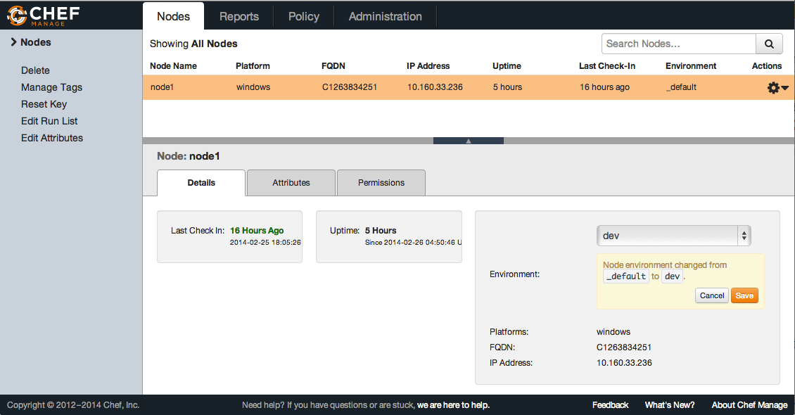

Rerun chef-client (command hidden)
remote@PS\> chef-client

environments\production.rb
name "production"
description "For Prods!"
cookbook "iis_demo", "= 0.1.0"
override_attributes({
"datacenter" => {
"location" => "china"
}
})

Use knife to create the production environment (command hidden)
PS\> knife environment from file production.rb

Change your node’s environment to "production"
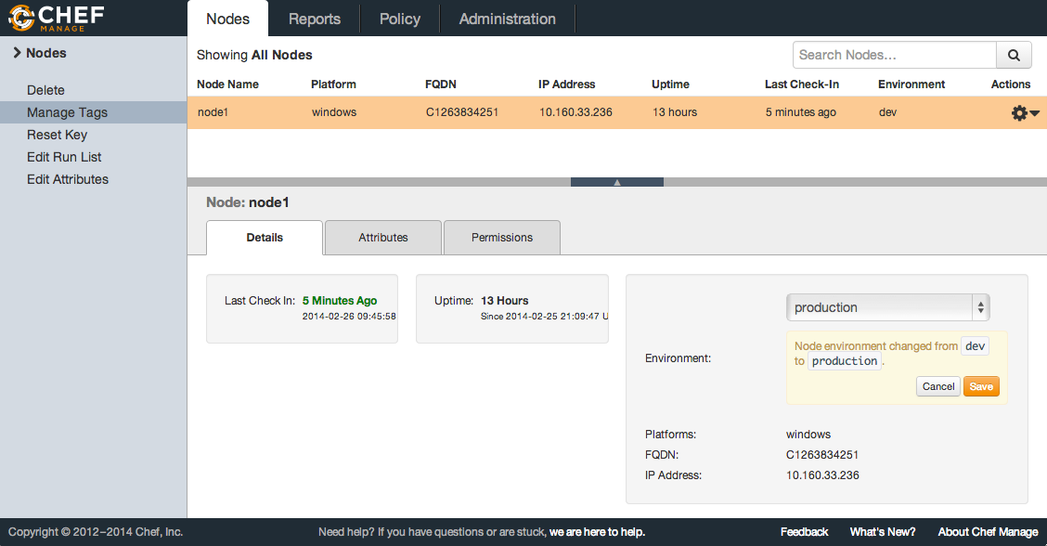

Rerun chef-client (command hidden)
remote@PS\> chef-client

environments\production.rb
name "production"
description "For Prods!"
cookbook "iis_demo", "= 0.2.0"
override_attributes({
"datacenter" => {
"location" => "china"
}
})

Use knife to create the production environment & rerun chef-client (commands hidden)
PS\> knife environment from file production.rb
remote@PS\> chef-client

Using Community Cookbooks
PS\> knife cookbook site search chef-client
PS\> knife cookbook site show chef-client
PS\> knife cookbook site download chef-client
PS\> tar -zxvf chef-client*.tar.gz -C cookbooks/

cookbooks\chef-client\recipes\delete_validation.rb
unless chef_server?
file Chef::Config[:validation_key] do
action :delete
backup false
only_if { ::File.exists?(Chef::Config[:client_key]) }
end
end

roles\base.rb
name "base"
description "Base Server Role"
run_list "recipe[chef-client::delete_validation]","recipe[hosts]", "recipe[users]"

cookbooks\chef-client\recipes\default.rb
include_recipe "chef-client::service"

cookbooks\chef-client\recipes\service.rb
supported_init_styles = [
'arch',
'bluepill',
'bsd',
'daemontools',
'init',
'launchd',
'runit',
'smf',
'upstart',
'winsw'
]
init_style = node["chef_client"]["init_style"]

# Services moved to recipes
if supported_init_styles.include? init_style
include_recipe "chef-client::#{init_style}_service"
else
log "Could not determine service init style, manual intervention required to start up the chef-client service."
end

Use knife to upload the 'chef-client' cookbook (command hidden)
Use knife to download the 'cron' cookbook (command hidden)
untar the 'cron' cookbook into the cookbooks directory (command hidden)
Use knife to upload the 'cron' cookbook (command hidden)
Use knife to upload the 'chef-client' cookbook (command hidden)
Use knife to download the 'logrotate' cookbook (command hidden)
untar the 'logrotate' cookbook into the cookbooks directory (command hidden)
Use knife to upload the 'logrotate' cookbook (command hidden)
Use knife to download the 'windows' cookbook (command hidden)
untar the 'windows' cookbook into the cookbooks directory (command hidden)
Use knife to upload the 'windows' cookbook (command hidden)
Use knife to download the 'chef_handler' cookbook (command hidden)
untar the 'chef_handler' cookbook into the cookbooks directory (command hidden)
Use knife to upload the 'chef_handler' cookbook (command hidden)
Use knife to upload the 'windows' cookbook (command hidden)
Use knife to upload the 'chef-client' cookbook (command hidden)

PS\> knife cookbook upload chef-client
PS\> knife cookbook site download cron
PS\> tar -zxvf cron*.tar.gz -C cookbooks/
PS\> knife cookbook upload cron
PS\> knife cookbook upload chef-client
PS\> knife cookbook site download logrotate
PS\> tar -zxvf logrotate*.tar.gz -C cookbooks/
PS\> knife cookbook upload logrotate
PS\> knife cookbook site download windows
PS\> tar -zxvf windows*.tar.gz -C cookbooks\
PS\> knife cookbook upload windows
PS\> knife cookbook site download chef_handler
PS\> tar -zxvf chef_handler*.tar.gz -C cookbooks\
PS\> knife cookbook upload chef_handler
PS\> knife cookbook upload windows
PS\> knife cookbook upload chef-client

roles\base.rb
name "base"
description "Base Server Role"
run_list "recipe[chef-client::delete_validation]",
"recipe[chef-client]", "recipe[hosts]", "recipe[users]"

Use knife to upload 'base' role and rerun chef-client (command hidden)
PS\> knife role from file base.rb
remote@PS\> chef-client

remote@PS\> get-service chef*

