## Appendix Z: Course-wide Instructor Notes

1. Training Lab System Setup
2. Open the AWS site from here:  <https://aws.amazon.com/>

* Login Credentials for Chef instructors:  [training-aws@chef.io](mailto:training-aws@chef.io)
* Password:  Contact Chef Training Services if you don’t know it or how to obtain it. [training@chef.io](mailto:training@chef.io)
* Partner credentials should be provided by Chef directly to partners.
* Ensure you are viewing the US East (N. Virginia) region since these AMIs reside there.  
  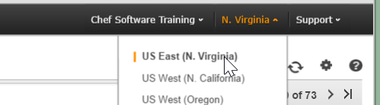

1. You may need to expand **All Services** and then click the **EC2** link shown below since the AWS UI may have changed since your last visit.  
   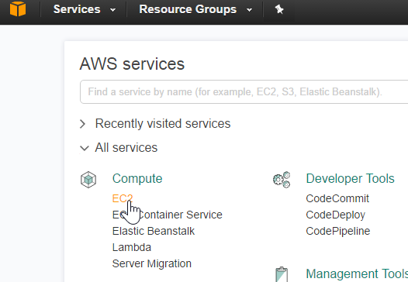
2. From the navigation pane on the left, select **Images > AMIs**.  A page will display with a list of available AMIs.  
   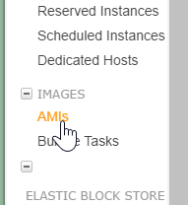
3. Select **Elegant Tests - CentOS 6.7 - 1.2.0** (ami-b519b8a3) from the list of options.
4. Click **Launch**.  The "Step 2" page displays.
5. Select the first **Micro Instance** from the list provided and click **Next: Configure Instance Details** at the bottom of the screen.  The "Step 3" page displays.
6. Enter the **Number of Instances**.

*Note:  You will need 1 instance for each student enrolled in the class – and 1 for yourself. This instance is a workstation that has Chef installed and all the code for the exercises.*

1. Click **Next: Add Storage** at the bottom of the page.  The "Step 4" page displays. Check the **Delete on Termination** check box.  
   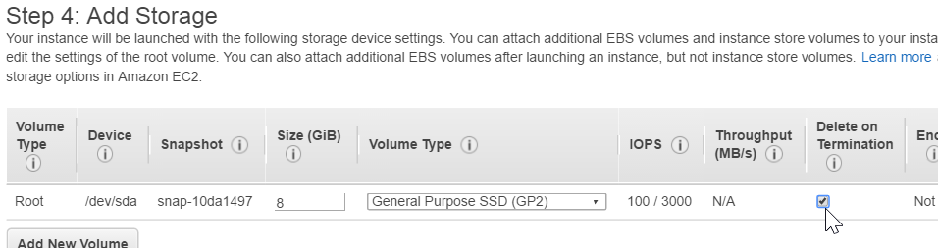
2. Click **Next: Tag Instance** at the bottom of the page.  The "Step 5" page displays.
3. Enter a **Value**.

*Note:  A recommended naming convention for the instances:  [TRAINER’S INITIALS] - [CLASS NAME] - [CLASS DATE]*

1. Click **Next: Configure Security Group**.  The "Step 6" page displays.
2. Click the **Select an existing security group** radio button.  A list of security groups displays.
3. Select **all-open**.
4. Click **Review and Launch** at the bottom of the screen.  The "Step 7" page displays.
5. After you review the instances, click **Launch**.  The "Select a key pair" window displays.
6. Select **Proceed without a key pair** from the drop down menu and click the acknowledgement check box. (**Note**: Optionally, you could select your own key pair if you want to ensure you can log into an instance in case a student changes the predefined password.)
7. Click **Launch Instances**.  The "Launch Status" page displays.
8. Click **View Instances**.  The instances list displays.
9. From here, copy all of the instances and create a gist file to share with the class.
10. Use [goo.gl](http://goo.gl) to shorten the URL to the gist file.

You could also use this spreadsheet to track and distribute IP addresses if you know how to copy and share such a spreadhseet : <http://bit.ly/1MYHVc3>

**Note**: The login credentials and password for the AMIs used in class are chef/chef. You’ll need to tell the students that at the appropriate time.

Please remember to terminate your instances when the class is completely done.