1: Introduction

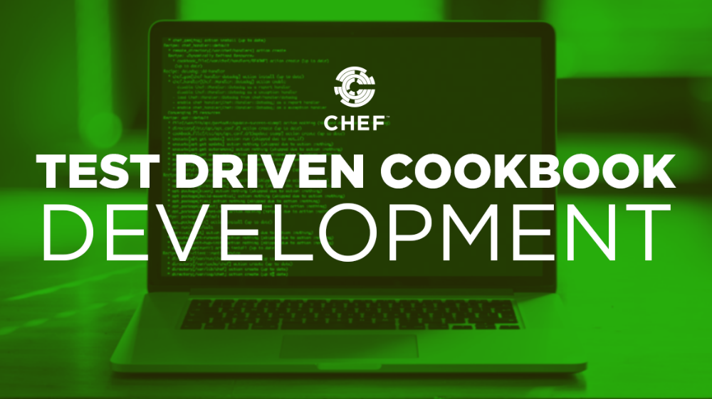

Welcome to Test Driven Cookbook Development.

Slide 2

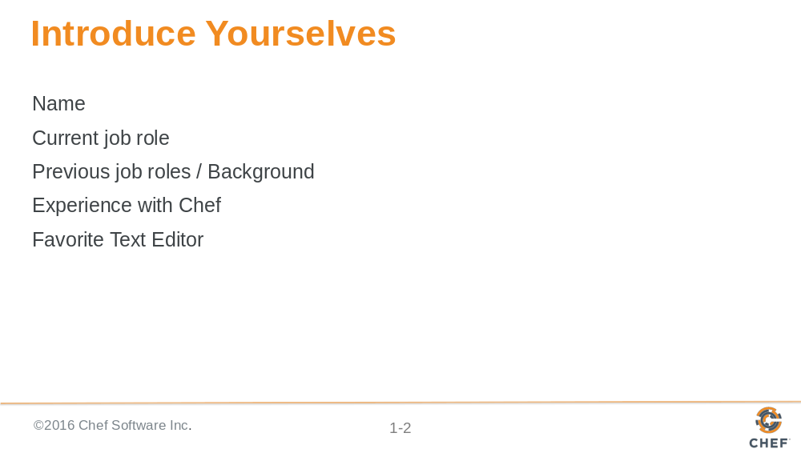

Before we start let me introduce myself. Then I would like it if everyone had a chance to introduce themselves.

Instructor Note: Often times with larger, in-person groups I prefer to have the individuals perform this introduction one-on-one. Having people leave their desks and greet as many people as they can during the time allotted. I often feel this works better as it removes the pressure from the single individual to introduce themselves in a way that is presenting themselves and not actually greeting people. When Online, I create a pre-defined order, announce that order, and then invite a person to speak, thank them when they are done.

Slide 3

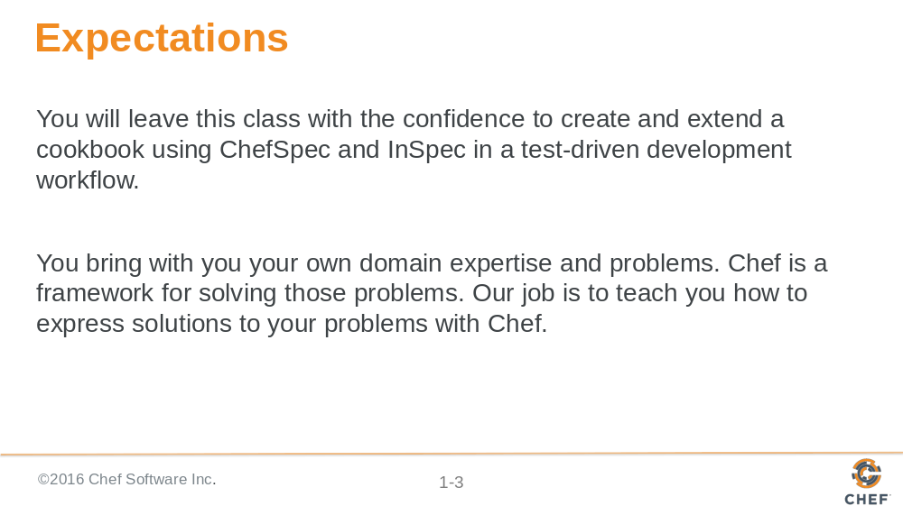

The goal of this class is to give you an introduction to these core testing tools that focuses on the workflow and thought process on why and how to best employ them. Testing is huge domain and will have to keep a tight focus on the challenges and exercises presented in this content. During and throughout the content we will have discussion where we may have additional time to talk about many different topics but in this interest of time and popular opinion we may need to leave those discussions.

During the introductions you learned about the other individuals here in the course with you. They may have shared similar problems and domains. During the time that we are here respectfully reach out them so that you can continue the conversation, grow each other’s knowledge, and become better professionals.

Slide 4

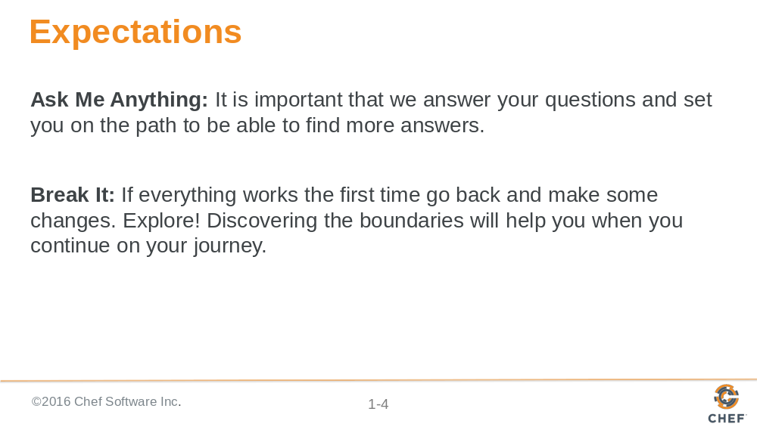

All throughout this training I strongly encourage you to ask questions whenever you do not understand a topic, an acronym, concept, or software. By asking a question you better your learning and often times better the learning of those with you in this training. Asking questions is a sign of curiosity that we want to encourage and foster while we are here together.

This curiosity can also be employed by exploring the boundaries of the tools you are using and the language you are writing. The exercises and the labs we will perform will often lead you through examples that work from the beginning to the end. When you develop solutions it is rare that something works from the start all the way to the end. Errors and issues come up from typos or the incorrect usage of a command of the programming language. When you fall off the path it can often be hard to find your way back. Here, if you find yourself always on the correct path explore what happens when you step off of it, what you see, the error messages you are presented with, the new results you might find.

Slide 5

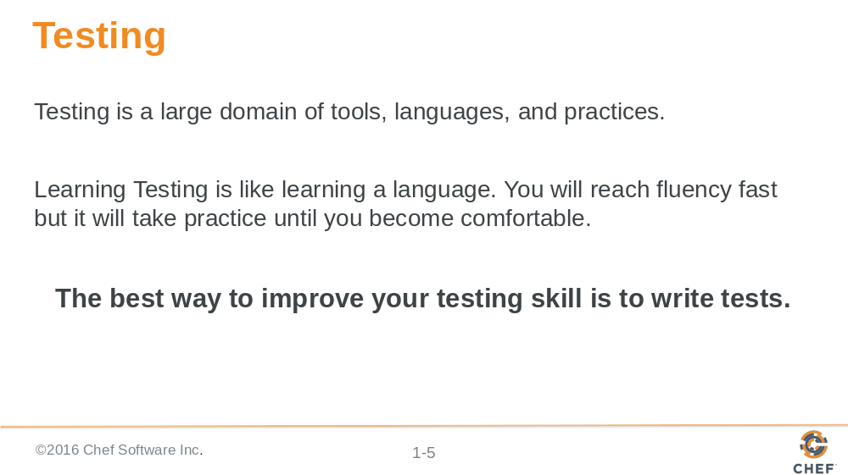

Testing is a large topic and we will spend the training focused on the core workflow of test-driven development, the tools, and the language constructs. During this time you will be performing a lot of hands on work by executing the commands and write the source code necessary to complete the objectives. While this means we will not move through a larger body of content it will mean that you have a better understanding of the material and have built the important muscle memory to perform this work after this training is done.

Slide 6

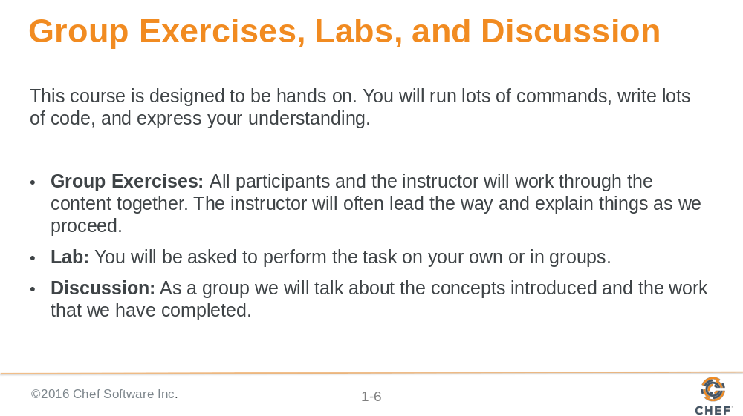

The content of this training has been designed in a way to emphasize this hands-on approach to the content. Together, we will perform exercises together that accomplish an understood objective. After that is done you will often emphasize an activity by performing a lab. The lab is designed to challenge your understanding and retention of the previously accomplished exercises. You can work through this labs on your own or in groups. After completing the labs we will all come together again to review the exercise. Finally, we will end each section with a discussion about the topics that we introduced. These discussions will often ask you to share your opinions, recent experiences, or previous experiences within this domain.

Slide 7

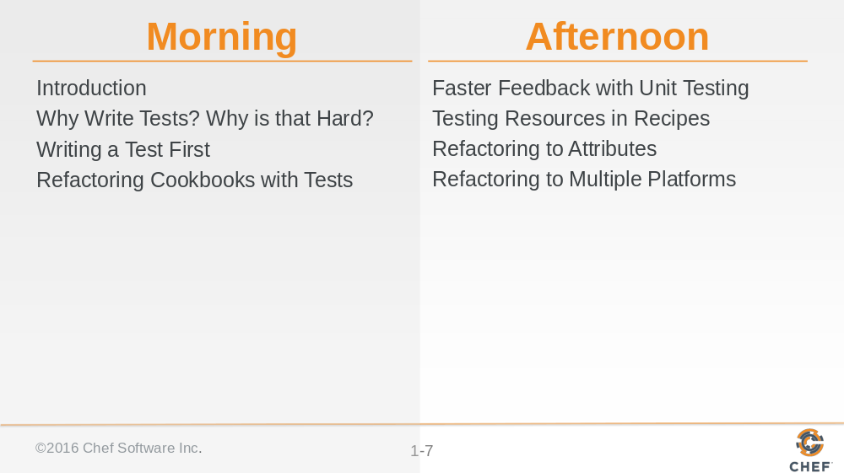

This is the outline of the events for this training. Please take a moment to review this list to ensure that the topics listed here meet your expectations. Take a moment to note which topics are of most interest to you. Also note which topics are not present here on this list. We will discuss your thoughts at the end of the section.

Slide 8

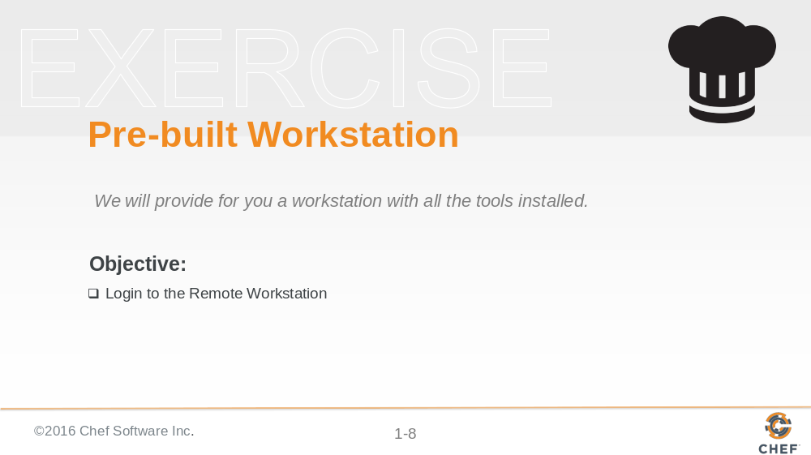

As I mentioned there is a lot work planned for the day. To ensure we focus on the concepts we introduce and not on troubleshooting systems we are providing you a workstation with the necessary tools installed to get started right away.

Instructor Note: At the end of the training it is often a good idea to offer your services to help individuals install necessary software or troubleshoot their systems.

Slide 9

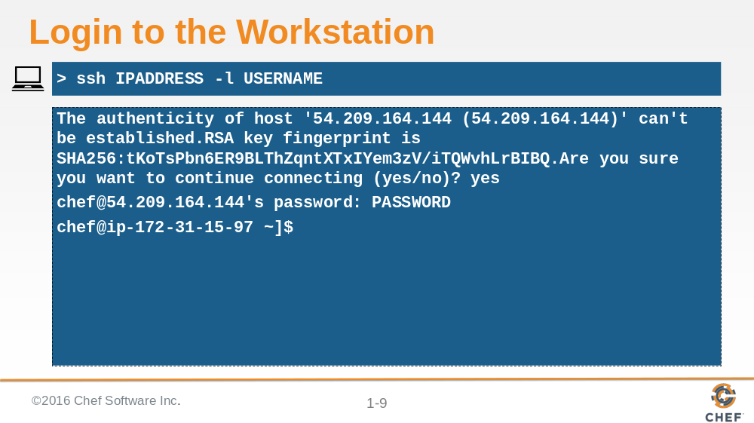

I will provide you with the address, username and password of the workstation. With that information you will need to use the SSH tool that you have installed to connect that workstation.

This demonstrates how you might connect to the remote machine using your terminal or command-prompt if you have access to the application ssh. This may be different based on your operating system.

Slide 10

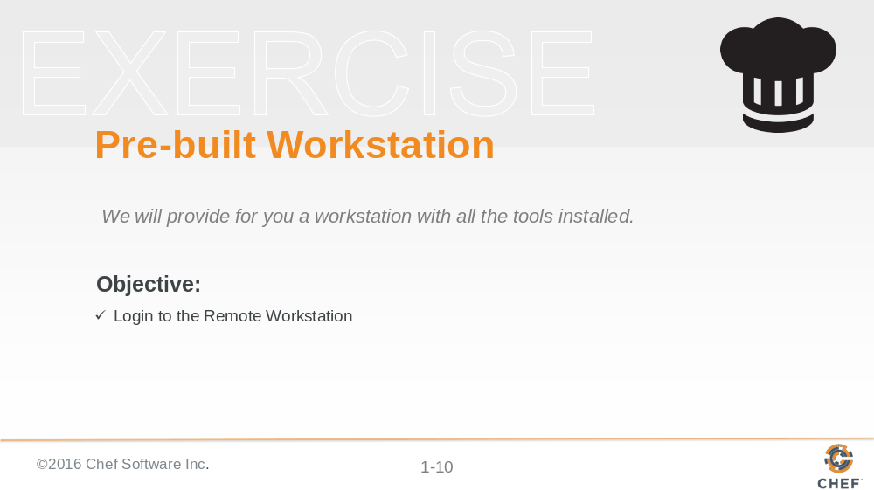

Now that you are connected to that workstation we have taken care of all the necessary work to get started with the training.

Slide 11

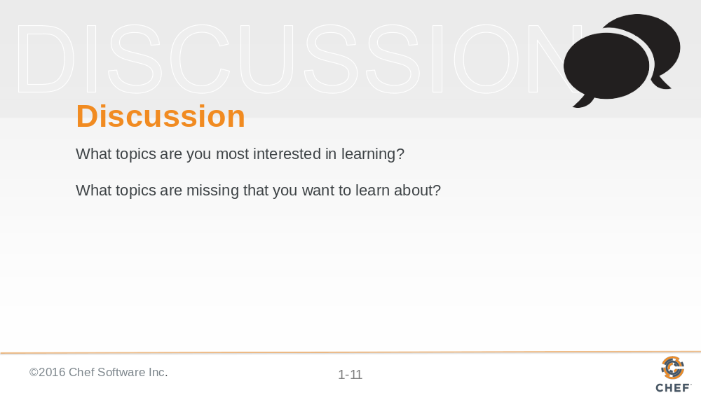

Let us end with a discussion about the following topics.

Instructor Note: With large groups I often find it better to have individuals turn to the individuals around them, form groups of whatever size they feel comfortable, and have them take turns asking and answering the questions. When all the groups are done I then open the discussion up to the entire group allowing each group or individuals to share their answers.

Slide 12

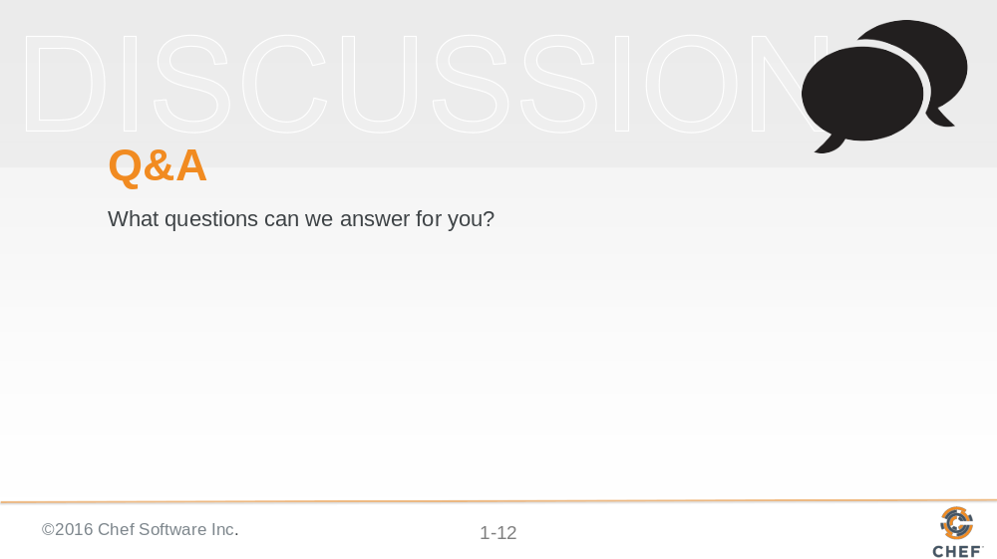

Before we continue let us stop for a moment answer any questions that anyone might have at this time.

Slide 13



