

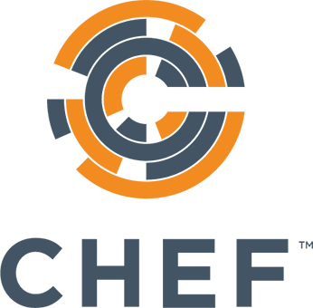

Chef Training Services

Test Driven Cookbook Development

Instructor Guide