Portfolio Website Overview – Isaac Caballero
My professional portfolio website is designed to showcase key academic achievements and technical competencies developed during my Bachelor of Science in Information Technology program, with a focus in cybersecurity.
The website will include the following sections, with attached screenshots of the portfolio website currently in progress:
- Home Page: Introduces my background, areas of expertise, and site navigation.
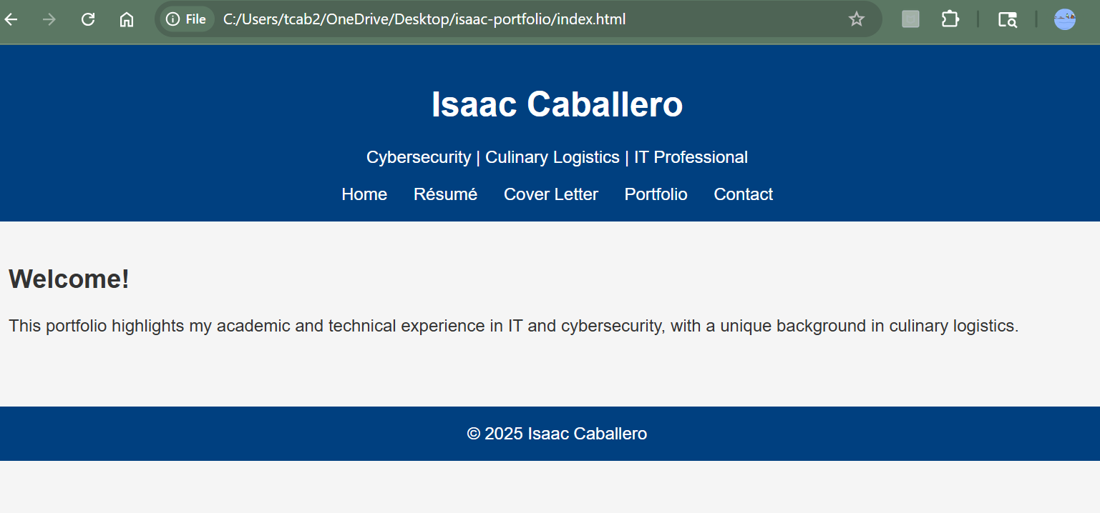
- Résumé Page: Displays a redacted version of my professional résumé.
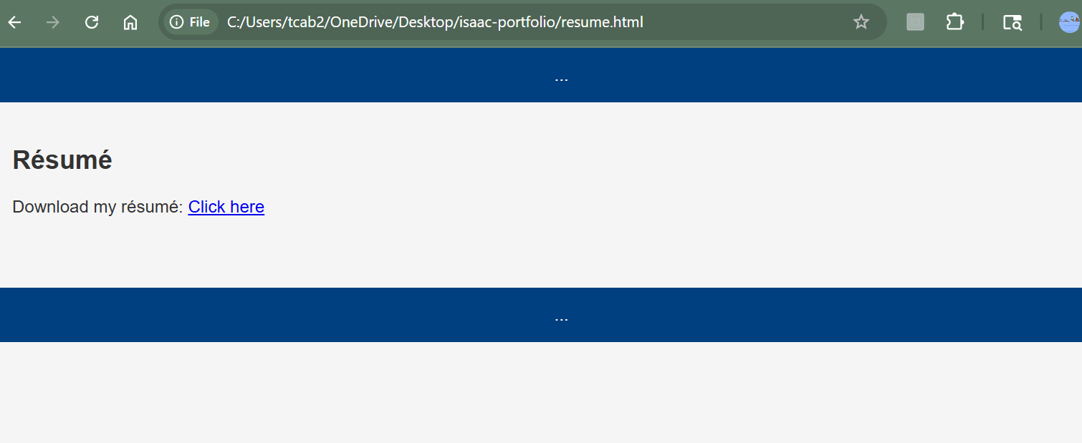

- Cover Letter Page: Contains a generic cover letter tailored to cybersecurity roles.
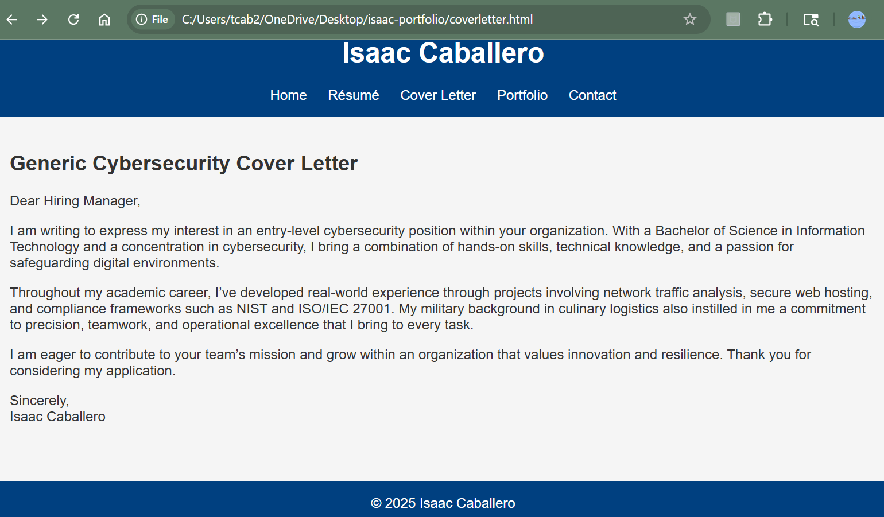
- Portfolio Page: Provides direct access to five high-stakes projects including project descriptions and downloadable documents.
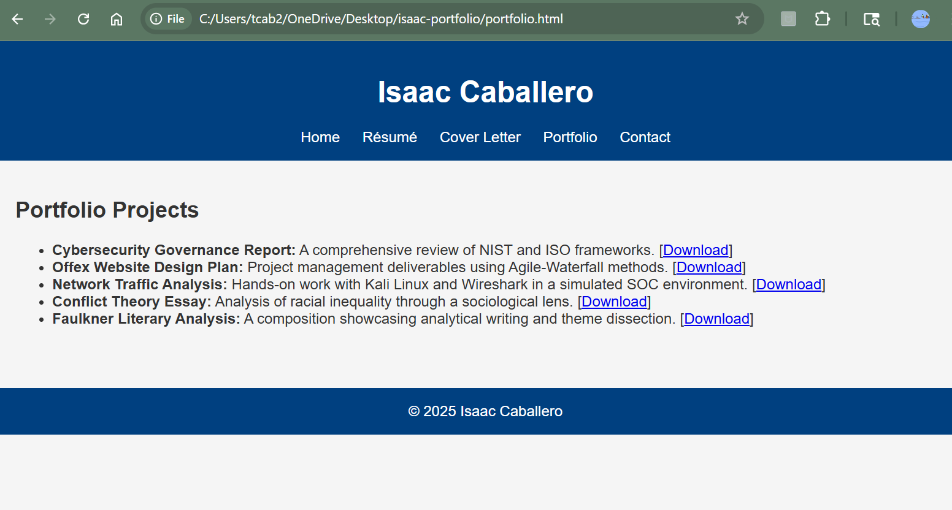

Contact Page:
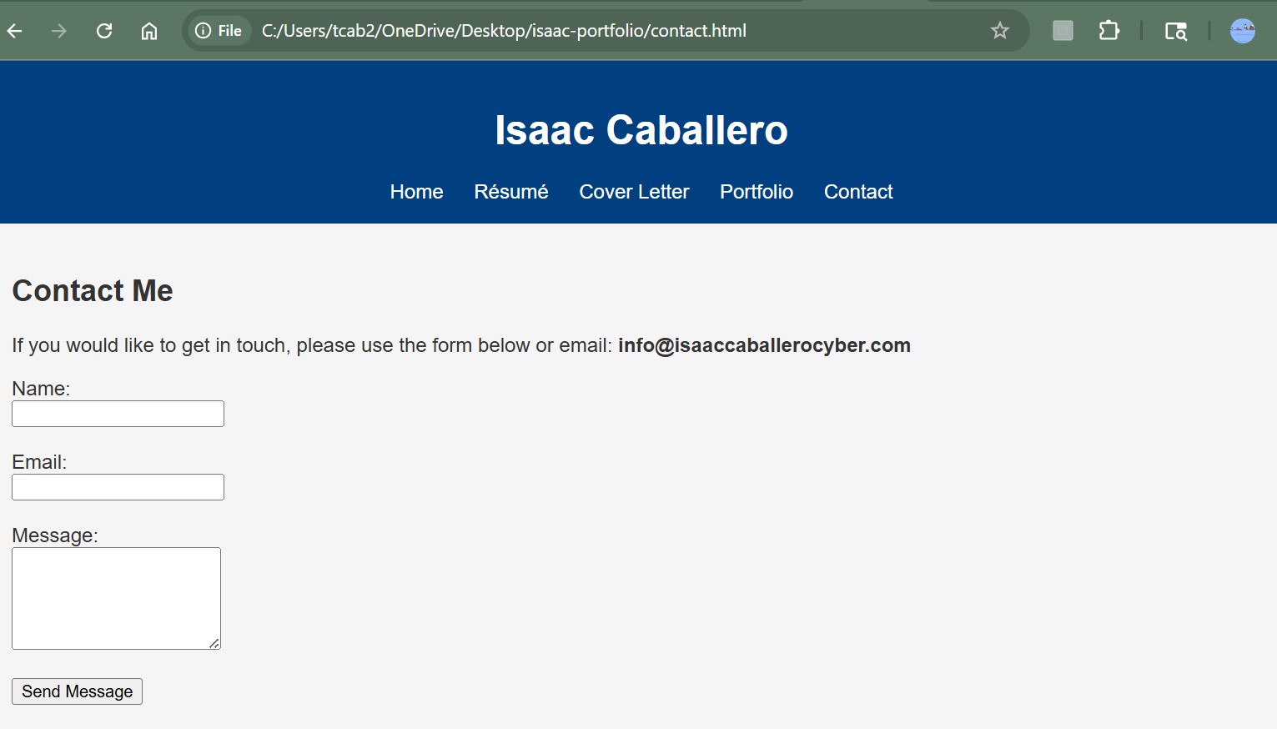
Each page will be accessible through a navigation bar and styled using a clean, professional layout. Personal information is excluded for security, and contact will be available through a contact form linked to a generic email (info@isaaccaballerocyber.com).
Domain name (planned): www.isaaccaballerocyberportfolio.com

