**Queries:**

1. List the names of cyclists and their bikes’ numbers and models which manufacturer is “Scott”:

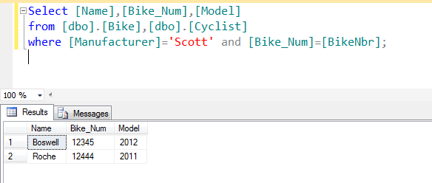

1. Count the number of bikes from each manufacturer:

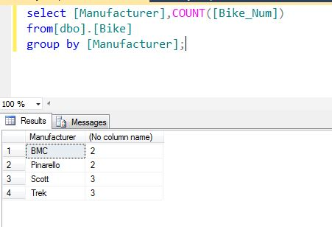

1. List the name , nationality and height of cyclists taller than “Knees” in ascending order:

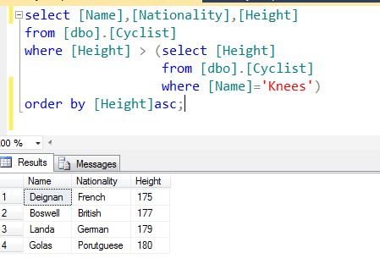

1. What is the name and distance of the race that “Roche” will participate in:

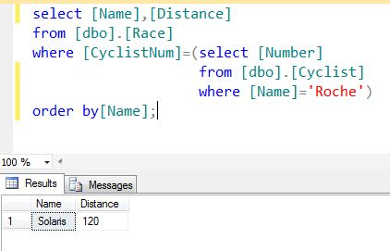

1. Give the birth dates and names of all mechanics born in the 70s and having an ‘USA’ nationality:

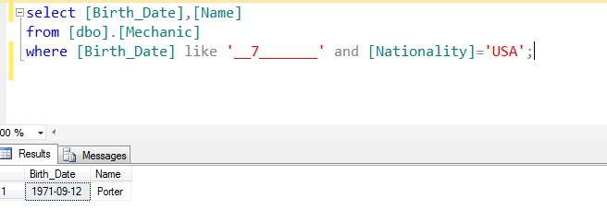

1. List the name and SSN of the nutritionists who prepare 2 meals only:

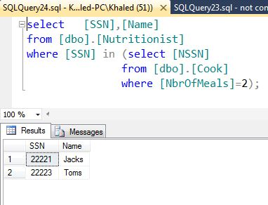

1. List the names and birthdates of cyclists which participate in races started in “Irving “ and ended “Irving”

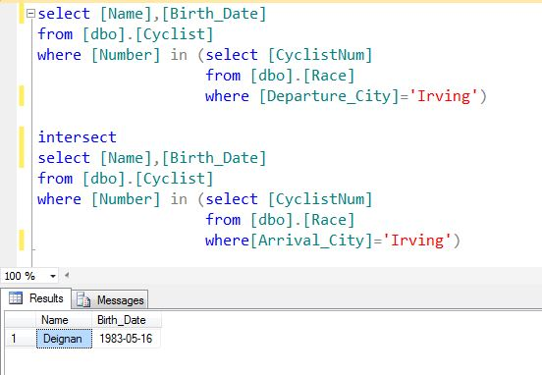

1. Give the name of French cyclists and mechanics born in the 80s

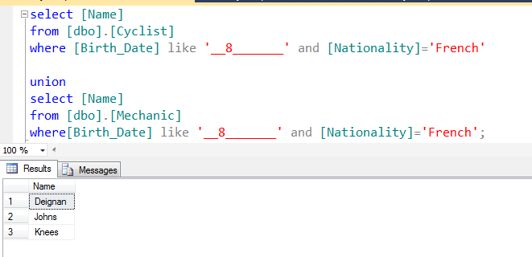

9-List the name of mechanics and supervisors that are responsible for the same bike:

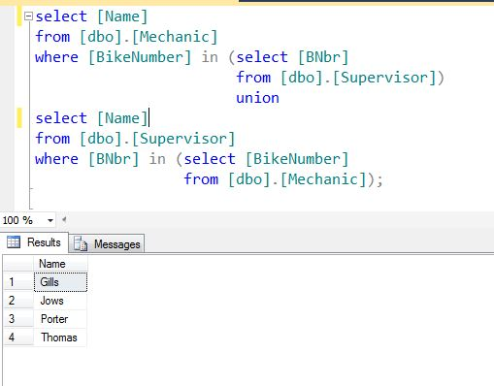

1. Update the distance of race 34 to 350:

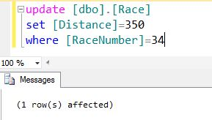

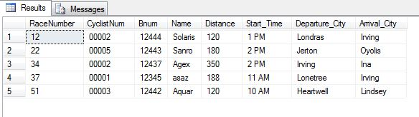

11-How many meals do nutritionists who had last health check done after 2011-03-10 prepare:

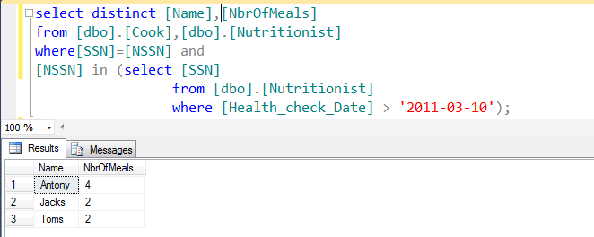

**Normalization:**

UNF :

Cyclist [CyclistNumber, name,(Bike_num,model), (Mechanic_ssn, mechanic_name), (supervisor_id, supervisor_name),(coach_ID, coach_name)]

1NF:

Cyclist [CyclistNumber, name]

Team [CyclistNumber, Bike_num, Mechanic_ssn, supervisor_id, coach_ID,model,mechanic_name, supervisor_name, coach_name]

2NF=3NF :

Cyclist [CyclistNumber, name]

Team [CyclistNumber, Bike_num, Mechanic_ssn, supervisor_id, coach_ID]

Bike [Bike_num,model]

Mechanic [Mechanic_ssn, mechanic_name]

Supervisor [supervisor_id, supervisor_name]

Coach [coach_ID, coach_name]