

**Software Engineering Project**

**Instructor: Mr. Ali Sabbahi**

**By: Wassim Abbas**

**Khaled Charkie**

**Lawand Tahar**

**Mohammad Amer**

**Spring 2016**

**Car Rental System**

**Description**

The car rental system is an online application were users can choose and rent cars for a specific amount of time. The System will be mainly used by three types of users:

1. **Guests**: This type of users is only capable of **viewing** the cars available, price, location of each car and the payment methods for rental. Also, these users can contact the dealer for any enquiry.

2. **Members**: After providing their full name, address and payment info, this type of user has the ability to not only view cars availabilty,prices, location and payment methods, but renting any chosen car and pay via the available method. Members are exclusively allowed to benefit from special offers and discounts on car rental prices and newly arrived models.

3. **Administrators**: Are the ones responsible for adding cars, prices, and availability of each model. They are also responsible for accepting payments from registered members, and replying to any enquiry.

* Members can pay via credit card. Once payment is done the money is transferred from the member's registered bank account to the administrator bank account.
* Members can only rent one car at a time.
* If a member delayed in returning a car, a fee is paid.
* Members cannot rent unavailable cars.

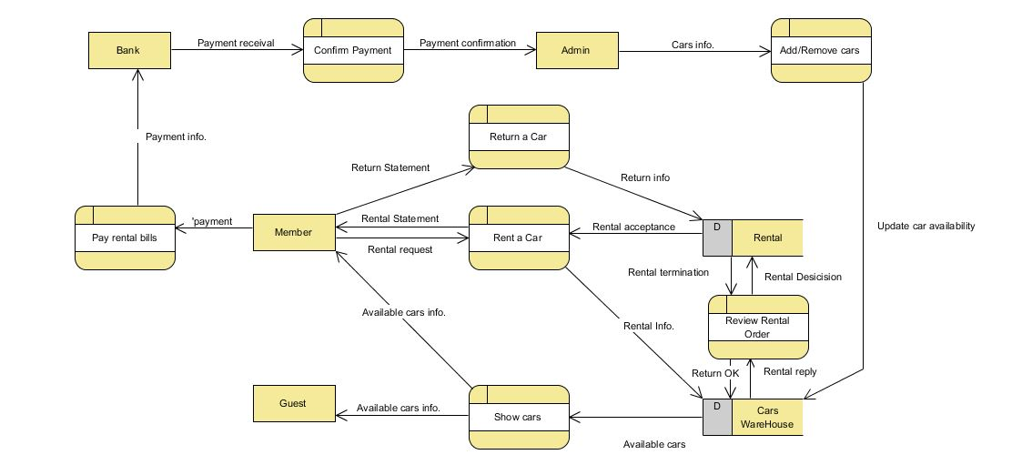**Data Flow Diagram:**

**Entity Relationship Diagram:**

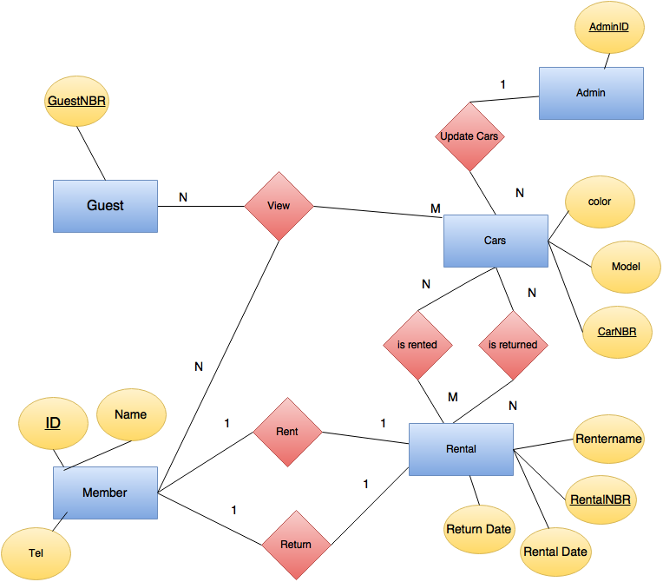

**Use Case Diagram:**

