DECO3801

Jeff and The Lads

Team Charter

1 Team Purpose and Shared Goals
The purpose of our team is to develop strong technical, professional, and collaborative skills while addressing the project problem space. Through this project, we aim to gain practical experience that will better prepare us for working in real-world design and development environments.
The team has agreed to aim for a Grade 7. To achieve this goal, all members will contribute consistently, complete work to a high standard, communicate openly, and support one another throughout the semester.

1.1 Team Members, Skills, and Responsibilities
may include project coordination, stakeholder communication, user research, design,
front-end or back-end development, data management, testing, deployment, documentation, and
risk, privacy, security, or ethics management.
Roles may change during the semester. The

Team Member | Skills | Responsibilities | Roles
Branden Rease Abrol | Coding (Python, C, C++, Java), DBMS (MySQL, PostgreSQL), teamwork, communication, system design, Machine Learning, Agentic AI systems, Linux. | Back-end development, data management, testing, user research, ethics management | Design Lead
Rashid Kazi | Teamwork, Communication, Coding (Python, C, html, Java, Assembly, css, SQL, php), CAD, Linux. | Project Coordination, Stakeholder Communication, Security, Ethics, Risk | Point-of-contact
Ishandeep Singh | Time Management, Teamwork, Communication, Coding (HTML, CSS, SQL & Python) | Stakeholder communication, User research,  Front-end development,  Documentation | Scribe
Pannatat Sribusarakham | Teamwork, Coding (Python, C, C++, Java, JavaScript, SQL, Go, Haskell), DBMS (MySQL, Oracle, PostgreSQL, MongoDB), Prototype Development & Design | Back-end development,  Testing,  Data management, Git management | Organiser
Chetan Hegde | Teamwork, Leadership, Communication, Software development in C, C++, Java, Python, Embedded C, Haskell, SQL, black-box, property, functional testing, static analysis, UI/UX design. | Project Coordination, front-end and back-end development, documentation, testing, Git and code-review management, style checker. | Leader
Adnaan Buksh | Software development in Python, C, Java, SQL, JavaScript, Node.js; embedded systems and microcontroller programming; automated and functional testing; debugging and quality assurance; technical documentation; project coordination; leadership; teamwork; and technical communication. | Git and code-review management, technical documentation, prototype development, and supporting project coordination and stakeholder communication. | Sceptic

1.2 Communication
Discord will be the team’s main communication platform. It will be used for regular updates, questions, meeting coordination, reminders, and informal discussion.
Microsoft Teams will be used for file sharing
Important decisions and task allocations should be recorded in writing so that all members can refer to them later.

1.3 Meetings
The team will primarily meet during the scheduled four-hour DECO3801 class.
Additional meetings may be organised through Discord or Microsoft Teams when required. These may be held online or in person, depending on the availability of team members.
Meeting: Thursday 5pm to 6pm or 9pm to 10pm

1.4 Work Allocation and Accountability
Mutual allocation of work by consensus in the team and based on voting.
Stand-ups at the beginning of every studio.
1.5 Decision-Making
The team will aim to make decisions through open discussion and consensus.
Before making a significant decision, members should be given an opportunity to present their views, concerns, and supporting evidence. Technical and design decisions should be based on project requirements, research, testing results, feasibility, and user needs.
When consensus cannot be reached within a reasonable period, the team will use a majority vote. If votes are Tied, team will reconsider options and revote.
1.6 Quality Expectations
As the team is aiming for a Grade 7, all submitted work should demonstrate a high level of quality, professionalism, originality, and attention to detail.
All work should:
- Meet the project requirements and assessment criteria.
- Be completed before the agreed internal deadline.
- Be reviewed by at least one other team member where practical.
- Use clear and consistent formatting, terminology, and referencing.
- Be tested or validated before being included in the final submission.
- Clearly document assumptions, limitations, and design decisions.
- Avoid incomplete, unverified, or placeholder content in final submissions.

1.7 Git and Development Practices
Merge Conflict
Branching Strategy:
- Task and Feature Tickets
Pull Request:
- 2 people approves
- General overview of what is being changed or done
- If tests are added what the tests are testing
Code Review Process:
- At least 85% branch or path coverage
Commit Conventions
- Commit Early Commit Often
- Clear and concise commit messages
- Verb + Object + Purpose – Structure
Testing Requirements
- General testing as per industry standard, subject to change based on selected project
Merge Conflict Process
- Communicate with team members to solve the issue
Merge Permissions
- Everyone can merge responsibly
Deployment Process
- Double triple check everything works under multiple people before deployment

1.8 Attendance, Availability, and Workload
All members should contribute what the team decides during the studio sessions within the set time frame. Team meetings will be held on Thursdays as needed and agreed upon by the team members. Team members should let the team know in advance if they will be absent from a scheduled studio or team meeting. Regular discussion on the MS teams' channel or discord to stay ahead of due deadlines and assessments. If a member cannot complete an assigned task, let the team know well in advance and another team member can nominate to help with the assigned task.

1.9 Managing Conflict and Under-Contribution
Talk it out have it mediated by the team leader. Involve tutor if it can't be resolved.
One chance before involving tutors.

1.10 Inclusivity and Professional Conduct
All members must be treated respectfully and given a reasonable opportunity to participate. The team will respect different backgrounds, abilities, communication styles, experience levels, and accessibility needs.

Members will maintain professional boundaries, listen to each other, acknowledge individual contributions, and support teammates who are developing unfamiliar skills.

1.11 Use of AI and External Resources
As necessary while following university guidelines

1.12 Ethics, Privacy, and Security
Be ethically responsible in a private and secure manner

1.13 Team Charter Agreement
The information in this team charter has been discussed by the team during the studio and agreed upon by every member of the team. We understand that effective communication, management, professional conduct and active participation is required for effective teamwork. We agree to raise concerns as soon as possible and use this team charter as a reference when resolving problems.

S.No. | Team Member Name | Signature | Date
1 | Branden Rease Abrol | 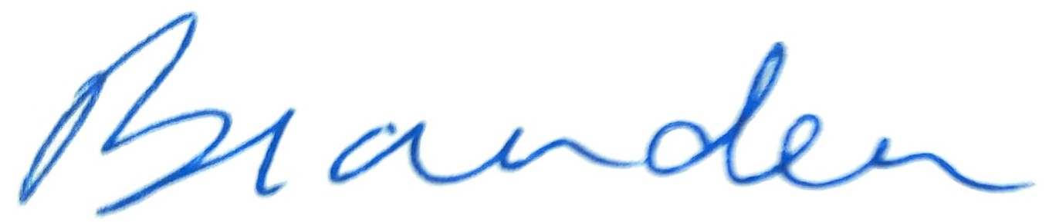 | 04/08/2026
2 | Chetan Hegde | 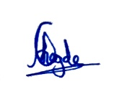 | 04/08/2026
3 | Ishandeep Singh |  | 04/08/2026
4 | Pannatat Sribusarakham |  | 04/08/2026
5 | Adnaan Buksh |  | 04/08/2026
6 | Rashid Kazi | 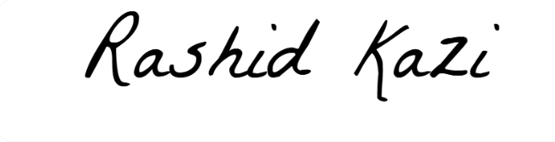 | 04/08/2026

