1/15/2021

EMPLOYEE SCHEDULING SYSTEM

**PROJECT DOCUMENTATION**

# **GROUP MEMBERS**

|  |  |
| --- | --- |
| *NAME* | *REGISTRATION NUMBER* |
| YVONNE KIMANI | SCT212-0475/2017 |
| MARK MUNENE | SCT 212-0224-2017 |
| STANLEY NGUGI | SCT212-0065/2017 |

Table of Contents

CHAPTER ONE 2

1.0 INTRODUCTION 2

1.1 BACKGROUND OF THE RESEARCH 2

1.2 PROBLEM STATEMENT 2

1.3 OBJECTIVES OF THE STUDY 3

1.3.1GENERAL OBJECTIVE 3

1.3.2 SPECIFIC OBJECTIVES 3

1.4 SCOPE OF THE STUDY 3

1.5 SYSTEM JUSTIFICATION 4

CHAPTER TWO 5

2.0 LITERATURE REVIEW 5

2.1 INTRODUCTION 5

2.2 EMPIRICAL REVIEW 5

2.3 PROPOSED SYSTEM ARCHITECTURE 8

2.4 SYSTEM DEVELOPMENT REQUIREMENT 9

2.5 SUMMARY 9

REFERENCES 10

# CHAPTER ONE

## 1.0 INTRODUCTION

Every organization needs a proper scheduling system for its employees to ensure better control over their activities. Automation of employee scheduling is one of the most valuable productivity improvements an organization can make to save a considerable amount of time. In many organizations, scheduling is still done manually with a pencil and paper (normally a hand-drawn employee schedule), often combined with cards, colored tags and large pegboards. In the hands of competent administrators, these paper-based systems may support the basic staffing requirements. However, paper-based scheduling systems have some serious drawbacks.

## 1.1 BACKGROUND OF THE RESEARCH

Today, the problem of personnel scheduling is very different from the one introduced by Dantzig [01] and Edie [02] in the 1950s. The relative importance of satisfying employee needs in staffing and scheduling decisions has grown. Company’s offer part-time contracts or flexible work hours and take into account employee preferences (e.g., working together with someone, preference for a specific shift type, specific days oﬀ or on and many more) when creating work schedules.

Baker [03] has proposed the classification methods for personnel scheduling problems. According to Baker, three main groups can be distinguished: shift scheduling, days-oﬀ scheduling and tour scheduling. In shift scheduling, one has to schedule across a daily planning horizon. The simplest type of schedule involves non-overlapping shifts. This implies that the staff requirements on each shift can be treated independently in determining appropriate allocations. This type of problem is typical faced by industrial companies. Its main advantage is that the allocation problem is easy to solve, and the solution is relatively easy to implement. However, whenever there is fluctuation in demand over small intervals compared to the shift length, this configuration is no longer useful and a model for allocations with overlapping shifts is needed. This kind of scheduling problem is encountered in cal.

## 1.2 PROBLEM STATEMENT

Traditional employee scheduling has proven to be inefficient. Maintaining parameters such as off-days, and who works when seem tedious when generating the employee schedule. Moreover, scheduling employees manually makes it prone to inconsistencies such as unscheduled employees, employees with more shifts than others, employees scheduled to work on more than one shift on the same day and many more since this is a stream of possible “human-like” errors.

The task at hand is to maintain data of employee, to make easy controlling of employees. With this data, it will be easy to divide jobs and access control between employees. This use of automation enhances the accuracy and timely scheduling of the employees. An employee information system with employee data will make the basis of operation for the scheduling system. This will eliminate or reduce the hardships of existing system as much as possible and prevent inconsistencies in the current system. No formal knowledge is needed for user to use the system except basic computer use skills. The system will also endure access control for all personnel

## 1.3 OBJECTIVES OF THE STUDY

### 1.3.1GENERAL OBJECTIVE

* To automate the manual employee scheduling system

### 1.3.2 SPECIFIC OBJECTIVES

* To alleviate data redundancy during employee registration and scheduling.
* To guarantee the security and fairness of the system.
* To provide access control to employee data.
* To enable the employees to sign in and out as well as access their relevant data.
* To efficiently and effectively facilitate the process of employee scheduling using a computer.
* To automate the current scheduling system

## 1.4 SCOPE OF THE STUDY

The software developed will be carried out using PHP Codeigniter framework and a database to manage both the database and make the system accessible online.

## 1.5 SYSTEM JUSTIFICATION

The proposed system is designed to solve problems affecting the manual system in use. It is designed to be used as an online platform thereby relieving the drawbacks associated with using the current manual system.

Other features of the proposed system include:

* Accuracy in handling of data
* Fast rate of operation
* Flexibility i.e. it can be accessed at any time
* Better storage and faster retrieval system

# CHAPTER TWO

## 2.0 LITERATURE REVIEW

## 2.1 INTRODUCTION

This chapter reviews the facts or statements used as guidance in developing the system.

In an organization, a relevant information system and a security system are the critical factors in determining its success in the manipulation and handling of data. This is a major consideration that has been thought of this automated system.

Every Employee needs to access to the information that the organization has about them, making it possible for them to make alterations where necessary. This brings the relevance of having an employee portal for the system

The system administrator as well has a panel from which they can manage and control employee data. The system admin is also required to ensure the smooth operation of the system as well as monitoring and maintaining user data from a managerial perspective.

## 2.2 EMPIRICAL REVIEW

Today, the problem of Employee scheduling is very different from the one introduced by Dantzig [01] and Edie [02] in the 1950s. The relative importance of satisfying employee needs in staffing and scheduling decisions has grown. Companies offer part-time contracts or flexible work hours and take into account employee preferences (e.g., working together with someone, preference for a specific shift type, specific days off or on and many more) when creating work schedules. Baker [03] has proposed the classification methods for personnel scheduling problems. According to Baker, three main groups can be distinguished: shift scheduling, days off scheduling and tour scheduling, which is combination of first two. In shift scheduling, one has to schedule across a daily planning horizon. The simplest type of schedule involves non-overlapping shifts. This implies that the staff requirements on each shift can be treated independently in determining appropriate allocations. Its main advantage is that the allocation problem is easy to solve, and the solution is relatively easy to implement. However, whenever there is fluctuation in demand over small intervals compared to the shift length, this configuration is no longer useful and a model for allocations with overlapping shifts is needed. This kind of scheduling problem is encountered in call centers. In the second group of problems (days off or day-of-week scheduling), the length of the operating week in the facility does not match the length of an employee’s working week. A widely used version of this problem is the instance of 5-day work weeks for employees and a 7-day operating week. A variation of the problem integrates the assumption that the employee’s days off have to be consecutive. The third case is a combination of the shift scheduling and the day’s off scheduling problem. In personnel tour scheduling, organizations operate seven days a week, with more than one shift a day (e.g., airlines, hotels, hospitals, etc.). Since employees must be given daily and weekly breaks, the particular tour (i.e., hours of the day and days of the week) in which the employee must work has to be specified. As with shift and days off scheduling problems, the complexity and size of the tour scheduling problems depend on a number of factors [04]. What really influences the complexity of the problem is the duration of the minimum planning interval, which typically ranges from 15 min to 8 hrs. A popular classification method is one based on the solution method applied. Bechtold et al. [05] classify personnel scheduling solution methods in two categories: linear programming or construction based. Subsequently, a number of categories have been added by different authors. In his survey, Alfares [04] proposes ten categories for tour scheduling approaches:

• Manual solution,

• Integer programming,

• Implicit modeling,

• Decomposition,

• Goal programming,

• Working set generation,

• LP-based solution,

• Construction/improvement,

• Metaheuristics and other methods.

*Ernst et al [06] present a review of staff scheduling and roistering.

**Functionality**

* User Registration
* User Login
* Forgot Password
* Employee data management with employee modifiable profile facility
* Employee scheduling with view allocated schedule
* Schedule control facility
* Admin panel

**Components**.

Graphical User Interface – Provides an access point for employees to interact with the system

Port - An explicit window into an encapsulated component. All of the interactions into and out of such component pass through ports.

## 2.3 PROPOSED SYSTEM ARCHITECTURE

1. Registration – Efficient employee registration features with data validation
2. User Login – Access control with session tracking for the system users
3. Employee Management – The system will store all necessary employee data required for decision making pocedures
4. Schedule control– Features to facilitate employee scheduling will be made available in the system from the administration section of the system

**Illustration of component diagram for the proposed system**

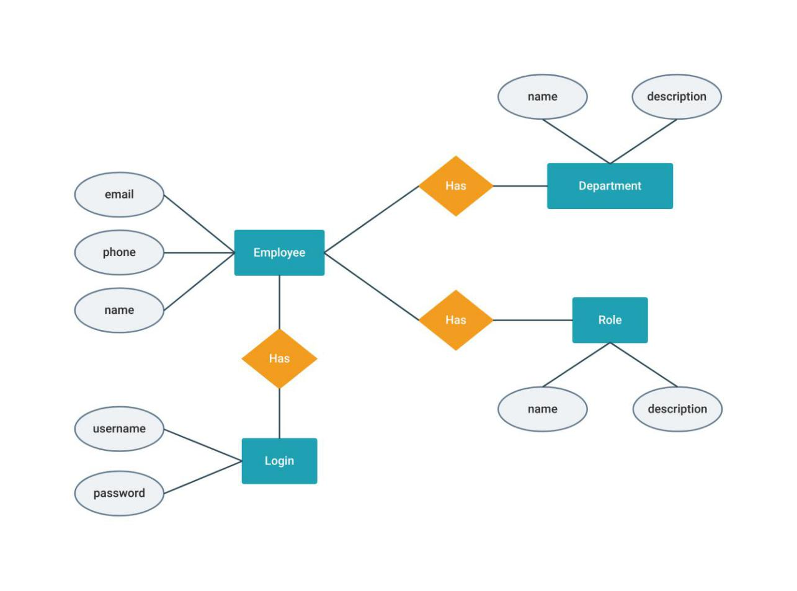

## 2.4 SYSTEM DEVELOPMENT REQUIREMENT

1. Data Requirements:

* Minimum 1GB needed to store our database.
* 512MB RAM is also needed to install our whole system

1. System requirements
   1. UBUNTU server to host the project on an online environment for production
   2. Apache, MYSQL and relevant PHP packages necessary to run the project on the server.

## 2.5 SUMMARY

The system will serve to improve any organization whose operations revolve around time-based employee shifts such as hospitals. This will make it easier to manage, monitor and modify employee operations in the organization

The future scope of the project circles around maintaining information regarding:

1. Advance software management system features such as different level user access control.
2. Integrate multiple load balancers to distribute the loads of the system.
3. Create the master and slave database structure to reduce the overload of the database queries.
4. Implementing the backup mechanism for taking backup on codebase and database on regular basis on different servers.

# CHAPTER THREE

## 3.0 SYSTEM DEVELOPMENT METHODOLOGY

## 3.1 INTRODUCTION.

A system development methodology is referred to as a standard process used to conduct all the steps necessary to the analysis, design, implement and maintain information systems. This chapter discusses the system development methodology that will be used to develop our system using the waterfall model.

## 3.2 SYSTEM DESIGN METHODOLOGY

The system design methodology we will be using is the waterfall model. The waterfall method illustrates the software development process in a linear sequential flow. This means that any phase in the process only begins if the previous is complete.

It consists of several phases: requirement gathering and documentation, system design, construction, implementation, delivery and maintenance.

The following are some reasons to use the waterfall methodology.

It keeps training simple –since it emphasizes on thorough documentation, you can easily add new team members to any project.

It shows progress simply and therefore eliminates the guesswork associated with the project’s timeline. The linear nature of the methodology makes the project easy to manage. Because of the sequential system you’ll know where the project is at a given time and if that is where it should be.

Taking time early on to discover and plan for requirements can save time and money.

### 3.2.1 Requirement Gathering

This stage involves collection of comprehensive information about what the project requires.

A requirements document is then distributed to the team. Information is gathered using a variety of ways, for examples interviews, questionnaires and brainstorming.

### 3.2.2 Analysis

Needs of the end users are analyzed to ensure that the new system can meet their expectations. It is vital in determining how the needs can be met, who will be responsible for individual pieces of the project and what sort of timeline should be expected. Many analysts view this phase as the most important. It is all very well building a sophisticated system which looks good and produces impressive output, but if these outputs are not what the users want, the system is a waste of time.

### 3.2.3 Feasibility Study.

It ascertains the likelihood of completing the project successfully.

It defines and documents software needs. It includes: economic feasibility, operational feasibility, technical and schedule feasibility.

### 3.2.4 System Design

This phase takes the requirements specification and converts it into a system design specification. This involves the design of inputs, outputs, databases, computer programs and user interfaces. The design phase is normally split into logical and physical design. Logical design describes the inputs, outputs, databases, procedures all in a format that meets user requirements. Physical design on the other hand focuses on how data is entered into a system, verified, processed and displayed as output. Most often the choice of programming language and database is already decided and these technologies are taken into account in physical design.

### 3.2.5 System Construction

This phase is where the system is actually built. The system specifications are turned into a working system by writing, testing and, in due course, documenting the programs which will make up the whole system.

### 3.2.6 System Implementation

The objective of this phase is to produce a fully functioning and documented system. It involves training users, transferring data from the old system to the new and actually putting the new system into operation –"going live". A final system evaluation will also need to be performed to make sure the system works according to expectations.

### 3.2.7 System Maintenance and Review

During the life of a system, continual review and maintenance will need to be performed in order to maintain its functionality. For example, new requirements may need to be implemented and errors in the system need to be rectified.

## 3.3 DATA COLLECTION METHODS

During this project research work, data needed for the project was gathered from the various sources. In gathering and collecting necessary data and information needed from the system analyses two major fact-finding techniques were used in this work and they include:

1. **Primary source**
   * This refers to the source of collecting original data in which the researcher made use of empirical approach such as personal interview and questionnaires.
2. **Secondary source** 
   * The secondary data were obtained by the researcher from magazines, journals, newspapers, library source and internet downloads. The data collected from this means have been covered in literature review in chapter two.

### 3.3.1 Study of Manual.

Manuals and reports based on scheduling were studied and a lot of information concerning the system in question was obtained.

### 3.3.2 Evaluation of The Forum.

Some of the forums that are necessary and available were accessed. These included scheduling forms, registration forms etc. these forms help in the design of the new system.

### 3.3.3 Questionnaire Method.

It is a research instrument consisting of series of questions and other prompts for the purpose of gathering information from respondents.

For this purpose, a survey has been conducted though the distribution of questionnaires. There are 100 questionnaires that were distributed among the employees

# REFERENCES

[1] Dantzig, G. B. (1954). Letter to the EditorA Comment on Edie’s Traffic Delays at Toll Booths. Operations Research, 2, 339-341

[2] Edie, L. C. (1954). Traffic Delays at Toll Booths., Operations Research,2, 107-138.

[3] Baker, K. R. (1976). Workforce Allocation in Cyclical Scheduling Problems: A Survey. Operational Research Quarterly, 27, 155-167.

[4] Alfares, H. K. (2004). Annals of Operations Research, 127, 145-175. Survey, categorization, and comparison of recent tour scheduling literature, Operations Research, 2, 107-138.

[5] Bechtold, S. E., Brusco, M. J., and Showalter, M. J. (1991). A Comparative-Evaluation of Labor Tour Scheduling Methods, Decision Sciences, 22, 683-699