OSSP-Practical:
Name: sreeya
Section 09
WEEk-4
4. Write a C program where a parent process creates multiple child processes and synchronizes their completion using wait() and waitpid(). Compare the behavior of both functions.
Create a scenario where a child process becomes a zombie process. Investigate the process table and then modify the program to eliminate zombie processes using proper synchronization techniques.
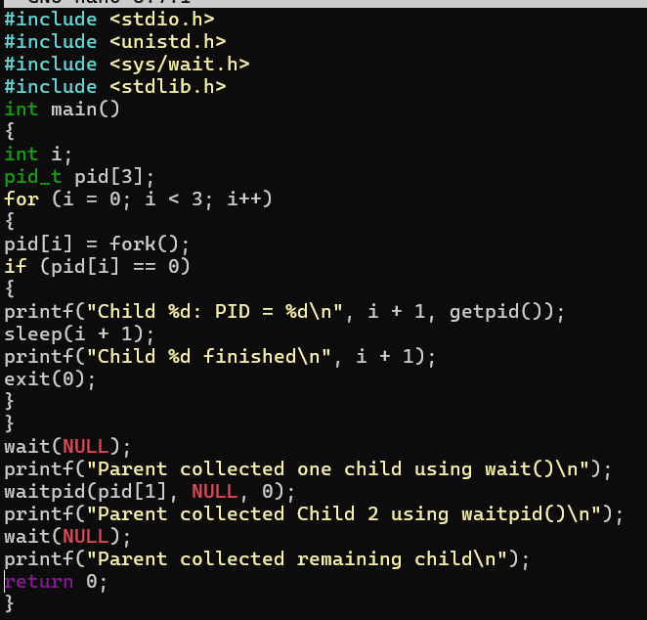
Output:
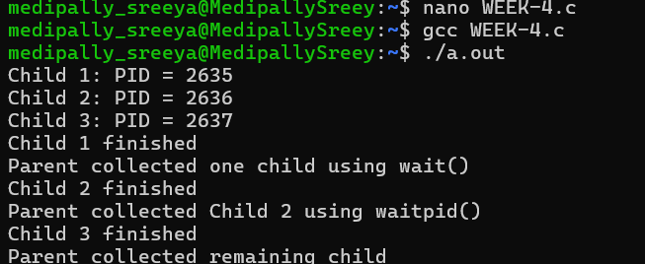
Zombie Process Code:
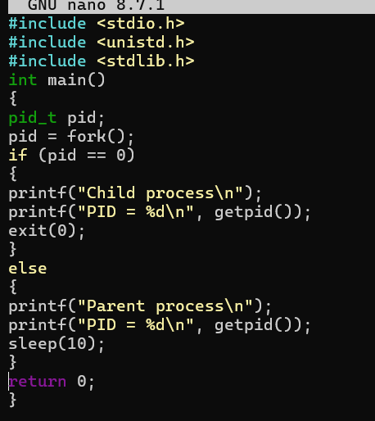
Output:
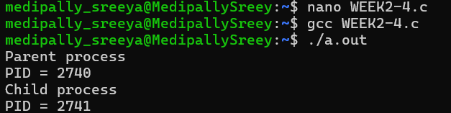
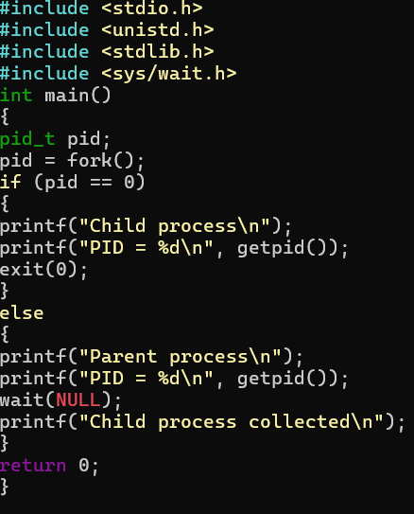
Output:
