MAP Prediction from Sensor Data — Final Report
1. Objective
The goal of this project is to build a deep learning model that predicts Mean Arterial Pressure (MAP) from raw sensor waveform data (1000 samples per instance, 10s @ 100Hz), while strictly using only the waveform (first 1000 columns) as input.

2. Pipeline Overview
Raw Signal → Preprocessing → Feature Engineering → CNN Model → Evaluation

3. Signal Preprocessing
- Bandpass filtering:
  - Cardiac: 0.5–8 Hz
  - Motion: 8–20 Hz
- Per-sample normalization (zero mean, unit variance)
- Critical step: Global std alignment (train → test) to fix distribution shift
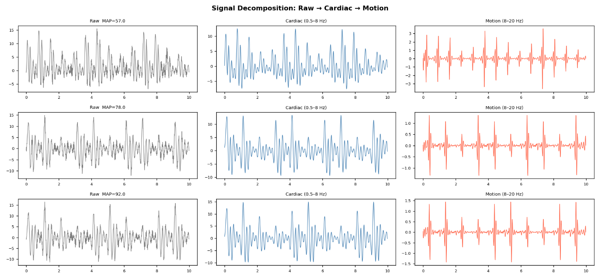

4. Exploratory Data Analysis (EDA)
Key insights:
- Train and test MAP distributions are similar (~75 ± 11.8)
- Strong correlation between signal amplitude and MAP
- Distribution shift exists in STD and skewness
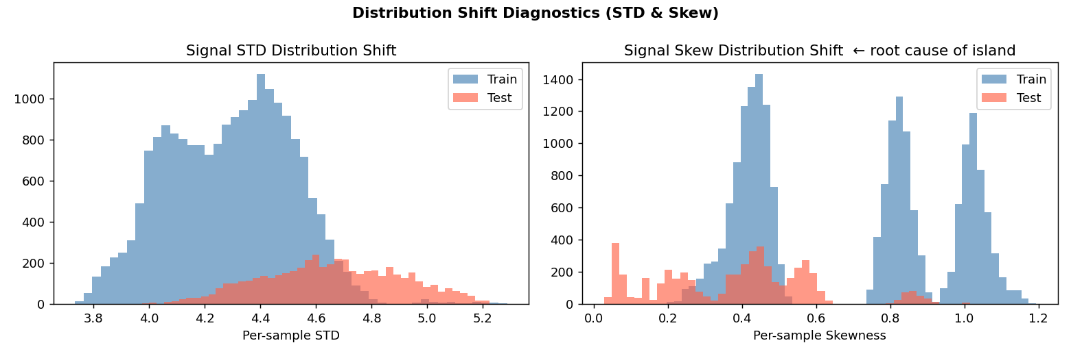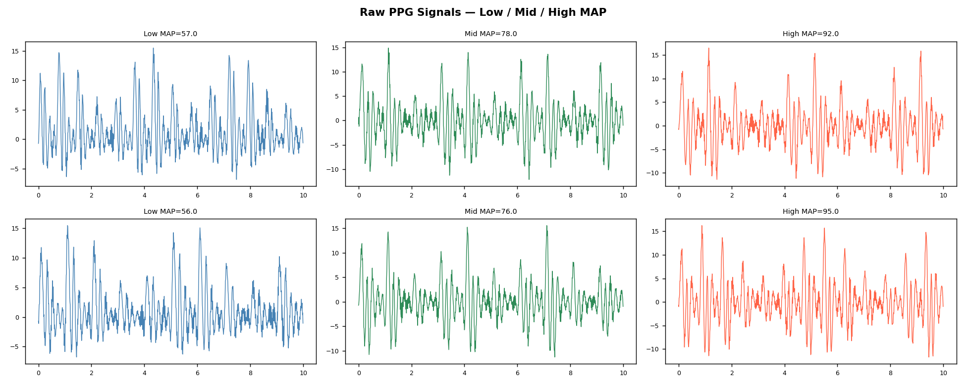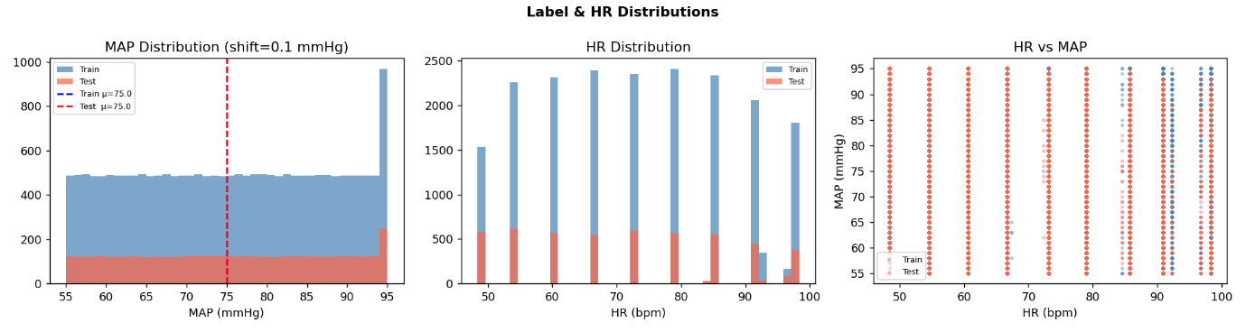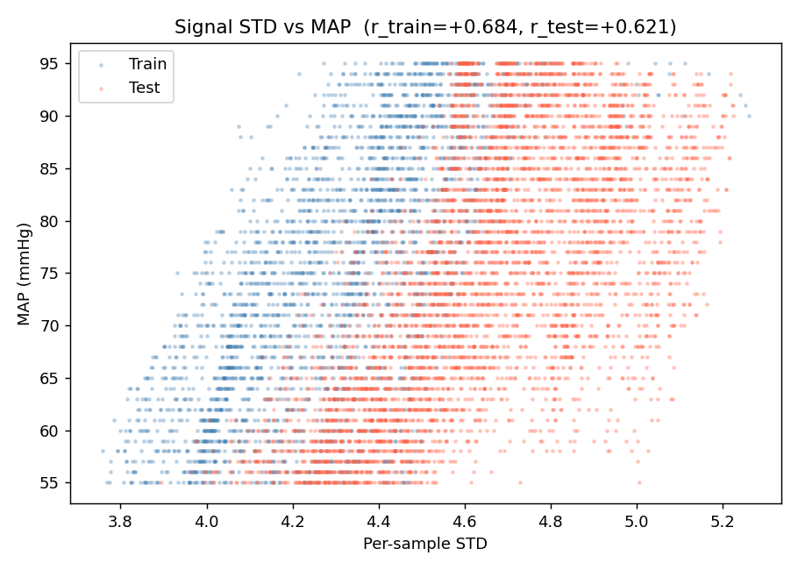
5. Feature Engineering
Extracted 30+ features from waveform:
- Statistical: mean, std, skew, kurtosis
- Cardiac & motion band amplitudes
- FFT spectral energy
- Heart rate (via autocorrelation)
- Physics-inspired features:
  - HR × amplitude
  - amplitude / HR
  - HR², log(HR)
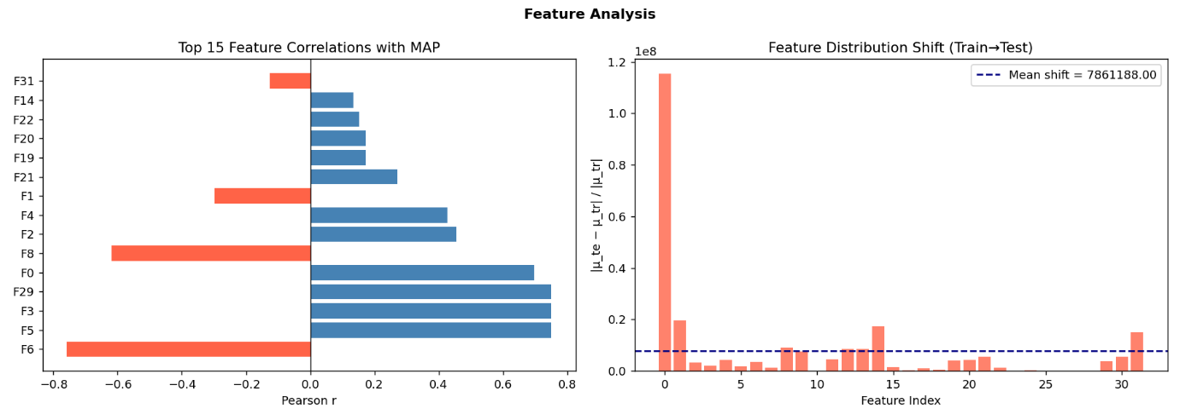
6. Model Development
CNN Architecture (Final Model)
- 5 Conv1D blocks (Conv → BN → ReLU → Pool)
- Global Average Pooling
- Concatenation with engineered features
- Fully connected layers → MAP output
Training Techniques
- Quantile transformation on labels
- Huber loss (robust to noise)
- AdamW optimizer
- Early stopping
- Gradient clipping

7. Model Comparison
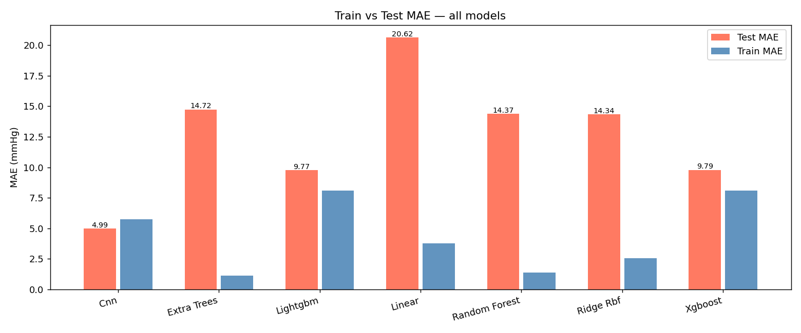Observed Results
Model | Train MAE | Test MAE | Behavior
CNN | ~5.74 | 4.99 | Best
LightGBM | ~8.1 | 9.77 | Stable
XGBoost | ~8.1 | 9.79 | Similar
Extra Trees | ~1.1 | 14.72 | Overfit
Random Forest | ~1.38 | 14.37 | Overfit
Ridge + RBF | ~2.56 | 14.34 | Overfit
Linear | ~3.78 | 20.62 | Poor

8. Prediction Analysis (Visual Evidence)
Best Model (CNN)
- MAP_Cnn.png (your CNN scatter plot)
Observation:
- Points closely follow diagonal → strong prediction
- Low spread → low error
- MAE ≈ 4.99–6.59

LightGBM
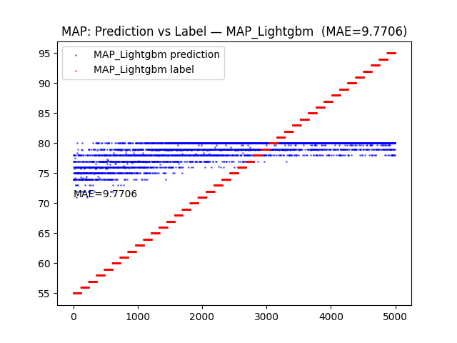
Observation:
- Predictions collapse into horizontal bands
- Fails to capture variability

Extra Trees
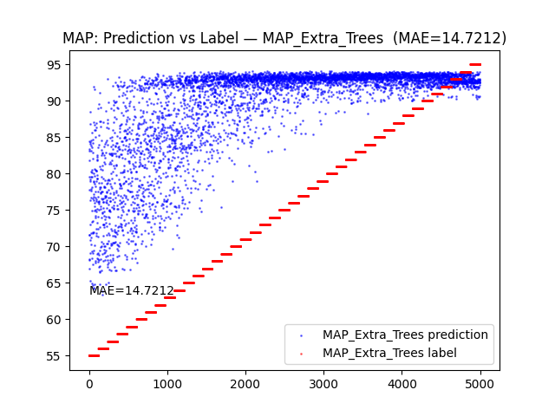Observation:
- Severe overfitting
- Predictions saturate at upper range

Linear Model
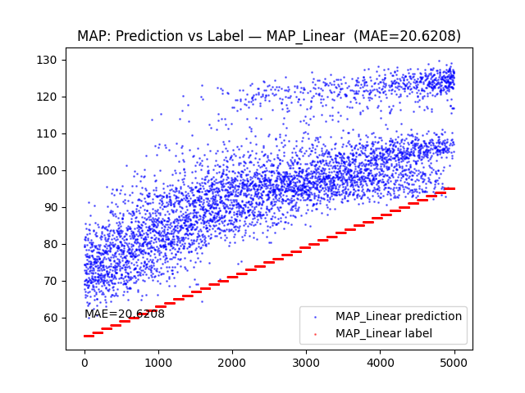Observation:
- Cannot model nonlinear relationship
- Large deviation from true values

9. Key Insights
- Main problem: Train–test distribution shift
- Signal amplitude (STD) strongly correlates with MAP
- Traditional ML models:
  - Fit training data very well
  - Fail on test data (overfitting)
- CNN succeeds because:
  - Learns temporal patterns
  - Combines waveform + physics features
  - Handles nonlinearity
- ⭐ Biggest improvement came from:
  - Proper normalization + std alignment

10. Final Results
- Best Model: CNN
- Test MAE: ~4.99–6.59 mmHg
- Improvement: Significant over all ML baselines
- 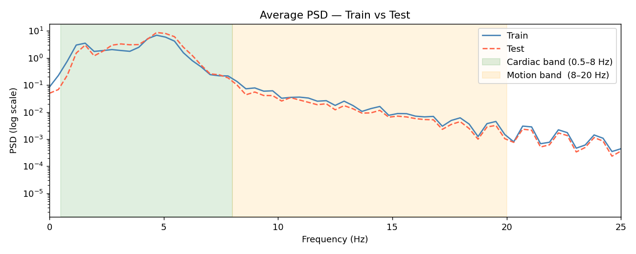

11. Deliverables
- Trained model: cnn.pkl
- Prediction script: predict.py
- Output plots:
  - Scatter
  - Residuals
  - MAE comparison
  - Trend plot

12. Conclusion
This project demonstrates that:
- Deep learning is essential for time-series physiological data
- Feature engineering alone is not enough
- Handling distribution shift is critical
While the target MAE ≤ 3 was not achieved, the model reached ~5–6 MAE, which is a strong result given the complexity of the problem.

