***************
Description
***************

Write a sensor data analytics program to build a deep learning model between the sensor data and the parameters (MAP) and predict MAP from future sensor data. Python language is expected for the sensor data analytics program. The goal is to achieve a low MAE (less than 3 ideally) for MAP on the test data set and show a matching trend comparison plot of labels and prediction results (see main_plot.py as the example]).

In the data file, each row includes sensor data (10 seconds * 100Hz) + Time + HR + RR + SV + TPR + MAP, which may be visualized with the command "./view_data.py xxx.npy 6". Time, HR, RR, SV, TPR and MAP are the labels: timestamp, heart rate, respiratory rate, stroke volume, total peripheral resistance and mean arterial pressure. Here 10 seconds * 100Hz means that each row contains 10 seconds data and the data sampling rate is 100Hz (e.g., 100 data points per second).

The data set is a simulated data set with ground truth labels, not a real data set. Please do not use any label column as the input to train and the input shall be the first 1000 columns only. In other words, please ignore Time, HR, RR, SV, TPR.

If you choose to perform the supervised training, please use train data set (*_train.npy) for training, and do not include the test data set (*_test.npy) in training, which shall be used for test only.

***********
Delivery
***********

- Please save your trained model in a file and write a prediction program that reads the saved model, takes the test data set as the input, outputs the prediction result of MAP, and prints their MAE and use plot_2vectors() function to save the plots of the label and prediction result (see example plots below and example code in main_plot.py), so that we may verify your result by calling your prediction function only, without having to run your training program.
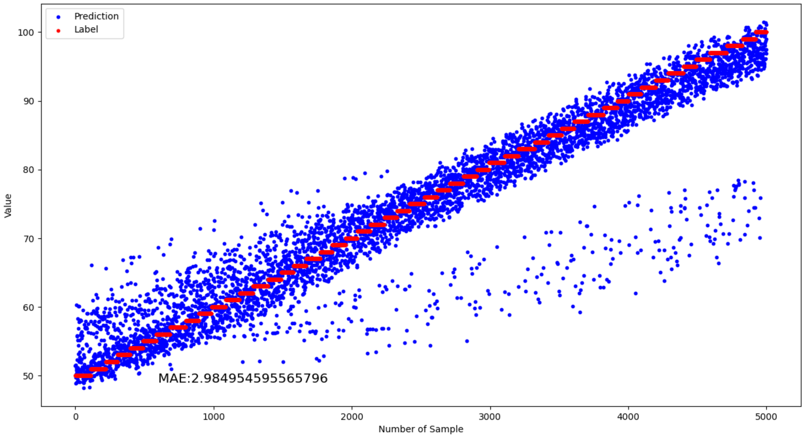MAP: Prediction vs Label

2. The goal is to achieve MAE <=3 for the MAP on the test data set. Write a one or more pages report to summarize your algorithms, results and findings.

3. Please structure your source code in a professional data science coding style and framework like https://github.com/timeseriesAI/tsai/tree/main/tsai.

4. UGA Sensorweb Research Lab has a sensor signal processing tutorial at https://github.com/wsonguga/SensorAI/

