StreamSync Study
Protocol Director: Ryan Sun MD, Assistant Professor, Department of Urology
Location: Stanford University
Condition: Benign Prostatic Hyperplasia (BPH)
Purpose of the study: We are studying whether home urine flow, Apple Watch, and medical record data can help predict who benefits from bladder treatment and track recovery after treatment.
Who is eligible: Men with urinary symptoms from enlarged prostate (BPH) who are planning bladder treatment and can use an iPhone.
What: Use StreamSync at home before and after treatment.
- Study Apple Watch and StreamSync app (compatible iPhone required)
- Throne One - passive home uroflow device
Benefits: You may learn more about your urinary patterns and recovery. Your participation may help improve future bladder care for others. You will receive $100, Throne One device, and Apple watch for completing the study
Time commitment: About 30 minutes for set-up, then home monitoring before and after treatment with brief surveys.

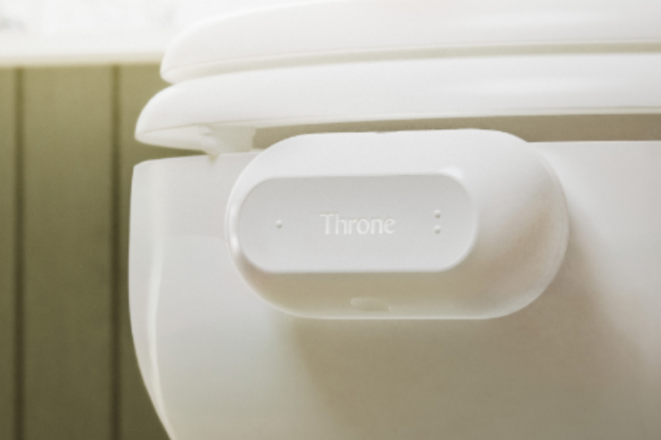
To participate or learn more scan the link below, ask your provider, or contact our research team at dgw1@stanford.edu

