1. Alter Store table to have hours of ‘start_at’ and ‘end_at’ with data type set to ‘TIME’

Syntax using ALTER statement

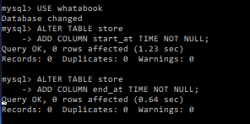

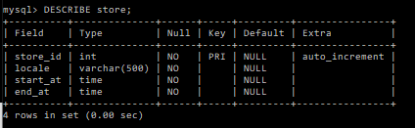

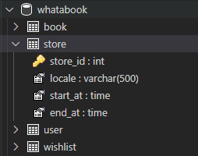

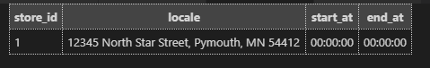

1. Update times from ’00:00:00’ of both ‘start_at’ and ‘end_at’ to ’10:00:00’ for start_at and ’17:00:00’ for end_at

Syntax using UPDATE statement

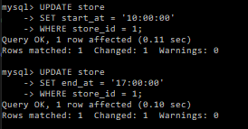

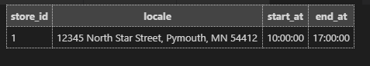

1. .
2. .
3. .
4. .
5. .
6. .
7. .
8. .