GitHub Repository Setup Instructions

GitHub Repository Link- <https://github.com/cheher21/csd-340>

1. Create repository

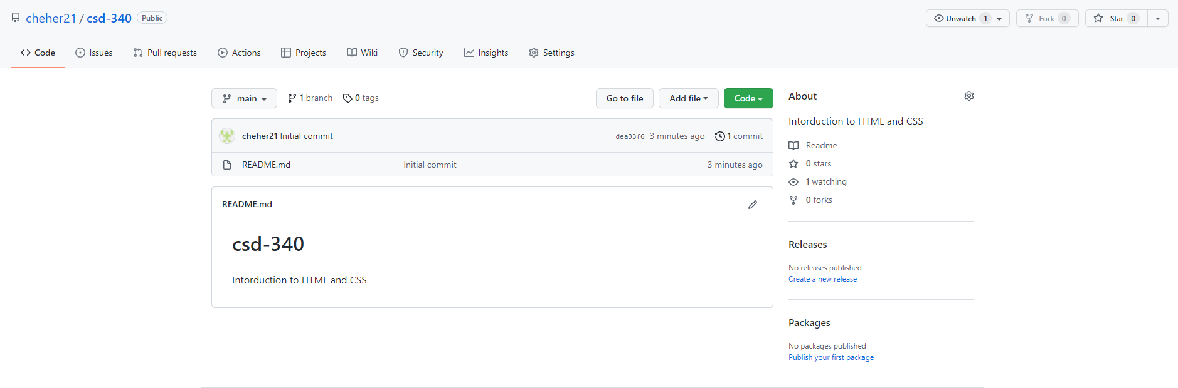

1. Clone using GitHub Desktop

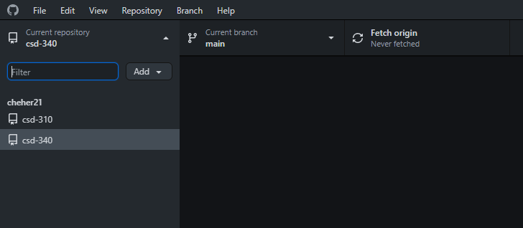

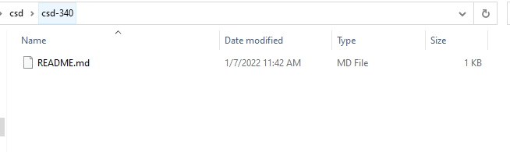

1. Git Bash Clone

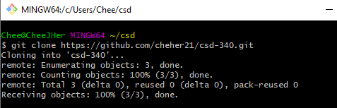

1. Verification of repository clone



1. Modify README.md

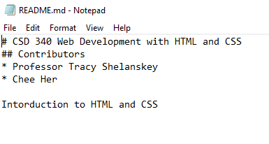

1. Show Modified README

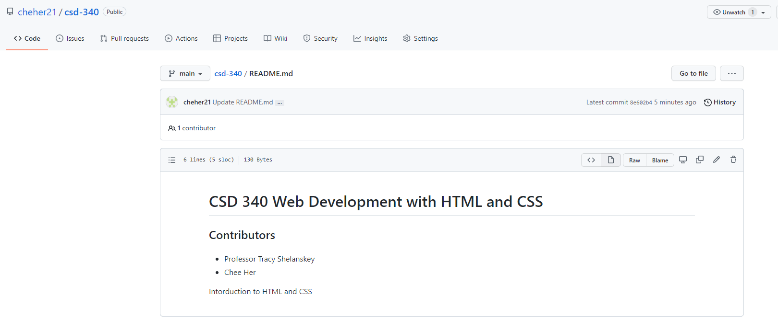

1. Create Module folders

