Assignment: Final: HTML5 Landing Page

In this assignment, you will be showcasing what you’ve learned throughout the entire course by putting your skills to work! For this assignment, you will be building a single HTML5 landing page of yourself. At minimum, this page should include your image, three columns for personal hobbies, and at least three columns for personal interests/work experience.

# Color Palette

<https://coolors.co/palette/fbf8cc-fde4cf-ffcfd2-f1c0e8-cfbaf0-a3c4f3-90dbf4-8eecf5-98f5e1-b9fbc0>

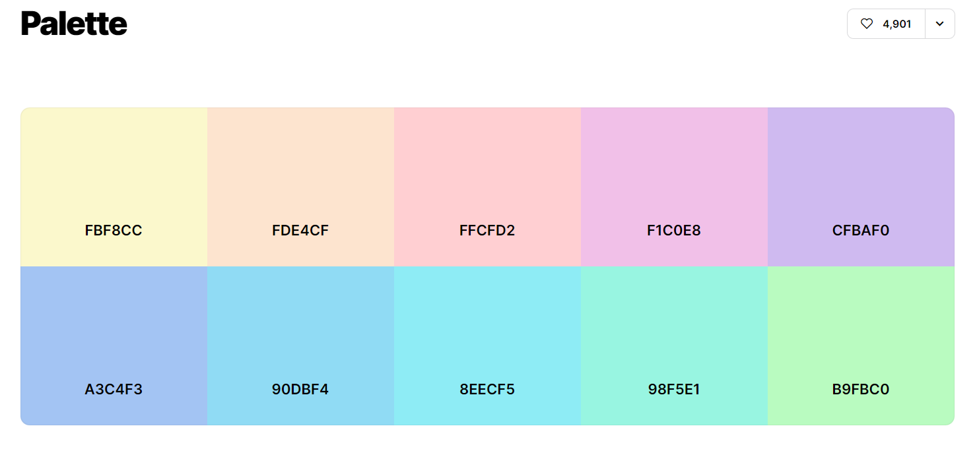

# Wireframe

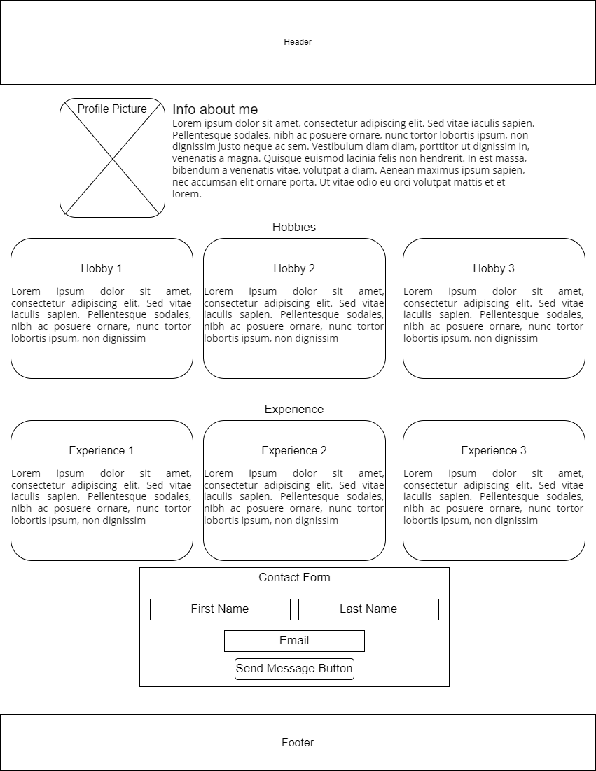

Instructions:

1. **Build an HTML5 landing page of yourself**
2. **Include**
   * **Header section**
   * **Hobbies div**
     + **3 columns representing your personal hobbies**
       - **Use CSS cards (refer to what we used in the Build a Web Page exercises)**
       - **Each card must include a brief description of what the card represents**
       - **This section will be for your personal hobbies, include an image and text explaining why this is one of your favorite hobbies.**

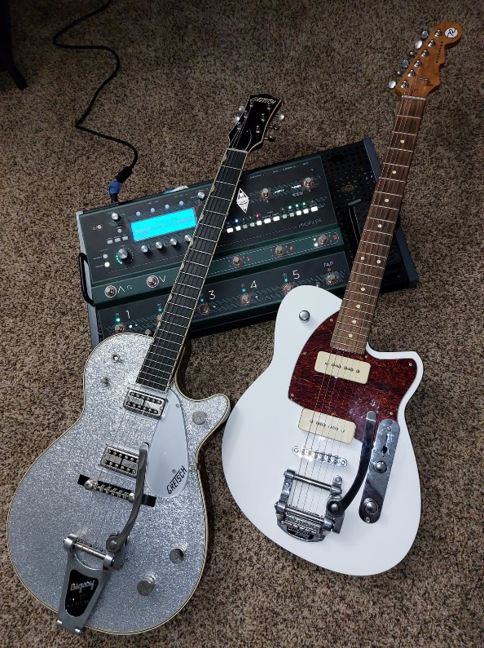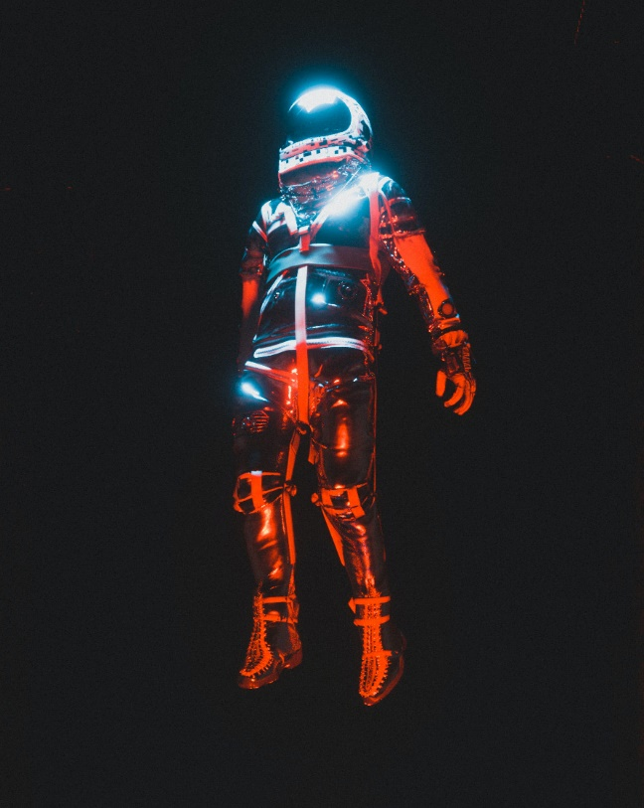

Photo by [Cash Macanaya](https://unsplash.com/@graphics_cash?utm_source=unsplash&utm_medium=referral&utm_content=creditCopyText) on [Unsplash](https://unsplash.com/s/photos/sci-fi?utm_source=unsplash&utm_medium=referral&utm_content=creditCopyText)

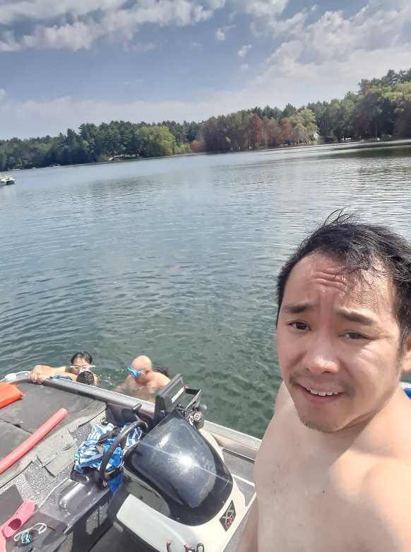

1. Playing the electric guitar is one of my favorite hobbies because it allows me to clear my mind. I become completely focus on the music that I love. It distracts me from my everyday worries. Music brings joy to my life.
2. Movies are another hobby that I enjoy. I like to watch sci-fi movies. My reason for this is because it allows the creators to do anything they want. Sci-fi movies can break any barrier that we currently understand here on Earth.
3. Swimming is another one of my favorite hobby which I do not get enough of. I do not have my own pool or live near a body of water. I can only swim when the opportunity presents itself. Although I am not the strongest swimmer, I can hold my own for a time if left in the middle of the ocean.
   * **Experience div**
     + **3 columns representing your work experience/personal interests**
       - **Use CSS cards (refer to what we used in the Build a Web page exercises)**
       - **Each card must include a brief description of what the card represents**
       - **This section will be for your personal work experience. If you are not working or have never worked, you can use potential children, parents, personal accomplishments, or personal embellishments.**



Photo by [Levi Meir Clancy](https://unsplash.com/@levimeirclancy?utm_source=unsplash&utm_medium=referral&utm_content=creditCopyText) on [Unsplash](https://unsplash.com/s/photos/marine-corps?utm_source=unsplash&utm_medium=referral&utm_content=creditCopyText)



Photo by [Fotis Fotopoulos](https://unsplash.com/@ffstop?utm_source=unsplash&utm_medium=referral&utm_content=creditCopyText) on [Unsplash](https://unsplash.com/s/photos/developer?utm_source=unsplash&utm_medium=referral&utm_content=creditCopyText)

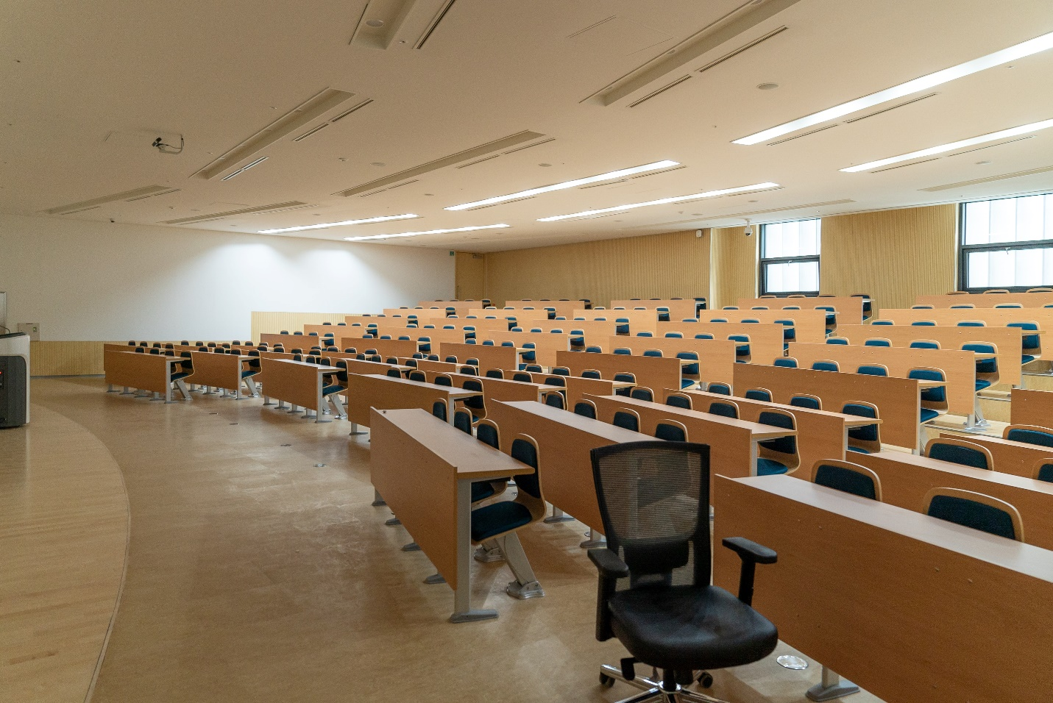

Photo by [Changbok Ko](https://unsplash.com/@kochangbok?utm_source=unsplash&utm_medium=referral&utm_content=creditCopyText) on [Unsplash](https://unsplash.com/s/photos/classroom?utm_source=unsplash&utm_medium=referral&utm_content=creditCopyText)

1. I served four years in the United States Marine Corps from 2009 to 2013. While in the service, my Military Occupation Specialist was Small Arms Repair/Technician (MOS 2111). I was deployed to Afghanistan in 2010 along with a second deployment in 2012 as part of Operation Enduring Freedom.
2. I got my associates degree in Software Developer in the fall of 2019 from my local technical college. This was the hardest part of my education as I knew little to nothing about computers. Towards the end of my second semester in the software developer program, something magically clicked in my head and I was able to understand everything I was doing. From then on, everything just went smoothly for me as I continued through the program.
3. Upon graduating with my associate’s degree, I was selected to become one of the teacher assistant at the college. As a teacher assistant, I helped students with their assignments and created learning materials.
   * **Contact div**
     + **Contact form with the following fields**
       - **First name**
       - **Last name**
       - **Email**
       - **Button with the text “Send Message”**

**Add a link to the starter code HTML file to your repositories index.html file**

**Hint: Refer back to assignment 4.2 if you are confused about what this item is referencing.**

**Note: Most of the CSS that you will need in this assignment has been created in previous “Build a Web Page” exercises. The easiest way to complete this assignment is to go through the code you wrote in the “Build a Web Page” exercises and reuse the CSS styles. As always, if you get stuck, the course's GitHub repository has a starter solution. But, you cannot just copy and paste the solution. You will need to personalize it with your information!**