Assignment: Final: HTML5 Landing Page

In this assignment, you will be showcasing what you’ve learned throughout the entire course by putting your skills to work! For this assignment, you will be building a single HTML5 landing page of yourself. At minimum, this page should include your image, three columns for personal hobbies, and at least three columns for personal interests/work experience.

# Color Palette

<https://coolors.co/palette/fbf8cc-fde4cf-ffcfd2-f1c0e8-cfbaf0-a3c4f3-90dbf4-8eecf5-98f5e1-b9fbc0>

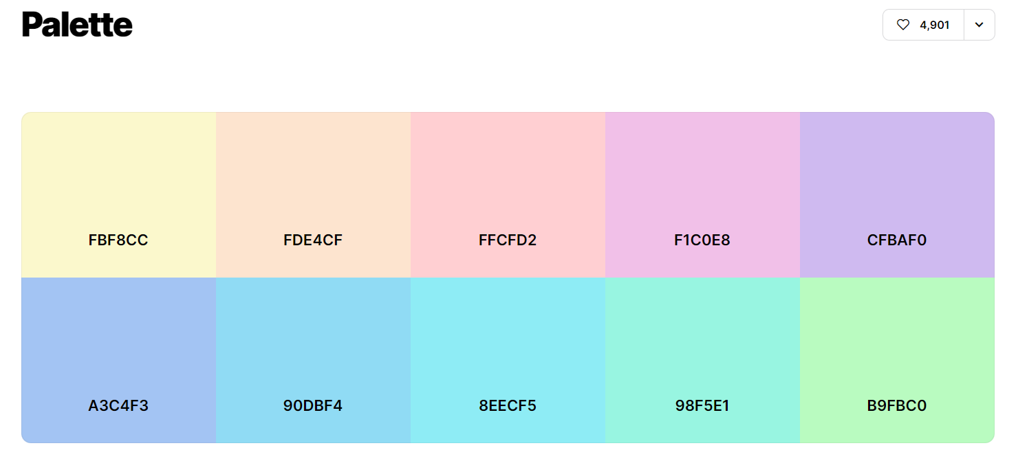

# Wireframe

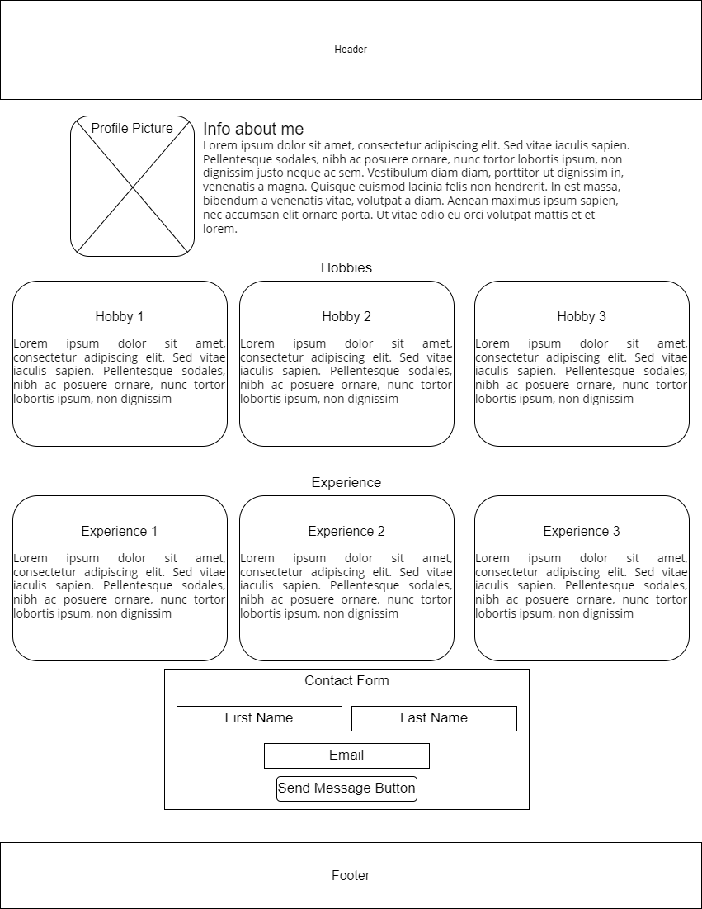

Instructions:

1. **Build an HTML5 landing page of yourself**

Hello and welcome to my Web Development with HTML and CSS Module 12.3 Final. My name is Chee Her and I am in the Software Development Degree program at Bellevue University. I transferred from local technical college and started attending Bellevue University in the Fall Semester of 2021.

Here you will learn a little bit about my hobbies and what I like to do on my free time. You will also learn about my personal experiences and work experience. Lastly, at the bottom of the page, you will have an opportunity to email me if you have further questions.

1. **Include**
   * **Header section**
   * **Hobbies div**
     + **3 columns representing your personal hobbies**
       - **Use CSS cards (refer to what we used in the Build a Web Page exercises)**
       - **Each card must include a brief description of what the card represents**
       - **This section will be for your personal hobbies, include an image and text explaining why this is one of your favorite hobbies.**

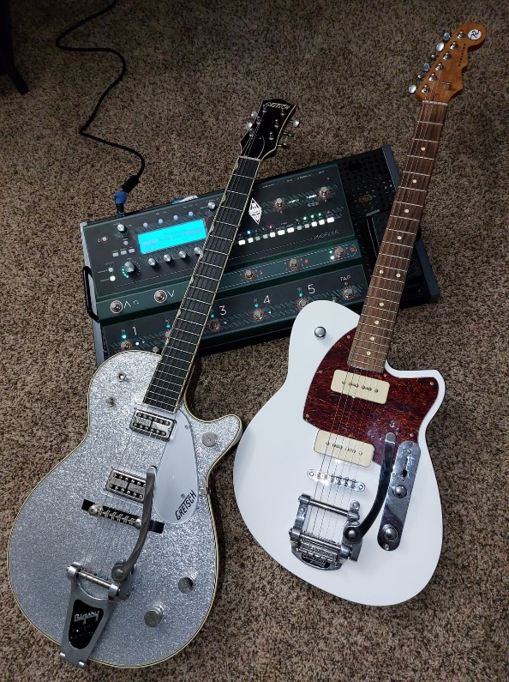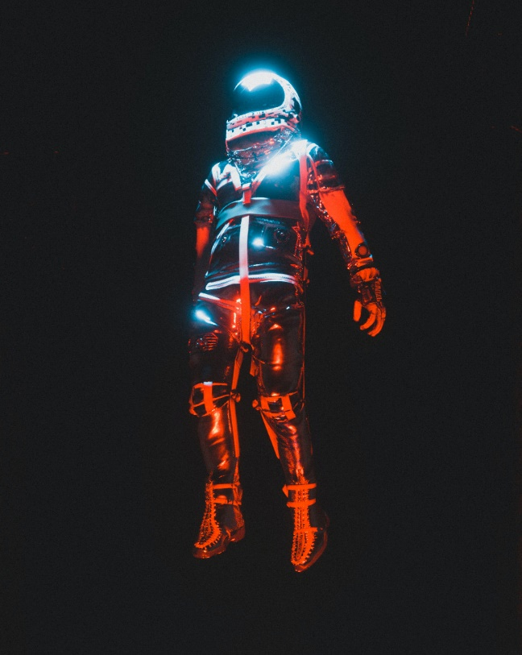

Photo by [Cash Macanaya](https://unsplash.com/@graphics_cash?utm_source=unsplash&utm_medium=referral&utm_content=creditCopyText) on [Unsplash](https://unsplash.com/s/photos/sci-fi?utm_source=unsplash&utm_medium=referral&utm_content=creditCopyText)

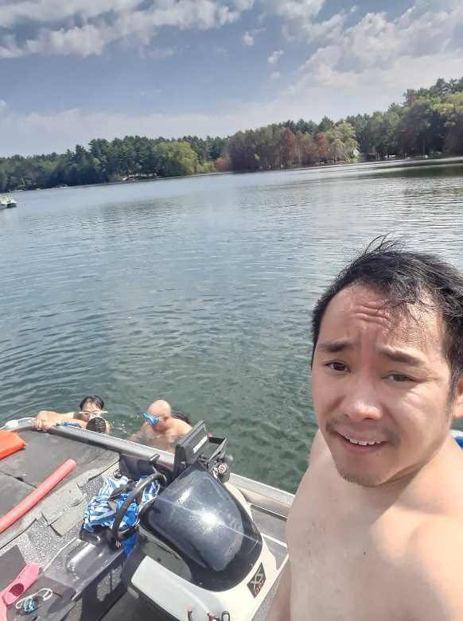

1. Playing the electric guitar is one of my favorite hobbies because it allows me to clear my mind. I become completely focus on the music that I love. It distracts me from my everyday worries. Music brings joy to my life.
2. Movies are another hobby that I enjoy. I like to watch sci-fi movies. My reason for this is because it allows the creators to do anything they want. Sci-fi movies can break any barrier that we currently understand here on Earth.
3. Swimming is another one of my favorite hobby which I do not get enough of. I do not have my own pool or live near a body of water. I can only swim when the opportunity presents itself. Although I am not the strongest swimmer, I can hold my own for a time if left in the middle of the ocean.
   * **Experience div**
     + **3 columns representing your work experience/personal interests**
       - **Use CSS cards (refer to what we used in the Build a Web page exercises)**
       - **Each card must include a brief description of what the card represents**
       - **This section will be for your personal work experience. If you are not working or have never worked, you can use potential children, parents, personal accomplishments, or personal embellishments.**



Photo by [Levi Meir Clancy](https://unsplash.com/@levimeirclancy?utm_source=unsplash&utm_medium=referral&utm_content=creditCopyText) on [Unsplash](https://unsplash.com/s/photos/marine-corps?utm_source=unsplash&utm_medium=referral&utm_content=creditCopyText)



Photo by [Fotis Fotopoulos](https://unsplash.com/@ffstop?utm_source=unsplash&utm_medium=referral&utm_content=creditCopyText) on [Unsplash](https://unsplash.com/s/photos/developer?utm_source=unsplash&utm_medium=referral&utm_content=creditCopyText)

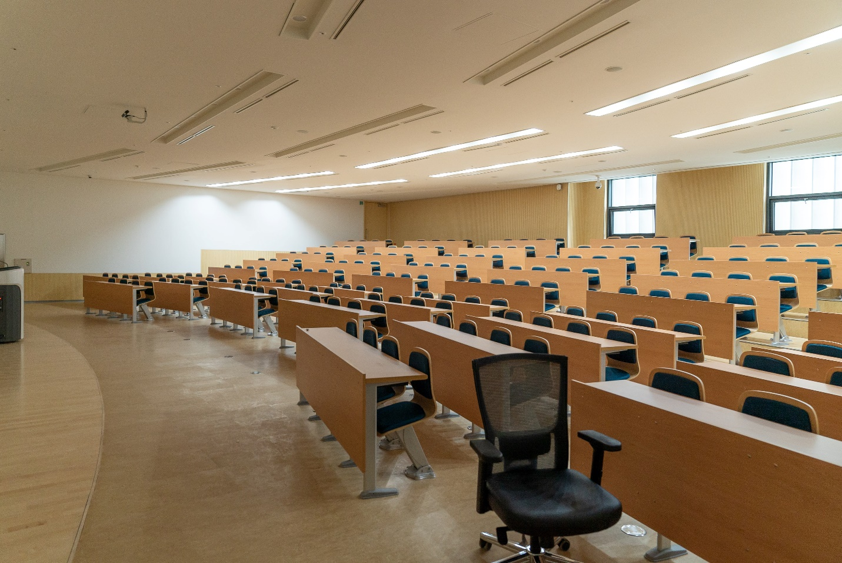

Photo by [Changbok Ko](https://unsplash.com/@kochangbok?utm_source=unsplash&utm_medium=referral&utm_content=creditCopyText) on [Unsplash](https://unsplash.com/s/photos/classroom?utm_source=unsplash&utm_medium=referral&utm_content=creditCopyText)

1. I served four years in the United States Marine Corps from 2009 to 2013. While in the service, my Military Occupation Specialist was Small Arms Repair/Technician (MOS 2111). I was deployed to Afghanistan in 2010 along with a second deployment in 2012 as part of Operation Enduring Freedom.
2. I got my associates degree in Software Developer in the fall of 2019 from my local technical college. This was the hardest part of my education as I knew little to nothing about computers. Towards the end of my second semester in the software developer program, something magically clicked in my head and I was able to understand everything I was doing. From then on, everything just went smoothly for me as I continued through the program.
3. Upon graduating with my associate’s degree, I was selected to become one of the teacher assistant at the college. As a teacher assistant, I helped students with their assignments and created learning materials.
   * **Contact div**
     + **Contact form with the following fields**
       - **First name**
       - **Last name**
       - **Email**
       - **Button with the text “Send Message”**

**Add a link to the starter code HTML file to your repositories index.html file**

**Hint: Refer back to assignment 4.2 if you are confused about what this item is referencing.**

**Note: Most of the CSS that you will need in this assignment has been created in previous “Build a Web Page” exercises. The easiest way to complete this assignment is to go through the code you wrote in the “Build a Web Page” exercises and reuse the CSS styles. As always, if you get stuck, the course's GitHub repository has a starter solution. But, you cannot just copy and paste the solution. You will need to personalize it with your information!**