Building a Web Page Exercise, Part 1

* Create a new directory under csd-340’s repository and name it module-2

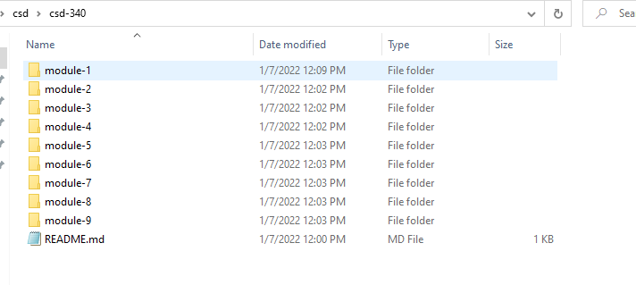

* Create a new HTML document in Visual Studio Code and name it <yourLastName_EX1>.html and place it under the module-2 directory

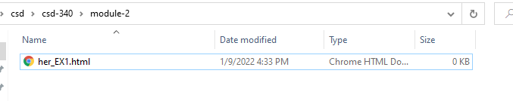

* Using the below starter code, create a basic HTML page and add the code to your <yourLastName_EX1>.html document

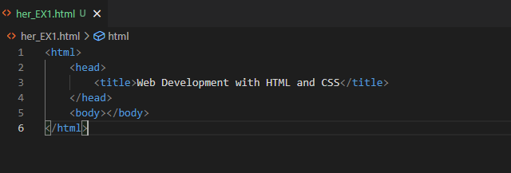

* Visit the World Wide Web Consortium (W3C) website and validate the markup you wrote using their HTML validator
* Hint: select the “Validate by Direct Input” link and paste the markup you wrote into the “Validate by direct input” field
* Take a screenshot of the validators results (there should be one or more errors)
* Correct the identified errors

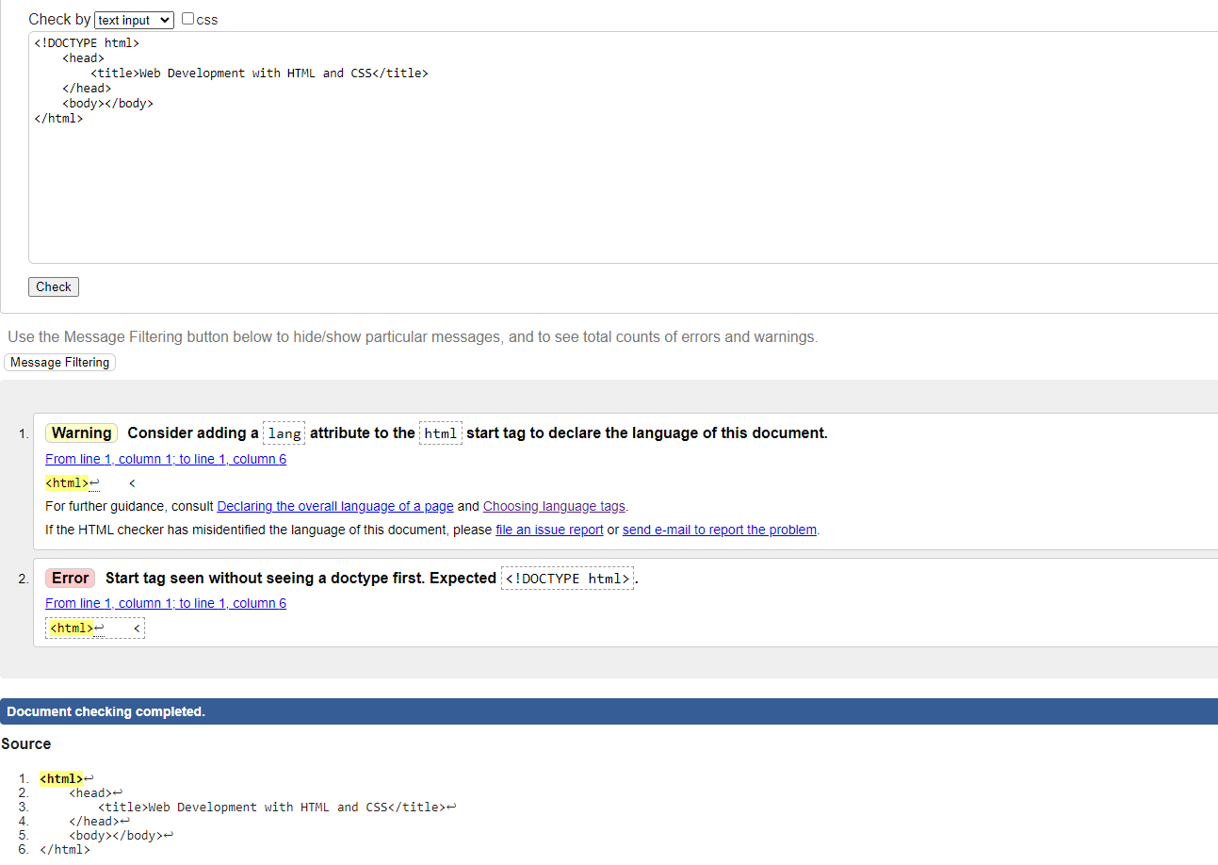

* Re-validate the HTML code

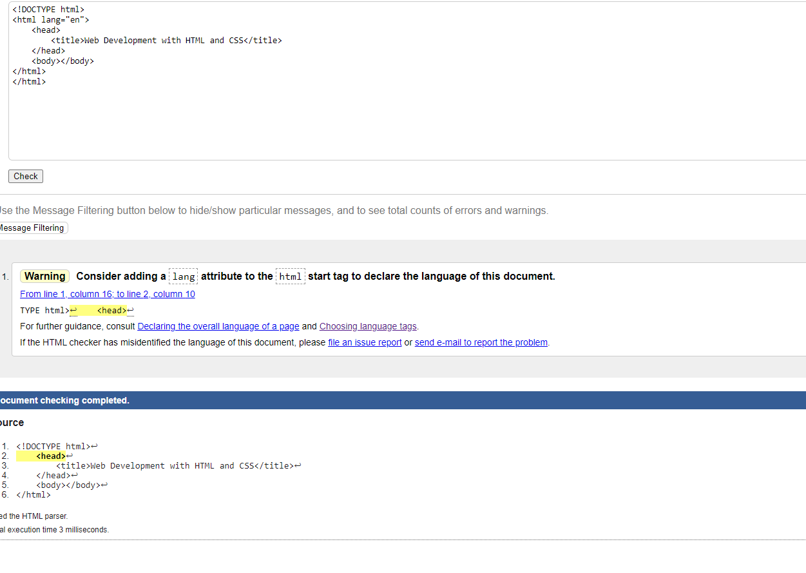

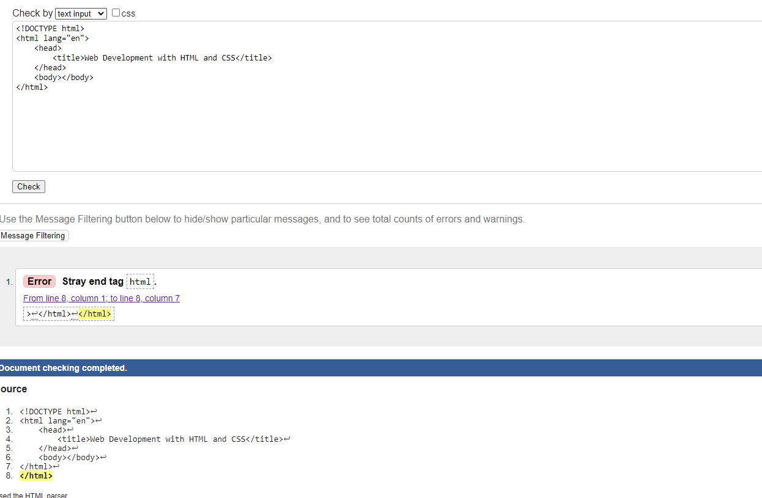

* Hint: select the “Validate by Direct Input” link and paste the markup you updated into the “Validate by direct input” field
* Take a screenshot of the updated results (this time, there should be 0 errors)

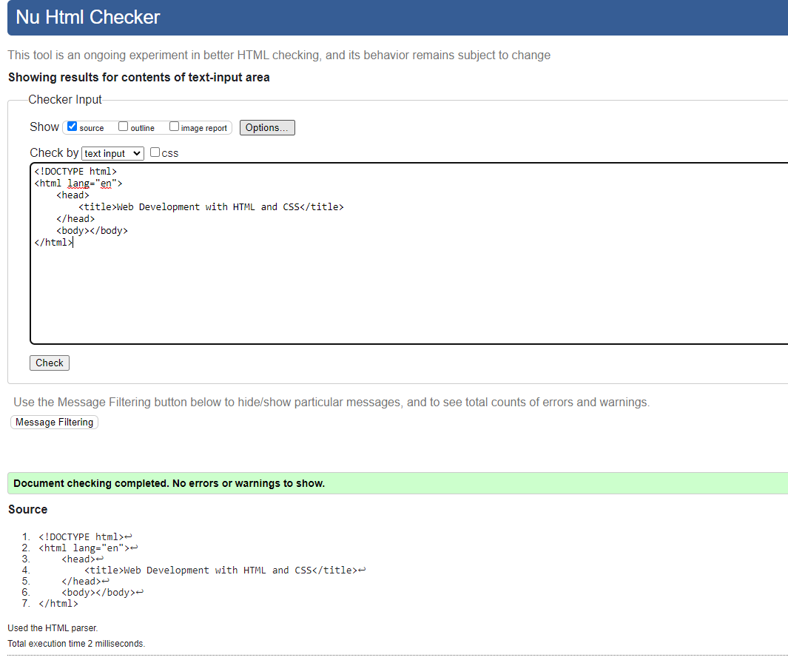

* Add a single h1 element underneath the body element with the following text: “Assignment 2.2 – Building a Web Page Exercise, Part 1”

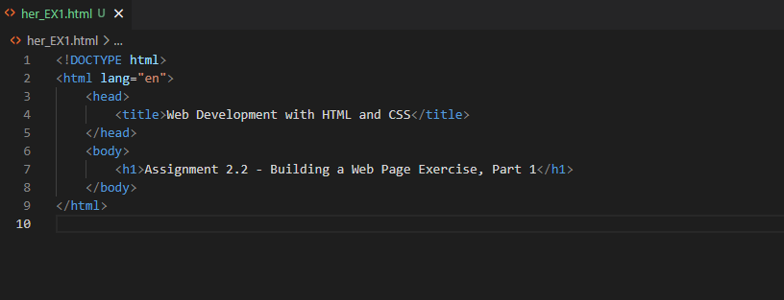

* Update the documents title to “CSD 340 Web Development with HTML and CSS’

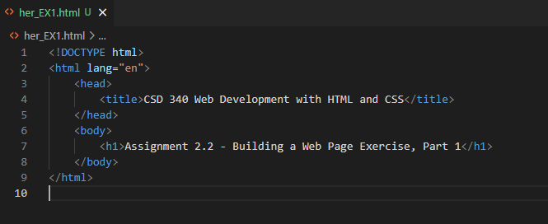

* Hint: update the text in the <title> element of the page <head>
* Re-validate the HTML code
* Take a screenshot of the updated results (this time, there should be 0 errors)

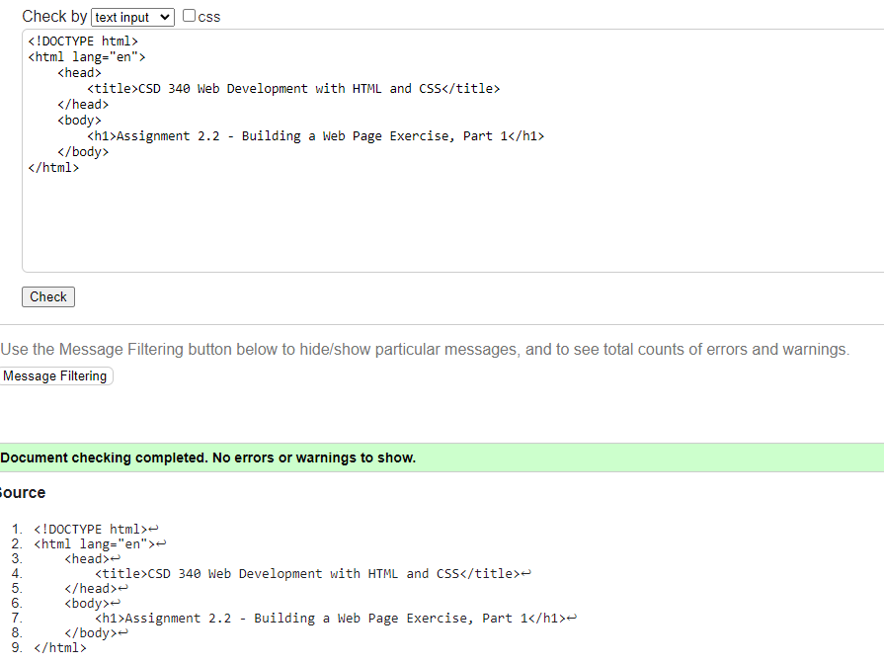

* Open the file in your computer's default browser and take a screenshot of the web page

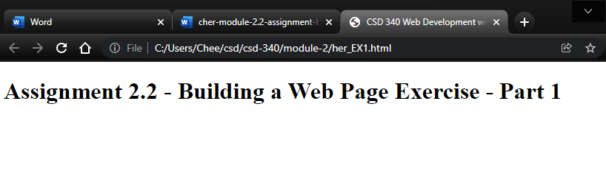

* Combine all images into a single word document and include your name, date, and assignment number. Name the file <yourLastName>-<assignmentName>.docx