COMP 3005:
Seydi Cheikh Wade
101323727
Project Report:
Health and Fitness Club Management System
Group Size (Solo)

Table of contents
1. System Scope and Functional Requirements: 3
1.1. System Overview: 3
1.2. Implemented Functions by Role (This Project): 3
2. Conceptual Database Design (ER Model): 5
3. Mapping ER to Relational Schema: 6
4. Schema Quality and Normalization: 7

- System Scope and Functional Requirements:
  - System Overview:
- The Health and Fitness Club Management System is a centralized, database-driven application that supports the day-to-day operations of a modern fitness center. The club offers both individual personal training sessions and group fitness classes, and the system is responsible for coordinating schedules, enforcing room capacities, and managing trainer assignments in a consistent way.
- The application is built on top of a relational database (PostgreSQL), which stores all persistent data related to members, trainers, rooms, equipment, sessions, and other operational records. The design emphasizes normalization, data integrity, and enforcement of business rules such as preventing double-booking of rooms or trainers and retaining a historical record of health metrics and other operational events..
- The system distinguishes three main user roles with different access privileges:
- Members, who manage personal information, fitness goals, health metrics, and bookings.
- Trainers, who manage their availability and review relevant member data to prepare for sessions.
- Administrative staff, who coordinate room allocation and equipment maintenance, and (in the full specification) oversee class schedules and billing activities.
- This solo implementation focuses on a core subset of these capabilities that still reflects a realistic club workflow and provides enough complexity to demonstrate solid database design and ER modeling.
  - Implemented Functions by Role (This Project):
Table 1 summarizes the concrete operations that will be implemented in the application and, therefore, must be supported by the ER model and relational schema.

Table 1: Implemented Functional Requirements
Role | Requirement ID | Operation name | Description
Member | M1 | User Registration | Create a new member with unique email and basic profile info.
Member | M2 | Profile Management | Update personal details, fitness goals (e.g., weight target), and input new  health metrics (e.g., weight, heart rate).
Member | M3 | Health History | Log multiple metric entries; do not overwrite. Must support time-stamped  entries.
Member | M4 | PT Session Scheduling | Book or reschedule training with a trainer, validating availability and  room conflicts.
Trainer | T1 | Set Availability | Define time windows when available for sessions or classes. Prevent overlap.
Trainer | T2 | Schedule View | See assigned PT sessions and classes.
Admin | A1 | Room Booking Management | Assign rooms for sessions or classes. Prevent double-booking
Admin | A2 | Equipment Maintenance | Log issues, track repair status, associate with room/equipment

These eight operations form the implemented subset for this solo project; other features from the full problem statement (e.g., detailed dashboards, full group class lifecycle, and billing) are considered out of scope.

- Conceptual Database Design (ER Model):

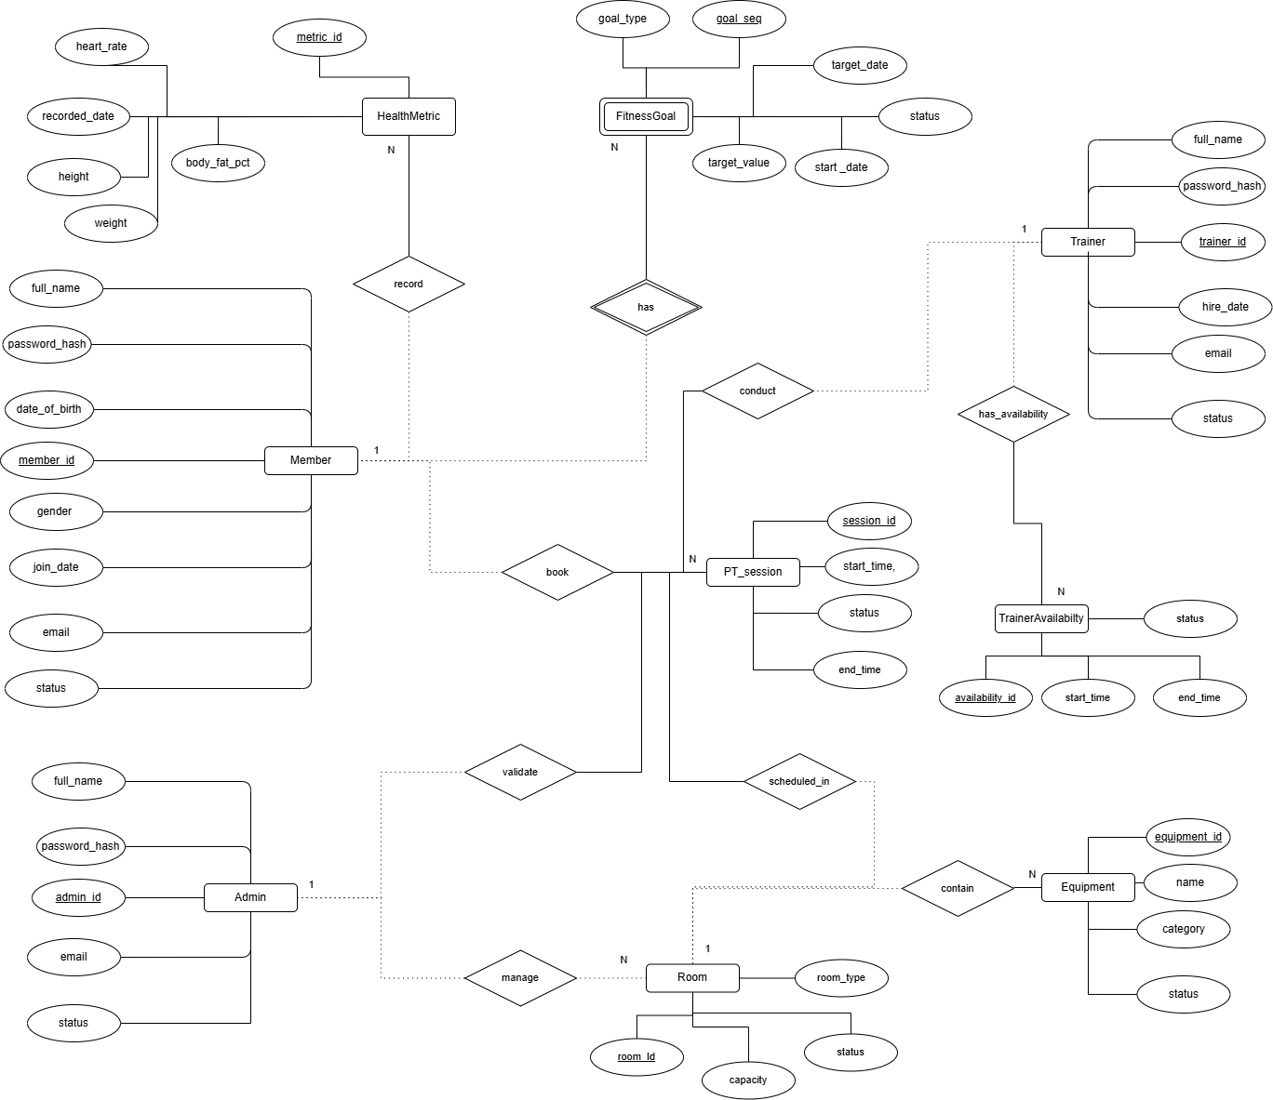
- Mapping ER to Relational Schema:
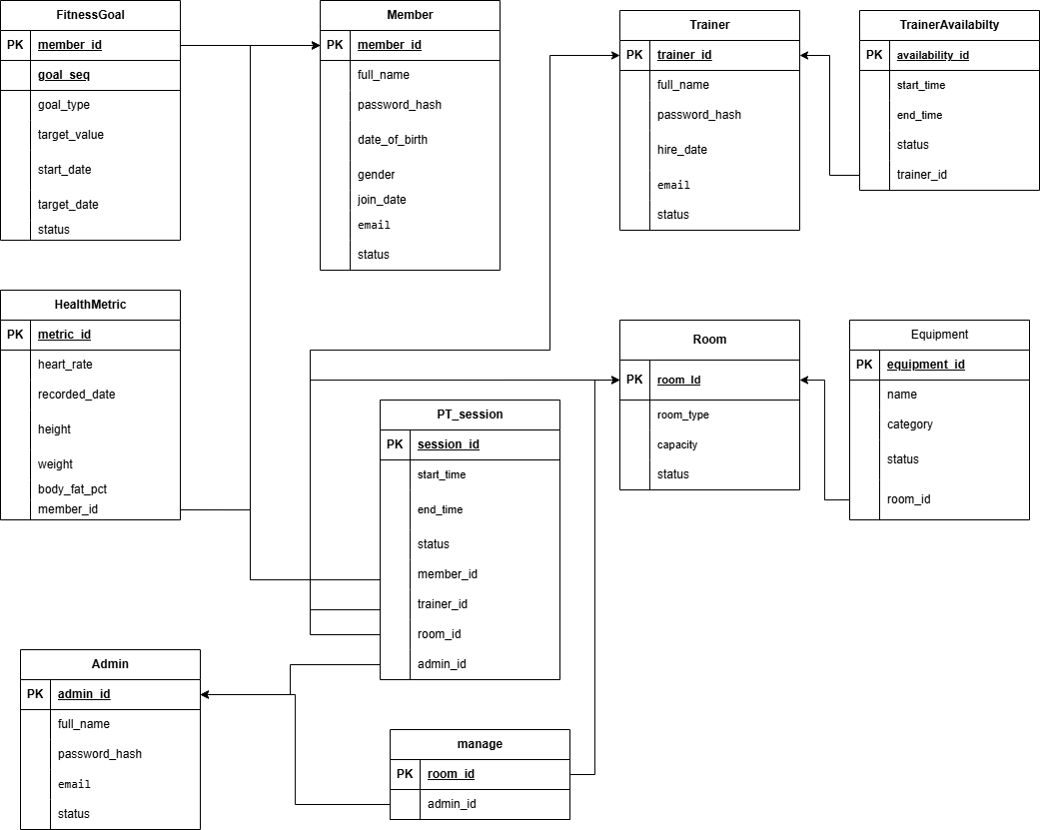

- Schema Quality and Normalization:
All relations in the schema were derived from the ER model using the standard ER-to-relational mapping rules. As a result, the tables are already in 3rd Normal Form (3NF) and in most cases also satisfy BCNF.
- 1NF: Every attribute stores atomic values only. Repeating information (fitness goals, health metrics, trainer availability slots, equipment items, PT sessions) is stored in separate tables (FITNESS_GOAL, HEALTH_METRIC, TRAINER_AVAILABILITY, EQUIPMENT, PT_SESSION), so there are no multivalued attributes.
- 2NF: The only relation with a composite key is FITNESS_GOAL(member_id, goal_seq). All non-key attributes (goal_type, target_value, start_date, target_date, status) depend on the whole key (member_id, goal_seq), not on just one component. The other relations have single-attribute primary keys, so 2NF holds trivially.
- 3NF: In every relation, non-key attributes depend directly on the key and not on other non-key attributes. For example, in PT_SESSION(session_id, member_id, trainer_id, room_id, admin_id, start_time, end_time, status) all attributes describe the session identified by session_id; there are no dependencies such as room_id → status or category → status in EQUIPMENT. Similarly, MEMBER, TRAINER, ADMIN, HEALTH_METRIC, TRAINER_AVAILABILITY, ROOM, and MANAGE have a single key and no non-key→non-key functional dependencies.
Because there are no partial or transitive dependencies in any table, no further decomposition is required. The schema therefore avoids unnecessary redundancy and helps prevent update, insertion, and deletion anomalies.

