For this task, we are keeping our models mostly the same, the only difference is that we are adding the “pic” attribute to the recipes model. This will allow us to upload and store images of our recipes for a better user experience and visuals for the app.

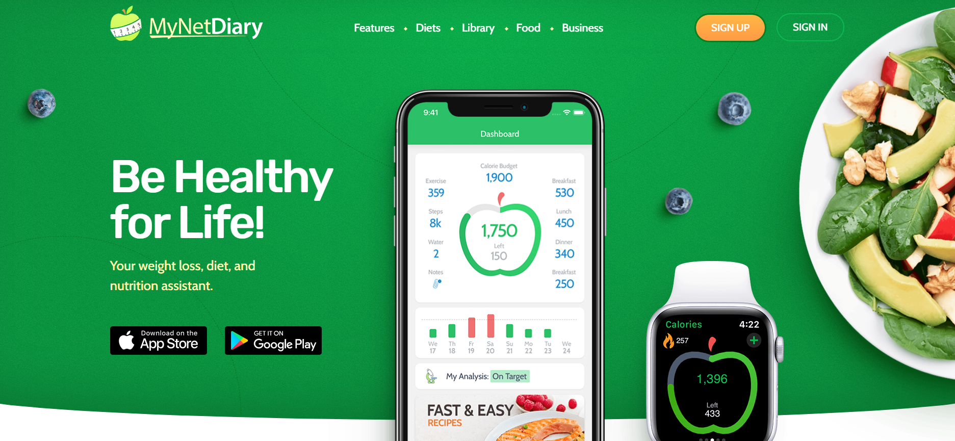
This is probably my favorite recipe app. The UI is simple and not doing too much and the functionality of the app to track calories and macros is unmatched. 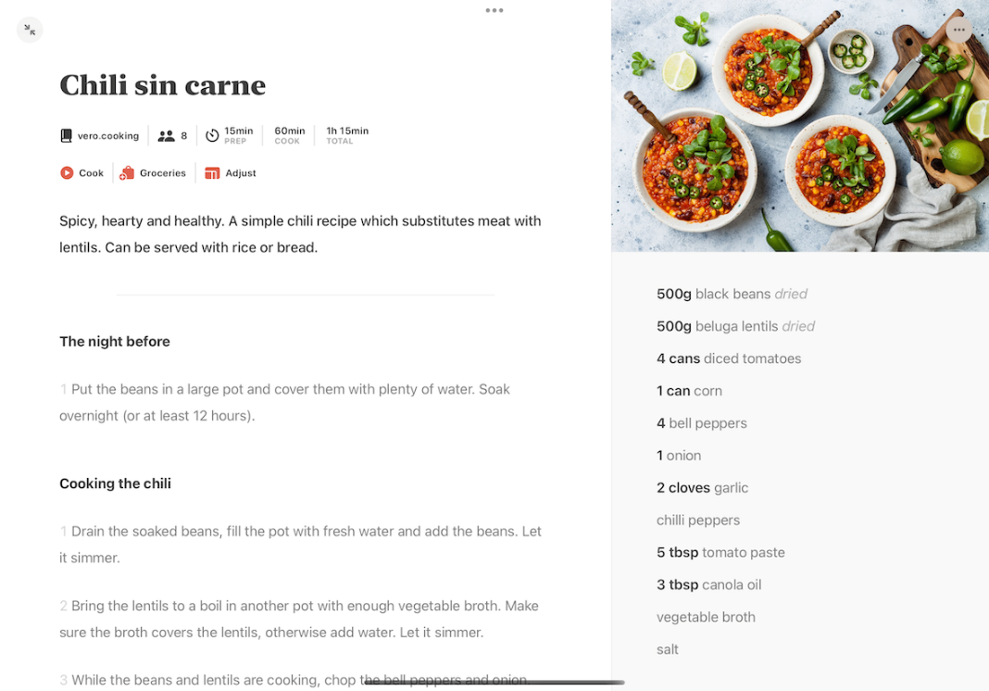
This one, called Mela has a nice UI that shows an image on the side as well as all the recipes listed at a glance. In addition, the “night before” section is a nice touch as it could highlight any additional prep that will go into the recipe.

