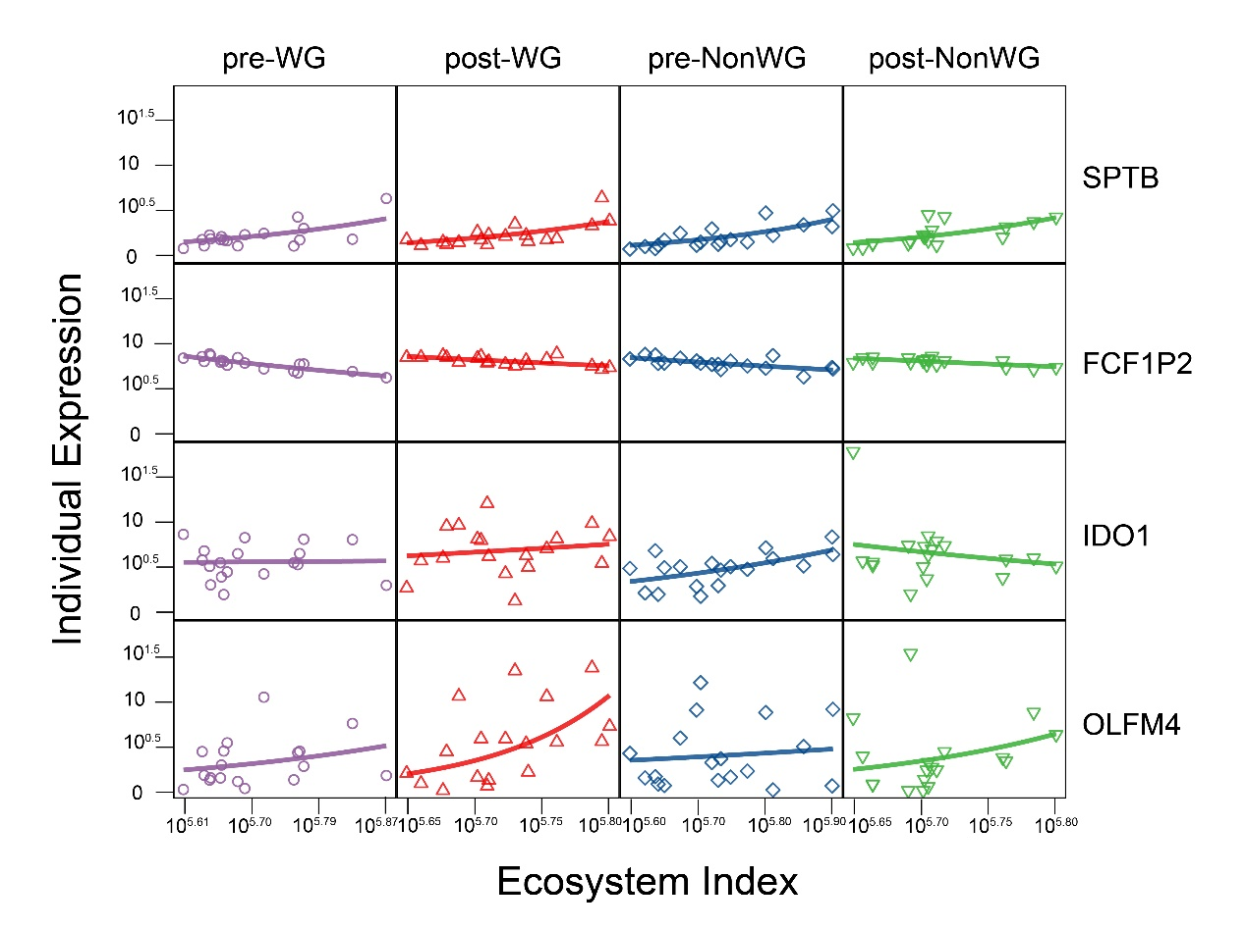

**Figure S1** The power fitting of expression of four representative genes against ecosystem index per- and post-intervention for weight gain group and wn weight gain group.

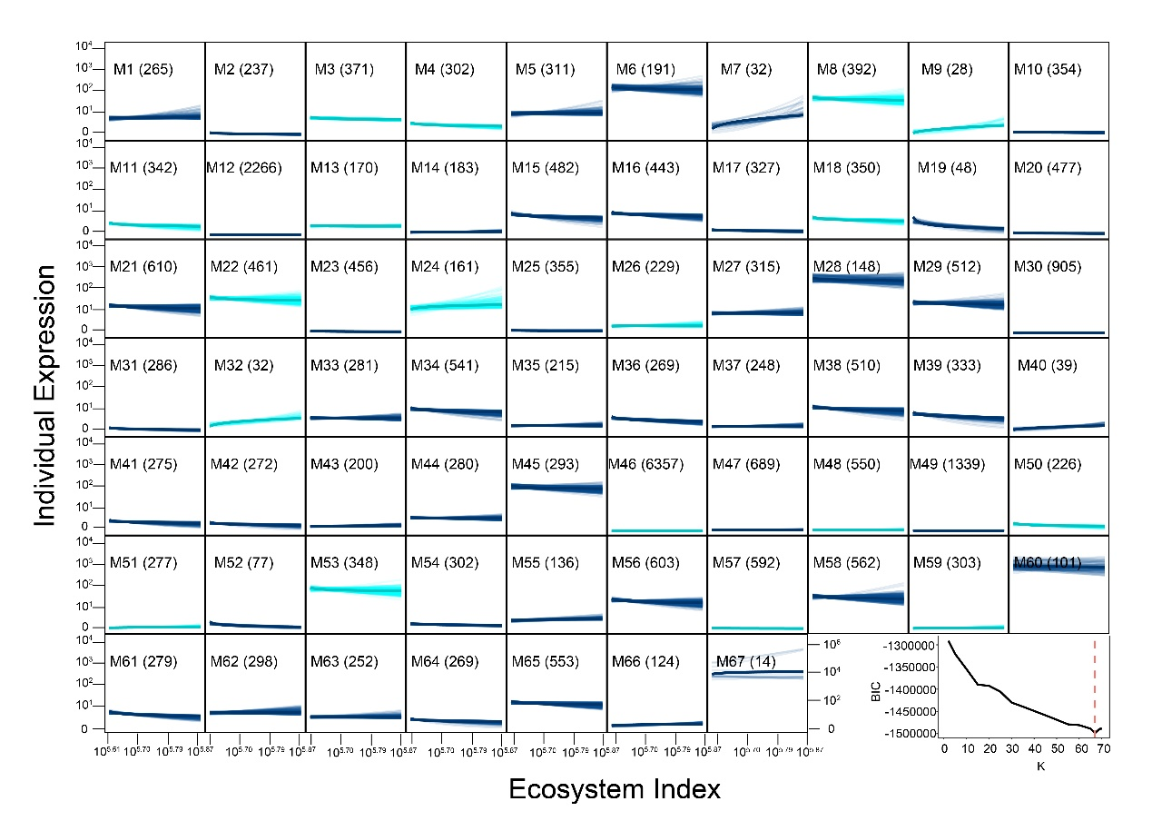

**Figure S2** Functional clustering of all genes into 61 modules M1-M61 based on their similarity of expression trajectories as a function of ecosystem index for the no weight gain group. Numbers in parentheses are the number of genes from each module. The optimal number of modules is determined from the BIC curve.

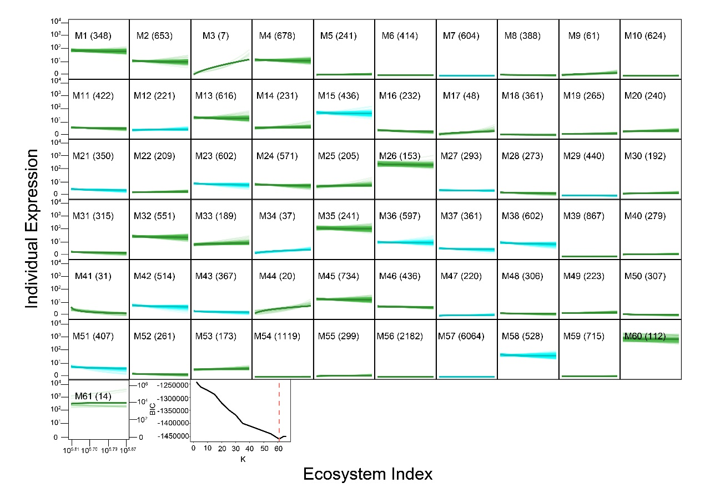

**Figure S3** Functional clustering of all genes into 67 modules M1-M67 based on their similarity of expression trajectories as a function of ecosystem index for the weight gain group. Numbers in parentheses are the number of genes from each module. The optimal number of modules is determined from the BIC curve.