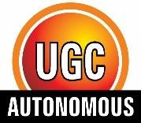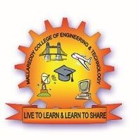

MALLA REDDY COLLEGE OF ENGINEERING & TECHNOLOGY
(Autonomous Institution – UGC, Govt. of India)
Sponsored by CMR Educational Society
(Affiliated to JNTU, Hyderabad, Approved by AICTE - Accredited by NBA & NAAC – ‘A’ Grade - ISO 9001:2015 Certified)
Maisammaguda, Dhulapally (Post Via Hakimpet), Secunderabad – 500100, Telangana State, India.
Contact Number: 040-23792146/64634237, E-Mail ID: mrcet2004@gmail.com, website: www.mrcet.ac.in
DATE : -02-2026
IV-YEAR II SEMESTER AY: 2025 -2026
PROJECT PHASE-II
[R22 REGULATION]
BABY CARE MANAGEMENT SYSTEM
ABSTRACT
The Baby Care Management System is a web-based full-stack application that enables parents to securely manage and monitor a child’s health, development, learning activities, and digital exposure from birth. The system centralizes medical records, vaccination schedules, prescriptions, growth metrics, and daily activities to prevent missed healthcare events and data loss. Parents can upload hospital documents and track progress, while doctors and support staff access reports through role-based logins. It also provides parental controls such as age-based media access and screen-time limits, along with learning assessment through timetable planning and knowledge scoring across domains like language, mathematics, creativity, behavior, and motor skills. Analytical dashboards and automated notifications inform parents about vaccinations and development progress. Overall, the system improves healthcare awareness, supports structured child development, and promotes safe digital usage within a single integrated platform.
Keywords: Child Monitoring, Health Records, Screen-Time Control, Growth Tracking, Family Dashboard, Development Analytics

TEAM DETAILS
S.NO | BATCH / YEAR / SECTION | ROLL NUMBERS | NAME(S)
1 | A-16  IV CSE-A | 22N31A0540 | CH.SHIVARAMAKRISHNA
2 |  | 22N31A0508 | A.SUMANTH
3 |  | 22N31A0563 | G.RAKESH
4
VERIFIED BY |  | FACULTY | SIGNATURE
1 | Guide | MS.N.BARATHI
2 | Class I/C | MS.N.BARATHI
3 | Project Coordinator | MR.P.A.HIMAKIRAN

PROJECT INCHARGE HOD CSE
Mr.P.A.HIMA KIRAN DR.G.RAVI

