7447
Here we are usind 7474 ic to increment the number

pin diagrame of 7474 ic:

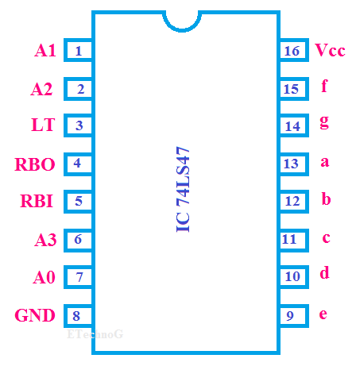

Connections:

7447 | a | b | c | d | e | f | g
sevenseg | a | b | c | d | e | f | g

7447 | A0 | A1 | A2 | A3 | GND | Vcc
Arduino | 2 | 3 | 4 | 5 | GND | 5v

Code:

int Z=0,Y=0,X=1,W=1;
int D,C,B,A;

//Code released under GNU GPL. Free to use for anything.
void disp_7447(int D, int C, int B, int A)
{
digitalWrite(2, A); //LSB
digitalWrite(3, B);
digitalWrite(4, C);
digitalWrite(5, D); //MSB

}
// the setup function runs once when you press reset or power the board
void setup() {
pinMode(2, OUTPUT);
pinMode(3, OUTPUT);
pinMode(4, OUTPUT);
pinMode(5, OUTPUT);
}

// the loop function runs over and over again forever
void loop() {
A=(!W&&!X&&!Y&&!Z) || (!W&&X&&!Y&&!Z) || (!W&&!X&&Y&&!Z) || (!W&&X&&Y&&!Z) ||(!W&&!X&&!Y&&Z);
B=(W&&!X&&!Y&&!Z) || (!W&&X&&!Y&&!Z) || (W&&!X&&Y&&!Z) || (!W&&X&&Y&&!Z);
C=(W&&X&&!Y&&!Z) || (!W&&!X&&Y&&!Z) || (W&&!X&&Y&&!Z) || (!W&&X&&Y&&!Z);
D = (W&&X&&Y&&!Z)||(!W&&!X&&!Y&&Z);

disp_7447(D,C,B,A);
}

Truth Table:

Z | Y | X | W | D | C | B | A
0 | 0 | 0 | 0 | 0 | 0 | 0 | 1
0 | 0 | 0 | 1 | 0 | 0 | 1 | 0
0 | 0 | 1 | 0 | 0 | 0 | 1 | 1
0 | 0 | 1 | 1 | 0 | 1 | 0 | 0
0 | 1 | 0 | 0 | 0 | 1 | 0 | 1
0 | 1 | 0 | 1 | 0 | 1 | 1 | 0
0 | 1 | 1 | 0 | 0 | 1 | 1 | 1
0 | 1 | 1 | 1 | 1 | 0 | 0 | 0
1 | 0 | 0 | 0 | 1 | 0 | 0 | 1

Output:
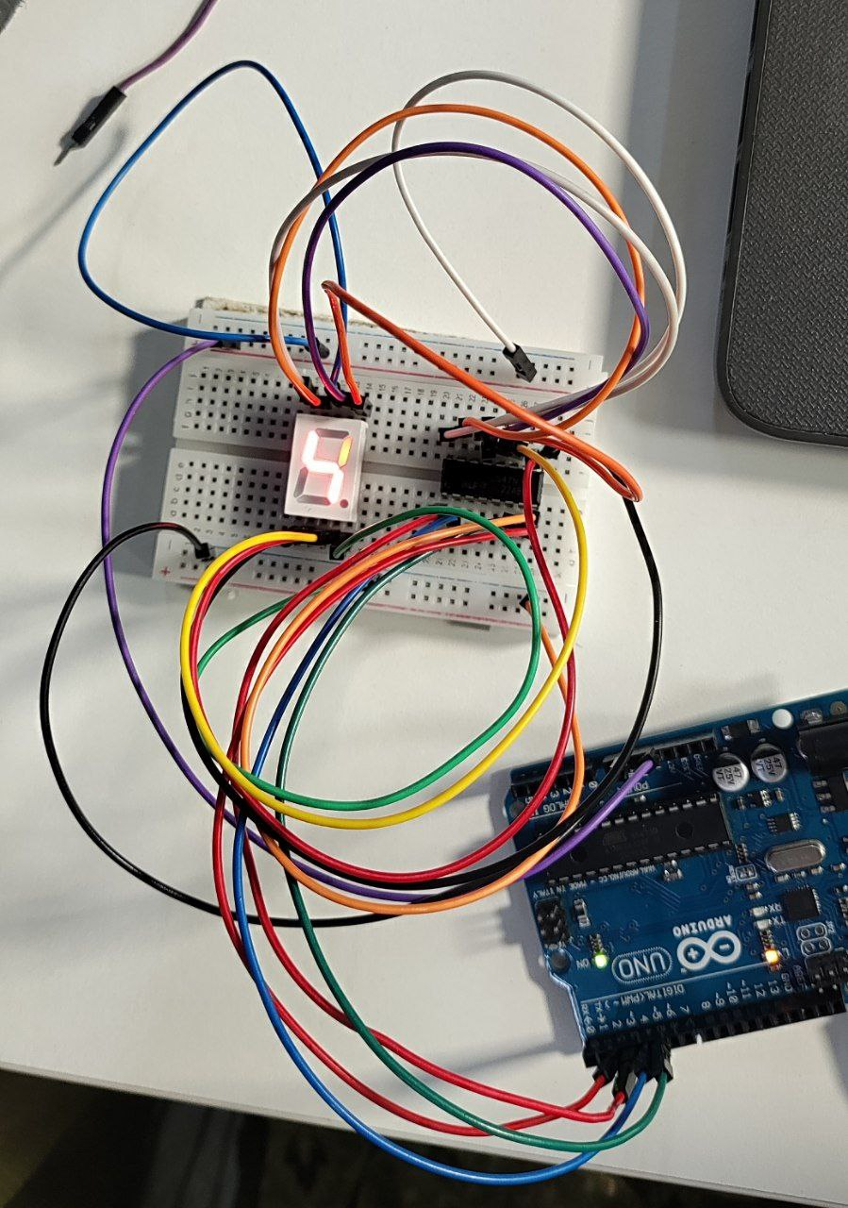

Q.Now write a program where
(a) the binary inputs are given by connecting to 0 and 1 on the breadboard
(b) incremented by 1 using Table and
(c) the incremented value is displayed on the seven segment display.

Code:
//Declaring all variables as integers
int Z,Y,X,W;
int D,C,B,A;

//Code released under GNU GPL. Free to use for anything.
void disp_7447(int D, int C, int B, int A)
{
digitalWrite(2, A); //LSB
digitalWrite(3, B);
digitalWrite(4, C);
digitalWrite(5, D); //MSB

}
// the setup function runs once when you press reset or power the board
void setup() {
pinMode(2, OUTPUT);
pinMode(3, OUTPUT);
pinMode(4, OUTPUT);
pinMode(5, OUTPUT);
pinMode(6, INPUT);
pinMode(7, INPUT);
pinMode(8, INPUT);
pinMode(9, INPUT);
}

// the loop function runs over and over again forever
void loop() {
W = digitalRead(6);
X = digitalRead(7);
Y = digitalRead(8);
Z = digitalRead(9);
A=(!W&&!X&&!Y&&!Z) || (!W&&X&&!Y&&!Z) || (!W&&!X&&Y&&!Z) || (!W&&X&&Y&&!Z) ||(!W&&!X&&!Y&&Z);
B=(W&&!X&&!Y&&!Z) || (!W&&X&&!Y&&!Z) || (W&&!X&&Y&&!Z) || (!W&&X&&Y&&!Z);
C=(W&&X&&!Y&&!Z) || (!W&&!X&&Y&&!Z) || (W&&!X&&Y&&!Z) || (!W&&X&&Y&&!Z);
D = (W&&X&&Y&&!Z)||(!W&&!X&&!Y&&Z);

disp_7447(D,C,B,A);
}

note:Here inputs are changing manually

