7474

DECADE COUNTER

7474 IC Pin diagrame:

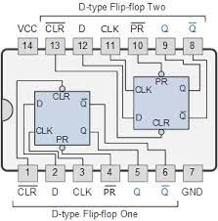

7447:
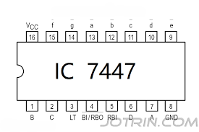

Connections:

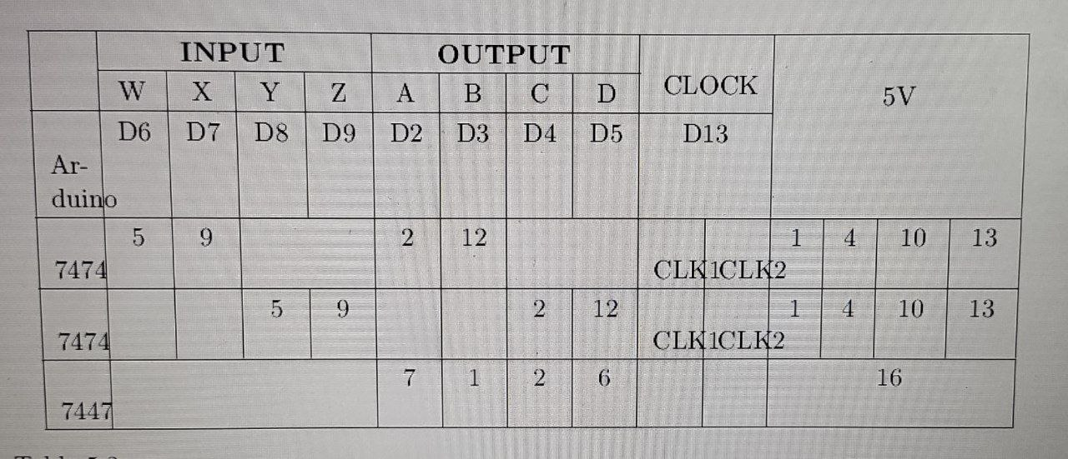

Code:

#include <Arduino.h>

int W,X,Y,Z;
int D,C,B,A;

void disp_7447(int D,int C,int B, int A)
{
digitalWrite(2, A); //LSB
digitalWrite(3, B);
digitalWrite(4, C);
digitalWrite(5, D); //MSB
}

void setup() {

pinMode(2, OUTPUT);
pinMode(3, OUTPUT);
pinMode(4, OUTPUT);
pinMode(5, OUTPUT);
pinMode(6, INPUT);
pinMode(7, INPUT);
pinMode(8, INPUT);
pinMode(9, INPUT);
pinMode(13, OUTPUT);

}

void loop() {

digitalWrite(13, HIGH);
delay(2000);

disp_7447(D,C,B,A);

W = digitalRead(6);
X = digitalRead(7);
Y = digitalRead(8);
Z = digitalRead(9);

A = (!W);
B = (!W&&!X&&Y) || (W&&X) || (!W&&Z);
C = (!W&&Z) || (X&&Y) || (W&&Y);
D = (!W&&!X&&!Y&&!Z)||(W&&Z);
delay(500);

W = A;
X = B;
Y = C;
Z = D;

digitalWrite(13, LOW);
delay(1000);
}

Output:

Incrementing counter from 0 to 9 in seven segment

Whats the processes going on???

