KMAPS
A Karnaugh map (K-map) is a pictorial method used to minimize Boolean expressions without having to use Boolean algebra theorems and equation manipulations.

Increment Decoder:

Without using Don’t cares

Z | Y | X | W | D | C | B | A
0 | 0 | 0 | 0 | 0 | 0 | 0 | 1
0 | 0 | 0 | 1 | 0 | 0 | 1 | 0
0 | 0 | 1 | 0 | 0 | 0 | 1 | 1
0 | 0 | 1 | 1 | 0 | 1 | 0 | 0
0 | 1 | 0 | 0 | 0 | 1 | 0 | 1
0 | 1 | 0 | 1 | 0 | 1 | 1 | 0
0 | 1 | 1 | 0 | 0 | 1 | 1 | 1
0 | 1 | 1 | 1 | 1 | 0 | 0 | 0
1 | 0 | 0 | 0 | 1 | 0 | 0 | 1

Expressions:

A = !W!X!Y!Z + !WX!Y!Z + !W!XY!Z + !WXY!Z + !W!X!YZ

B = W!X!Y!Z + !WX!Y!Z + W!XY!Z + !WXY!Z

C = WX!Y!Z + !W!XY!Z + W!XY!Z + !WXY!Z

D = WXY!Z + W!X!Y!Z

for A:
yz
wx 00 01 11 10
1 | 1 |  | 1
1 | 1 |  | 1

A = !W!Y + !WY!Z

for B:
yz
wx 00 01 11 10
1 |  |  | 1
1 |  |  | 1

B = !WX!Z + W!X!Z

for C:
yz
wx 00 01 11 10
1
1
1
1
1

C = WX!Y!Z + !XY!Z + !WY!Z

For D:

yz
wx 00 01 11 10
1
1

D = WXY!Z + !W!X!YZ

Code:

//Declaring all variables as integers
int Z=0,Y=0,X=1,W=1; // int Z,Y,X,W
int D,C,B,A;

//Code released under GNU GPL. Free to use for anything.
void disp_7447(int D, int C, int B, int A)
{
digitalWrite(2, A); //LSB
digitalWrite(3, B);
digitalWrite(4, C);
digitalWrite(5, D); //MSB

}
// the setup function runs once when you press reset or power the board
void setup() {
pinMode(2, OUTPUT);
pinMode(3, OUTPUT);
pinMode(4, OUTPUT);
pinMode(5, OUTPUT);
//pinMode(6,OUTPUT);
//pinMode(7,OUTPUT);
//pinMode(8,OUTPUT);
//pinMode(9,OUTPUT);
}

// the loop function runs over and over again forever
void loop() {
//W = digitalWrite(6);
//X = digitalWrite(7);
//Y = digitalWrite(8);
//Z = digitalWrite(9);
A=(!W&&!Y || !W&&Y&&!Z);
B=(!W&&X&&!Z || W&&!X&&!Z);
C=(W&&X&&!Y&&!Z || !X&&Y&&!Z || !W&&Y&&!Z);
D=(W&&X&&Y&&!Z || !W&&!X&&!Y&&Z);

disp_7447(D,C,B,A);
}

OUTPUT:

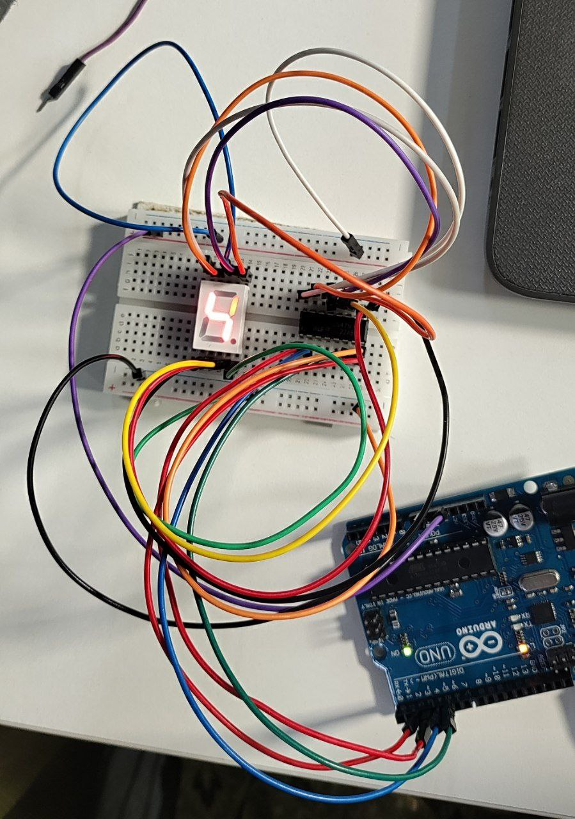
With Don’t care Conditions:

Z | Y | X | W | D | C | B | A
0 | 0 | 0 | 0 | 0 | 0 | 0 | 1
0 | 0 | 0 | 1 | 0 | 0 | 1 | 0
0 | 0 | 1 | 0 | 0 | 0 | 1 | 1
0 | 0 | 1 | 1 | 0 | 1 | 0 | 0
0 | 1 | 0 | 0 | 0 | 1 | 0 | 1
0 | 1 | 0 | 1 | 0 | 1 | 1 | 0
0 | 1 | 1 | 0 | 0 | 1 | 1 | 1
0 | 1 | 1 | 1 | 1 | 0 | 0 | 0
1 | 0 | 0 | 0 | 1 | 0 | 0 | 1
1 | 0 | 0 | 1 | x | x | x | x
1 | 0 | 1 | 0 | x | x | x | x
1 | 0 | 1 | 1 | x | x | x | x
1 | 1 | 0 | 0 | x | x | x | x
1 | 1 | 0 | 1 | x | x | x | x
1 | 1 | 1 | 0 | x | x | x | x
1 | 1 | 1 | 1 | x | x | x | x

for A:
yz
wx 00 01 11 10
1 | 1 | X | 1
1 | 1 | X | 1
 | X | X
 | X | X

A = !W

for B:
yz
wx 00 01 11 10
 |  | X
1 |  | X | 1
 | X | X
1 | X | X | 1

B = !WX!Z + W!X

for C:
yz
wx 00 01 11 10
1
 |  | X | 1
 |  | X | 1
1 | X | X
 | X | X | 1

C = WX!Y!Z + !XY + !WY

For D:

yz
wx 00 01 11 10
 | 1 | X
 |  | X
 | X | X | 1
 | X | X

D = WXY+ !XZ

code:

//Declaring all variables as integers
int Z=0,Y=0,X=0,W=0; // int Z,Y,X,W
int D,C,B,A;

//Code released under GNU GPL. Free to use for anything.
void disp_7447(int D, int C, int B, int A)
{
digitalWrite(2, A); //LSB
digitalWrite(3, B);
digitalWrite(4, C);
digitalWrite(5, D); //MSB

}
// the setup function runs once when you press reset or power the board
void setup() {
pinMode(2, OUTPUT);
pinMode(3, OUTPUT);
pinMode(4, OUTPUT);
pinMode(5, OUTPUT);
//pinMode(6,OUTPUT);
//pinMode(7,OUTPUT);
//pinMode(8,OUTPUT);
//pinMode(9,OUTPUT);
}

// the loop function runs over and over again forever
void loop() {
//W = digitalWrite(6);
//X = digitalWrite(7);
//Y = digitalWrite(8);
//Z = digitalWrite(9);
A=(!W);
B=(!W&&X&&!Z || W&&!X);
C=(W&&X&&!Y&&!Z || !X&&Y || !W&&Y);
D=(W&&X&&Y || !X&&Z);

disp_7447(D,C,B,A);
}

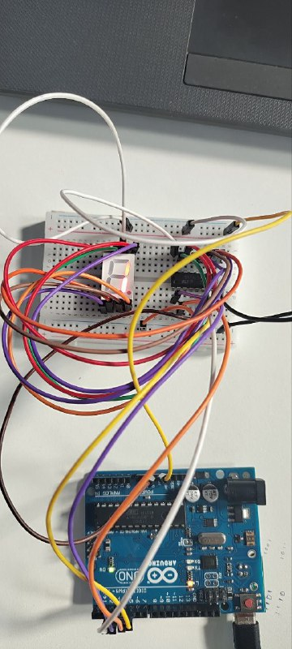
Output:

