SEVEN SEGMENT
PIN DIAGRAME:
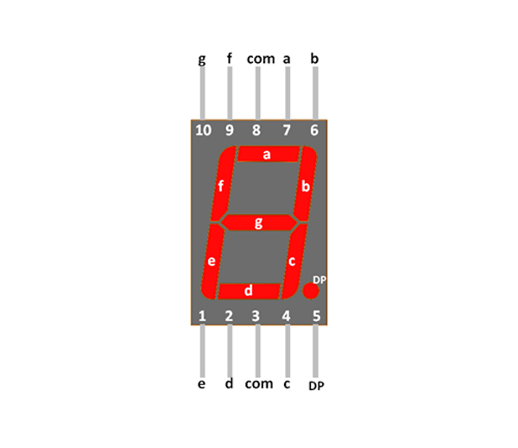

Connection:

Arduino | 2 | 3 | 4 | 5 | 6 | 7 | 8 | GND | 5V
Sevense | a | b | c | d | e | f | g | com | dot

Code:
void sevenseg(int a,int b,int c,int d,int e,int f,int g)
{
digitalWrite(2, a);
digitalWrite(3, b);
digitalWrite(4, c);
digitalWrite(5, d);
digitalWrite(6, e);
digitalWrite(7, f);
digitalWrite(8, g);
}
void setup()
{
pinMode(2, OUTPUT);
pinMode(3, OUTPUT);
pinMode(4, OUTPUT);
pinMode(5, OUTPUT);
pinMode(6, OUTPUT);
pinMode(7, OUTPUT);
pinMode(8, OUTPUT);
}
void loop()
{
sevenseg(1,0,0,1,1,1,1);
}

Note : 0 means led glow
1 means led offf

Output:
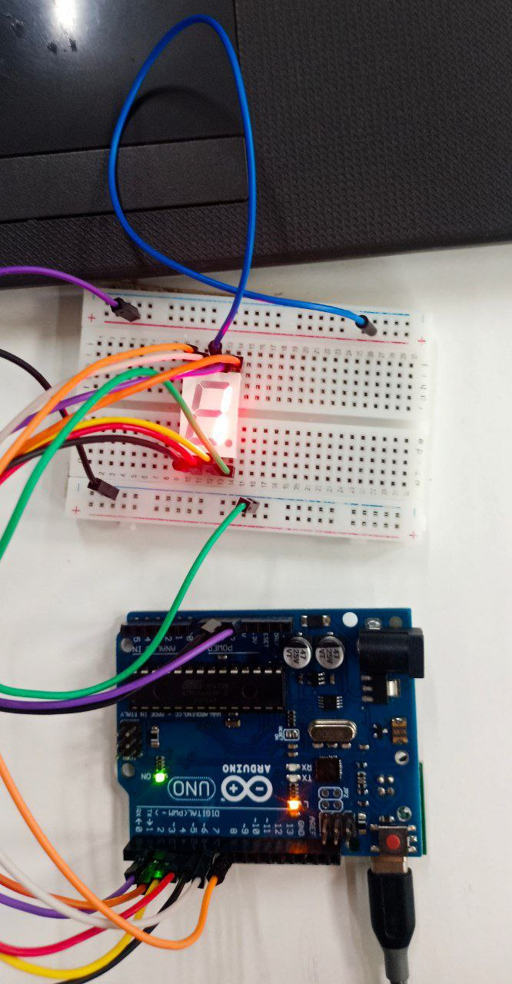

Compilation:
2 methods
1.directly copy the code and paste in Arduino droid then compile and upload
2.
- open termux
- enter proot-distro login debian
- git clone https://github.com/gadepall/fwc-1
- enter ranger(go to below path)
ide/sevenseg/codes(then shift+s)
- pio run(here hex file is generated)
- open arduinodroid app
Action<Upload<Upload precompiled>FWC<fwc-1<ide<sevenseg<codes<.pio<build<uno<firmware.hex

sevenseg(1,0,0,1,1,1,1); change this 1 and 0 according you get output

