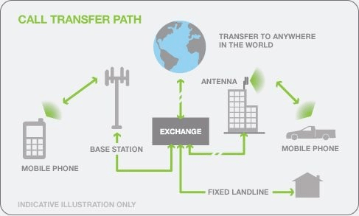

Cellular networks started with the launch of 1G in Tokyo in 1979. It used analog radios and wireless technology and was the first Radio Access Network (RAN).
The US built the first commercial cellular network in 1983. And with the launch of 2G GSM in Finland.
NTT Docomo commercialized 3G in 2001. There were two types of 3G: UMTS and CDMA2000; they made mobile internet access possible. T
The first cellular technology to use IP for all data packets, including voice, was 4G-LTE. It was launched in December 2009 in Oslo, Norway, and Stockholm.
5G technology started in late 2018 and is the most recent RAN technology.

What is the difference between O-RAN and GNB
- gNB (Next-Generation NodeB): gNB is a term used in the 5G New Radio (NR) standard to refer to the base station or cell site that communicates directly with the 5G user equipment (UE), such as a smartphone or other devices. The gNB is responsible for transmitting and receiving radio signals to and from the UE over the air interface. It is a key component of the 5G radio access network (RAN).
- ORAN (Open Radio Access Network): ORAN is an initiative that promotes the use of open and interoperable interfaces in the RAN, including the gNB. ORAN aims to disaggregate the traditional RAN architecture, allowing network operators to mix and match hardware and software components from different vendors to build more flexible and cost-effective networks. ORAN specifies open interfaces between the gNB's components, such as the Distributed Unit (DU) and Centralized Unit (CU), enabling a more modular and interoperable RAN architecture.
In summary, gNB refers to the base station in 5G networks, while ORAN is an initiative that advocates for open and interoperable interfaces in the RAN, including the gNB, to enable more flexible and cost-effective network deployments.

In wireless communication system the network is composed into three parts
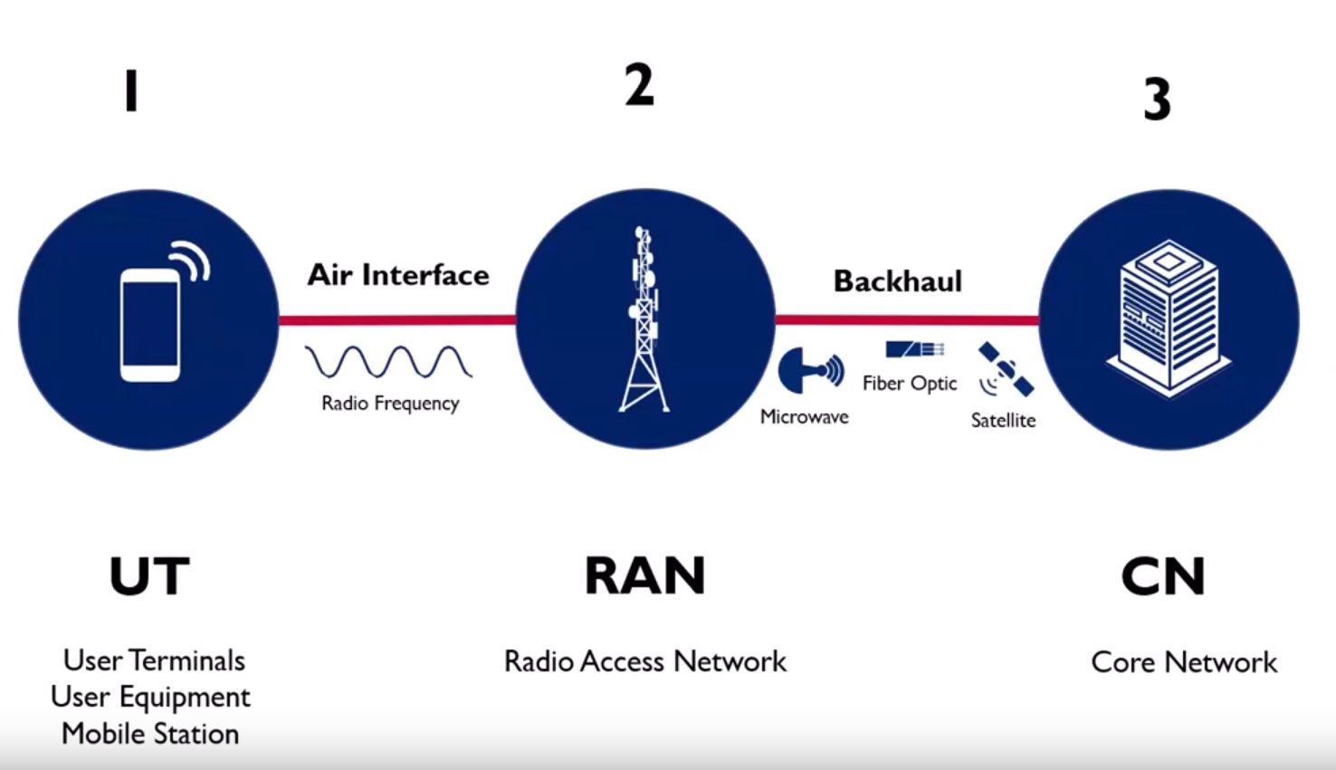
Core Network is responsible for managing the overall operation of the network.It includes traffic routing between different networks and providing advanced services.
RAN is responsible for providing the wireless connectivity required for mobile devices to connect to the core network it includes a network of cell sites each of which has a base station that communicates with mobile devices over the air.
User Equipment end users
=======================================================================
What is RAN
Radio access network uses radio frequencies to provide wireless connectivity to devices by converting users’ voice and data into digital signals to send through as radio waves.
RAN is responsible for transmitting and receiving wireless signals as well as managing the handoff of devices between different cells in the network as they move around.

RAN Components:

- Antennas:These convert electrical signals to radio waves. It is responsible for transmitting and receiving radio signals between mobile and ran components.
- Radio Remote Unit: It is responsible for converting the radio signals recieved by the antenna. It performs radio functions,including frequency conversion and amplification.
- Base Band Unit: Responsible for digital signals received from the RRU and transmitting them to the core Network.It is converting digital signals in to radio signals.BBU is responsible for processing the baseband signals and is placed in the equipment room and connected with RRU via optical fibre.
- CPR(Common Public Radio):It is a interface between the RRU and the basebandunit.
CPRI enables the high-speed transmission of data over fibre optic cables,allowing the RRU and the baseband processing unit to communicate with each other.

What is mean by O-RAN

Open Radio Access Network is a key part of a mobile network system that uses cellular radio connections to link individual devices to other parts of a network.
Open RAN is the manifes

Faster time to market
Faster Rollout for new features,services,and capabilities
Significant investmentts in new networking technologies
Flexibility
Better Performance
Expand and impove system capacities
better coverage
enhanced Qos
Lower cost
cut in energy consumption
lower equipment costs
Reduce CAPEX & OPEX

The ambition for Open RAN is to create a Multi-supplier RAN solution that aloows the seperation between hardware and software with open interface

