Homework #4 – Threat Modeling
CYBR 6780 – Fall 2026 – Due: September 23, 2026
Student Name: Chell LaRue

INTRODUCTION
System under analysis: the calculator from Homeworks 1–3 (sum_difference.py, with add/subtract/multiply/divide, plus the input checks in input_validation.py). As a local command-line script it has almost no attack surface, so — as the assignment allows — I assume the added requirement that the calculator becomes a web application with user login and saved calculation history. The Homework 2 integrity requirements (numeric-only operands, no silent overflow, defined divide-by-zero behavior) carry forward.
Evidence basis: every threat below that says "verified" was reproduced by running the current code under Python 3, not assumed from a generic threat list.

PART 1 – Software Architecture Diagram
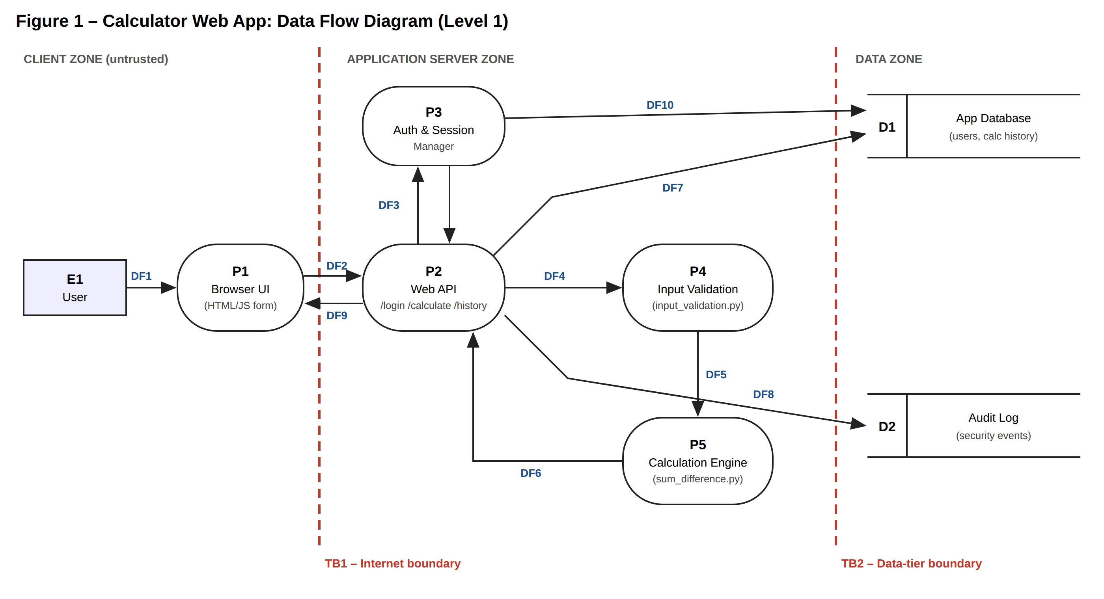
Label descriptions. Shapes follow DFD conventions: square = external entity, rounded box = process, open-ended box = data store, red dashed line = trust boundary.
Label | Name | Description
E1 | User | A person using the calculator from a web browser. Untrusted.
P1 | Browser UI | HTML/JS page with two operand fields, an operator selector, login form and history view. Runs on the user's machine, so anything it enforces can be bypassed.
P2 | Web API | Server endpoints /login, /calculate and /history. Entry point for all requests crossing TB1.
P3 | Auth & Session Manager | Verifies credentials, issues and checks session cookies.
P4 | Input Validation | Server-side checks (type, length, range) — the role input_validation.py plays today.
P5 | Calculation Engine | add_numbers, subtract_numbers, multiply_numbers, divide_numbers from sum_difference.py.
D1 | App Database | User accounts (password hashes) and each user's saved calculation history.
D2 | Audit Log | Security events: logins, failed logins, errors, rejected inputs.
DF1 | User input | Operands, operator, username/password typed into P1.
DF2 | Request | HTTPS POST to P2: JSON {a, b, op} or credentials, plus session cookie.
DF3 | Auth check | P2 sends credentials/session token to P3; P3 returns allow/deny and user ID.
DF4 | Raw operands | Untrusted operand values passed from P2 to P4.
DF5 | Validated operands | Numbers that passed P4, passed to P5.
DF6 | Result / error | Computed result or error returned from P5 to P2.
DF7 | History read/write | P2 saves each calculation to D1 and reads it back for /history (SQL).
DF8 | Security events | P2 and P3 append events to D2.
DF9 | Response | JSON result or error message returned to the browser.
DF10 | Credential lookup | P3 reads the password hash for a username from D1.
TB1 | Internet boundary | Everything left of it is attacker-controllable. All DF2 data must be treated as hostile.
TB2 | Data-tier boundary | Separates the app server from stored data; crossing it requires a DB credential.

PART 2 – Identify Threats

2a. STRIDE threat list
ID | STRIDE | Target (Fig. 1) | Threat | Evidence / notes
T1 | Spoofing | P3, DF2, DF10 | Attacker logs in as another user by credential stuffing or brute force on /login, or by stealing a session cookie, then views that user's history. | Classic web threat; no login throttling or MFA is specified yet.
T2 | Tampering | DF2 → P4 → P5 | Attacker bypasses the browser form and sends crafted JSON directly to /calculate — e.g. strings instead of numbers — so P5 returns wrong results that are saved to history. | Verified: add_numbers("2","5") returns "25" and multiply_numbers("ab",3) returns "ababab". Violates HW2 requirement: numeric operands only.
T3 | Repudiation | D2, DF8 | A user deletes or changes saved history, or abuses the service, and later denies it; logs are missing, not tied to a user ID, or editable by the app account. | No audit log exists in the current code.
T4 | Information Disclosure | P2 → DF9 | Unhandled exceptions return a Python traceback to the browser, revealing file names, source lines and library versions that help an attacker. | Verified: entering "abc" prints a traceback showing the exact source line in sum_difference.py.
T5 | Denial of Service | P5 (via DF2, DF4) | Attacker crashes or stalls the service with malformed or oversized operands, or floods /calculate. (Attack tree: Figure 2.) | Verified: uncaught ValueError on non-numeric input; divide_numbers(10**400, 3) raises OverflowError, which main() does not catch; one multiply of two 1,000,000-digit numbers took ~0.9 s CPU.
T6 | Elevation of Privilege | DF7 → D1 | SQL injection through the history search on /history lets an attacker read every user's data or run statements with the app's database role. (Misuse case: Figure 3.) | input_validation.py's check_sql is a blocklist; it would reject "SELECT" but not every injection form, and blocklisting is not a substitute for parameterized queries.
Integer overflow note. Python integers are arbitrary-precision, so the classic wraparound bug in the Wikipedia article does not occur inside P5. The risk moves elsewhere: (1) divide_numbers converts to float and raises OverflowError above ~1.8 × 10^308 (T5); (2) unbounded size becomes a CPU/memory problem (T5); (3) at the boundaries, JavaScript numbers in P1 lose precision above 2^53, and a 64-bit integer column in D1 would overflow above 2^63 − 1. So the HW2 "no silent overflow" requirement must be enforced at P4 with explicit bounds, not left to the language.

2b. Attack tree – T5 Denial of Service
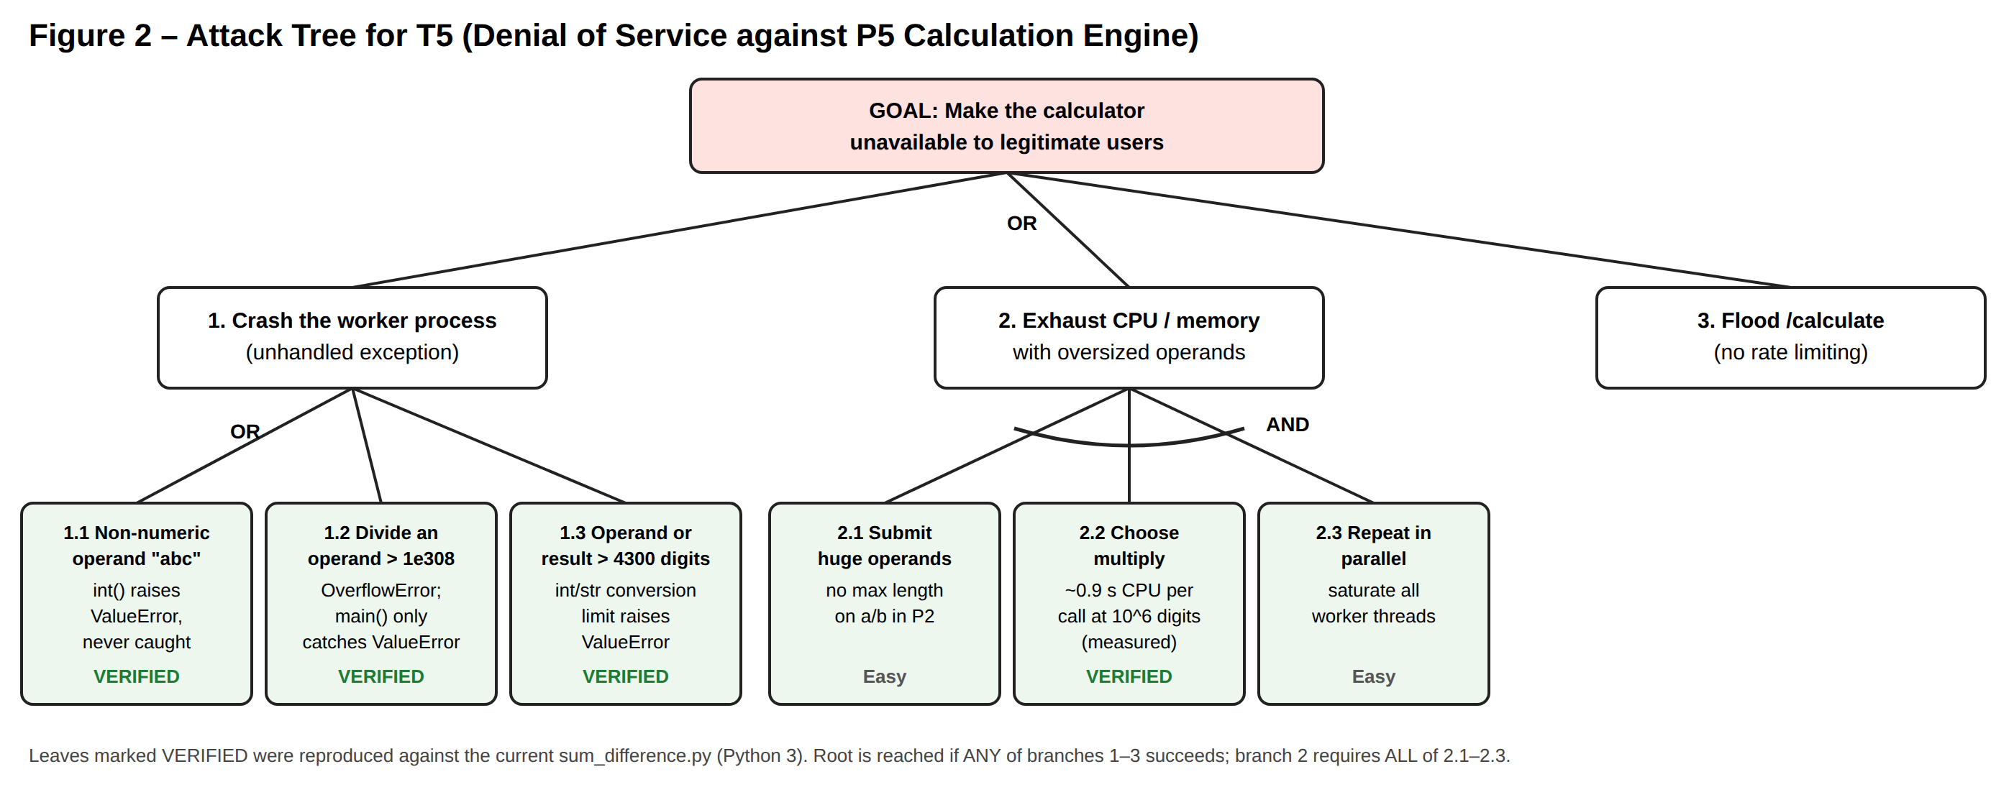
The tree shows that the cheapest path to the goal needs no special skill: a single request with the operand "abc" (1.1) or a very large divisor (1.2) crashes the current code. Because the root is an OR node, every branch must be closed; fixing only the crash paths still leaves branches 2 and 3.

2c. Misuse case – T6 SQL injection via history search
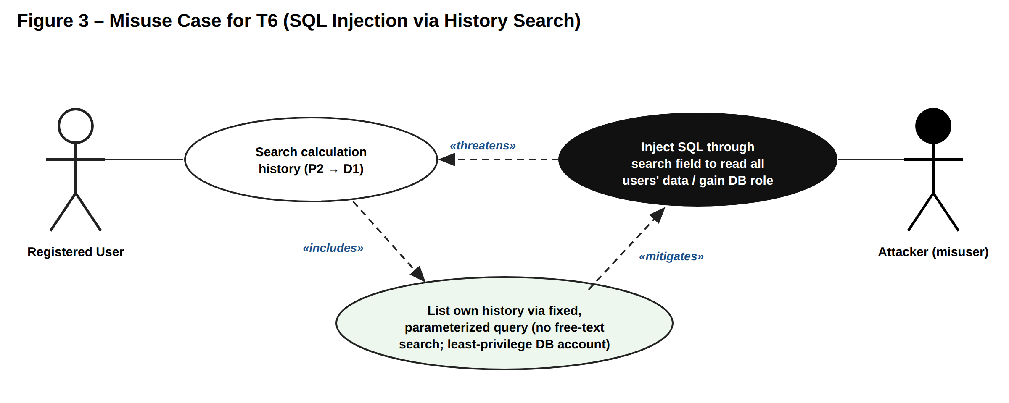
Field | Description
Misuse case | Inject SQL through the history search field
Misuser | Registered user or attacker with a stolen/free account (external, low skill; automated tools such as sqlmap exist)
Threatened use case | Search calculation history (P2 → DF7 → D1)
Preconditions | /history accepts a free-text search term, and P2 builds the SQL string by concatenating that term.
Basic path | 1. Misuser logs in. 2. Enters ' OR 1=1 -- (or a UNION SELECT) in the search box. 3. P2 concatenates it into its query. 4. D1 returns every user's rows, or runs statements with the app account's rights.
Result | Confidentiality loss for all users; possible data changes or admin rights if the DB account is over-privileged (elevation of privilege).
Mitigating use case | List own history via a fixed, parameterized query (user_id bound from the session, not from input); remove free-text search; DB account limited to SELECT/INSERT on the history table.

PART 3 – Identify Controls
All decisions were made on the date shown and are owned by the accountable person listed. Location refers to the labels in Figure 1.
ID | Decision | Control | Where implemented | Date | Accountable
T1 | Mitigation | Hash passwords with a slow algorithm (bcrypt/Argon2); lock or slow logins after 5 failures; session cookies set Secure, HttpOnly, SameSite; optional MFA. | P3, DF2, DF10, D1 | Sept 24, 2026 | Chell LaRue, Project Owner / Security Lead
T2 | Mitigation | Server-side type check: accept only int/float values (reject strings, bools, NaN, Infinity) before calling P5. Client-side checks in P1 are convenience only. | P4 (on DF4 → DF5) | Sept 24, 2026 | Chell LaRue, Project Owner / Security Lead
T3 | Acceptance | No new control now. Calculations are low-value and non-sensitive; the web server's standard access log (timestamp, user ID, endpoint) is judged enough. Revisit if history ever holds sensitive data. | D2 (existing server logs) | Sept 24, 2026 | Chell LaRue, Project Owner / Security Lead
T4 | Mitigation | Catch all exceptions at the API layer; return a generic message with an error ID; write details only to D2. Debug mode off in production. | P2 → DF9; D2 | Sept 24, 2026 | Chell LaRue, Project Owner / Security Lead
T5 | Mitigation | Reject any operand or result outside ±10^15 (below the 2^53 limit where P1's JavaScript loses precision); catch ValueError and OverflowError around P5; per-user and per-IP rate limit on /calculate; request timeout. | P4, P5, P2 | Sept 24, 2026 | Chell LaRue, Project Owner / Security Lead
T6 | Avoidance | Remove the free-text history search feature. History is listed only by a fixed parameterized query keyed on the session user ID; the DB account gets least privilege. | P2, DF7, D1 | Sept 24, 2026 | Chell LaRue, Project Owner / Security Lead

PART 4 – Prioritize Controls
Method: Probability × Impact. Each threat is scored 1 (low) to 5 (high) for probability (how easy and likely the attack is, given the current design) and impact (harm to users and the service if it succeeds). The risk score is the product (1–25). Controls are sorted by score, highest first. Ties are broken by impact, so the more damaging threat goes first. Scores are for the design before any controls are applied.
Rank | ID | Control | Probability | Impact | Score | Rationale
1 | T5 | Input bounds, exception handling, rate limiting | 5 | 4 | 20 | Anonymous, one request, already proven to crash the code.
2 | T6 | Remove free-text search; parameterized query; least-privilege DB | 3 | 5 | 15 | Needs an account, but exposes every user's data.
3 | T1 | Password hashing, login throttling, secure cookies, MFA | 3 | 4 | 12 | Tie with T2; wins on impact (full account takeover).
4 | T2 | Server-side numeric type checking | 4 | 3 | 12 | Trivial to do; harm is wrong results, not data loss.
5 | T4 | Generic error responses; details to log only | 4 | 2 | 8 | Easy to trigger; helps attackers but does not directly harm users.
6 | T3 | None (accepted); rely on server access logs | 2 | 2 | 4 | Low value of the data does not justify the cost now.
Limits of this method. The 1–5 scores are one person's judgment, so small changes can reorder close items (T1, T2 and T4 are within 4 points of each other). A Delphi round with a second reviewer would make the ranking more defensible. The method also ignores the cost of each control: T2's type check and T4's error handler are cheap and could reasonably be done in the same change as T5, regardless of rank.

