**Niral Thiruvizha**

**High Achievers Team project**

**Smart Urban Lighting Infrastructure Management System**

**Problem:**How might we develop an automated system for real-time street light fault detection, precise location tracking, and efficient maintenance in cities to enhance urban lighting infrastructure?

**Innovaction concepts:** Develop an automated system for real-time street light fault detection, precise location tracking, and efficient maintenance in cities.

**Expected output:** Automated controller of street light management systems and provide alert system of police and TNEB

**ABSTRACTION:**

* Install **sensors** on each street light to monitoring the streets

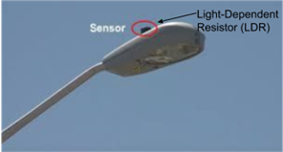

* **sensors** can detect various parameters :
* light intensity
* power consumption
* voltage fluctuations
* motion detection.
* To collection **centralized data** and processing to system .
* Wireless communication technologies such as **IoT (Internet of Things)** to transmit data.
* To analyze the data received from **sensors to detect any faults** in the street lights.



* To fixing the **GPS** location data as a simple input for pinpointing the location of

detected fault.

* To collection location data as a simple input for pinpointing the location of

detected fault.

* The transmit of collected sensor data to make the **Alert system** stakeholders.
* To Implement an **automated alert system.**



* To Alerting the **police and TNEB** contribute to improved safety, security, and power management in urban areas.
* Alerts can be sent via **SMS, email, emergency alerts sound**(eg:virus alert).
* To provide **mobile applications** of all the street member alerting member and to provide complain sytem.
* To provide the **emergency calling** system of street members.
* Install **High-resolution Cameras** on each street light.
* **Cameras** to capture visual data of the surroundings.
* These cameras can **provide images for fault detection**, such as identifying burnt-out bulbs, physical damage, or unauthorized tampering.

. This allows administrators to view real-time data, receive alerts, and remotely diagnose faults.

**For example,**

* **Infrared Sensor** to detect heat signatures,anomalies associated with electrical faults and overheating components in the street light.
* **Acoustic Sensor** detect unusual sounds or vibrations to indicate the mechanical faults or physical impacts on the street light.
* **Vibration sensor** Utilize vibration sensors to monitor structural integrity and to indicate potential damage or instability.

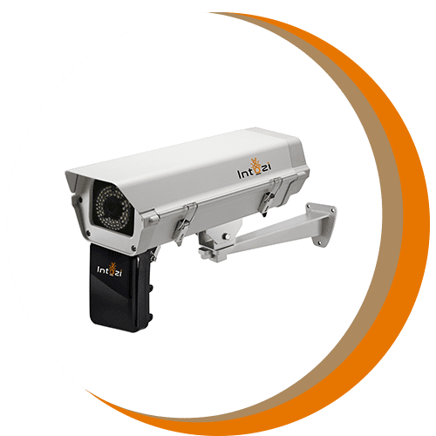**ANPR camera** is automatic traffic camera. ANPR/LPR/ALPR implies that the

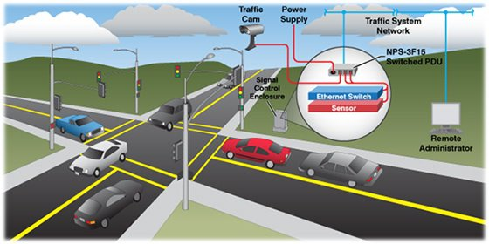process of capturing and interpreting license plate information is performed automatically without human intervention. They operate without the need for manual input or supervision during the process of capturing and recognizing license plates. (**ANPR**:Automatic Number Plate Recognition)



**Benefit:**

* Improved Public Safety
* To avoid the accidents
* Strong security management
* Precise Location Tracking
* To avoid the crimes at night

**Team Members:**

* CHELLAPANDI M
* MUGILAN A
* MOHAMED AADIL A
* PRADEEP BALA R
* SAM SUDEEN S
* Remote Monitoring and Control