Significance of the study
This study is focused on the implementation of the Administrative Document Tracking System that will modernize the operational workflow of the Department of Agriculture Regional Field Office 8 (DA RFO 8), transitioning the agency from labor-intensive manual logging to an automated digital environment. Moreover, this study will provide valuable insights, significance, and beneficial to the following:
Regional Director. The system provides high-level transparency and real-time visibility into the status of all files. Enabling leadership to immediately identify procedural bottlenecks and assess department productivity.
Administrative Head. As a critical management tool to ensure accountability in handling policy guidelines and budgetary allocations while eliminating "information silos" through a synchronized digital repository.
Administrative Staff and Assistants. The system streamlines document lifecycle management, effectively eliminating the common issues such as document loss, redundant data entry, and the labor-intensive burden of manual record-keeping.
Agricultural Community (Farmers and Stakeholders). By reducing the "paper-trail" bottleneck, the agency can ensure a more responsive and timely delivery of essential resources and support to the stakeholders of Region 8.
Future Researchers. This study serves as a valuable reference for digital transformation in government bureaucracy, specifically addressing gaps in “multi-level approval” workflows and hierarchical routing.
Scope and Delimitations of the Study
This study focuses on designing and developing an Administrative Document Tracking System for the Department of Agriculture Regional Field Office 8. It includes key system features like document logging, real-time status tracking, automated routing, and audit trail generation. Additional features such as data validation, deduplication, and deadline prioritization are included to improve accuracy and efficiency in document processing. The study examines the system’s effectiveness in enhancing workflow efficiency, transparency, and accountability within the organization. The research is limited to the Administrative Department of the Department of Agriculture Regional Field Office 8, where the system will be developed, implemented, and evaluated. The
participants in the study are selected administrative staff, unit heads, and the Director who are directly involved in handling and processing documents. The study will take place from February 2026 to May 2026 It will cover the phases of system design, development, testing, and evaluation. A system development approach is used, which includes methods like system design, implementation, and user testing. Evaluation methods are applied to measure system performance, usability, and user acceptance within the organization.
This study is confined in scope and focused only on the development and implementation of the said document tracking system to the Department of Agriculture Regional Field Office 8 and does not cover the other regional offices of the said department and other government agencies outside the Department of Agriculture - RFO 8. The system only covers internal administration documents and makes no provision for financial management, HR systems / tools or external communication such as email. The study only looks at the flow of documents from one status to another and does not include any aspect of content management within the system, nor does it consider cloud or mobile functionality. The evaluation was based on a select number of “users” who utilize the system on an ongoing basis within the organization. The evaluation did not include assessment of future enhancements, implementation for other agencies, or long-term effects of the system.
Definition of terms
Administrative Head. Refers to the authorized personnel in DA RFO 8 responsible for overseeing the processing of policy guidelines, budgetary allocations, and the overall coordination of document routing within the system.
Audit Trail. Refers to the detailed, chronological record within the system that tracks the history of a document, including its movement, the personnel in charge at each stage, and the duration it remained in each unit.
Centralized Digital Repository. Refers to the synchronized digital framework used to store all administrative records in a single location to eliminate information silos and prevent data duplication.
Document Metadata. Refers to the essential descriptive data entered into the system for every document, such as the subject, origin, and date of entry.
Hierarchical Routing. Refers to the automated workflow that directs documents through the established organizational structure of DA RFO 8, moving from staff to assistants and finally to the Regional Director.
Information Silos. Refers to the operational problem where data is isolated within specific units due to manual replication, making it difficult to maintain transparency across the entire organization.
Live Progress View. Refers to a system feature that provides real-time visibility into the current location and approval status of a pending file.
Regional Director. Refers to the highest authority in the agency who uses the system to monitor departmental productivity and identify procedural bottlenecks through high-level transparency.
Role-Based Access Control (RBAC). Refers to the security mechanism that restricts or grants system access and dashboard features based on the specific job responsibilities of the user.
Unique Tracking ID. Refers to the specific identification number automatically generated by the system for every new entry to ensure that no document is misplaced or lost during the routing process.

CHAPTER III
METHODS AND PROCEDURE
Research Design
This study employs a Development Research Design utilizing a Descriptive Evaluation approach. The researcher chose this design because the primary objective is to develop a functional software solution the Administrative Document Tracking System and evaluate its effectiveness in streamlining document workflows and enhancing data accountability within the organization. System Development Model The study follows the Agile Development Model. This iterative process allows the researcher to continuously refine the system based on feedback, ensuring that the features (such as real time status updates and automated logs) align with perfectly with the administrative requirements of the office. Phase of Development Analysis Phase: The researcher conducted interviews and workflow observations to identify current bottlenecks, such as manual logging delays and lost documents. These findings were to define the functional requirements of the system. Design Phase During this phase, the system’s architecture was mapped out. This included creating the Entity Relationship Diagram (ERD) for the database, designing the user interface (UI) for navigation, and planning the tracking mechanism (e.g., unique transaction IDs or QR codes). Development Phase the researcher translated the design into a working application. This involved backend coding for document status management and frontend development to ensure a responsive dashboard for the administrative staff. Testing Phase the system underwent rigorous Alpha Testing to identify and fix technical bugs. This was followed by Beta Testing, where the system was deployed in a controlled environment to ensure that the documentation routing logic works correctly under actual office conditions. Evaluation Phase: The final system was assessed by IT experts and end-users to measure its quality and performance. System Testing and Evaluation to determine the success of the system, it was evaluated using ISO/IEC 25010 Software Quality. Participants, specifically the administrative staff and records office, provided feedback through a survey questionnaire based on a 5-point Likert Scale. The evaluation focused on key criteria: Functional Suitability (if it tracks documents accurately), Usability (if it easy to learn), and Security (how well it protects sensitive administrative data).

Research Locale
The study was conducted at the Department of Agriculture Regional Field Office 8 (DA RFO 8), located at Kanhuraw Hill, Paterno Extension, Tacloban City, Leyte. As the primary administrative hub for agricultural governance in Eastern Visayas, this institution serves as the central point for handling a high volume of time-sensitive documents, policy guidelines, and service requests for the entire region.
This locale was purposively selected because it currently utilizes a traditional manual logbook-based system that is prone to human error and difficulty in tracking document movement. The institution's management has expressed a critical need for improving operational efficiency and maintaining a transparent digital trail across its distinct administrative layers—from staff to assistant and finally to the Director. Consequently, DA RFO 8 is the primary beneficiary of the proposed system, as the implementation of an automated tracking framework is intended to eliminate information silos and enhance overall institutional transparency within their specific high-stakes bureaucratic workflow.
Figure 1. Map - DA RFO 8 Tacloban City
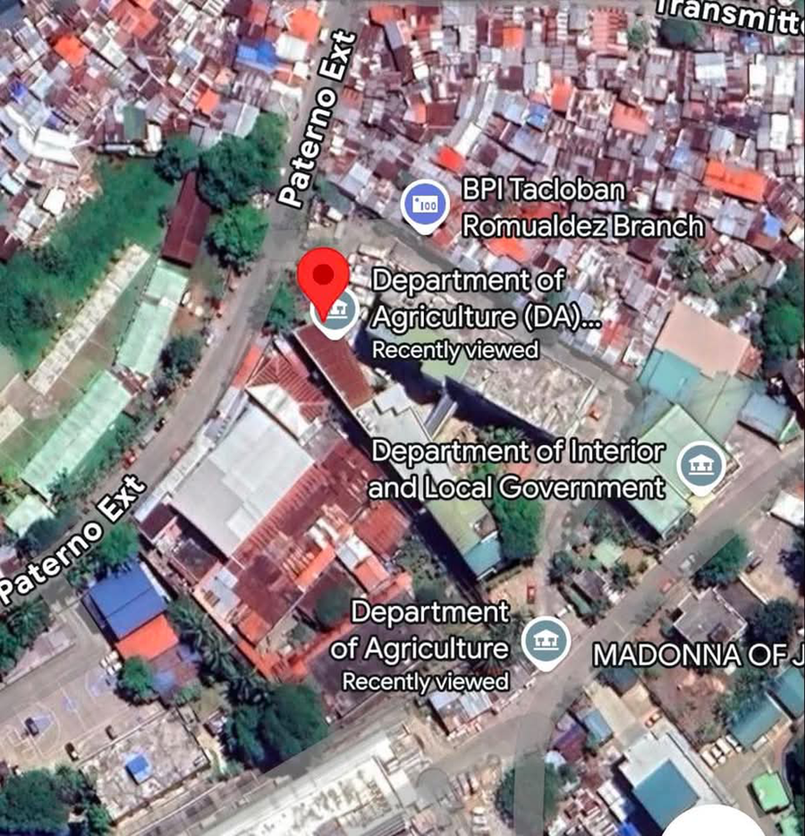

Research Instruments
The primary data collection tool for this study is a structured System Evaluation Questionnaire adapted from the internationally recognized ISO/IEC 25010 Product Quality Model. This survey instrument is designed to quantitatively measure the technical efficacy, quality, and user acceptability of the Administrative Document Tracking System among the target end-users at the Department of Agriculture Regional Field Office 8 (DA RFO 8).
To ensure a comprehensive evaluation tailored to a government institutional workflow, the questionnaire is divided into four main categories based on specific software quality characteristics:
- Functional Suitability: Evaluates how completely the system's automated features—such as unique tracking ID generation, immutable record handling, and multi-level routing—meet the operational requirements of the agency.
- Usability: Assesses the user interface (UI) design, ease of navigation across role-specific dashboards (Staff, Assistant, Admin Head, and Director), and how intuitive the live progress view is for non-technical administrative personnel.
- Security: Examines the system's access control mechanisms, specifically checking the reliability of the Role-Based Access Control (RBAC), user authentication, and data protection layouts.
- Performance Efficiency: Measures the system's responsiveness, particularly how quickly records can be retrieved and updated compared to traditional manual methods, to determine if it effectively eliminates paper-trail bottlenecks.
The survey utilizes a Five-Point Likert Scale to allow respondents to rate their level of agreement with various performance indicators. The statistical ranges and their corresponding verbal interpretations are presented in Table 1.
Table 1. The Five-Point Likert Scale Interpretative Guide
Scale | Range | Verbal Interpretation
5 | 4.21 – 5.00 | Strongly Agree (Excellent)
4 | 3.41 – 4.20 | Agree (Very Satisfactory)
3 | 2.61 – 3.40 | Neutral (Satisfactory)
2 | 1.81 – 2.60 | Disagree (Fair)
1 | 1.00 – 1.80 | Strongly Disagree (Poor)

Respondent of the Study
The respondents of this study consist of the active administrative personnel and structural officers tasked with handling the document routing pipeline within the Department of Agriculture Regional Field Office 8 (DA RFO 8). To achieve a precise and relevant evaluation of the tracking system, the researcher will implement a purposive sampling technique. This non-probability sampling methodology guarantees that only individuals with specific operational duties and direct day-to-day engagement with institutional workflows are selected to evaluate the platform.
The target evaluation pool is strategically categorized into distinct administrative strata to mirror the hierarchical routing structure of the software. This includes the Admin Staff and specialized unit teams like the General Services Unit (GGU) who manage baseline intake and initial immutable tracking ID generation; the Admin Assistants who oversee middle-tier task assignments; the Admin Heads responsible for intermediate validations; and the Regional Director who executes final organizational sign-offs. Testing across this multi-tiered cohort ensures that both baseline operational features and high-level executive dashboard tracking are thoroughly evaluated. A total sample size of 20 respondents will participate in the software assessment process. The complete distribution of the study's respondents is detailed in Table 2.
.

Respondent Category / Unit | Frequency | Percentage
Director | 1 | 5.0%
Admin Head | 2 | 10.0%
Admin Assistant | 5 | 25.0%
Admin Staff / GGU Personnel | 12 | 60.0%
Total | 20 | 100%

Table 2 illustrates the distribution and structural stratification of the twenty (20) target respondents selected to evaluate the Administrative Document Tracking System at the Department of Agriculture Regional Field Office 8 (DA RFO 8). The largest group of evaluators belongs to the Admin Staff and GGU Personnel category, representing 60.0% (f = 12) of the total sample size, as they are the primary operational end-users tasked with initial data entry and baseline tracking ID generation. This is followed by the Administrative Assistants, who comprise 25.0% (f = 5) of the cohort and handle mid-tier task delegation and document distribution. The remaining segments consist of the Administrative Heads at 10.0% (f = 2) and the Regional Director at 5.0% (f = 1), representing the executive layers responsible for higher-level system monitoring, verification, and final administrative approvals.
Validation of the Instruments
To establish the structural integrity, relevance, and accuracy of the data collection tools, the developed survey instrument underwent a strict vetting process before final field deployment. This procedure ensured that all criteria indicators were precisely aligned with both the technical standards of software development and the local administrative workflows of the agency. Content Validation. The preliminary draft of the questionnaire was submitted to a panel of Information Technology (IT) experts, including systems analysts, senior web developers, and academic professors. These evaluators scrutinized the individual questionnaire items to ensure they comprehensively measured the four core software quality dimensions of the ISO/IEC 25010 model: Functional Suitability, Usability, Security, and Performance Efficiency. Recommendations regarding technical phrasing and structural clarity were fully integrated into the revised instrument.
Face Validation. The instrument was subsequently reviewed to evaluate its visual layout, font readability, syntax, and overall presentation format. This step guaranteed that the non-technical administrative personnel at the Department of Agriculture Regional Field Office 8 (DA RFO 8)—ranging from baseline Admin Staff to the Regional Director—could easily comprehend and answer each item without ambiguity, Operational Alignment Validation. Finally, the specific terminology used in the survey was checked against the custom system architecture of the tracking application. This verified that the questionnaire effectively captured unique, immutable operational rules—such as preventing the cancellation of a tracking ID once it is generated by the system—and accurately reflected the distinct routing permissions assigned to Admin Staff, Admin Assistants, Admin Heads, and Director roles.

Data Gathering Procedure
The researcher initiated the procedure by drafting a formal request letter addressed to the Regional Director and Administrative Head of DA RFO 8 to secure institutional permission to conduct the study within the agency. Upon obtaining the necessary endorsements, the survey instruments were subjected to content validation by a panel of Information Technology experts to verify item reliability and alignment with the ISO/IEC 25010 framework. System Demonstration and User Orientation. Before distributing the evaluation instruments, the researcher conducted a controlled deployment and user orientation at the research locale. The researcher set up the web-based tracking system interface on designated workstations and demonstrated the primary role-specific features—such as immutable tracking ID generation for the Admin Staff and macro pipeline monitoring for the executive dashboards. The twenty (20) purposively selected respondents were given adequate time to interact directly with the software components to establish an objective user experience, Survey Administration and Retrieval. Immediately following the system interaction sessions, the structured ISO/IEC 25010 survey questionnaires were personally distributed to the participants. To safeguard respondent rights, an Informed Consent Form accompanied each questionnaire, explicitly stating that participation was entirely voluntary and that individual data would be kept strictly confidential. The completed questionnaires were collected directly by the researcher, ensuring a 100% response retrieval rate, and the gathered data were consolidated for statistical compilation.
Statistical Treatment of Data
To objectively analyze and interpret the quantitative responses gathered from the system evaluation questionnaire, the following descriptive statistical tools will be applied to the dataset:
1. Frequency Distribution and Percentage This descriptive tool will be used to organize and summarize the demographic and profile distribution of the respondents across their respective administrative roles and units. The formula for calculating the percentage is expressed as follows:
Formula: P = (f / N) x 100
Where:
- P = the calculated percentage.
- f = the frequency or total count of responses within a specific category.
- N = the total number of respondents (20) participating in the study.
2. Weighted Mean The weighted mean will serve as the primary metric to determine the overall level of user acceptability and technical performance of the software across the designated ISO/IEC 25010 characteristics. This mathematical value will quantify the collective assessment of the respondents for each survey indicator, using the following formula:
Formula: Mean = Sum of (f x x) / N
Where:
- Mean = the computed weighted mean.
- Sum of (f x x) = the sum of the products of the option weight (x) and the frequency of responses (f) for that option.
- N = the total number of respondents.
The resulting statistical means will be directly referenced against the established five-point Likert scale interpretative boundaries to derive their corresponding verbal classifications.

