“”

[]

【】

各用一种字体。

你从一个黑暗的密室中醒来，眼前的一切逐渐从模糊到清晰。你听见一个声音对你说到：

“Hello. I want to play a game with you. Right now, you are trapped in this special place I designed for you. If you want to get out, then uncover the secret behind each room. Game start, now.”

[Where does that voice come from? I cannot remember anything about here. I was from Massachusetts and I have a wife and three kids. I have to get out of this place.]

你进入第一个房间，看到的是一扇门，门上写着106。门是锁着的。旁边有一个信箱，互动打开后看到了一张诡异的发黄的照片和一把钥匙。

【You found a key and an old picture.】

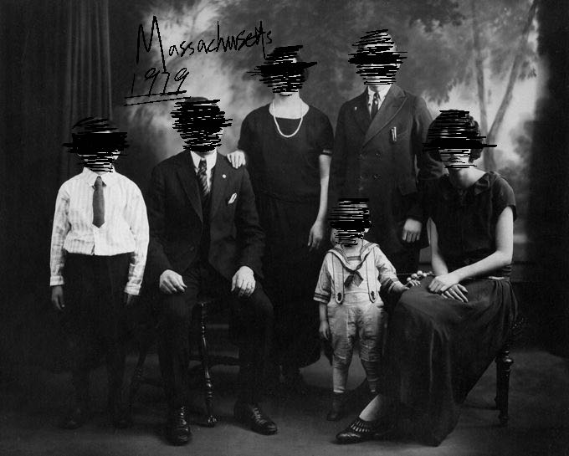

[Is this a family photo? Why their faces are all blurred?]

门开了。你看到了狭窄的，通往楼上的楼梯。顺着楼梯走上楼进入了第一个房间。当你进入房间后，门在背后锁上了。房间内的陈式十分简单，一张书桌，一个柜子，一张床。还有一扇可以打不开的但是可以看向外面的窗户。书桌上有一张可以进行互动并书写的纸条。

[I think I can write on this paper.]

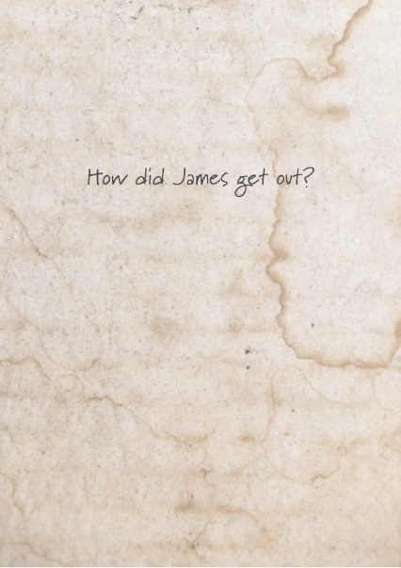

打开衣柜，衣柜里面有一张纸条。

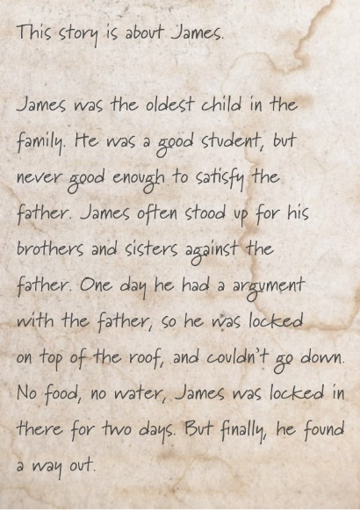

在衣柜旁边的小柜子里还可以找到一个手电筒。

[I think this is a flashlight. Can’t think of any use now.]

【Press F to turn on the flashlight】

从窗户向外看，偶尔可以看到从楼上坠下一闪而过的黑影。

在桌上的纸条输入答案：带有“jump”,”fall”都算正确。输入答案错误，[Nothing happened perhaps this is not the right answer]；输入答案正确，声音会响起。

“You answered correctly, now you will go to the next room.”

地板突然打开，玩家被迫从房间摔下楼进入了一个密室。

这个房间的陈式很暗，唯一的光源是刚才坠落的地方，四周都是一片漆黑，你被4面透明玻璃隔在了一个狭小的空间里。这里只有一张床，一张桌子上摆着个鸟笼，还有一部电话。声音再次响起

“The big sister was Mary. She was so adorable. She liked to wear purple dress. But after James died, the father locked her in a basement. Mary suffered the most. Before she died, she said something. What was her last word?”

和电话互动，会出现提示音。可以输入文字。

【Leave your message after the beep——】

观察四周，在某一面墙上有一盏灯，灯的闪烁频率似乎有规律。可以蹲下在床下捡到一张纸条。

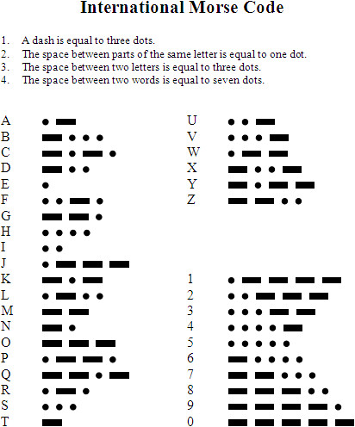

根据灯光闪烁的频率。破译出了Mary临死前说的话是‘HELP’。

在电话机输入正确的信息后，四面的玻璃缓缓升起。声音再次响起：

“Yes! I know you know it! Now enter the door, you are so close to get out!”

<注-此处会出现剧情分支。分支真结局将会在后面详细讲述。>

进入闪烁灯光旁边的门，会看见里面有一张桌子，上面放了一朵花和一瓶药。和空的药瓶互动，声音再次响起，

“Mother. She was weak and pathetic. But after the death of two children, even a fool could know to take action.”

进入最后一个房间，身后的门反锁上了。里面是一个婴儿床，和一个吊灯。这时身后响起了敲门声，然后声音再度响起。

“Of course. Her plan failed. Now, the father is knocking at her door. There is only one thing she could do now.”

紧张的敲门声迫使玩家四处寻找，终于玩家找到了可以互动的电灯开关。互动电灯开关，四周突然进入了一片黑暗，敲门声也停止了。再次打开电灯。天花板上出现了吊死人的绳索。过了10秒钟，声音再度响起：

“Now, this is the end of the tragic family. I am now, humbly asking you, tell me, who do you think is responsible for all the misfortunes in the family?”

这里玩家出现了可以输入的文本框，将决定到最终结局。

输入“Father.” 声音会响起：

“Good. You told the right answer. I am so happy you remembered it. Now, go to the last room and you will be out.”

玩家进入最后一个房间，发现这里三面都是墙，门在背后锁上了。声音

[What is this? I did everything you asked? Why I cannot be freed?]

“The father was responsible for what happened to the family, my family, but he was never caught. I spent years tried to track him done, and now I found you. You must have not remembered. You must have forgotten everything! But it doesn’t matter, now I will have my revenge, and you will face your way to get out. Game is over, father.”

当声音说完这些话，两边的墙开始向中间挤压。

[No! No! This cannot be true! This cannot be true!]

随着墙面逐渐将玩家挤成一团，视线开始变红，最后变成红色底，黑色字幕出现：GAME END 1: THE FATHER.

第二结局路线：

在先前的分支处使用手电进入黑暗中，走到一个墙面的背后会发现一扇门，打开后进入会找到一个柜子，打开柜子里面会看到一张纸条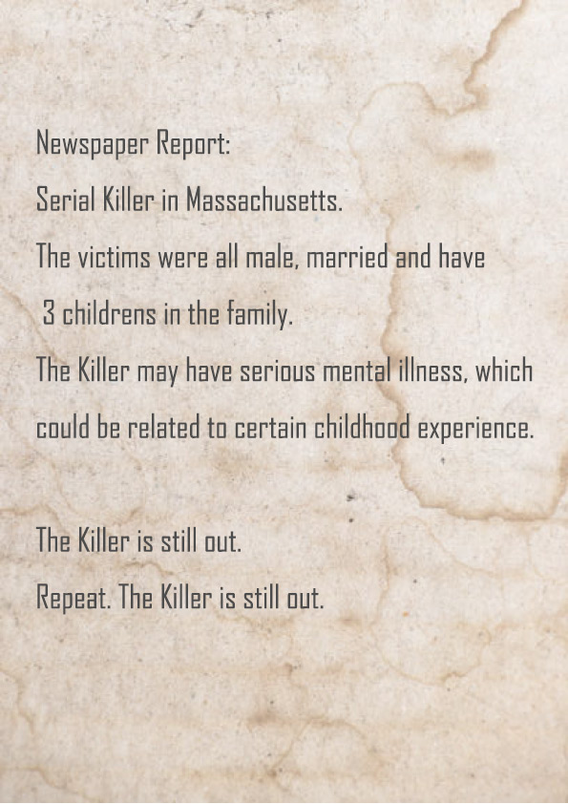

在最后回答环节，回答“Son”. 声音会突然沉默，然后说道：“This is not the correct answer, answer again.”

继续回答“Son.”声音会回答：“I. This is wrong. I cannot do this anymore. I cannot lie to myself. No. He is lying to me. Remember your family. This, I. Could not.”

玩家这时可以输入一些东西，随便输入什么都无所谓，之后声音会说：

“It’s over. My father has been long dead. I am sorry.”

之后黑屏（懒得做后面的内容了），出现文字

“The police later came and saved you. The serial killer was brought to justice. It seems he was trying to seek the revenge to his dead father by killing people who had family like his father.”

出现字幕：GAME END 2: THE SON