**Project Charter Document**

**Project Name : PREDICTIVE AGRICULTURAL ANALYTICS**

**Department : Agriculture**

**Focus Area : crops and ROI**

**Product/Process:Data Analysis**





**Prepared By**

| **Document Owner(s)** | **Project/Organization Role** |
| --- | --- |
| **Nayan soni** | **INTERN** |
|  |  |
|  |  |
|  |  |
|  |  |
|  |  |

**Project Charter Version Control**

| **Version** | **Date** | **Author** | **Change Description** |
| --- | --- | --- | --- |
| 1.0 | 27/12/2021 | Deepak | Document created |
| 1.2 | 27/02/2022 | Nayan Soni | Prepared final Draft |

**TABLE OF CONTENTS**

**1** **PROJECT CHARTER PURPOSE 3**

**2** **PROJECT EXECUTIVE SUMMARY 3**

**3** **PROJECT OVERVIEW 3**

**4** **PROJECT SCOPE 4**

4.1 Goals and Objectives 4

4.2 Project Deliverables 4

4.3 Deliverables Out of Scope 4

4.4 Project Duration 4

**5** **PROJECT CONDITIONS 5**

5.1 Project Assumptions 5

5.2 Project Issues 5

5.3 Project Risks 5

5.4 Project Constraints 5

**6** **Project Structure Approach 6**

**7** **Project Team Organization Plans 6**

**8** **PROJECT REFERENCES 6**

**9** **APPROVALS 6**

**10** **APPENDICES 8**

10.1 Document Guidelines 8

10.2 Project Charter Document Sections Omitted 8

# PROJECT CHARTER PURPOSE

The project charter defines the scope, objectives, and overall approach for the work to be completed. It is a critical element for initiating, planning, executing, controlling, and assessing the project. It should be the single point of reference on the project for project goals and objectives, scope, organization, estimates, work plan, and budget. In addition, it serves as a contract between the Project Team and the Project Sponsors, stating what will be delivered according to the budget, time constraints, risks, resources, and standards agreed upon for the project.



# PROJECT EXECUTIVE SUMMARY

* Business understanding
* Data Understanding
* Technical Stacks
* Project Architecture
* Data Preparation
* Data Description
* Data Visualizations and Summary
* Model Approch
* Deployment



# PROJECT OVERVIEW

Predicting high demand crop in upcoming season as if done manually is time consuming process.We are building this model to minimize time for selecting crops which farmer should grow to get good profit , provide as accurate and through results as possible.



# PROJECT SCOPE

## Goals and Objectives

| **Goals** | **Objectives** |
| --- | --- |
| * **To recommend proper crops suitable with soil and environment to the farmer.** * **To increase their production by providing befitting information.** | * **It will help farmers to select proper option of crops for cultivation.** * **It will raise their profit margin and might reduce their loss.** |

## Project Deliverables

| **Milestone** | **Deliverable** |
| --- | --- |
| * **Identifying Constraints and design the project architecture, explore various public forums to collect relevant data, Data Preparation.** | * **Deliverable 1.1—Identifying Constraints and design the project architecture.** * **Deliverable 1.2—Explore various public forums to collect relevant data.** * **Deliverable 1.3— Data Preparation** |
| * **EDA and Descriptive Analytics, Model Building for association and recommendation..** | * **Deliverable 2.1— EDA and Descriptive Analytics** * **Deliverable 2.2— Model Building for association and recommendation..** |
| * **Model Evaluation, tuning and insights, Deployment** | * **Deliverable 3.1— Model Evaluation, tuning and insights.** * **Deliverable 3. 2— Deployment** |
| * **Show case and review, Final Presentation and documentation, Handover and KT.** | * **Deliverable4.1 – show case and review** * **Deliverable4.2 – Final Presentation and documentation** * **Deliverable4.3 – Handover and KT** |

## Deliverables Out of Scope

* **Mobile app**
* **Designs**

## Project Duration (start date: 22/12/2021 End date: 15/01/2022)

| **Project Milestone** | **Date Estimate** | **Deliverable(s) Included** | **Confidence Level** |
| --- | --- | --- | --- |
| * **Identifying Constraints and design the project architecture, explore various public forums to collect relevant data, Data Preparation.** | **[22/12/2021]**  **-**  **[25/01/2022]** | * **Deliverable 1.1—Identifying Constraints and design the project architecture.** * **Deliverable 1.2—Explore various public forums to collect relevant data.** * **Deliverable 1.3— Data Preparation** | **[High]** |
| * **EDA and Descriptive Analytics, Model Building for association.** | **25/01/2022]**  **-**  **[12/02/2022]** | * **Deliverable 2.1— EDA and Descriptive Analytics** * **Deliverable 2.2-model building for association and recommendation** | **[High]** |
| * **Model Evaluation, tuning and insights, Deployment** | **[12/02/2022]**  **-**  **[24/02/2022]** | * **Deliverable 3.1— Model Evaluation, tuning and insights.** * **Deliverable 3. 2— Deployment** | **[High]** |
| * **Show case and review, Final Presentation and documentation, Handover and KT.** | **[25/02/2022]**  **-**  **[27/02/2022]** | * **Deliverable 4.1 – show case and review** * **Deliverable 4.2 – Final Presentation and documentation** * **Deliverable 4.3 – Handover and KT** | **[Medium]** |



# PROJECT CONDITIONS

## Project Assumptions

**Work on data which is extracted from the open source..**

**Can create a web API by using flask or streamlit.**

**Deployment should be done.**

**Robust Tested: Application should be tested for new data also.**

## Project Issues

**Priority Criteria**

1 − High-priority/critical-path issue; requires immediate follow-up and resolution.

2 − Medium-priority issue; requires follow-up before completion of next project milestone.

3 − Low-priority issue; to be resolved prior to project completion.

4 − Closed issue.

## 

## Project Constraints

**Unavailability of exact data.**

**Lack of knowledge of soil, its fertility,environment.**

**Crop recommendation for upcoming season with best return of investment.**

# Project Structure Approach

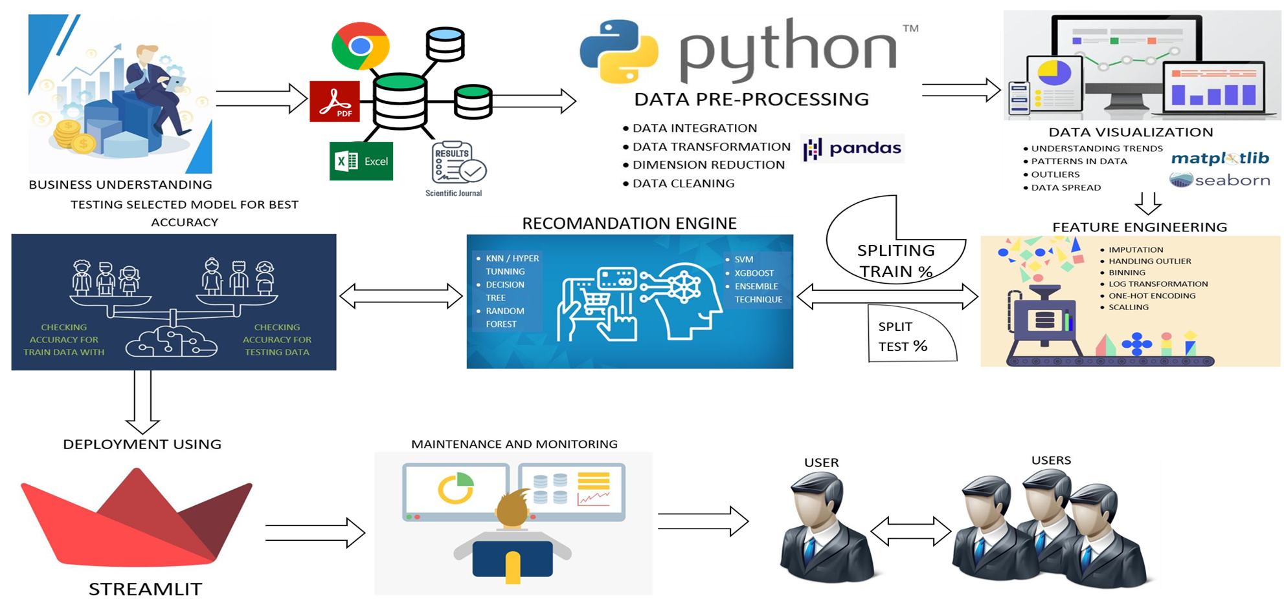



# Project Team Organization Plans

| **ProjectTeam Role** | **Project Team Member(s)** | **Responsibilities** |
| --- | --- | --- |
| Business Data dataUnderstanding | **Team Member** | * Deliverable 1 |
| Data collection | **Team Member** | * Deliverable 2 |
| Data Preprocessing  Data preparation | **Team Member** | * Deliverable 3 |
| Data visualization | **Team Member** | * Deliverable 4 |
| Model Built &  Deployment | **Team Member** | * Deliverable 5 |



# PROJECT REFERENCES

| **Milestone** | **Deliverable** |
| --- | --- |
| Soil moisture content as influenced by varied levels of irrigation | <https://www.researchgate.net/publication/348870244> |
| Crop Yield Prediction by using Machine Learning Techniques | <https://www.annalsofrscb.ro/index.php/journal/article/view/5869> |
| Geographical Study Impact of Climate | <https://drive.google.com/drive/folders/1tqMMpkEa4P_-t9bbApRMSuPXEhhjeQ7j> |

# APPROVALS

**Prepared by** NAYAN SONI

Project Manager

**Approved by** **Sharat sir**

Project Sponsor

Sharat Chandra ___________________________

Executive Sponsor

Innodatics________________________________

Client Sponsor



# APPENDICES

## Document Guidelines

## Project Charter Document Sections Omitted

