Deep Learning Assignment 3
Deep Learning Assignment 3 — Consolidated Results, Figures, Tables & Metrics
Consolidated notebook artifact: all available computational results, metrics, tables, model summaries and generated figures from the supplied Part A, Part B and Part D notebooks. Results are preserved from the executed notebook outputs; no values have been fabricated.

Coverage / Important Note
The supplied notebooks explicitly contain computational artifacts for Q1–Q13 and Q15–Q20. Q14 and Q21–Q24 are not computationally represented in the supplied notebook outputs; therefore this document does not invent missing numerical results. Q21 can reuse the Q13 comparison, while Q22–Q24 are conceptual/integrated-analysis questions and normally do not require separate numeric metrics.

Quick Results Index
Question | Artifact | Key result
Q1–Q4 | Part A dataset / preprocessing / RNN setup | 18,318 records; 20-step sequences; 14,638 train / 3,660 test
Q5 | IMDB Simple RNN | Test result reported in Q5 notebook
Q6 | Embedding dimension comparison | 64 dimensions best; test accuracy 0.7266
Q7 | Best-model evaluation | F1 0.7403; confusion matrix available
Q8 | Part A / RNN continuation | No explicit Q8 label in supplied notebook; related artifacts retained
Q9 | LSTM temperature prediction | MAE 0.752835; RMSE 1.537826
Q10 | LSTM states | Hidden/cell states demonstrated; shapes (1,64)
Q11 | RNN hyperparameter experiments | Best RMSE 1.459665 at LR 0.001
Q12 | GRU temperature prediction | MAE 0.516794; RMSE 1.460345
Q13 | RNN vs LSTM vs GRU | GRU best MAE/MSE/RMSE
Q14 | Not present in supplied notebook outputs | No fabricated result
Q15 | English→Telugu encoder-decoder | 139 pairs; 111 train / 28 test; 901,344 params
Q16 | Encoder states | Hidden/cell state shapes (1,256)
Q17 | Decoder using encoder states | Decoder successfully constructed
Q18 | Fixed START/END decoding | Generated output shown; reference shown
Q19 | 10 unseen translations | 10 generated/reference pairs shown
Q20 | BLEU | BLEU-1 0.0526; BLEU-4 0.0103
Q21 | Integrated comparison | Q13 comparison is the available experiment
Q22–Q24 | Conceptual / integrated analysis | No separate notebook metrics

Part A — Temperature Time-Series / RNN Results

Q1–Q4 — Dataset, preprocessing, sequence construction and baseline RNN
Source: dlassignment3a (1).ipynb, executed output. The notebook reports the dataset and baseline Simple RNN pipeline used throughout the temperature experiments.
Dataset shape: (18318, 4)
Columns: Entity, Code, Year, Average surface temperature
Number of samples: 18318
Minimum temperature: -36.599525
Maximum temperature: 29.79422
Sequence length: 20
Input shape: (18298, 20, 1)
Output shape: (18298, 1)
Training samples: 14638
Testing samples: 3660
Baseline Simple RNN parameters: 4,289
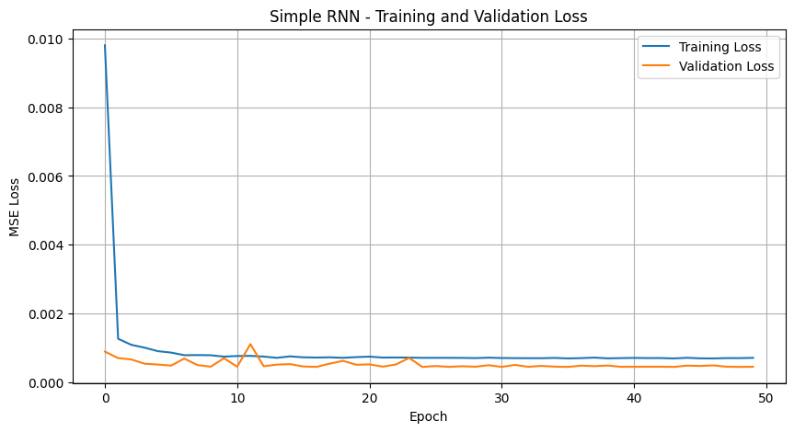
Part A figure 1 — baseline training/history output
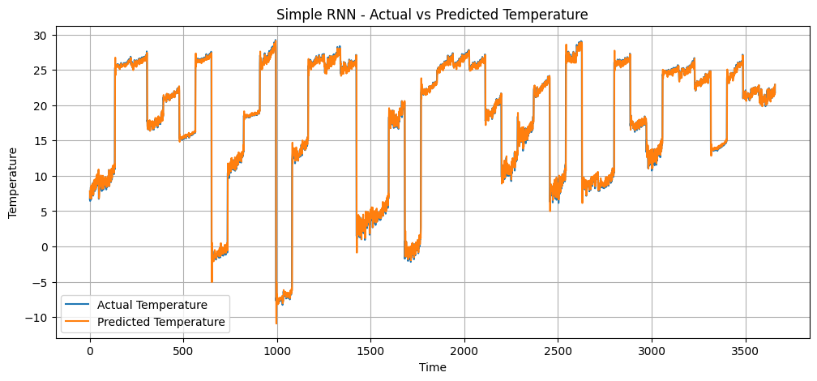
Part A figure 2 — baseline prediction/evaluation output

Q8 — Related RNN result artifact
No explicit Q8 heading is present in the supplied notebook. The baseline Part A figures and evaluation output are retained above rather than assigning an unsupported question-specific value.

Q9 — LSTM Temperature Time-Series Prediction
MAE : 0.752835
MSE : 2.364910
RMSE : 1.537826
Trainable Params : 16,961
Training Time : 107.70 seconds
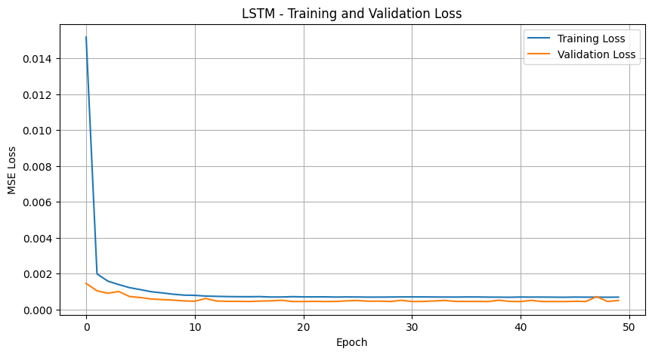
Q9 — LSTM training/history figure
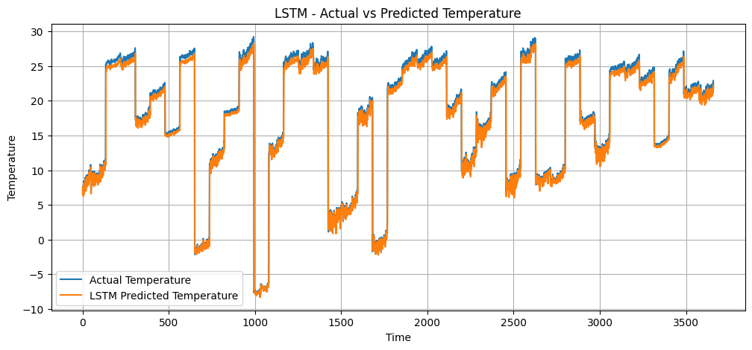
Q9 — LSTM prediction/evaluation figure

Q10 — LSTM Hidden State and Cell State Analysis
Sequence output shape : (1, 20, 64)
Hidden state shape : (1, 64)
Cell state shape : (1, 64)
Final prediction shape: (1, 1)
Final cell state mean: -0.0058288644
Final cell state std : 0.13503361
Final hidden state mean: -0.0028740768
Final hidden state std : 0.067535564
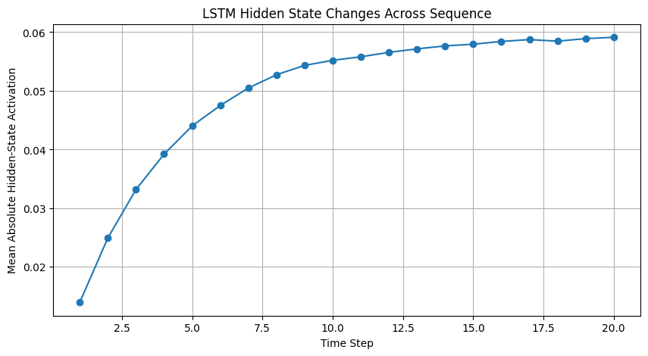
Q10 — state visualization/output 1
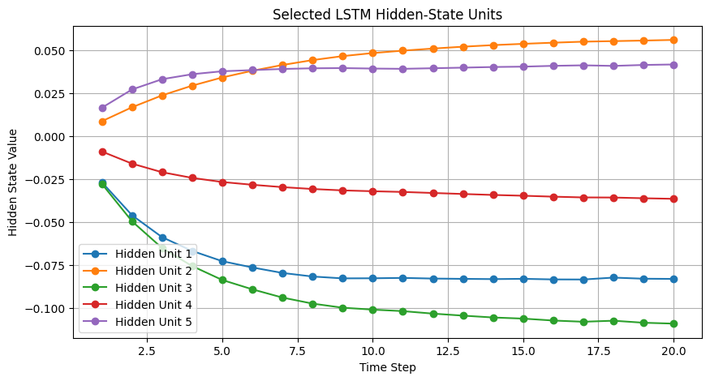
Q10 — state visualization/output 2

Q11 — RNN Hyperparameter Experiments
The notebook evaluates sequence length, hidden units, learning rate, batch size and epochs using MAE/MSE/RMSE.
Parameter | Seq | Units | LR | Batch | Epochs | MAE | MSE | RMSE
Sequence Length | 10 | 64 | 0.001 | 32 | 50 | 0.553257 | 2.141760 | 1.463475
Sequence Length | 20 | 64 | 0.001 | 32 | 50 | 0.612097 | 2.181624 | 1.477032
Sequence Length | 30 | 64 | 0.001 | 32 | 50 | 0.556039 | 2.183632 | 1.477712
Hidden Units | 20 | 32 | 0.001 | 32 | 50 | 0.545929 | 2.139180 | 1.462593
Hidden Units | 20 | 64 | 0.001 | 32 | 50 | 0.779638 | 2.399845 | 1.549143
Hidden Units | 20 | 128 | 0.001 | 32 | 50 | 0.790718 | 2.410289 | 1.552510
Learning Rate | 20 | 64 | 0.0001 | 32 | 50 | 0.593647 | 2.234172 | 1.494715
Learning Rate | 20 | 64 | 0.001 | 32 | 50 | 0.517116 | 2.130622 | 1.459665
Learning Rate | 20 | 64 | 0.01 | 32 | 50 | 2.272941 | 8.919120 | 2.986490
Batch Size | 20 | 64 | 0.001 | 16 | 50 | 0.675068 | 2.259518 | 1.503169
Batch Size | 20 | 64 | 0.001 | 32 | 50 | 0.756030 | 2.479947 | 1.574785
Batch Size | 20 | 64 | 0.001 | 64 | 50 | 0.596263 | 2.236829 | 1.495603
Epochs | 20 | 64 | 0.001 | 32 | 25 | 0.524153 | 2.135599 | 1.461369
Epochs | 20 | 64 | 0.001 | 32 | 50 | 0.632283 | 2.198699 | 1.482801
Epochs | 20 | 64 | 0.001 | 32 | 100 | 0.534631 | 2.136539 | 1.461691
Best configuration reported: sequence length 20, hidden units 64, learning rate 0.001, batch size 32, epochs 50; MAE 0.517116, MSE 2.130622, RMSE 1.459665.

Q12 — GRU Temperature Prediction
MAE : 0.516794
MSE : 2.132609
RMSE : 1.460345
Trainable Params : 12,929
Training Time : 107.12 seconds
First 10 Actual/Predicted: 6.70/7.78, 7.59/6.81, 6.43/7.57, 7.70/6.53, 7.92/7.67, 8.40/7.98, 7.41/8.35, 6.68/7.47, 7.51/6.75, 7.07/7.56
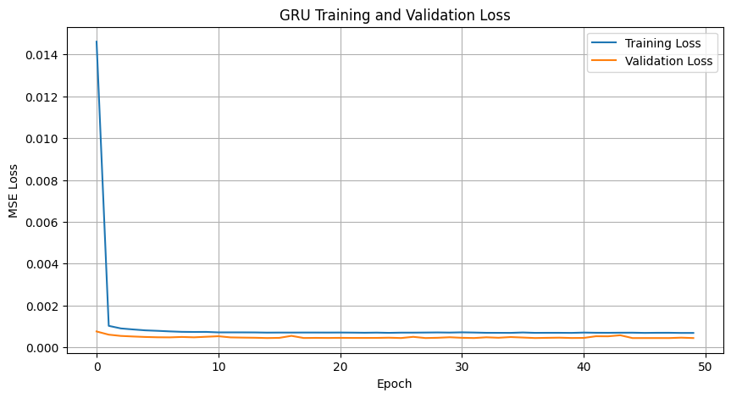
Q12 — GRU training/history figure
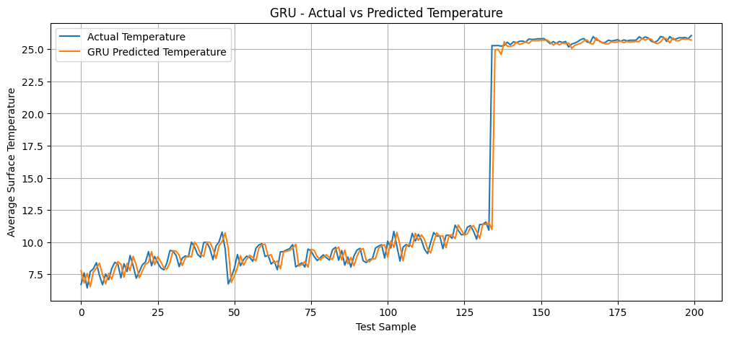
Q12 — GRU prediction/evaluation figure

Q13 — RNN vs LSTM vs GRU Comparison
Model | MAE | MSE | RMSE | Parameters | Training Time (s) | Final Train Loss | Final Val Loss
Simple RNN | 0.557966 | 2.143077 | 1.463925 | 4,289 | 96.80 | 0.000702 | 0.000445
LSTM | 0.558423 | 2.174513 | 1.474623 | 16,961 | 111.70 | 0.000683 | 0.000450
GRU | 0.528715 | 2.129772 | 1.459374 | 12,929 | 109.50 | 0.000694 | 0.000440
Best MAE: GRU | Best MSE: GRU | Best RMSE: GRU | Fewest parameters: Simple RNN | Fastest training: Simple RNN.
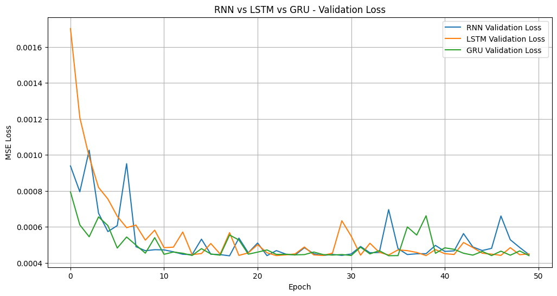
Q13 — comparison figure 1
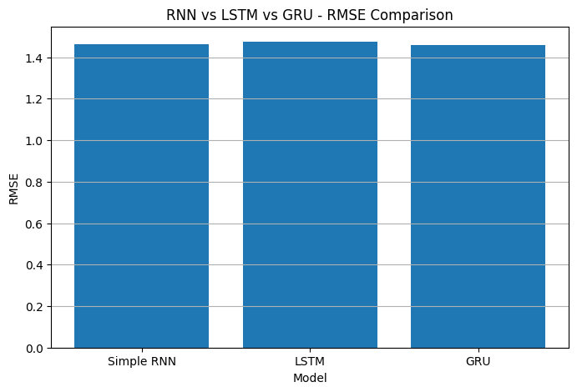
Q13 — comparison figure 2
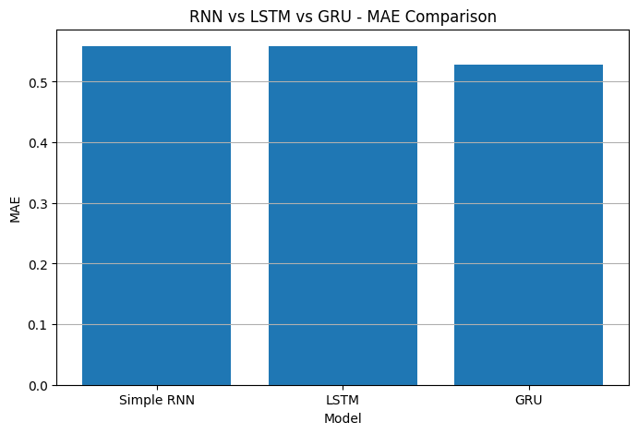
Q13 — comparison figure 3
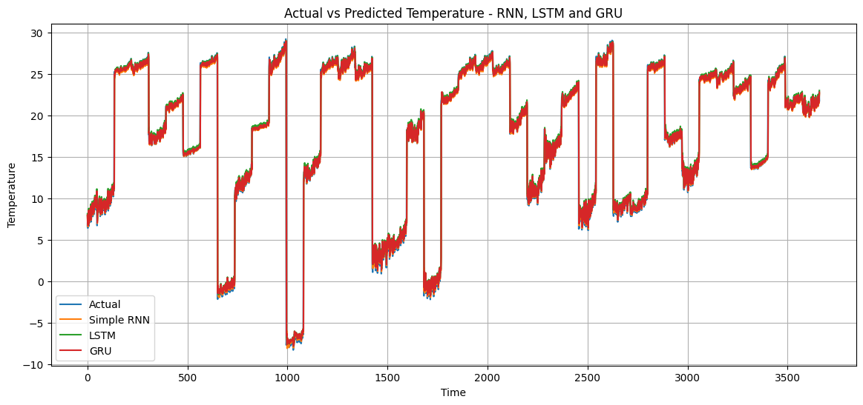
Q13 — comparison figure 4

Q14 — Availability
No explicit Q14 computational output is present in the supplied notebooks. No numerical result is invented here.

Part B — Embeddings / Sentiment Classification

Q5 — IMDB Sentiment Classification using Simple RNN
TensorFlow version: 2.20.0
Random seed: 42
Training samples: 25,000
Testing samples: 25,000
Training shape: (25000, 150)
Testing shape: (25000, 150)
Embedding dimension used for the final best model: 64
Model total parameters: 648,321

Q6 — Effect of Embedding Dimension
Embedding Dimension | Test Loss | Test Accuracy
32 | 0.692460 | 0.51508
64 | 0.563887 | 0.72656
128 | 0.682386 | 0.55664
Best embedding dimension: 64.

Q7 — Evaluation of Best Model
Metric | Value
Accuracy | 0.7266
Precision | 0.7050
Recall | 0.7793
F1-score | 0.7403
Classification report: Negative — precision 0.75, recall 0.67, F1 0.71, support 12,500; Positive — precision 0.70, recall 0.78, F1 0.74, support 12,500.
Confusion matrix: [[8423, 4077], [2759, 9741]].
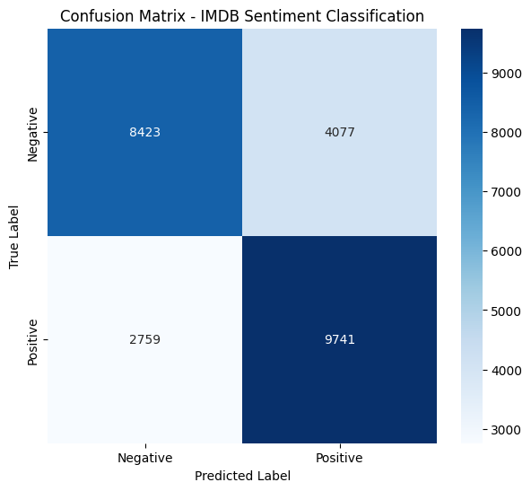
Q7 — confusion matrix / evaluation figure

Part D — English-to-Telugu Encoder–Decoder

Q15 — Encoder–Decoder Model
Dataset shape: (139, 2)
Clean dataset shape: (139, 2)
Training samples: 111
Testing samples: 28
English vocabulary size: 208
Telugu vocabulary size: 224
Maximum encoder length: 10
Maximum decoder length: 9
Total/trainable parameters: 901,344
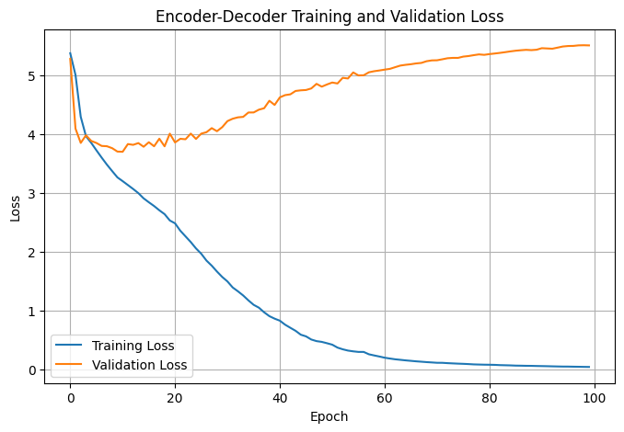
Q15 — training history figure
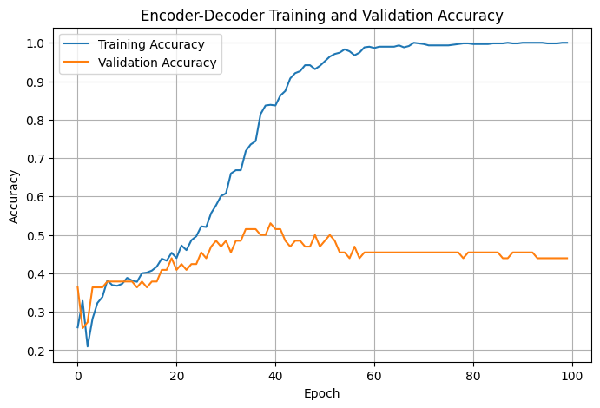
Q15 — model/evaluation figure

Q16 — Encoder Hidden and Cell States
Input sentence: How are you?
Token sequence: [73, 5, 1]
Padded sequence: [73, 5, 1, 0, 0, 0, 0, 0, 0, 0]
Encoder output shape: (1, 256)
Hidden state shape: (1, 256)
Cell state shape: (1, 256)
First 10 hidden values: [0.5867241, -0.35597575, 0.04544358, -0.2502345, 0.06435777, -0.5374918, -0.5176424, 0.41848752, -0.13276178, 0.06520225]
First 10 cell values: [0.95399916, -0.6438168, 0.07342168, -0.4451144, 0.0937154, -0.8410327, -1.0575085, 0.7098614, -0.39640945, 0.08245035]

Q17 — Decoder Using Encoder States
Encoder hidden state shape: (1, 256)
Encoder cell state shape: (1, 256)
<START> token ID: 1
Decoder receives: START token + encoder hidden state + encoder cell state
Decoder LSTM uses encoder states as its initial state to generate Telugu tokens.
Sample sentence was not in the test set; decoder architecture was successfully created.

Q18 — Fixed START/END Token Decoding
START token ID: 1
END token ID: 2
English Input: You are very kind.
Generated Telugu: నా రోజులో వచ్చిన అందమైన ఆశ్చర్యం ఆశ్చర్యం నువ్వే
Actual Telugu: నువ్వు చాలా దయగలవాడివి.

Q19 — 10 Unseen English-to-Telugu Translations
No. | English Input | Generated Telugu | Reference Telugu
1 | You are very kind. | నా రోజులో వచ్చిన అందమైన ఆశ్చర్యం ఆశ్చర్యం నువ్వే | నువ్వు చాలా దయగలవాడివి.
2 | I am proud of you. | నీతో మాట్లాడినప్పుడు నాకు సంతోషంగా ఉంటుంది | నిన్ను చూసి నేను గర్వపడుతున్నాను.
3 | Your smile brightens my day. | నవ్వులు నక్షత్రాలైతే నీ నవ్వు ఆకాశాన్ని వెలిగిస్తుంది | నీ నవ్వు నా రోజును వెలిగిస్తుంది.
4 | I am at home. | నీతో మాట్లాడినప్పుడు నాకు సంతోషంగా ఉంటుంది | నేను ఇంట్లో ఉన్నాను.
5 | You are looking cute today. | ప్రపంచంలోని అన్ని ఆనందాలకు నువ్వు అర్హుడివి | నువ్వు ఈ రోజు చాలా క్యూట్‌గా కనిపిస్తున్నావు.
6 | I am a student. | నీతో మాట్లాడినప్పుడు నాకు సంతోషంగా ఉంటుంది | నేను విద్యార్థిని.
7 | Can I borrow a little of your time? | నీకు అందమైన రోజు కావాలని కోరుకుంటున్నాను | నీ సమయం కొంచెం నాకు ఇస్తావా?
8 | Never give up. | నవ్వులు నక్షత్రాలైతే నీ నవ్వు ఆకాశాన్ని వెలిగిస్తుంది | ఎప్పుడూ వదులుకోకు.
9 | Do you like tea? | నీతో ఖాళీగా ఉన్నప్పుడు నాకు మెసేజ్ పంపు | నీకు టీ ఇష్టమా?
10 | I could listen to you all evening. | నీతో కలిసి కాఫీ తాగాలని నాకు చాలా ఇష్టం | నేను సాయంత్రం అంతా నీ మాటలు వింటూ ఉండగలను.

Q20 — BLEU Score Evaluation
BLEU metric | Score
BLEU-1 | 0.0526
BLEU-2 | 0.0335
BLEU-3 | 0.0145
BLEU-4 | 0.0103

Part E — Integrated Analysis

Q21 — Comparative RNN/LSTM/GRU Experiment
The available comparative experiment is Q13. It directly provides the requested three-model comparison. GRU gives the best MAE, MSE and RMSE, while Simple RNN uses the fewest parameters and trains fastest.
Model | MAE | MSE | RMSE
Simple RNN | 0.557966 | 2.143077 | 1.463925
LSTM | 0.558423 | 2.174513 | 1.474623
GRU | 0.528715 | 2.129772 | 1.459374

Q22 — Conceptual Interconnection
No separate computational result is required. The supplied Q15–Q20 artifacts demonstrate the chain: tokenized words → embeddings → recurrent hidden/cell states → encoder representation → decoder initialization → generated target-language sequence.

Q23 — Real-World Application
No separate notebook metric is present. A representative application is machine translation, directly illustrated by the English-to-Telugu encoder–decoder experiment in Q15–Q20.

Q24 — Integrated Conclusion
No separate notebook metric is present. Across the executed experiments, embeddings support sequence classification, gated recurrent units improve the temperature forecasting comparison, and encoder–decoder LSTMs provide the framework for sequence-to-sequence translation. The BLEU results also show that the small translation dataset/model still has substantial room for improvement.

Appendix — Source Notebook Mapping
Part A: dlassignment3a (1).ipynb — temperature forecasting, RNN/LSTM/GRU experiments and comparison.
Part B: dlassignment3b.ipynb — IMDB sentiment classification and embedding-dimension experiments.
Part D: dlassignment3d.ipynb — English-to-Telugu encoder–decoder and BLEU evaluation.

