**PROBLEM TWO: MERCHANT'S GUIDE TO THE GALAXY**

You decided to give up on earth after the latest financial collapse left 99.99% of the earth's population with 0.01% of the wealth. Luckily, with the scant sum of money that is left in your account, you are able to afford to rent a spaceship, leave earth, and fly all over the galaxy to sell common metals and dirt (which apparently is worth a lot).

Buying and selling over the galaxy requires you to convert numbers and units, and you decided to write a program to help you.

The numbers used for intergalactic transactions follows similar convention to the roman numerals and you have painstakingly collected the appropriate translation between them.

Roman numerals are based on seven symbols:

Symbol Value

[2]I [3]1

[4]V [5]5

[6]X [7]10

[8]L [9]50

[10]C [11]100

[12]D [13]500

[14]M [15]1,000

Numbers are formed by combining symbols together and adding the values. For example, MMVI is 1000 + 1000 + 5 + 1 = 2006. Generally, symbols are placed in order of value, starting with the largest values. When smaller values precede larger values, the smaller values are subtracted from the larger values, and the result is added to the total. For example MCMXLIV = 1000 + (1000 − 100) + (50 − 10) + (5 − 1) = 1944.

The symbols "I", "X", "C", and "M" can be repeated three times in succession, but no more. (They may appear four times if the third and fourth are separated by a smaller value, such as XXXIX.) "D", "L", and "V" can never be repeated. "I" can be subtracted from "V" and "X" only. "X" can be subtracted from "L" and "C" only. "C" can be subtracted from "D" and "M" only. "V", "L", and "D" can never be subtracted. Only one small-value symbol may be subtracted from any large-value symbol. A number written in [16]Arabic numerals can be broken into digits. For example, 1903 is composed of 1, 9, 0, and 3. To write the Roman numeral, each of the non-zero digits should be treated separately. Inthe above example, 1,000 = M, 900 = CM, and 3 = III. Therefore, 1903 = MCMIII.

(Source: Wikipedia ( [17]<http://en.wikipedia.org/wiki/Roman_numerals>)

Input to your program consists of lines of text detailing your notes on the conversion between intergalactic units and roman numerals.

You are expected to handle invalid queries appropriately.

Test input: glob is I prok is V pish is X tegj is L glob glob Silver is 34 Credits glob prok Gold is 57800 Credits pish pish Iron is 3910 Credits how much is pish tegj glob glob ? how many Credits is glob prok Silver ? how many Credits is glob prok Gold ? how many Credits is glob prok Iron ?

Test Output: pish tegj glob glob is 42 glob prok Silver is 68 Credits glob prok Gold is 57800 Credits glob prok Iron is 782 Credits

EJECUCION DE LA APLICACION

Para ejecutar la aplicación con ayuda de ANT se debe realizar la tarea **build** la cual generara un .jar dentro del mismo proyecto, este archivo jar se lo debe copiar a cualquier parte del computador por ejemplo el escritorio y ejecutar la siguiente línea. (No olvidar que debemos tener previamente instalado nuestro JDK, JRE y JVM.)

*java -jar merchant.jar*

En nuestro caso fue de la siguiente manera:

**C:\Users\HIDALGO_M\Desktop>java -jar merchant.jar**

Una vez iniciado aparecerá lo siguiente:

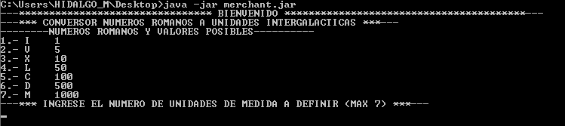

Debemos ingresar el número de las nuevas unidades a definir por ejemplo máximo 7(Como está basado en los numero romanos solo existen 7 posibilidades).

En este caso hemos definido de la siguiente manera:

|  |  |  |
| --- | --- | --- |
| SÍMBOLO | VALOR | NUEVA UNIDAD |
| I | 1 | UNO |
| V | 5 | DOS |
| X | 10 | TRES |
| L | 50 | CUATRO |
| C | 100 | CINCO |
| D | 500 | SEIS |
| M | 1000 | SIETE |

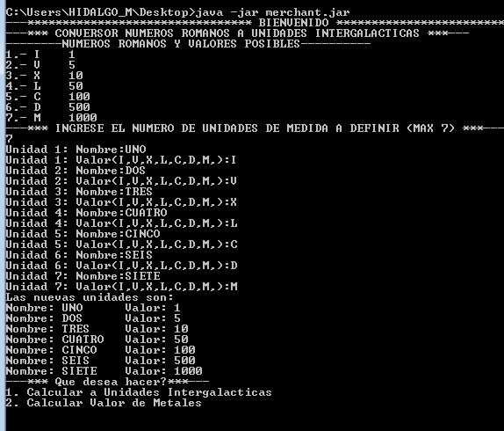

Debemos ingresar la opción que nos pide el programa, tal y como observamos en la anterior imagen.

Si seleccionamos la opción 1 y deseamos convertir la cantidad “SIETE CINCO SIETE UNO UNO UNO” el resultado equivale a MCMIII = 1903.

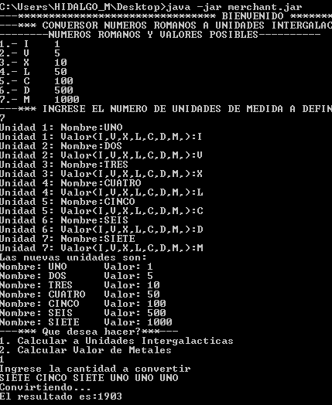

Si seleccionamos la opción 2, nos pedirá que definamos los metales a comercializar, tanto en número de metales a comercializar como a su equivalencia en las nuevas unidades creadas.

En el siguiente ejemplo definir que son 3 metales a comercializar: GOLD, IRON, SILVER; La equivalencia de cada metal respectivamente 3,2,1.

Nos pedirá adicionalmente de cual metal queremos encontrar su respectiva equivalencia.

