**PICO Y PLACA PREDICTOR**

This is a JAVA challenge project using Eclipse as IDE, if you want to use another please remove the files/folders not supported.

**### Prerequisites**

- [JDK 1.8]

- [Eclipse]

- [Maven]

**### How to run**

- Install Eclipse.

- Import/Open the project on Eclipse.

- In order to verify project's compile please open command prompt in the root project's path and put mvn clean install

(No test) mvn clean install -Dmaven.test.skip=true

**###IMPORTANT!**

- If you want to test the program you must change the inputs inside the main test java class (PicoPlacaPredictorTest)

**WHAT DO I SUPPOSE?**

In order to develop the application, I developed taking reference the sistem about pico y placa in Ecuador. So, you can see a dummy class call AgenciaNacionalTransitoService in order to validate one car as Taxi or Goverment car(These cars does not have pico y placa).

**Project’s design**

**PicoPlacaPredictor**

**Car**

**Main**

**LicensePlateNumber**

**PicoPlacaConfiguration**

**PicoPlacaSchedule**

PicoPlacaDayConfigurations

Day Configuration

**Monday**

**Friday**

**Configuration**

**Configuration**

**TuesdayConfiguration**

**WednesdayConfiguration**

**As you can see, I have used a State pattern and Conditional withPolymorphism( Book Refactorin by Martin Fowler).**

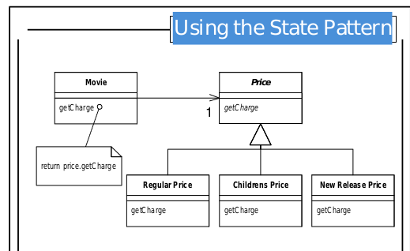

**TEST OF APPLICATION (mvn clean install)**

**Generate JAR**

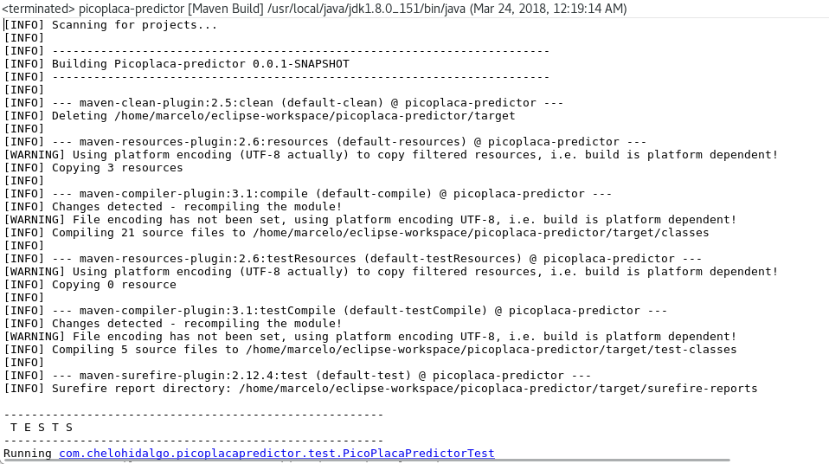

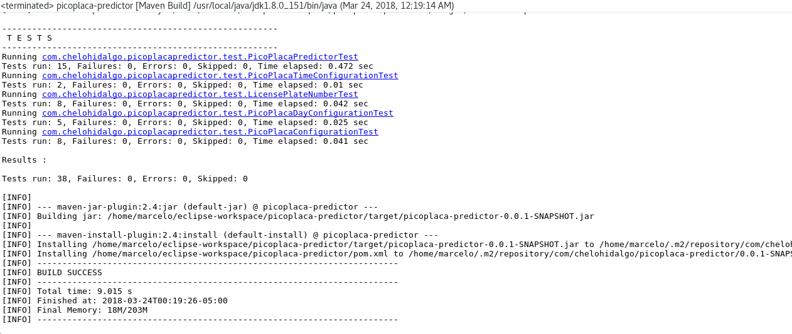

**EXAMPLE UNIT TEST CASES**

This is the example with just one test clase with Junit.