Architecture application

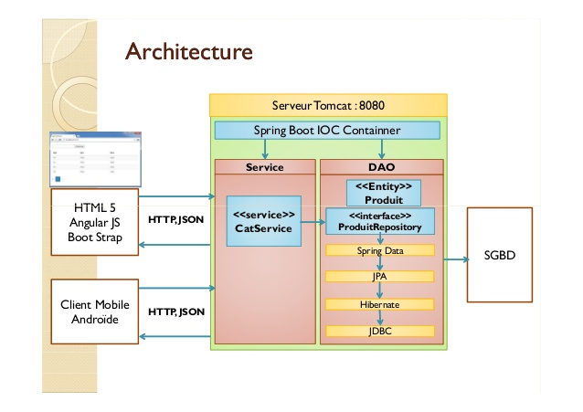

The application has been done using:

|  |  |
| --- | --- |
| **BACKEND** | **FRONT END** |
| Spring Boot 1.5.3-RELEASE  Maven 3.2.5  MySQL 5.7 | Angular 1  Bootstrap  Kendo |

In order to generate the application I have used Maven as a tool for deployments.

The MySQL database for this challenge is called as library, the user root and the password root.

Start application

Go to the source folder example C:\Users\mhidalgo\Desktop\test-spring-boot-mysql, and using the command line to execute “mvn spring-boot:run”.

Consider if we need to change the port we must change it at “application.properties” and “app.js”, then to compile again(mvn clean install -Dmaven.test.skip=true)

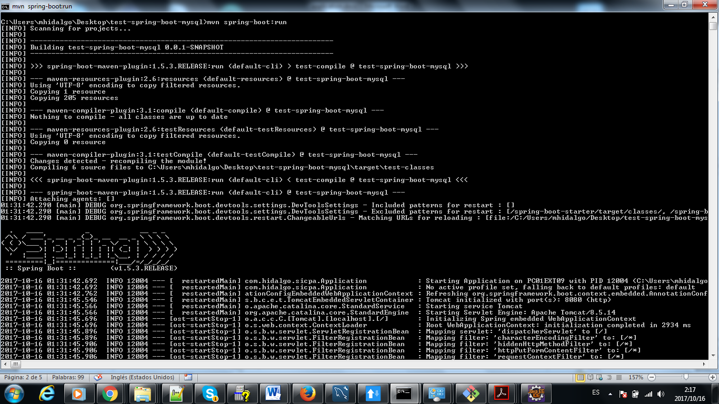

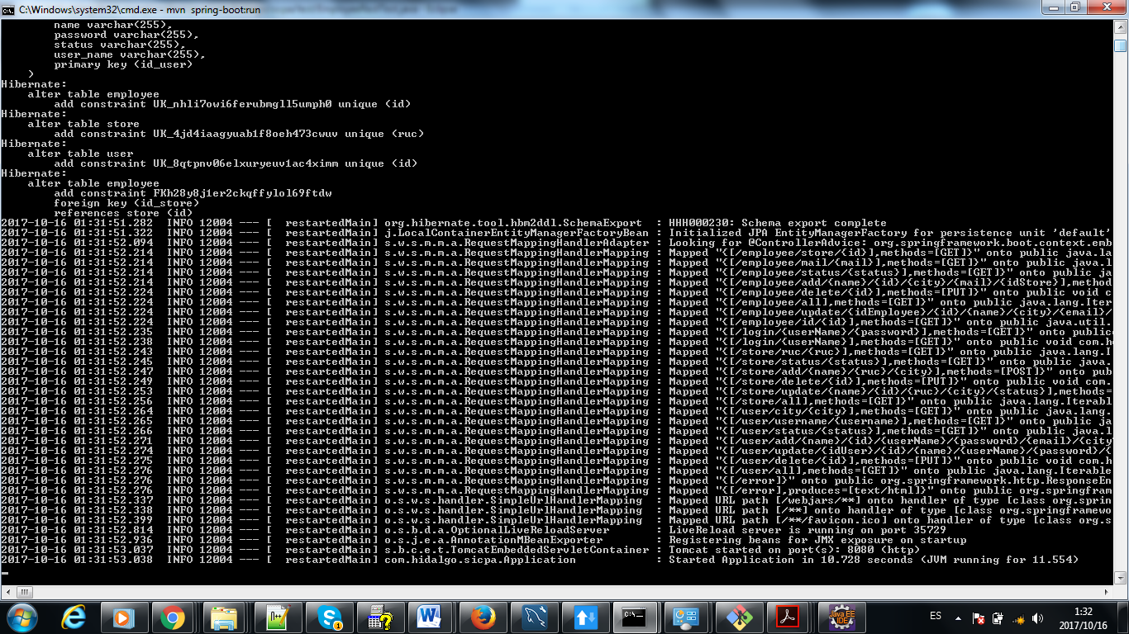

Project Structure

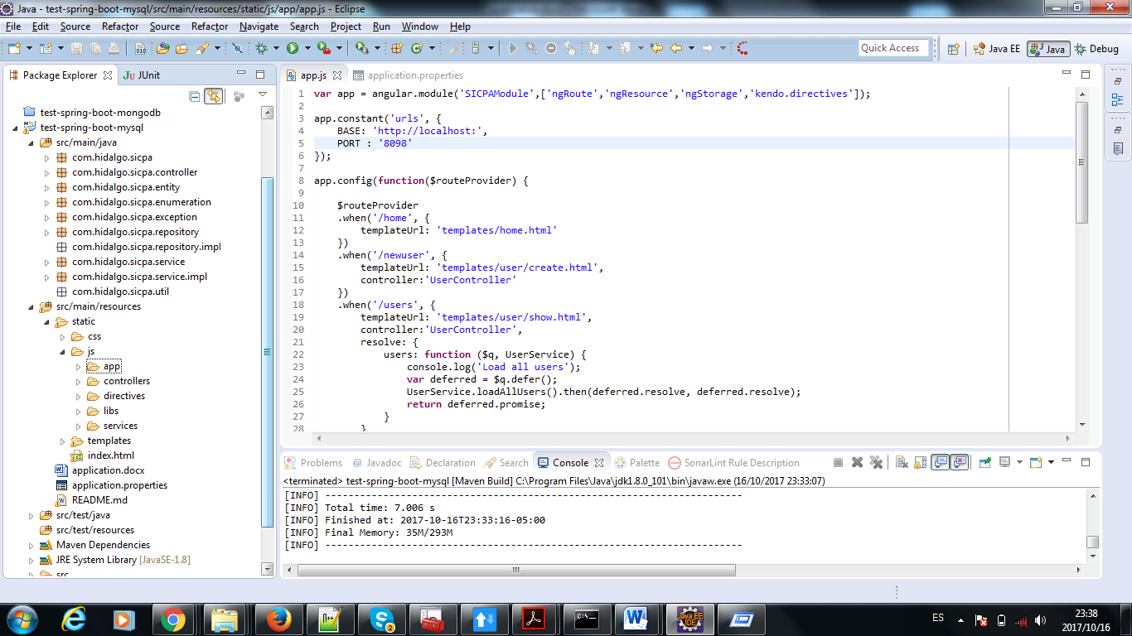

Unit tests over stores

In order to verify the unit test please to execute the test one by one with Run as Junit Test.

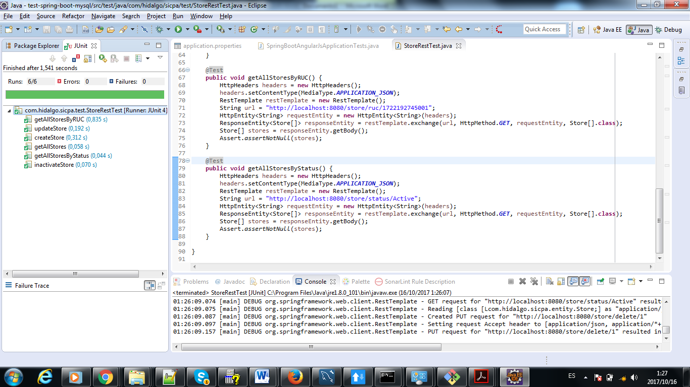

Unit test over user

In order to verify the unit test please to execute the test one by one with Run as Junit Test.

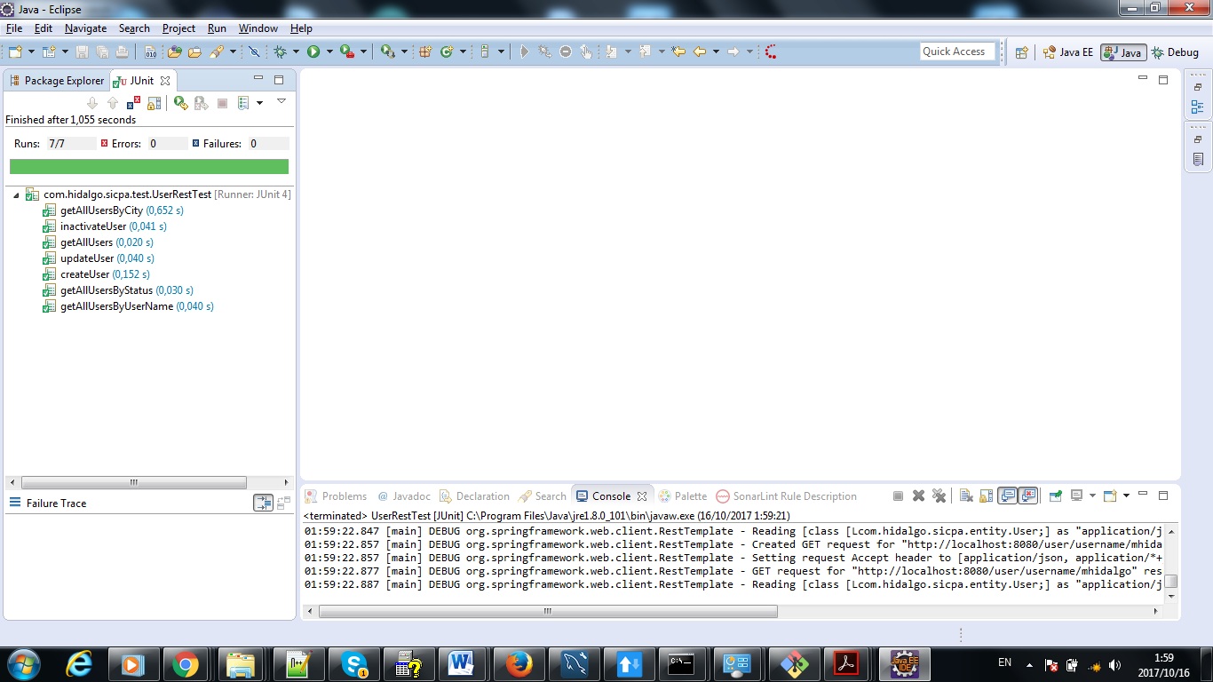

Unit test over employee

In order to verify the unit test please to execute the test one by one with Run as Junit Test.

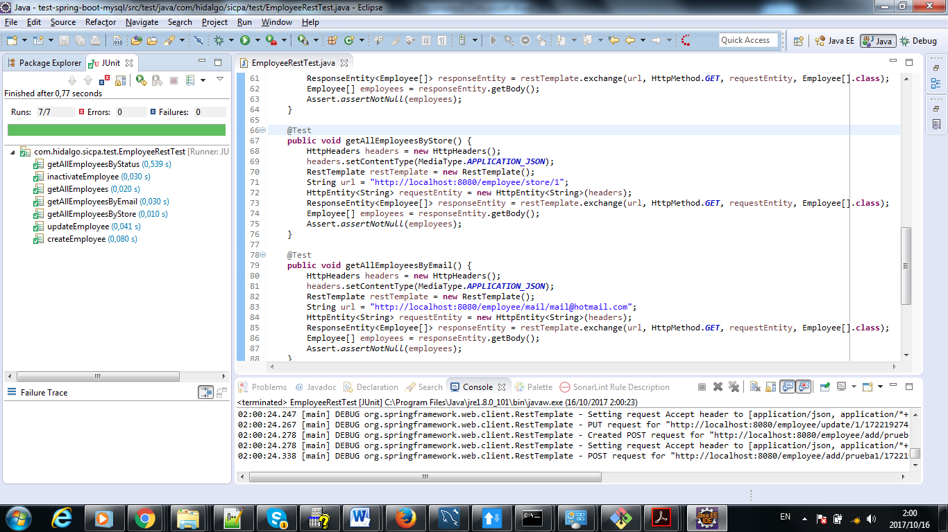

Spring Boot Unit test Validations

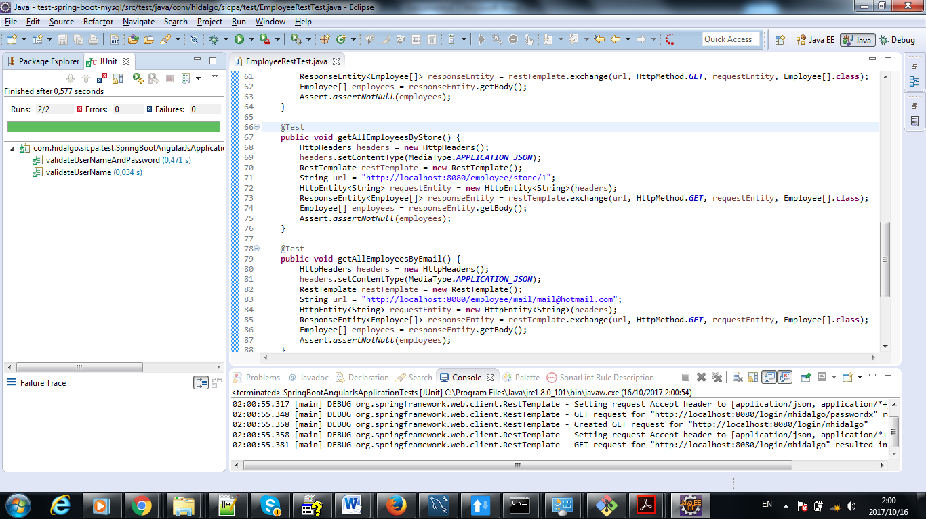

User validations units test

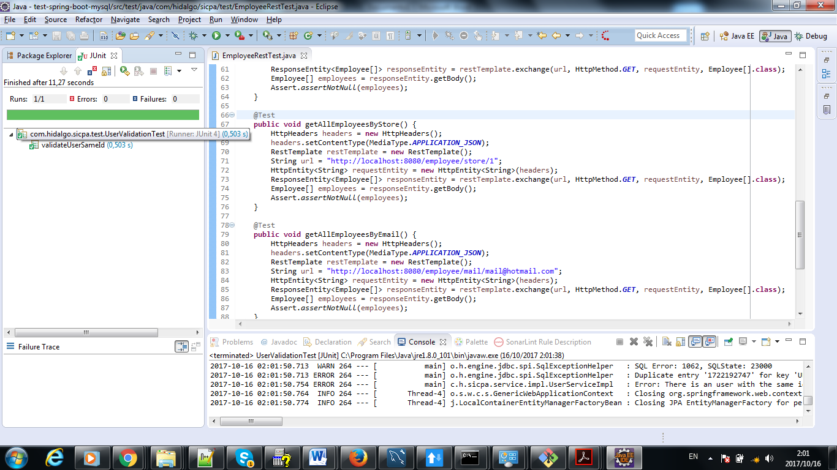

Store Validation Unit test

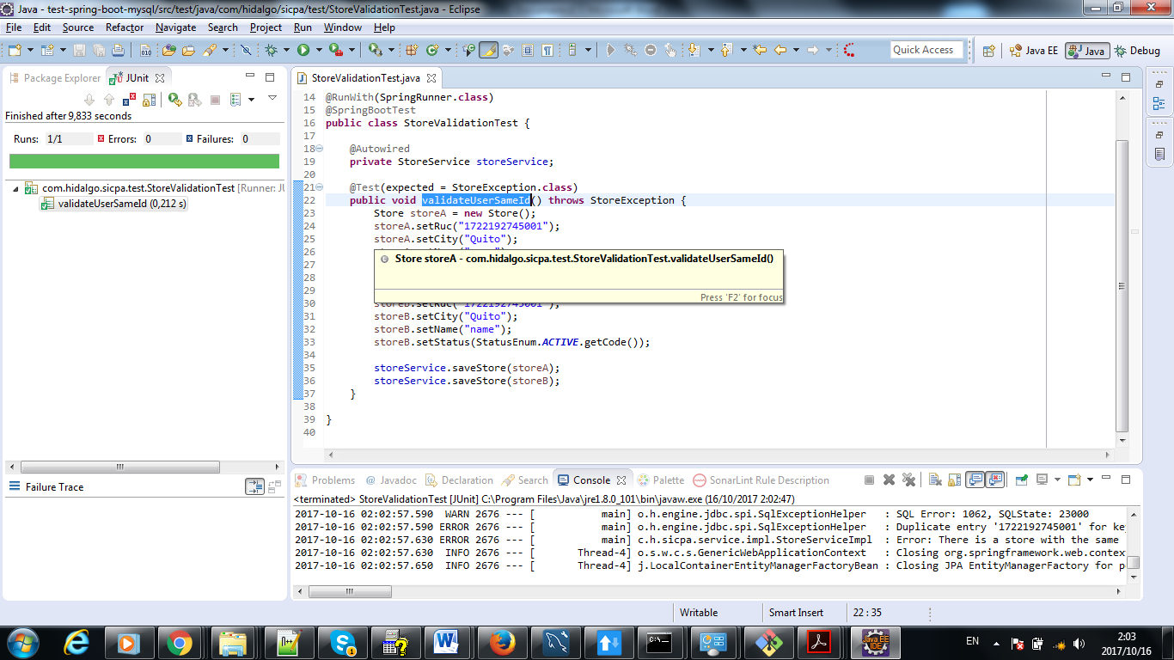

LOGIN PAGE(login.html)

In the browser put <http://localhost:8010/index.html#!/>.

Don’t forget to change the port with the same port that you deploy the project.

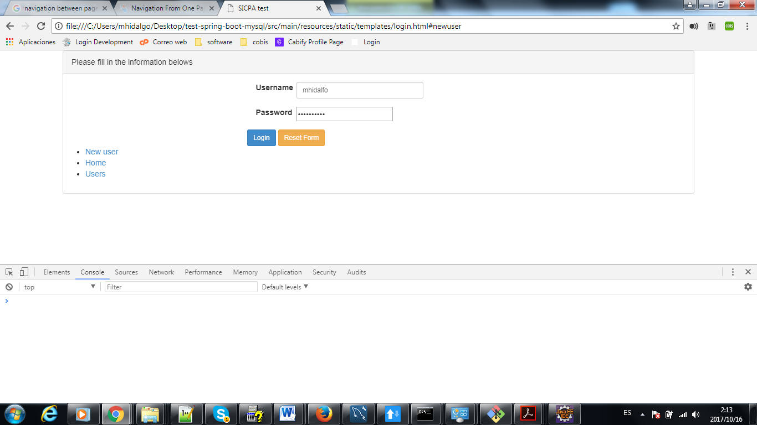

Si el ingreso fue correcto

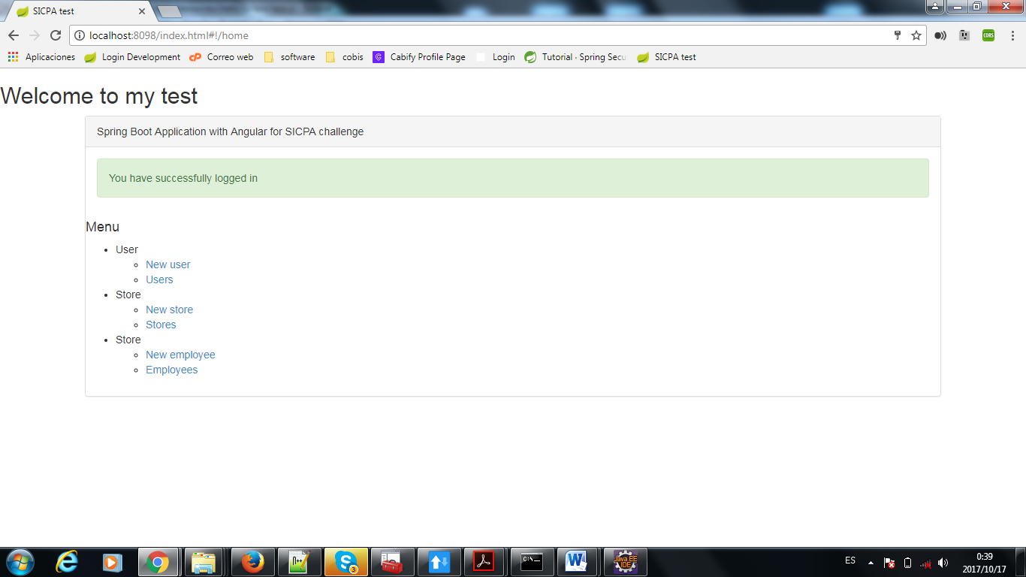

Ingreso no exitoso

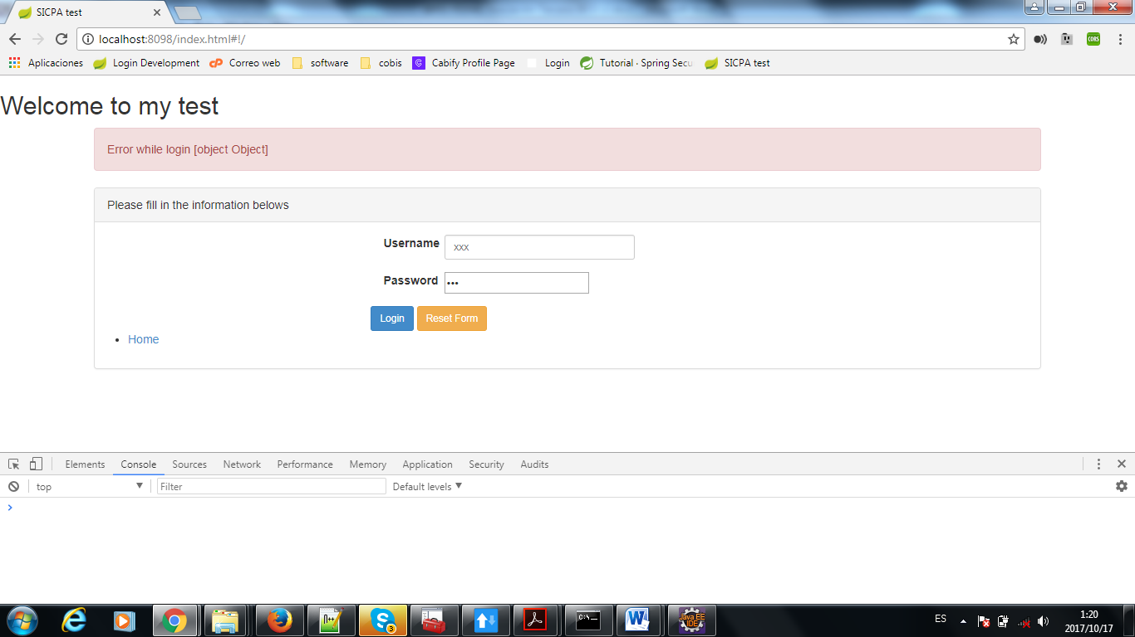

Creacion de usuario

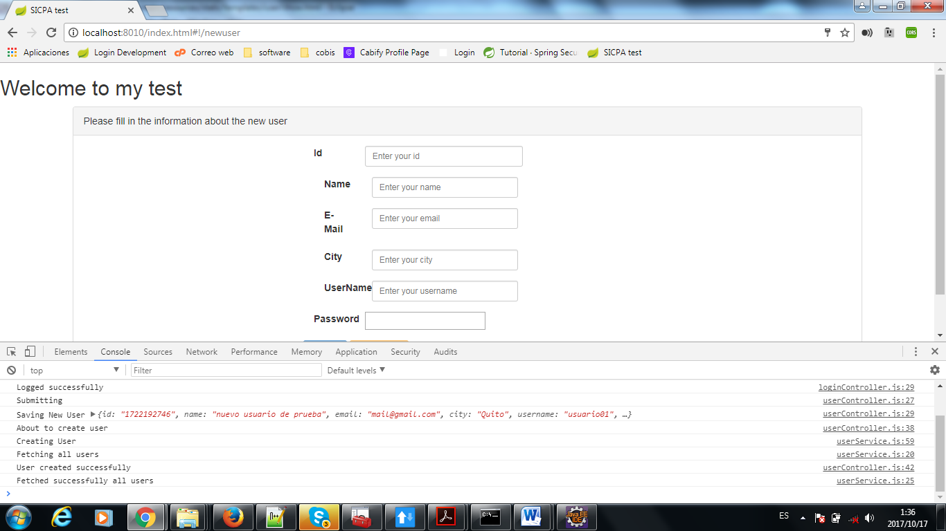

Busqueda de Usuario

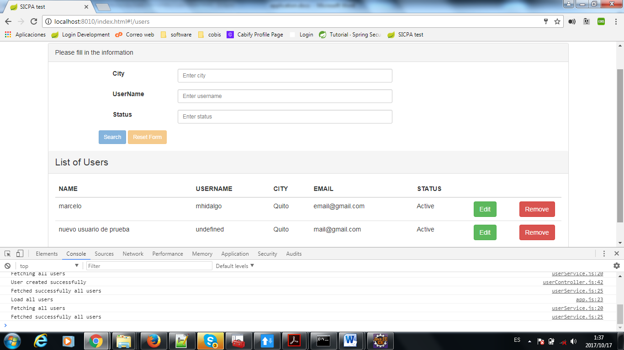

Inactivacion de usuario (Borrado lógico --- cambio de estado)

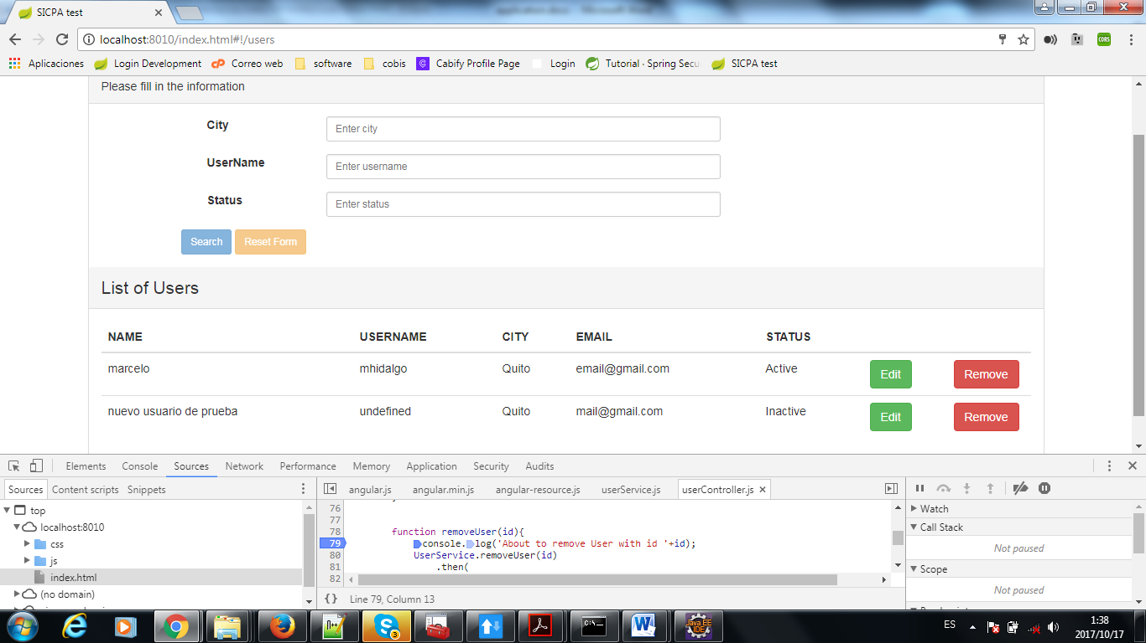

Creating new Store

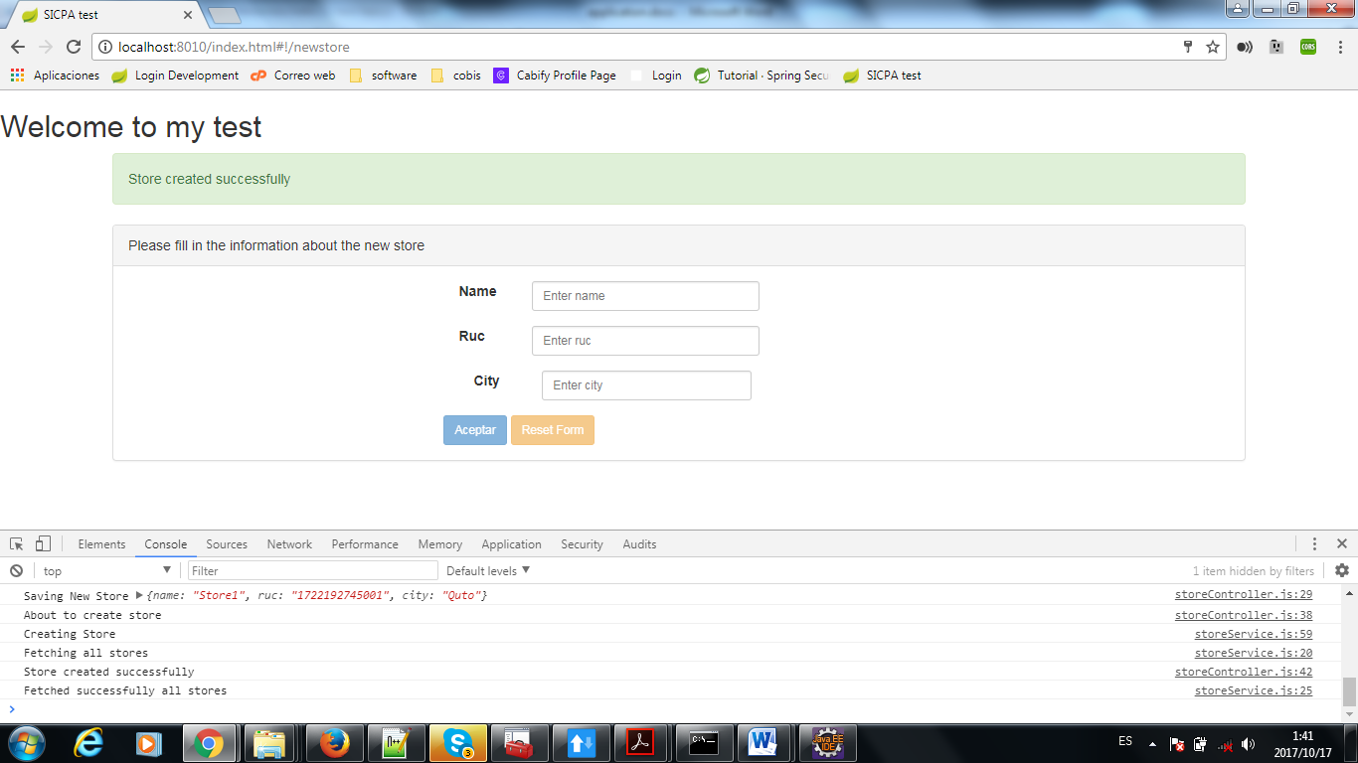

Get All Stores

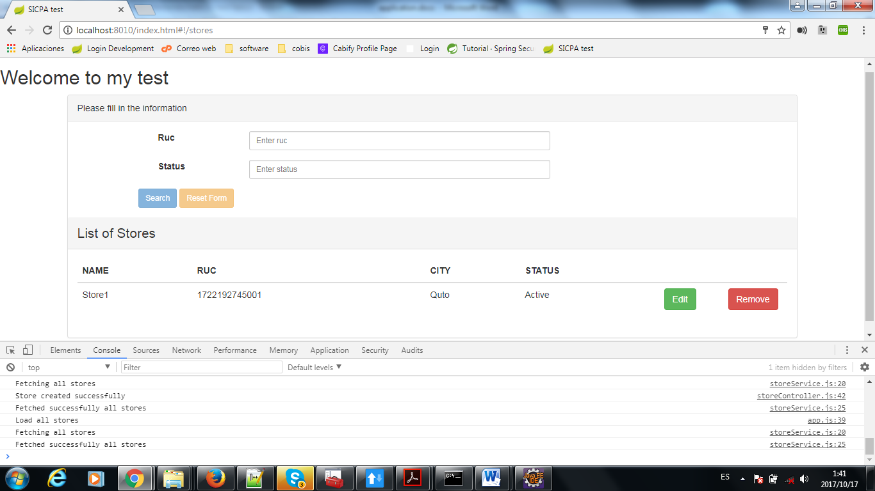

Inactivate Store

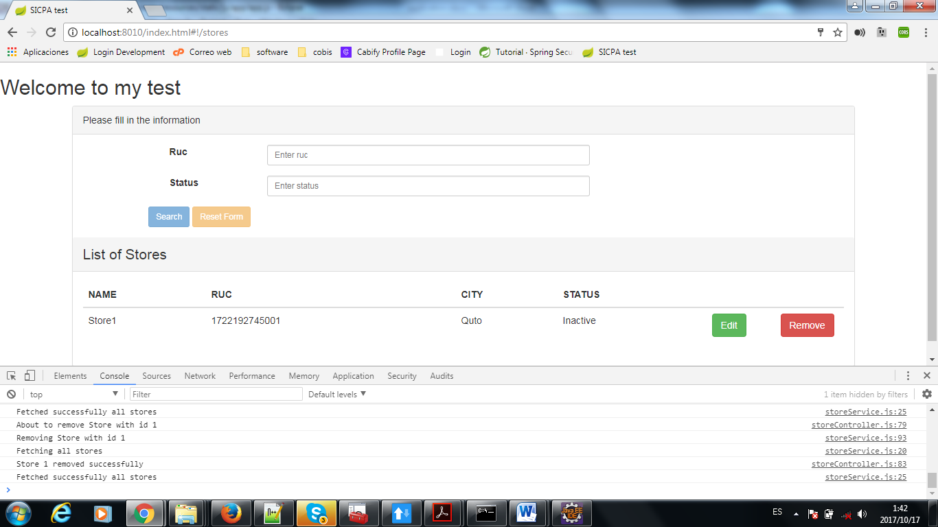

Find Stores by RUC

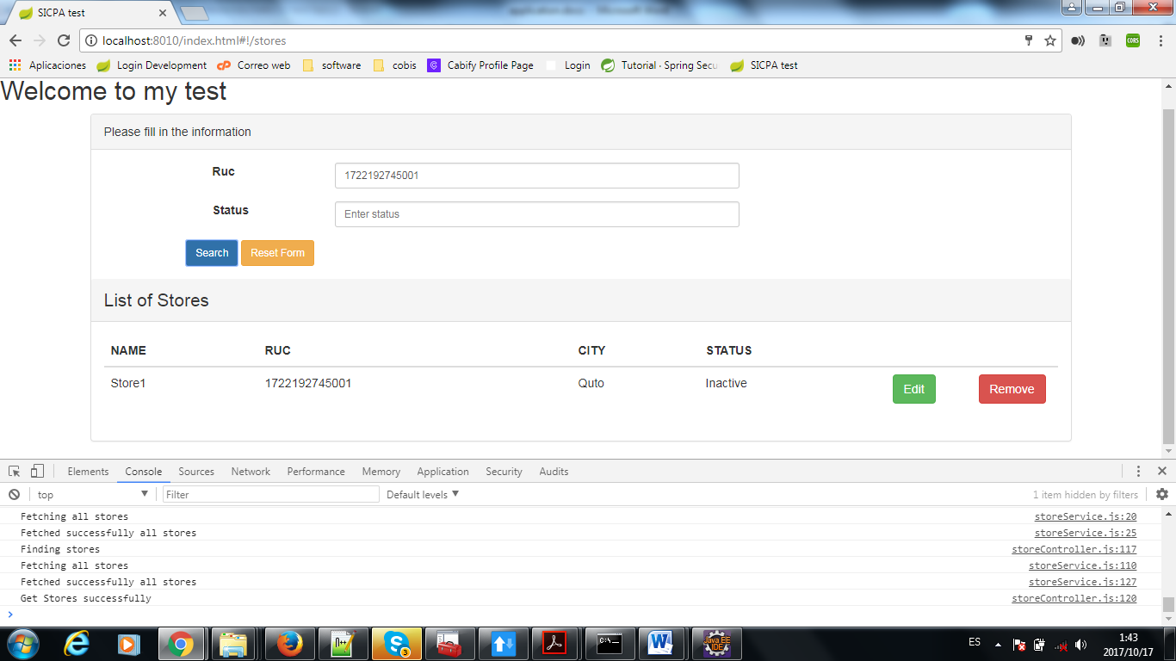

I had troubles in order to create employees with an associate store.

I didn´t make the spring security, being honest this was my first angular 1 application done by myself.

Good luck.

Thanks and regards