Supporting Figures
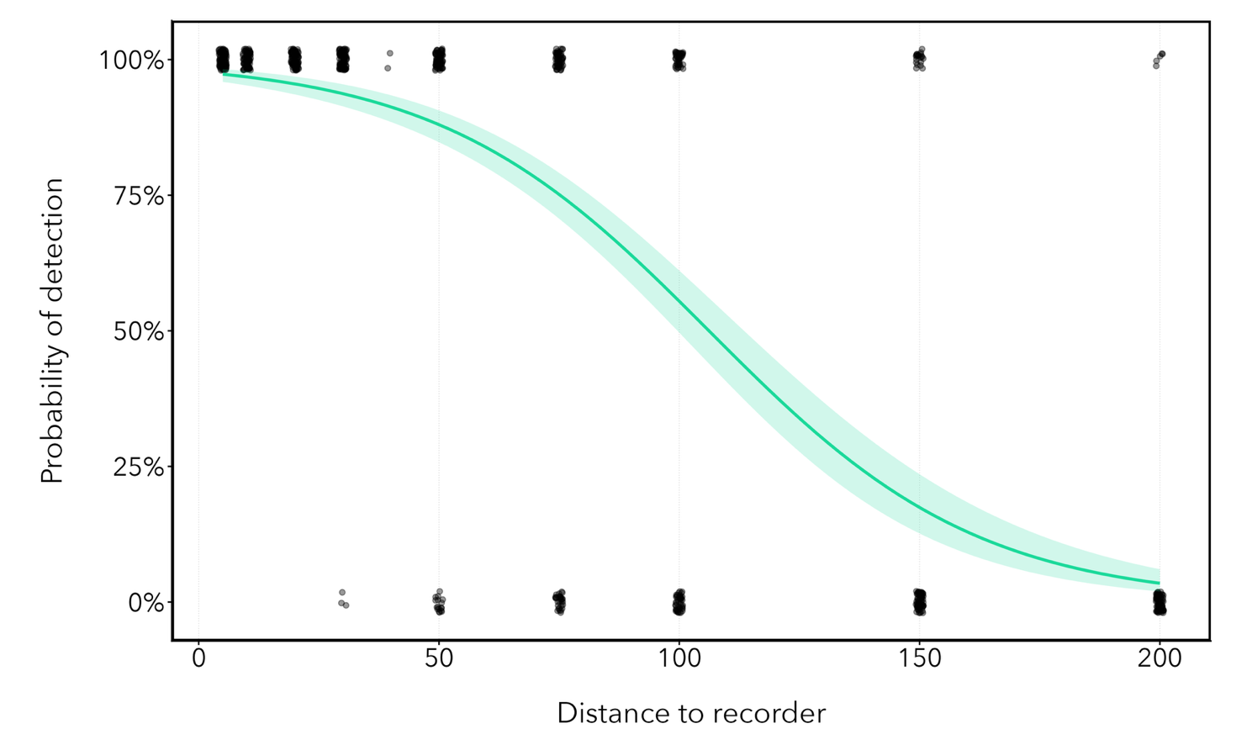
Figure S1. Probability of detecting the call of Litoria gracilenta at increasing distance from the recorder, based on field playback trials using the same recording equipment (Frontier Labs Solar BAR with a Primo EM172 microphone). Broadcast calls were played at distances of 5–200 m and scored as detected or not detected in the resulting recordings. The green line shows the fitted probability of detection from a logistic regression, and the shaded band represents the 95% confidence interval. Black points represent individual playback trials (detected = 1, not detected = 0) and are jittered vertically and horizontally to reduce overplotting.

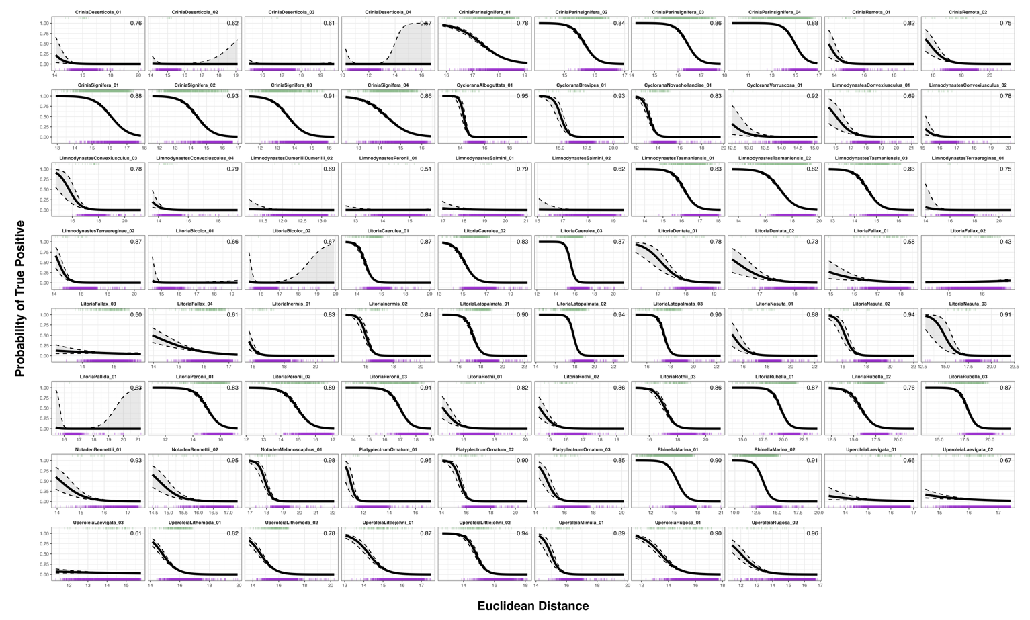
Figure S2. Probability of correctly predicting true positive detections based on the Euclidean distance for each of the 115 example calls, analysed for the 50 frog species used in this study. The green bars represent true positive detections and purple bars false positive detections. The dashed lines and grey area indicate the 95% confidence intervals. The number in the top right corner of each plot indicates the probability that a true positive detection had a lower Euclidean distance than a false positive detection on any given day for that specific example call. Lower Euclidean distances generally corresponded to a higher probability of correctly detecting of an example call.

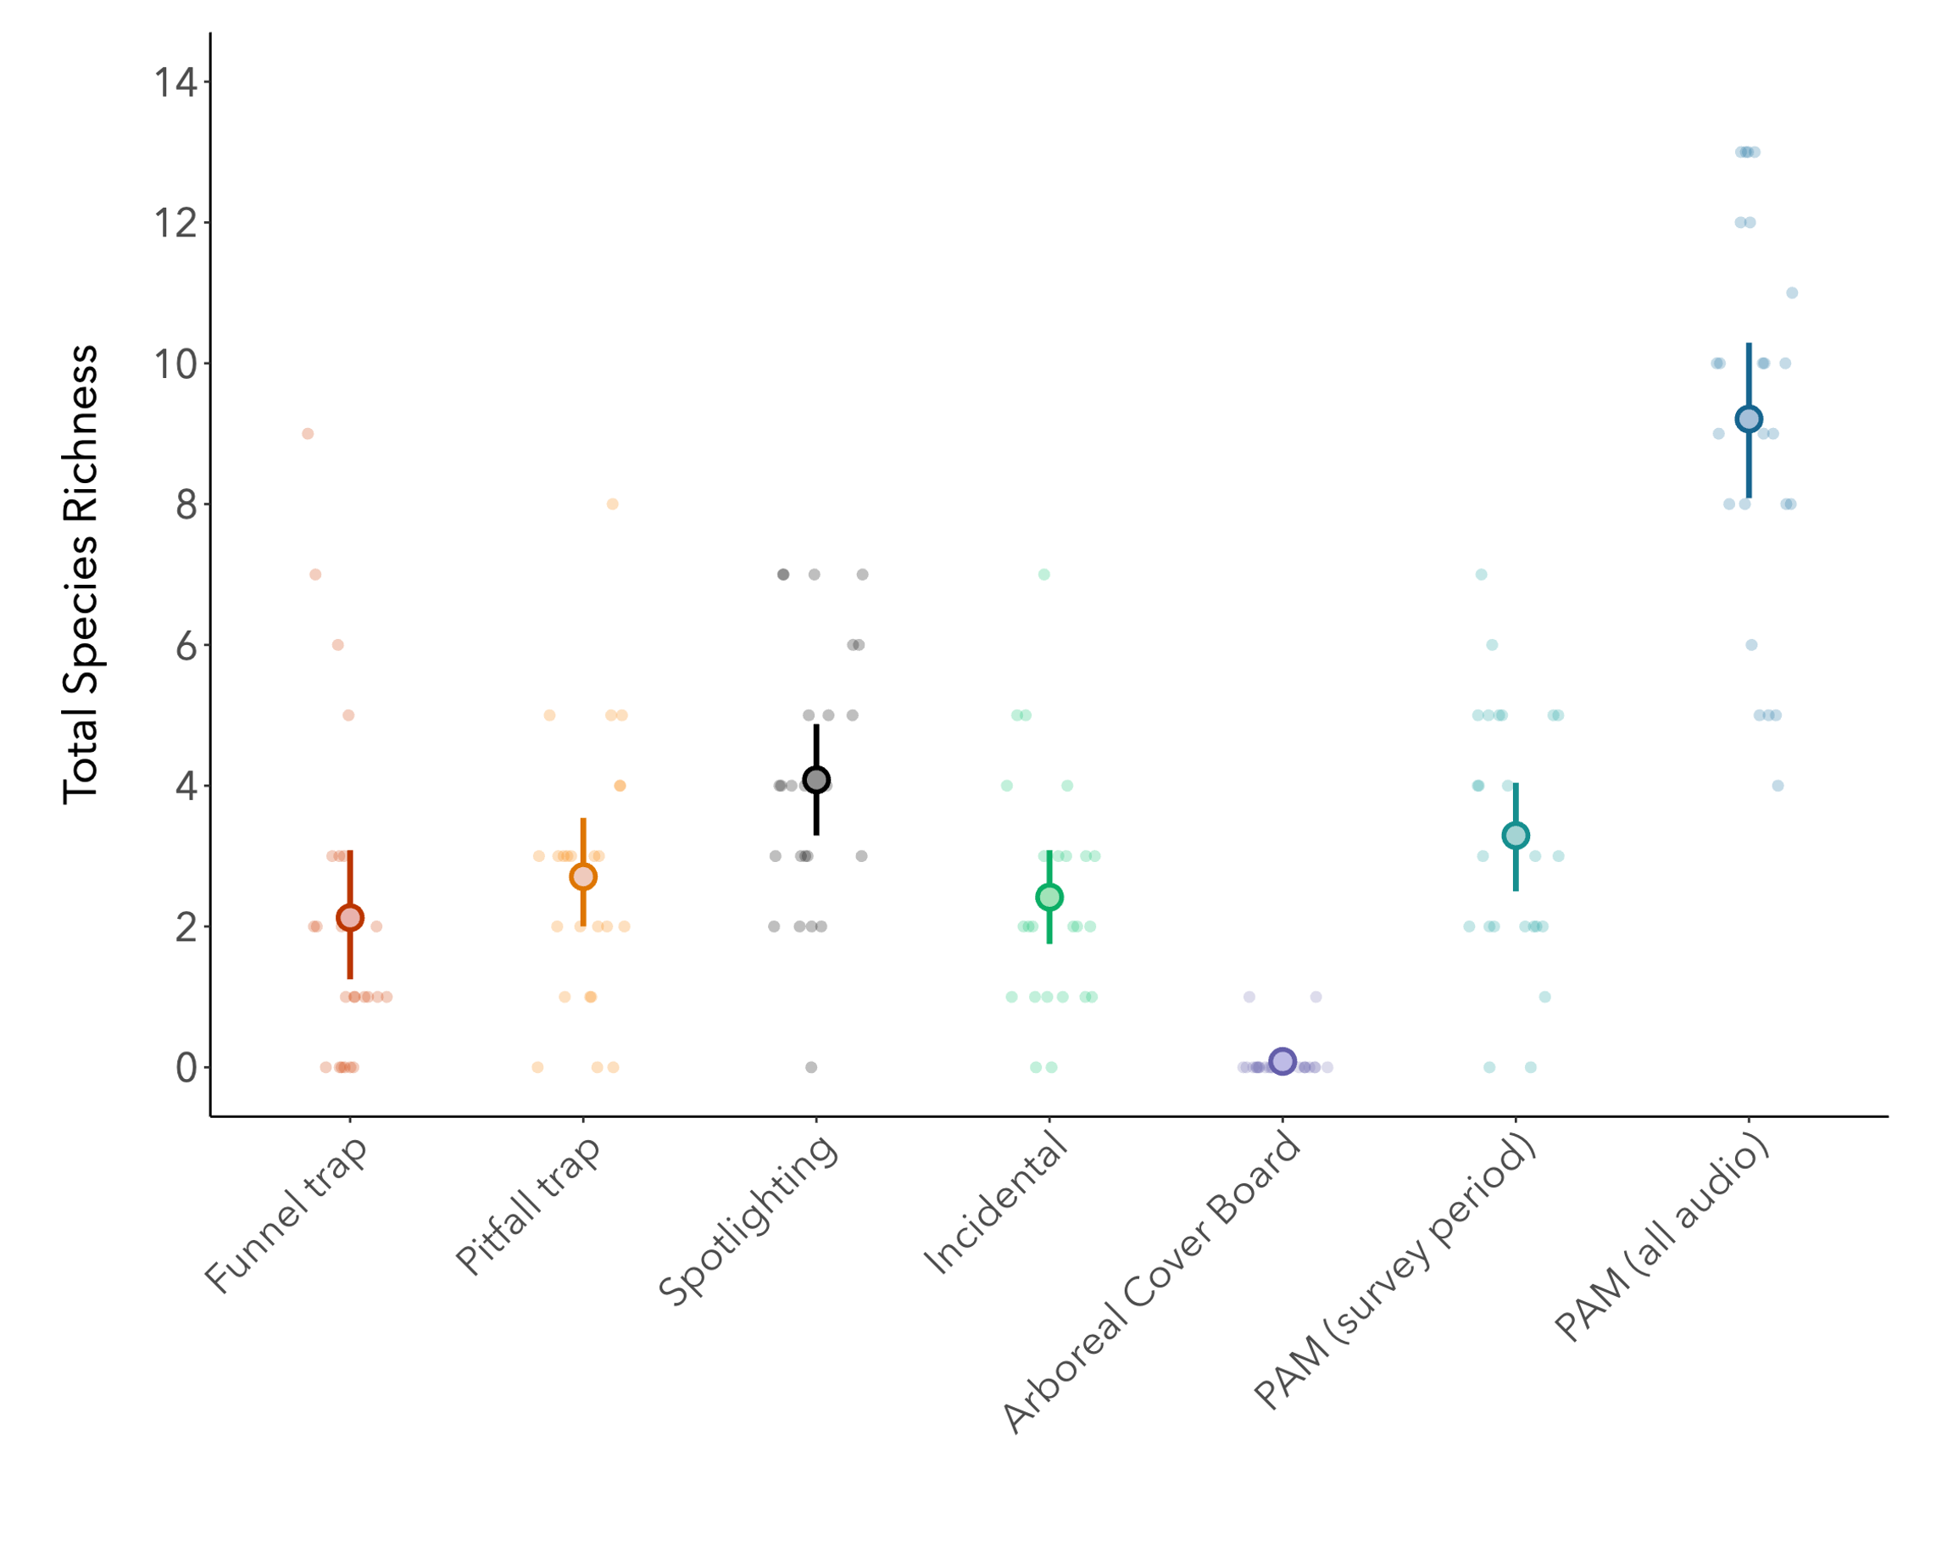
Figure S3. Total species richness of frogs for each survey plot at each site detected by each individual survey method: observer-based monitoring split into funnel trapping (red), pitfall trapping (orange), spotlighting (black), incidental encounters (green), and arboreal cover boards (purple), passive acoustic monitoring using only audio data matching the survey period (light blue), and passive acoustic monitoring using all available audio data (dark blue). Points and error bars represent the mean ± 95% confidence intervals.
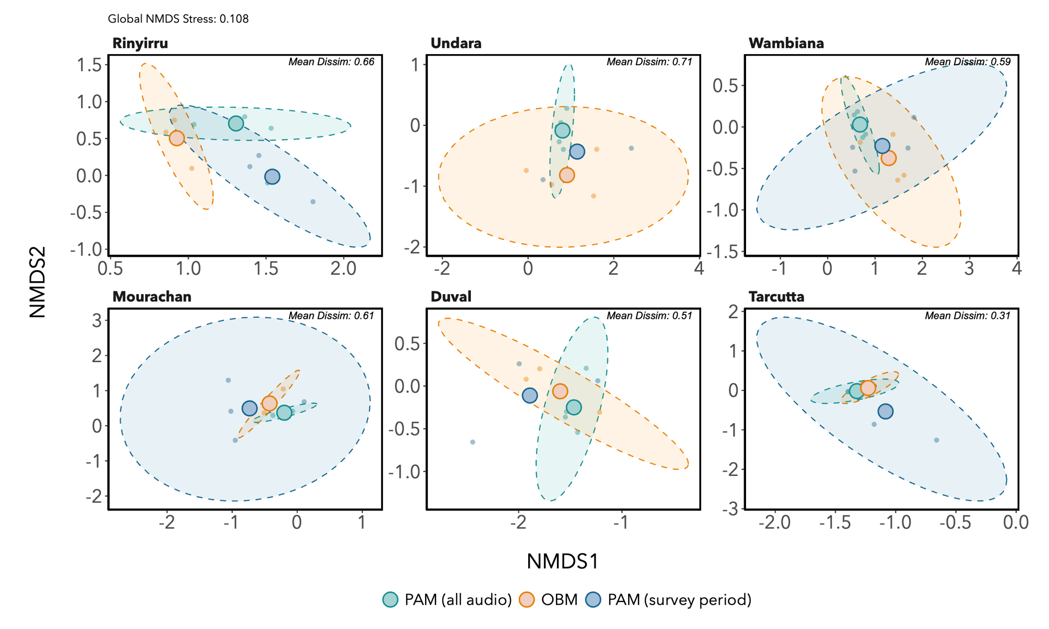
Figure S4. Community composition analysis comparing frog survey methods at each site separately. Non-metric multidimensional scaling (NMDS) ordination of frog communities based on Jaccard dissimilarity (presence-absence). Large points represent the centroids for each method, shaded regions indicate 95% confidence ellipses, and small points represent individual survey plots.
Supporting Tables
Table S1. Overview of the number and source of the 115 example calls for 50 Australian frog species used in this study.
Common Name | Scientific Name | Example Call | Source
Bufonidae
Cane Toad | Rhinella marina | RhinellaMarina_01 | David Stewart
Cane Toad | Rhinella marina | RhinellaMarina_02 | David Stewart
Hylidae
Striped Burrowing Frog | Cyclorana alboguttata | CycloranaAlboguttata_01 | David Stewart
Superb Collared Frog | Cyclorana brevipes | CycloranaBrevipes_01 | David Stewart
Knife-footed Frog | Cyclorana cultripes | CycloranaCultripes_01 | David Stewart
Knife-footed Frog | Cyclorana cultripes | CycloranaCultripes_02 | David Stewart
Eastern Snapping Frog | Cyclorana novaehollandiae | CycloranaNovaehollandiae_01 | David Stewart
Eastern Water-holding Frog | Cyclorana platycephalus | CycloranaPlatycephala_01 | FrogID
Eastern Water-holding Frog | Cyclorana platycephalus | CycloranaPlatycephala_02 | FrogID
Rough Collared Frog | Cyclorana verrucosa | CycloranaVerruscosa_01 | David Stewart
Northern Sedge Frog | Carichyla bicolor | LitoriaBicolor_01 | David Stewart
Northern Sedge Frog | Carichyla bicolor | LitoriaBicolor_02 | David Stewart
Booroolong Frog | Rhyaconastes booroolongensis | LitoriaBooroolongensis_01 | Michael Mahony
Booroolong Frog | Rhyaconastes booroolongensis | LitoriaBooroolongensis_02 | Michael Mahony
Booroolong Frog | Rhyaconastes booroolongensis | LitoriaBooroolongensis_03 | Michael Mahony
Green Tree Frog | Pelodryas caerulea | LitoriaCaerulea_01 | David Stewart
Green Tree Frog | Pelodryas caerulea | LitoriaCaerulea_02 | David Stewart
Green Tree Frog | Pelodryas caerulea | LitoriaCaerulea_03 | David Stewart
Robust Bleating Tree Frog | Coleeneremia dentata | LitoriaDentata_01 | David Stewart
Robust Bleating Tree Frog | Coleeneremia dentata | LitoriaDentata_02 | David Stewart
Brown Tree Frog | Rawlinsonia ewingii | LitoriaEwingii_01 | FrogID
Brown Tree Frog | Rawlinsonia ewingii | LitoriaEwingii_02 | FrogID
Brown Tree Frog | Rawlinsonia ewingii | LitoriaEwingii_03 | FrogID
Eastern Dwarf Tree Frog | Drymomantis fallax | LitoriaFallax_01 | David Stewart
Eastern Dwarf Tree Frog | Drymomantis fallax | LitoriaFallax_02 | David Stewart
Eastern Dwarf Tree Frog | Drymomantis fallax | LitoriaFallax_03 | David Stewart
Eastern Dwarf Tree Frog | Drymomantis fallax | LitoriaFallax_04 | David Stewart
Bumpy Rocket Frog | Litoria inermis | LitoriaInermis_01 | David Stewart
Bumpy Rocket Frog | Litoria inermis | LitoriaInermis_02 | David Stewart
Broad-palmed Rocket Frog | Litoria latopalmata | LitoriaLatopalmata_01 | David Stewart
Broad-palmed Rocket Frog | Litoria latopalmata | LitoriaLatopalmata_02 | David Stewart
Broad-palmed Rocket Frog | Litoria latopalmata | LitoriaLatopalmata_03 | David Stewart
Jevelin Frog | Mahonabatrachus microbelos | LitoriaMicrobelos_01 | David Stewart
Jevelin Frog | Mahonabatrachus microbelos | LitoriaMicrobelos_02 | David Stewart
Striped Rocket Frog | Litoria nasuta | LitoriaNasuta_01 | David Stewart
Striped Rocket Frog | Litoria nasuta | LitoriaNasuta_02 | David Stewart
Striped Rocket Frog | Litoria nasuta | LitoriaNasuta_03 | David Stewart
Tawney Rocket Frog | Litoria nigrofrenata | LitoriaNigrofrenata_01 | David Stewart
Pale Rocket Frog | Litoria pallida | LitoriaPallida_01 | David Stewart
Pale Rocket Frog | Litoria pallida | LitoriaPallida_02 | David Stewart
Peron’s Tree Frog | Pengilleyia peronii | LitoriaPeronii_01 | David Stewart
Peron’s Tree Frog | Pengilleyia peronii | LitoriaPeronii_02 | David Stewart
Peron’s Tree Frog | Pengilleyia peronii | LitoriaPeronii_03 | David Stewart
Southern Bell Frog | Ranoidea raniformis | LitoriaRaniformis_01 | Sarah Talbot
Southern Bell Frog | Ranoidea raniformis | LitoriaRaniformis_02 | Sarah Talbot
Northern Laughing Tree Frog | Pengilleyia rothii | LitoriaRothii_01 | David Stewart
Northern Laughing Tree Frog | Pengilleyia rothii | LitoriaRothii_02 | David Stewart
Northern Laughing Tree Frog | Pengilleyia rothii | LitoriaRothii_03 | David Stewart
Ruddy Tree Frog | Coleeneremia pyrina | LitoriaRubella_01 | David Stewart
Ruddy Tree Frog | Coleeneremia pyrina | LitoriaRubella_02 | David Stewart
Ruddy Tree Frog | Coleeneremia pyrina | LitoriaRubella_03 | David Stewart
Tyler's Tree Frog | Pengilleyia tyleri | LitoriaTyleri_01 | David Stewart
Tyler's Tree Frog | Pengilleyia tyleri | LitoriaTyleri_02 | David Stewart
Whistling Tree Frog | Rawlinsonia verreauxii verreauxii | LitoriaVerreaixiiVereauxii_01 | David Stewart
Whistling Tree Frog | Rawlinsonia verreauxii verreauxii | LitoriaVerreaixiiVereauxii_02 | David Stewart
Limnodynastidae
Tusked Frog | Adelotus brevis | AdelotusBrevis_01 | David Stewart
Tusked Frog | Adelotus brevis | AdelotusBrevis_02 | David Stewart
Tusked Frog | Adelotus brevis | AdelotusBrevis_03 | David Stewart
Tusked Frog | Adelotus brevis | AdelotusBrevis_04 | David Stewart
Marbled Frog | Limnodynastes convexiusculus | LimnodynastesConvexiusculus_01 | David Stewart
Marbled Frog | Limnodynastes convexiusculus | LimnodynastesConvexiusculus_02 | David Stewart
Marbled Frog | Limnodynastes convexiusculus | LimnodynastesConvexiusculus_03 | David Stewart
Marbled Frog | Limnodynastes convexiusculus | LimnodynastesConvexiusculus_04 | David Stewart
Eastern Banjo Frog | Limnodynastes dumerilii dumerilii | LimnodynastesDumeriliiDumerilli_01 | David Stewart
Eastern Banjo Frog | Limnodynastes dumerilii dumerilii | LimnodynastesDumeriliiDumerilli_02 | David Stewart
Eastern Banjo Frog | Limnodynastes dumerilii dumerilii | LimnodynastesDumeriliiDumerilli_03 | David Stewart
Barking Frog | Limnodynastes fletcheri | LimnodynastesFletcheri_01 | David Stewart
Giant Banjo Frog | Limnodynastes interioris | LimnodynastesInterioris_01 | Sarah Talbot
Giant Banjo Frog | Limnodynastes interioris | LimnodynastesInterioris_02 | Sarah Talbot
Giant Banjo Frog | Limnodynastes interioris | LimnodynastesInterioris_03 | Sarah Talbot
Striped Marsh Frog | Limnodynastes peronii | LimnodynastesPeronii_01 | David Stewart
Striped Marsh Frog | Limnodynastes peronii | LimnodynastesPeronii_02 | David Stewart
Salmon-striped Frog | Limnodynastes salmini | LimnodynastesSalmini_01 | David Stewart
Salmon-striped Frog | Limnodynastes salmini | LimnodynastesSalmini_02 | David Stewart
Spotted Marsh Frog | Limnodynastes tasmaniensis | LimnodynastesTasmaniensis_01 | David Stewart
Spotted Marsh Frog | Limnodynastes tasmaniensis | LimnodynastesTasmaniensis_02 | David Stewart
Spotted Marsh Frog | Limnodynastes tasmaniensis | LimnodynastesTasmaniensis_03 | David Stewart
Superb Banjo Frog | Limnodynastes terraereginae | LimnodynastesTerraereginae_01 | David Stewart
Superb Banjo Frog | Limnodynastes terraereginae | LimnodynastesTerraereginae_02 | David Stewart
Sudell's Frog | Neobatrachus sudellae | NeobatrachisSudelli_01 | Dale Roberts
Holy Cross Frog | Notaden bennettii | NotadenBennettii_01 | David Stewart
Holy Cross Frog | Notaden bennettii | NotadenBennettii_02 | David Stewart
Northern Spadefoot | Notaden melanoscaphus | NotadenMelanoscaphus_01 | David Stewart
Ornate Burrowing Frog | Platyplectrum ornatum | PlatyplectrumOrnatum_01 | David Stewart
Ornate Burrowing Frog | Platyplectrum ornatum | PlatyplectrumOrnatum_02 | David Stewart
Ornate Burrowing Frog | Platyplectrum ornatum | PlatyplectrumOrnatum_03 | David Stewart
Myobatrachidae
Desert Froglet | Crinia deserticola | CriniaDeserticola_01 | David Stewart
Desert Froglet | Crinia deserticola | CriniaDeserticola_02 | David Stewart
Desert Froglet | Crinia deserticola | CriniaDeserticola_03 | David Stewart
Desert Froglet | Crinia deserticola | CriniaDeserticola_04 | David Stewart
Beeping Froglet | Crinia parinsignifera | CriniaParinsignifera_01 | David Stewart
Beeping Froglet | Crinia parinsignifera | CriniaParinsignifera_02 | David Stewart
Beeping Froglet | Crinia parinsignifera | CriniaParinsignifera_03 | David Stewart
Beeping Froglet | Crinia parinsignifera | CriniaParinsignifera_04 | David Stewart
Northern Froglet | Crinia remota | CriniaRemota_01 | David Stewart
Northern Froglet | Crinia remota | CriniaRemota_02 | David Stewart
Clicking Froglet | Crinia signifera | CriniaSignifera_01 | David Stewart
Clicking Froglet | Crinia signifera | CriniaSignifera_02 | David Stewart
Clicking Froglet | Crinia signifera | CriniaSignifera_03 | David Stewart
Clicking Froglet | Crinia signifera | CriniaSignifera_04 | David Stewart
Sloane's Froglet | Crinia sloanei | CriniaSloanei_01 | Alexandra Knight
Sloane's Froglet | Crinia sloanei | CriniaSloanei_02 | Alexandra Knight
Sloane's Froglet | Crinia sloanei | CriniaSloanei_02 | Alexandra Knight
Brown Toadlet | Pseudophryne bibronii | PseudophryneBibronii_01 | David Stewart
Brown Toadlet | Pseudophryne bibronii | PseudophryneBibronii_02 | David Stewart
Smooth Toadlet | Uperoleia laevigata | UperoleiaLaevigata_01 | David Stewart
Smooth Toadlet | Uperoleia laevigata | UperoleiaLaevigata_02 | David Stewart
Smooth Toadlet | Uperoleia laevigata | UperoleiaLaevigata_03 | David Stewart
Stonemason Toadlet | Uperoleia lithomoda | UperoleiaLithomoda_01 | David Stewart
Stonemason Toadlet | Uperoleia lithomoda | UperoleiaLithomoda_02 | David Stewart
Einasleigh Toadlet | Uperoleia littlejohni | UperoleiaLittlejohni_01 | David Stewart
Einasleigh Toadlet | Uperoleia littlejohni | UperoleiaLittlejohni_02 | David Stewart
Mimic Toadlet | Uperoleia mimula | UperoleiaMimula_01 | David Stewart
Chubby Toadlet | Uperoleia rugosa | UperoleiaRugosa_01 | David Stewart
Chubby Toadlet | Uperoleia rugosa | UperoleiaRugosa_02 | David Stewart

Table S2. Detailed summary of the survey dates, acoustic recording hours, and camera trapping days (summed for all four camera traps) at a survey plot level across the six study sites.
Site | Plot | First survey |  |  | Second survey |  |  | Third survey |  |  | Fourth survey |  |  | Total survey days | Total camera trapping days | Total acoustic data (survey period) in hours | Total acoustic data (all audio) in hours
 |  | Dates | Acoustic data (hours) | Camera trapping days | Dates | Acoustic data (hours) | Camera trapping days | Dates | Acoustic data (hours) | Camera trapping days | Dates | Acoustic data (hours) | Camera trapping days
Tarcutta | Dry A | 29/4/2021  –  6/5/2021 | 167 | 28 | 18/10/2021  –  25/10/2021 | 168 | 14 | 8/5/2022  –  15/5/2022 | 154 | 28 | 22/11/2022  –  29/11/2022 | 160 | 28 | 28 | 98 | 649 | 18600
Tarcutta | Dry B | 29/4/202  –  6/5/2021 | 167 | 28 | 18/10/2021  –  25/10/2021 | 168 | 28 | 8/5/2022  –  15/5/2022 | 166 | 28 | 22/11/2022  –  29/11/2022 | 158 | 28 | 28 | 112 | 659 | 22356
Tarcutta | Wet A | 29/4/2021  –  6/5/2021 | 163 | 28 | 18/10/2021  –  25/10/2021 | 168 | 28 | 8/5/2022  –  15/5/2022 | 164 | 28 | 22/11/2022  –  29/11/2022 | 158 | 28 | 28 | 112 | 653 | 8605
Tarcutta | Wet B | 29/4/2021  –  6/5/2021 | 167 | 28 | 18/10/2021  –  25/10/2021 | 168 | 28 | 8/5/2022  –  15/5/2022 | 163 | 28 | 22/11/2022  –  29/11/2022 | 158 | 28 | 28 | 112 | 656 | 20289
Duval | Dry A | 18/4/2021  –  25/4/2021 | 167 | 28 | NA | NA | NA | 28/4/2022  –  5/5/2022 | 166 | 28 | 12/11/2022  –  19/11/2022 | 129 | 28 | 21 | 84 | 462 | 11397
Duval | Dry B | 18/4/2021  –  25/4/2021 | 168 | 28 | NA | NA | NA | NA | NA | NA | 12/11/2022  –19/11/2022 | 144 | 28 | 14 | 56 | 312 | 16209
Duval | Wet A | 18/4/2021  –  25/4/2021 | 167 | 28 | NA | NA | NA | 28/4/2022  –  5/5/2022 | 163 | 28 | 12/11/2022  –  19/11/2022 | 148 | 28 | 21 | 84 | 478 | 12402
Duval | Wet B | 18/4/2021  –  25/4/2021 | 168 | 21 | NA | NA | NA | NA | NA | NA | 12/11/2022  –  19/11/2022 | 133 | 28 | 14 | 49 | 301 | 10921
Mourachan | Dry A | 9/5/2021  –  16/5/2021 | 167 | 28 | NA | NA | NA | 19/6/2022  –  26/6/2022 | 167 | 28 | 2/11/2022  –  9/11/2022 | 167 | 28 | 21 | 84 | 501 | 14894
Mourachan | Dry B | 9/5/2021  –  16/5/2021 | 8 | 28 | NA | NA | NA | 19/6/2022  –  26/6/2022 | 1 | 28 | 2/11/2022  –  9/11/2022 | 166 | 28 | 21 | 84 | 175 | 10667
Mourachan | Wet A | 9/5/2021  –  16/5/2021 | 118 | 28 | NA | NA | NA | 19/6/2022  –  26/6/2022 | 4 | 28 | 2/11/2022  –  9/11/2022 | 166 | 28 | 21 | 84 | 288 | 13299
Mourachan | Wet B | 9/5/2021  –  16/5/2021 | 158 | 28 | NA | NA | NA | 19/6/2022  –  26/6/2022 | 165 | 28 | 2/11/2022  –  9/11/2022 | 166 | 28 | 21 | 84 | 489 | 8083
Wambiana | Dry A | 5/7/2021  –  12/7/2021 | 165 | 28 | 10/11/2021  –  17/11/2021 | 16 | 28 | 12/6/2022  –  19/6/2022 | 165 | 28 | 28/9/2022  –  5/10/2022 | 166 | 28 | 28 | 112 | 512 | 27108
Wambiana | Dry B | 5/7/2021  –  12/7/2021 | 164 | 28 | 10/11/2021  –  17/11/2021 | 163 | 28 | 12/6/2022  –  19/6/2022 | 166 | 28 | 28/9/2022  –  5/10/2022 | 3 | 28 | 28 | 112 | 496 | 15323
Wambiana | Wet A | 5/7/2021  –  12/7/2021 | 166 | 28 | 10/11/2021  –  17/11/2021 | 166 | 28 | 12/6/2022  –  19/6/2022 | 164 | 28 | 28/9/2022  –  5/10/2022 | 166 | 28 | 28 | 112 | 662 | 15108
Wambiana | Wet B | 5/7/2021  –  12/7/2021 | 164 | 28 | 10/11/2021  –  17/11/2021 | 158 | 28 | 12/6/2022  –  19/6/2022 | 161 | 28 | 28/9/2022  –  5/10/2022 | 167 | 28 | 28 | 112 | 650 | 21185
Undara | Dry A | 3/6/2021  –  10/06/2021 | 164 | 28 | 29/9/2021  –  6/10/2021 | 164 | 28 | 8/5/2022  –15/5/2022 | 146 | 28 | 13/10/2022  –  20/10/2022 | 160 | 28 | 28 | 112 | 634 | 11971
Undara | Dry B | 3/6/2021  –  10/06/2021 | 161 | 28 | 29/9/2021  –  6/10/2021 | 155 | 28 | 8/5/2022  –15/5/2022 | 151 | 28 | 13/10/2022  –  20/10/2022 | 163 | 28 | 28 | 112 | 630 | 12280
Undara | Wet A | 3/6/2021  –  10/06/2021 | 159 | 28 | 29/9/2021  –  6/10/2021 | 41 | 28 | 8/5/2022  –  15/5/2022 | NA | 28 | 13/10/2022  –  20/10/2022 | NA | 28 | 27 | 112 | 200 | 4382
Undara | Wet B | 3/6/2021  –  10/06/2021 | 165 | 28 | 29/9/2021  –  6/10/2021 | 95 | 28 | 8/5/2022  –15/5/2022 | 133 | 28 | 13/10/2022  –  20/10/2022 | 158 | 28 | 27 | 112 | 551 | 11212
Rinyirru | Dry A | 14/6/2021  –  21/6/2021 | 166 | 21 | 8/10/2021  –  15/10/2021 | 145 | 28 | 7/8/2022  –  14/8/2022 | 137 | 28 | 23/10/2022  –  30/10/2022 | 130 | 28 | 28 | 105 | 578 | 8548
Rinyirru | Dry B | 14/6/2021  –  21/6/2021 | 159 | 28 | 8/10/2021  –  15/10/2021 | 110 | 28 | 7/8/2022  –  14/8/2022 | 161 | 28 | 23/10/2022  –  30/10/2022 | 160 | 28 | 28 | 112 | 590 | 10495
Rinyirru | Wet A | 14/6/2021  –  21/6/2021 | 158 | 28 | 8/10/2021  –  15/10/2021 | 142 | 28 | 7/8/2022  –  14/8/2022 | 146 | 28 | 23/10/2022  –  30/10/2022 | 135 | 28 | 28 | 112 | 581 | 5898
Rinyirru | Wet B | 14/6/2021  –  21/6/2021 | 161 | 28 | 8/10/2021  –  15/10/2021 | 144 | 28 | 7/8/2022  –  14/8/2022 | 141 | 28 | 23/10/2022  –  30/10/2022 | 150 | 28 | 28 | 112 | 596 | 6178

Table S3. Frog species detected via observer-based monitoring (OBM) through pitfall traps (PF), funnel traps (FT), arboreal cover boards (ACB), spotlighting (SL), and incidental encounters (IE); and passive acoustic monitoring (PAM) for both matching only the survey period, and all available audio data. The numbers for each species represent instances of detection rather than abundances.
Common name | Scientific name | Observer-based monitoring (OBM) |  |  |  |  | Passive acoustic monitoring (PAM)
 |  | PT | FT | ACB | SL | IE | Survey period | All audio
Bufonidae
Cane Toad | Rhinella marina | 143 | 119 |  | 321 | 19 | 65 | 1547
Hylidae
Striped Burrowing Frog | Cyclorana alboguttata |  |  |  |  |  |  | 33
Superb Collared Frog | Cyclorana brevipes |  |  |  |  |  |  | 25
Eastern Snapping Frog | Cyclorana novaehollandiae |  | 2 |  | 8 | 8 | 3 | 67
Rough Collared Frog | Cyclorana verrucosa |  |  |  |  |  |  | 3
Northern Sedge Frog | Carichyla bicolor |  |  |  |  |  |  | 3
Green Tree Frog | Pelodryas caerulea | 4 | 2 |  | 52 | 19 | 35 | 717
Robust Bleating Tree Frog | Coleeneremia dentata |  |  |  |  |  |  | 56
Eastern Dwarf Tree Frog | Drymomantis fallax |  |  |  | 82 | 4 | 19 | 446
Bumpy Rocket Frog | Litoria inermis | 1 | 9 |  | 40 |  | 1 | 76
Broad-palmed Rocket Frog | Litoria latopalmata | 4 | 7 |  | 187 | 27 | 50 | 582
Striped Rocket Frog | Litoria nasuta | 8 | 4 |  | 1 | 1 | 1 | 57
Pale Rocket Frog | Litoria pallida |  |  |  |  |  |  | 1
Peron’s Tree Frog | Pengilleyia peronii |  |  |  | 276 | 10 | 54 | 1164
Northern Laughing Tree Frog | Pengilleyia rothii |  |  |  |  | 1 | 1 | 184
Little Red Tree Frog | Coleeneremia pyrina | 26 | 6 | 2 | 107 | 16 | 26 | 1108
Limnodynastidae
Marbled Frog | Limnodynastes convexiusculus | 4 | 1 |  |  |  | 1 | 75
Eastern Banjo Frog | Limnodynastes dumerilii dumerilii | 1 |  |  | 33 | 11 | 1 | 5
Scarlet-sided Banjo Frog | Limnodynastes grayi | 6 | 4 |  | 5 | 2 | 8 | 21
Striped Marsh Frog | Limnodynastes peronii | 1 |  |  |  |  |  | 8
Salmon-Striped Frog | Limnodynastes salmini |  |  |  |  |  |  | 11
Spotted Marsh Frog | Limnodynastes tasmaniensis | 54 | 10 |  | 160 | 9 | 53 | 1413
Superb Banjo Frog | Limnodynastes terraereginae | 2 | 3
Holy Cross Frog | Notaden bennettii | 3 |  |  | 5 | 1 |  | 28
Northern Spadefoot | Notaden melanoscaphus | 23 | 4 |  | 15 | 2 |  | 26
Ornate Burrowing Frog | Platyplectrum ornatum | 95 | 22 | 1 | 4 | 6 |  | 65
Myobatrachidae
Desert Froglet | Crinia deserticola |  |  |  |  |  | 2 | 26
Beeping Froglet | Crinia parinsignifera | 11 | 8 |  | 603 | 65 | 86 | 2298
Northern Froglet | Crinia remota |  |  |  | 1 |  | 9 | 44
Clicking Froglet | Crinia signifera | 20 | 7 |  | 208 | 62 | 92 | 2612
Smooth Toadlet | Uperoleia laevigata |  |  |  |  |  |  | 166
Stonemason Toadlet | Uperoleia lithomoda |  |  |  |  |  | 17 | 323
Einasleigh Toadlet | Uperoleia littlejohni |  |  |  |  |  | 3 | 210
Mimic Toadlet | Uperoleia mimula |  |  |  |  |  |  | 33
Chubby Toadlet | Uperoleia rugosa | 13 | 2 |  | 47 |  | 13 | 144
Total number of species |  | 18 | 16 | 2 | 19 | 17 | 21 | 34

Table S4. Total frog species richness detected via observer-based monitoring (OBM), passive acoustic monitoring (PAM) for both matching only the survey period, and all available audio data, and all methods combined.
Total species richness
 | OBM | PAM  (survey period) | PAM  (all audio) | All methods  combined
Rinyirru | 12 | 8 | 16 | 19
Undara | 9 | 10 | 15 | 15
Wambiana | 7 | 6 | 12 | 12
Mourachan | 9 | 8 | 13 | 13
Duval | 6 | 7 | 10 | 10
Tarcutta | 6 | 5 | 6 | 6

Table S5. Number of PAM sampling days needed to match the maximum OBM species richness at each site. PAM spring = sampling only in spring (Sep - Dec), PAM summer = sampling only in summer (Dec - Mar), PAM autumn = sampling only in autumn (Mar - Jun), PAM winter = sampling only in winter (Jun - Sep), PAM all season = sampling throughout the whole year.
Days to match OBM species richness
 | PAM  spring | PAM  summer | PAM  autumn | PAM  winter | PAM  all season
Rinyirru | – | 37 | – | – | 68
Undara | 62 | 13 | 221 | – | 35
Wambiana | 35 | 9 | 35 | 61 | 19
Mourachan | 24 | 39 | – | – | 40
Duval | 4 | 5 | 34 | 51 | 10
Tarcutta | – | – | – | – | 387

