**Boba Shops in the City of Orange: Case Study**

**Case Study:** In the City of Orange, what is the optimal location for an up and coming boba business?

**Quick Facts about Orange:** Data provided by: [Data USA: Orange, California](https://datausa.io/profile/geo/orange-ca/#:~:text=Orange%2C%20CA%20is%20home%20to,any%20other%20race%20or%20ethnicity)

* **Population:** 138,723 (Very small decline rate)
* **Average Age of Population:** 36.9 Years Old
* **2023 Median Household Income:** $116,945
* **2023 Median Property Value:** $900,700
* **% of People living in Poverty:** 9.15% Decrease
* **Average Education Level:** 16.7% Bachelors degree
* <https://datausa.io/profile/geo/orange-ca/>
* <https://www.cityoforange.org/home/showpublisheddocument/4/637696511430870000>
* <https://www.visitcalifornia.com/places-to-visit/orange/>

**What to do in Orange?**

* **Colleges in the Area:** Santiago Canyon College (Offers NO housing, all commuters) , Chapman University
* **Health Corridor in Orange:** CHOC, St. Joseph Hospital of Orange, UC Irvine Medical Center
* **Old Towne Orange:** Chapman, Orange City Hall, Orange Public Library (Popular for film and television production!)
* **Orange’s Auto Dealerships:** Toyota of Orange, Villa Ford, and Selman Chevrolet
* **Uptown Orange:** UCI Medical center, Outlets at Orange
* **West Katella Corridor:** Near Angel Stadium + Honda Center (Concert Venue)

[**https://www.loopnet.com/Listing/1762-1776-N-Tustin-St-Orange-CA/35297177/**](https://www.loopnet.com/Listing/1762-1776-N-Tustin-St-Orange-CA/35297177/)

[**https://pos.toasttab.com/blog/on-the-line/how-much-does-it-cost-to-open-a-boba-shop?srsltid=AfmBOooK1acbTnNu6-fISdTJ_1lIrN3_577L3Am7P_oLTP2zvQZy0v55**](https://pos.toasttab.com/blog/on-the-line/how-much-does-it-cost-to-open-a-boba-shop?srsltid=AfmBOooK1acbTnNu6-fISdTJ_1lIrN3_577L3Am7P_oLTP2zvQZy0v55)

[**https://www.ziprecruiter.com/Salaries/Boba-Barista-Salary--in-California#:~:text=As%20of%20Apr%2020%2C%202025,California%20is%20%2415.35%20an%20hour.**](https://www.ziprecruiter.com/Salaries/Boba-Barista-Salary--in-California#:~:text=As%20of%20Apr%2020%2C%202025,California%20is%20%2415.35%20an%20hour)

* Info from: [Bubbleteaology: How much does it cost to Make Boba](https://www.bubbleteaology.com/how-much-does-it-cost-to-make-a-cup-of-bubble-tea/#:~:text=50g%20of%20Bubble%20Tea%20Powder,thrive%20as%20a%20small%20business.)

**Tech**

* **Toaster Oven ($400):** [**https://www.webstaurantstore.com/avantco-co-16-half-size-countertop-convection-oven-1-5-cu-ft-120v-1600w/177CO16.html**](https://www.webstaurantstore.com/avantco-co-16-half-size-countertop-convection-oven-1-5-cu-ft-120v-1600w/177CO16.html)
* **Reach in Fridge ($1,949.00):**

[**https://www.webstaurantstore.com/avantco-a-49r-hc-54-solid-door-reach-in-refrigerator/178A49RHC.html**](https://www.webstaurantstore.com/avantco-a-49r-hc-54-solid-door-reach-in-refrigerator/178A49RHC.html)

* **Automatic Bubble Tea Sealer ($349.99):** [**https://www.webstaurantstore.com/galaxy-automatic-cup-sealing-machine-110v/177CSFA.html**](https://www.webstaurantstore.com/galaxy-automatic-cup-sealing-machine-110v/177CSFA.html)
* **Bubble Tea Shaker ($999.00)**

[**https://www.webstaurantstore.com/shaking-machine-bubble-tea/378SHKMCH.html**](https://www.webstaurantstore.com/shaking-machine-bubble-tea/378SHKMCH.html)

* **Fructose Dispenser ($849.00):**

[**https://www.webstaurantstore.com/narvon-9-qt-bubble-tea-fructose-dispenser/378FD24.html**](https://www.webstaurantstore.com/narvon-9-qt-bubble-tea-fructose-dispenser/378FD24.html)

* **Stovetop ($1,042.00):** [**https://www.restaurantsupply.com/atosa-usa-inc-achp-6-lp-cookrite-hotplate-counter-top-gas?gad_source=1&gbraid=0AAAAADrZoM9KGyj98oVlEKV4CY3sQO8fG&gclid=EAIaIQobChMIkZeA6JCBjQMVLwVECB3k4iHpEAQYBCABEgL_AvD_BwE**](https://www.restaurantsupply.com/atosa-usa-inc-achp-6-lp-cookrite-hotplate-counter-top-gas?gad_source=1&gbraid=0AAAAADrZoM9KGyj98oVlEKV4CY3sQO8fG&gclid=EAIaIQobChMIkZeA6JCBjQMVLwVECB3k4iHpEAQYBCABEgL_AvD_BwE)
* **Aluminium Stock Pot (16 qt stock pot $55.49):** [**https://www.webstaurantstore.com/vigor-16-qt-heavy-duty-stainless-steel-aluminum-clad-stock-pot-with-cover/473SSPOT16.html**](https://www.webstaurantstore.com/vigor-16-qt-heavy-duty-stainless-steel-aluminum-clad-stock-pot-with-cover/473SSPOT16.html)
* **Spider Strainer: ($33.48)** [**https://www.webstaurantstore.com/skimmer-nickel-plated-chrome-round-coarse-mesh-reinf-8/407SKMCRS8.html?utm_source=google&utm_medium=cpc&gbraid=0AAAAAD_Dx-uJ4jn5a0jCL7rBOtxVyu2Mf&gclid=EAIaIQobChMIrPTDvJGBjQMVpJXuAR2HvSBSEAQYAiABEgItevD_BwE**](https://www.webstaurantstore.com/skimmer-nickel-plated-chrome-round-coarse-mesh-reinf-8/407SKMCRS8.html?utm_source=google&utm_medium=cpc&gbraid=0AAAAAD_Dx-uJ4jn5a0jCL7rBOtxVyu2Mf&gclid=EAIaIQobChMIrPTDvJGBjQMVpJXuAR2HvSBSEAQYAiABEgItevD_BwE)
* **Tables + Chairs ($519.00):**[**https://www.webstaurantstore.com/lancaster-table-seating-alloy-series-63-x-32-rectangle-black-dining-height-table-with-6-arm-chairs-and-walnut-wooden-seats/164A3263BLKW.html**](https://www.webstaurantstore.com/lancaster-table-seating-alloy-series-63-x-32-rectangle-black-dining-height-table-with-6-arm-chairs-and-walnut-wooden-seats/164A3263BLKW.html)
* **Couch:** [**https://www.webstaurantstore.com/flash-furniture-bt-827-3-bn-gg-hercules-diplomat-brown-leather-sofa-with-wooden-feet/354BT8273BN.html**](https://www.webstaurantstore.com/flash-furniture-bt-827-3-bn-gg-hercules-diplomat-brown-leather-sofa-with-wooden-feet/354BT8273BN.html)

**Drink:**

* **Tapioca Pearls ($64.99 Per Case, 6.6 lbs):** [**https://www.webstaurantstore.com/fanale-6-6-lb-tapioca-boba-pearls-case/535FTAPIOCA.html**](https://www.webstaurantstore.com/fanale-6-6-lb-tapioca-boba-pearls-case/535FTAPIOCA.html)
* **3.5 lb Drink Powder/5 Case ($114.49 each, $3,434.70 for 30 flavors total):** [**https://www.webstaurantstore.com/59589/bubble-tea-powders.html**](https://www.webstaurantstore.com/59589/bubble-tea-powders.html)
* **Lychee Jelly (7.28 lbs, 84.99)**

[**https://www.webstaurantstore.com/bossen-8-38-lb-lychee-jelly-topping-case/535JLYLYCHEE.html**](https://www.webstaurantstore.com/bossen-8-38-lb-lychee-jelly-topping-case/535JLYLYCHEE.html)

* **Creamer Powder (2.64 lb for $19.49):** [**https://www.webstaurantstore.com/bossen-2-64-lb-non-dairy-creamer-powder/535PWDCREAMS.html**](https://www.webstaurantstore.com/bossen-2-64-lb-non-dairy-creamer-powder/535PWDCREAMS.html)
* **1000 Rounded 24 oz cups ($218.99):** [**https://www.webstaurantstore.com/tossware-natural-24-oz-plant-based-pla-plastic-rounded-bottom-arc-cold-cup-case/61ACC24ARCPLA.html**](https://www.webstaurantstore.com/tossware-natural-24-oz-plant-based-pla-plastic-rounded-bottom-arc-cold-cup-case/61ACC24ARCPLA.html)
* **Boba Seals ($47.49):** [**https://www.webstaurantstore.com/bossen-450-m-good-times-print-sealing-film-for-90-98-mm-pp-cups-case/535CPP55.html**](https://www.webstaurantstore.com/bossen-450-m-good-times-print-sealing-film-for-90-98-mm-pp-cups-case/535CPP55.html)
* **1600 Boba Straws ($65.99):** [**https://www.webstaurantstore.com/choice-9-neon-wide-pointed-wrapped-boba-straw-case/485WB9NEONW.html**](https://www.webstaurantstore.com/choice-9-neon-wide-pointed-wrapped-boba-straw-case/485WB9NEONW.html)

**Food:**

* **Tofu Gyoza Dumplings 40 oz 8 case (102.99):** [**https://www.webstaurantstore.com/chef-one-vegetable-and-tofu-whole-wheat-dumpling-40-oz-case/878SCH66970.html**](https://www.webstaurantstore.com/chef-one-vegetable-and-tofu-whole-wheat-dumpling-40-oz-case/878SCH66970.html)
* **Pork Gyoza Dumplings 6.6 lbs ($62.49):** [**https://www.webstaurantstore.com/passport-cuisine-6-6-lb-pork-gyoza-dumplings-case/878PORKDMP6.html**](https://www.webstaurantstore.com/passport-cuisine-6-6-lb-pork-gyoza-dumplings-case/878PORKDMP6.html)
* **Assorted Case of 105 Macrons ($88.99):** [**https://www.webstaurantstore.com/white-toque-french-signature-assorted-macarons-case/108MACASSORT63122.html**](https://www.webstaurantstore.com/white-toque-french-signature-assorted-macarons-case/108MACASSORT63122.html)
* **Boxes:** [**https://www.webstaurantstore.com/choice-8-1-2-x-6-x-2-1-2-kraft-microwavable-folded-paper-3-take-out-container-case/795PTOKFT3.html**](https://www.webstaurantstore.com/choice-8-1-2-x-6-x-2-1-2-kraft-microwavable-folded-paper-3-take-out-container-case/795PTOKFT3.html)

**Boba in the City of Orange: Source:** Boba shops are often used for

* Consider Opening a branch of 7 Leaves Boba in the City of Orange
* Note on Data: For Drink prices, I will NOT be including prices of drinks like: Water bottles, soda cans, etc, just because I am mostly trying to gauge the price of things like smoothies, milk tea, tea, coffee, and other specialized drinks that a cafe shop may have. I will also be looking for the most expensive **single drink**, with **no add-ons**.
* I focused on **restaurants with boba**
* **Had to add one extra restaurant to Garden Grove because there were no other boba places in Santa Ana OR the City of Orange**
* Use R To Calculate Statistics
* Foot Traffic in the city of Orange
* Look for where boba is in demand..??
* Considerations in Data: I had to use Yelp for some of the prices, BUT I also had made sure to look at the website menu

**Additional Investments:**

* **Food**
* **Free Wifi**
* **Space to study**
* **Board Games?**
* **Social Media**
* **Stroller space**
* **Bathroom**

**Map of Boba Shops in the City of Orange:**

[**https://www.google.com/maps/search/where+to+get+boba+in+the+city+of+orange/@33.8071086,-117.8915405,13z?entry=ttu&g_ep=EgoyMDI1MDQxNC4xIKXMDSoASAFQAw%3D%3D**](https://www.google.com/maps/search/where+to+get+boba+in+the+city+of+orange/@33.8071086,-117.8915405,13z?entry=ttu&g_ep=EgoyMDI1MDQxNC4xIKXMDSoASAFQAw%3D%3D)

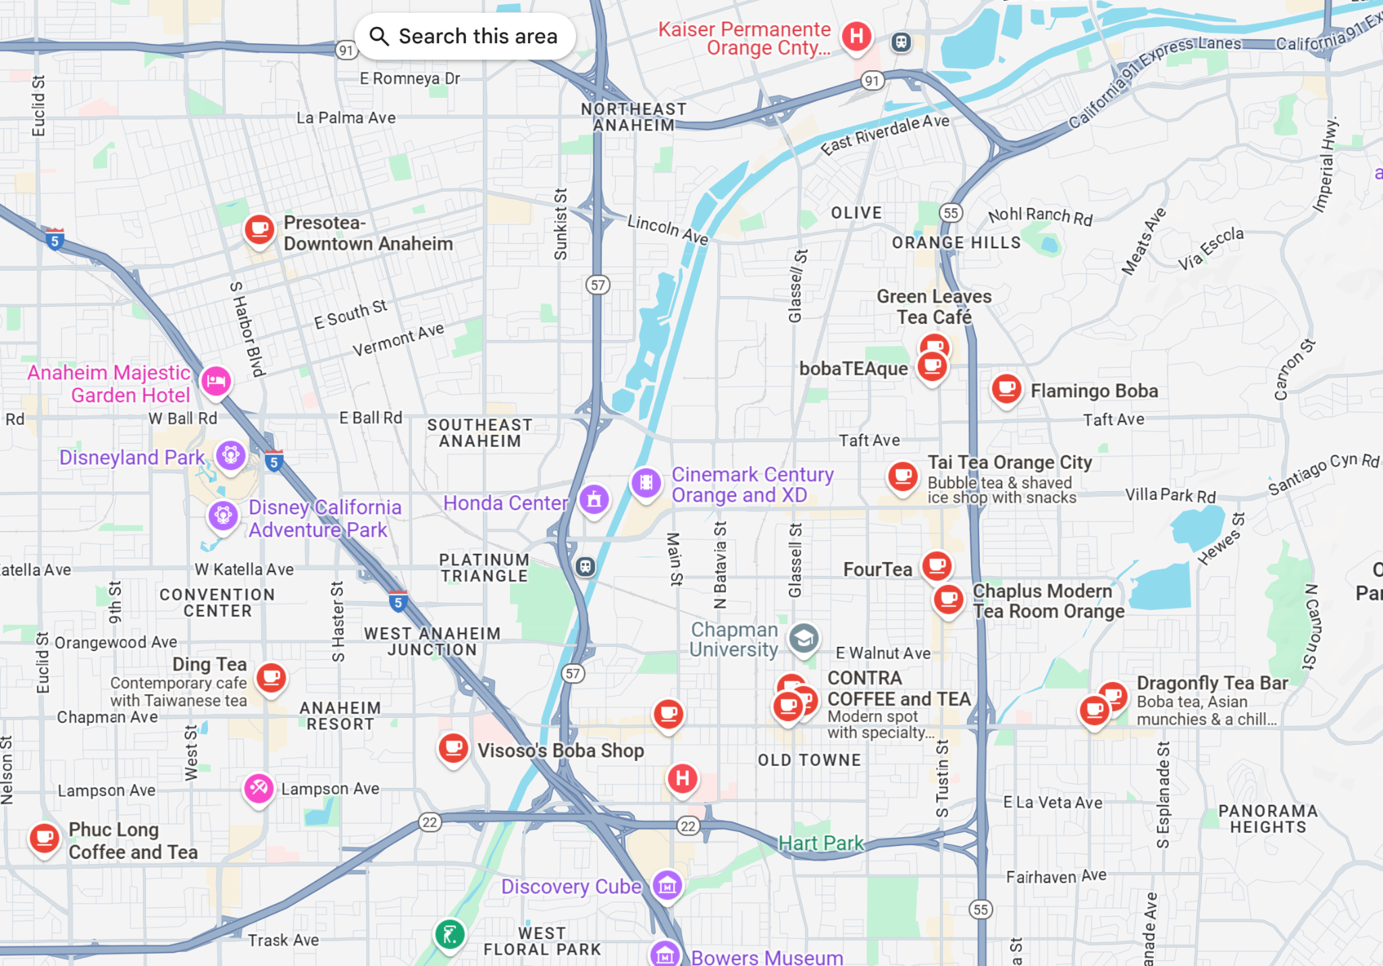

**Cost to rent a location in a standalone shop, shopping center, or mall kiosk in the City of Orange:** [**Average Monthly Rent for Orange County**](https://www.statista.com/statistics/1469078/shopping-center-asking-rent-orange-county/)

https://www.loopnet.com/search/retail-space/orange-ca/for-lease/2/?sk=0f614514e2a800306d0934c31d04a2a6

**Recommendation: Should they buy an existing business, or build and equip their own? (Consider start-up costs, operational expenses. Provide sources of this information, plus graphs with your analysis)**

**What are the total costs and total income per year? How many years will it take to break even?**

**Recommendation of location:**