Henry McAdam,

After thorough analysis of the network of the Commercialization Team, I have listed below seven important insights I’ve found regarding the existing network of the team along with recommendations to resolve the issues identified by this analysis.

1. Misalignment across functions: It is clear that there is not cohesion within the team across the three functions: Sales & Marketing, Product Development, and Research. Specifically, the Marketing & Sales function is essentially isolated from Product Development and Research. This is likely why 56% of the Commercialization Team believes that the team is misaligned. Misalignment occurs when there are sub-groups within a team and often create tension, conflict, and inefficiencies. I believe these sub-groups are the Marketing & Sales function and the Research and Product Development functions. These two sub-groups are fighting against each other instead of working as part of a team. This is reflected in the silos I identified within the team, which show that the flow of information, general access, and energy from Marketing & Sales to the other two functions, as well as from the other two functions to Marketing & Sales, is much lower than expected. This is one of the main problems we need to solve as we look to restructure the Commercialization Team.
2. Disconnect among project leadership: To try and identify the cause of misalignment across functions, I examined the connections between project leaders on the Commercialization Team. Across high-level management (managers of managers) all Marketing & Sales leaders exhibit the isolation I viewed at the functional level. Marketing & Sales leaders across the board scored very low on their boundary spanning indices- several of them even scoring 0%- indicating that the Marketing & Sales leaders have little to no connection with the other two functions. Though their openness indices all indicate appropriate levels of openness to the team, it is clear that these leaders are only open to those with the Marketing & Sales function, since they are not working with those in other functions. To improve this situation, I believe that upper-level management would benefit from a cross-functional meeting in which they themselves perform a network analysis to identify the misalignment across functions and its root cause. Project leaders can use this meeting to discuss how to solve these issues and foster collaboration across functions. This will encourage team-building and cohesion among project leadership by forcing functional leaders to solve existing issues *together.*
3. Overwhelmed management: To understand why project leadership is not working together, I investigated the sentiment among leadership. I found that 92% of managers feel like the Commercialization Team’s network is overwhelmed. Managers feel like most of the team is involved in most processes, decisions, and communications. This is causing leadership to feel overwhelmed and frustrated with a team that feels inefficient and ineffective. For example, several leaders seem extremely overworked, including Gary Shelton who is at 76% collaborative overload and Macy Atkins at 59% collaborative overload. Overall, project leadership needs to be enabled to lower the demands on their collaboration, to make more decisions and complete more of their work individually. This will allow the team in general to function better together, more efficiently and effectively, since leaders will be empowered to make the decisions they need to make, and to collaborate with the rest of the team when necessary. In order to do this, I recommend using effective workload analytics and metrics. This could take the form of redesigning group structure, redefining roles and responsibility, empowering team members (especially leadership) to say no to collaborative demands, practicing communication discipline, or a combination of several of these approaches. It will likely be most effective for project leadership to identify which of these approaches to the problem they perceive would be most helpful for the Commercialization team, and implement those measures accordingly. Regardless, I believe it is imperative that the Commercialization Team restructure to ease the burdens on its leadership, so that these leaders may function on the team more effectively and productively.
4. Disengaged team members: Realizing the negative sentiment among leadership on the Commercialization team, I decided to look further into who on the team is disengaged and unhappy. Unfortunately, there are several people on the team who indicated that they feel disengaged with their work, including Gary Shelton, Hayden Mckinney, Aiden Li, Elian Ramsey, Nick Coffey, and Deborah George. If any of these people were to leave the team, it would have a significant negative impact on productivity. Specifically, Elian, Deborah, and Gary are all top contributors on the Commercialization Team. For example, Elian Ramsey has a high energy and openness index, indicating that his colleagues feel energized through working with him. To lose someone who so positively impacts his colleagues would be discouraging to the team, causing a decrease in productivity and an increase in discontent on the team. Similarly, Aiden Li has a high boundary spanning index. This shows that Aiden interacts with many people across functions. To lose him would be to lose a key bridge between functions. Since collaboration across functions is already so low, I believe Aiden is an important team member to not only keep on the team, but to re-engage in his work. Overall, I recommend that in restructuring the team, we pay specific attention to these team members and aim to somehow re-engage them with their work, due to the damage their potential absence would cause.
5. New sales team lead: Regarding the replacement for sales team lead Royce Santiago, I’m aware that the CEO suggested Gary Shelton. I would advise against putting Gary in the sales team lead role. As I mentioned before, Gary is extremely overwhelmed and admittedly unhappy. To assign more responsibility to Gary would only serve to further frustrate him. Further, I believe that with our choice of the replacement for Royce, we have an opportunity to choose someone who would help repair the disconnect between Sales & Marketing and Research and Product Development. I think it is important for us to strategically fill Royce’s position with someone who is well-connected on the Commercialization team; someone who can model a positive cross-functional relationship and foster important connections for those that they lead. Regarding Gary, not only is his collaborative overload at an exceedingly high 76%, but his boundary spanning index across functions is at a very low 5%. So, even if Gary could handle more responsibility (which he cannot), he does not have the connections to bridge the existing gap between the functions. Keeping in mind the importance of cross-functional collaboration being modeled at the level of upper-management, I recommend Deborah George for the position of sales team lead. Compared to other potential candidates for the position, including Brennan Shaffer and Elian Ramsey, Deborah has the highest boundary spanning index, indicating that she has the most connections across functions. Additionally, she has a high openness index, so she energizes those that she works with and her colleagues feel comfortable working with her. As an open and well-connected individual on the team, I believe Deborah could lead the sales team to create more connections with both Research and Product Development, increasing both collaboration and in turn contributing to the effectiveness and productivity of the team as a whole. Lastly, Deborah is one of the individuals who is currently disengaged and assigning her more responsibility will likely renew her excitement for her work on the Commercialization team.
6. New Research team lead: I’m aware that the CEO also suggested appointing Braydon Vaughn as the Research work stream leader. Based on my network analysis, I would also advise against this. Braydon would not be a good choice for the Research team lead because his energy and openness index is at 0%, indicating that none of his eight connections on the team feel energized by him, or feel like he is open to them for collaboration. As a team leader, I imagine this trend would continue and likely Braydon would isolate his team more than he would encourage and support them. To further this point, only two of Braydon’s colleagues indicated that greater access to Braydon would improve their effectiveness, suggesting that when Braydon does collaborate, it isn’t particularly useful to his teammates. Instead, I would recommend Nick Coffey as the Research team lead. Nick’s colleagues ranked him as 50% open and energetic and 25% of his connections are outside of the Research function. This suggests that not only do Nick’s teammates feel like he is approachable for collaboration and then feel excited about their work after collaborating with him, but he is able to do this outside of the Research function. Since, as I previously mentioned, I believe it is important to foster more cross-functional collaboration, I believe that this is an important quality in a team leader. Additionally, Nick’s collaborative overload is only at a 20%, suggesting that he is able to assume more responsibility.
7. Key collaborative team members: Lastly, with the goal in mind of increasing cross-functional team collaboration, I decided to identify the most highly connected and energizing people on the Commercialization team. I recommend that we aim to build and strengthen connections among these individuals to foster more collaboration across Sales & Marketing, Research, and Product Development. Within the Marketing & Sales department, Deborah George and Ernest Reese both score highly on energy and boundary spanning, indicating that they are cross-functionally connected and open to those they are connected to. I recommend that we aim to encourage more cross-functional connections with these two individuals as a way to bridge the gap between Marketing & Sales and the rest of the Commercialization team. On the Product Development side of the team, Kadin Williams and Adelaide Vance are the most energetic and highly connected. In the Research function, Marina Cortex and Macy Atkins are extremely energetic and well-connected. Similarly to my suggestion with Deborah and Ernest, I recommend that we aim to foster more connections with these individuals to increase cross-functional collaboration. If we could succeed in getting these six individuals well-connected with one another, we can likely model for the rest of the Commercialization team, among some of the most influential and energetic team members, positive collaboration and the impact it can have on effectiveness and productivity.

I hope these recommendations are helpful to you. Please see the attached appendix for the analysis behind these recommendations.

Looking forward to working with a re-engaged, re-energized, and restructured Commercialization team,

Beth

**Appendix**

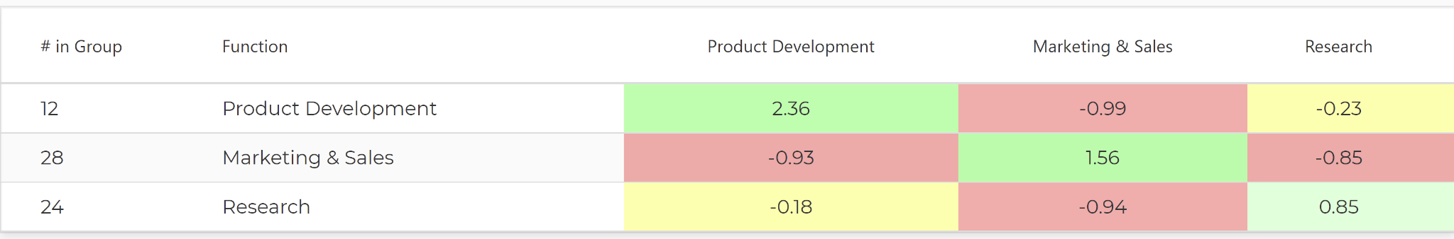

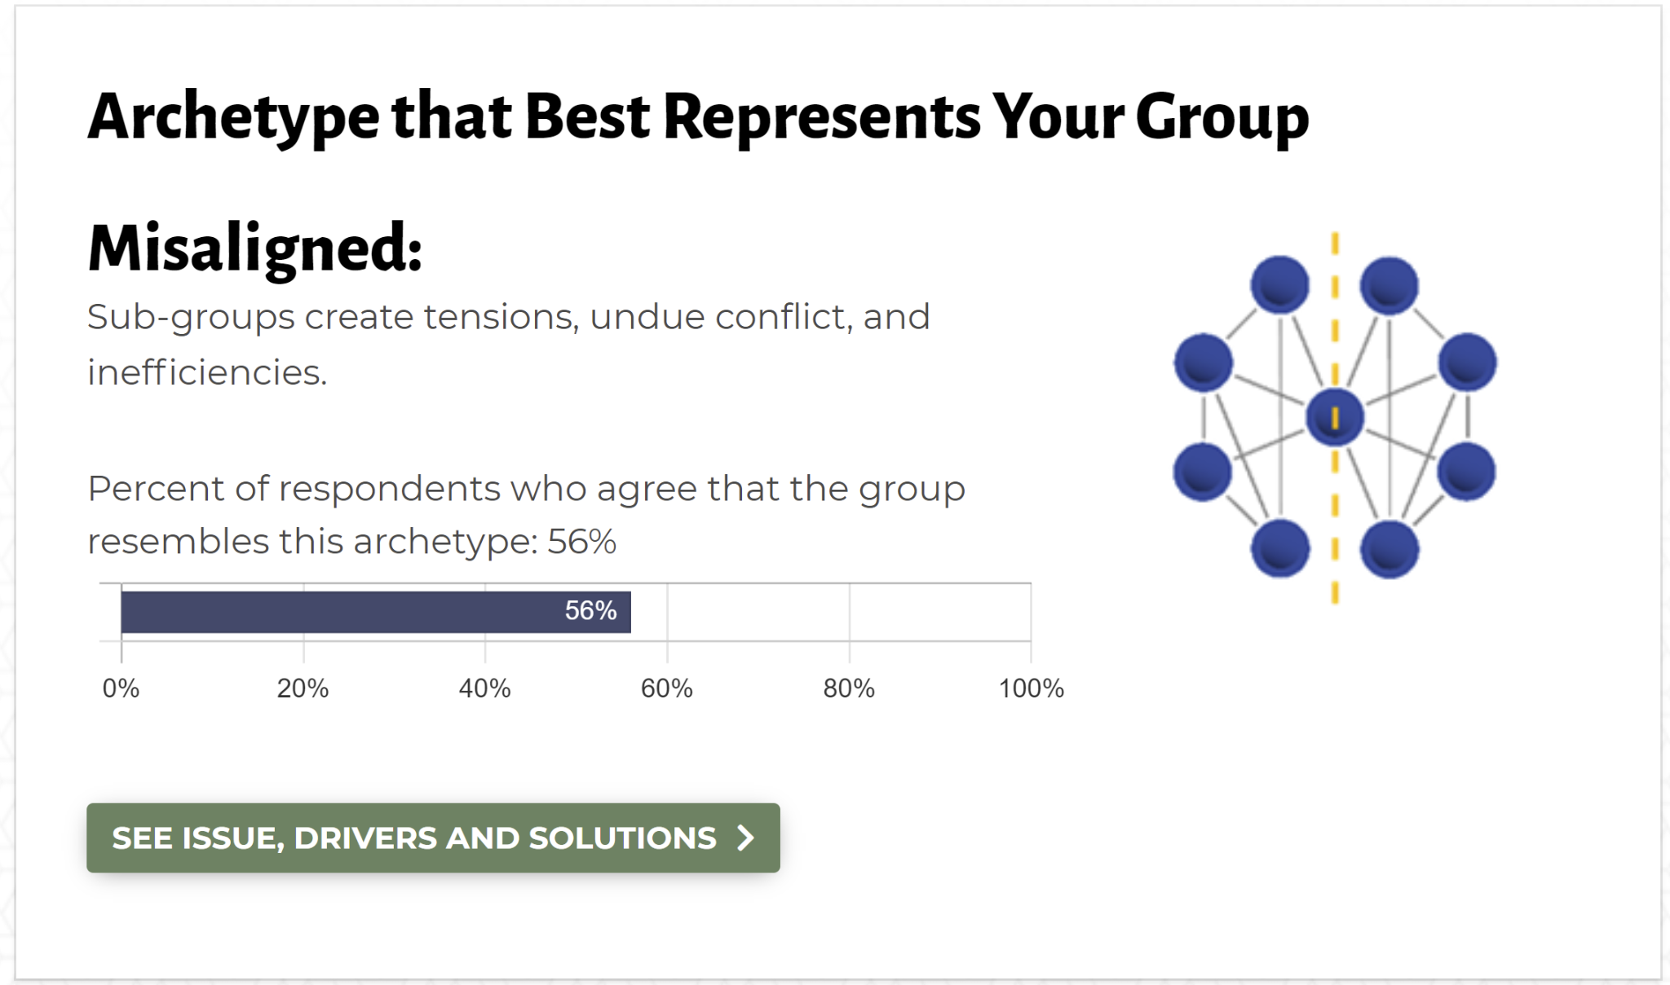

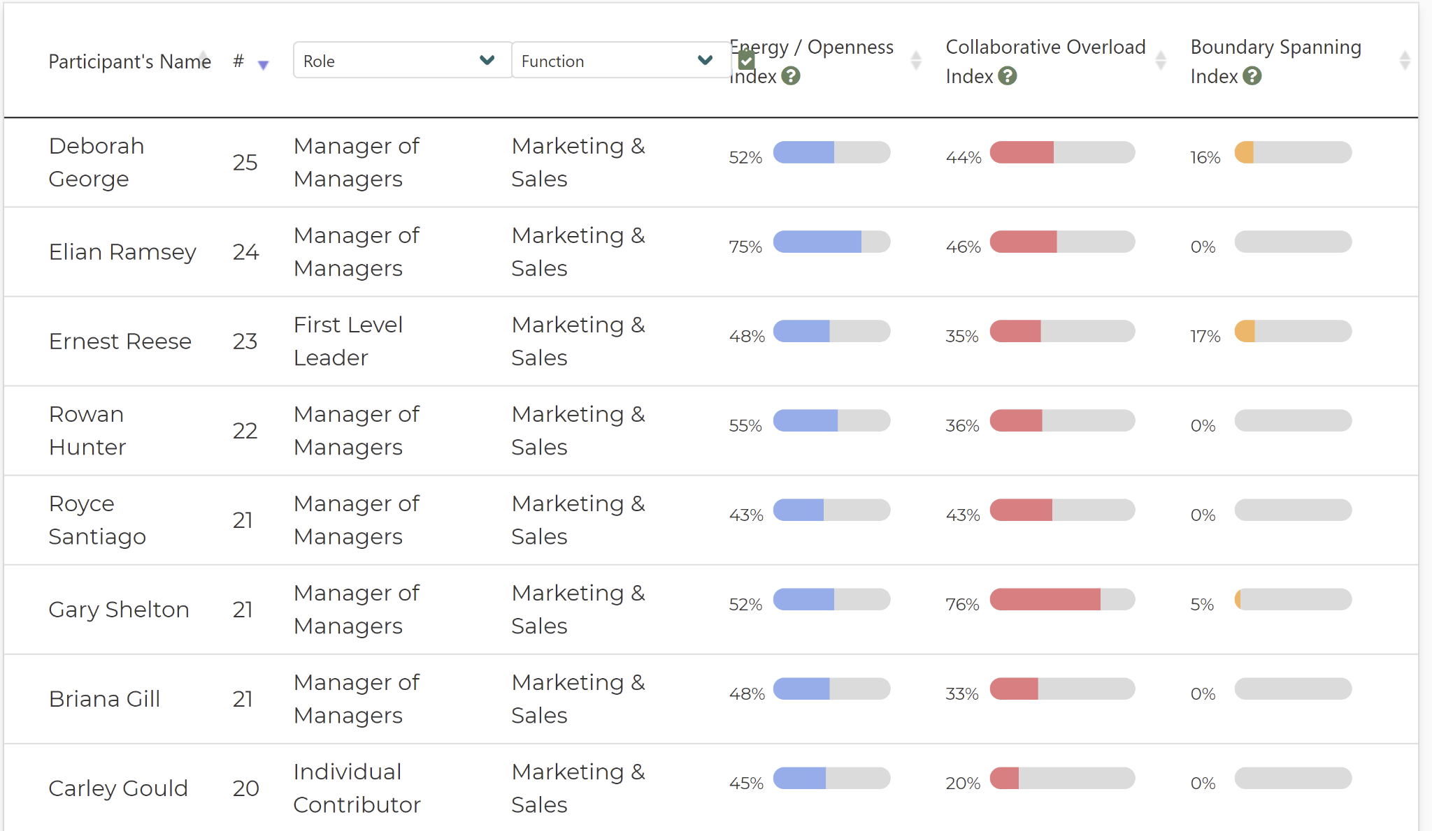

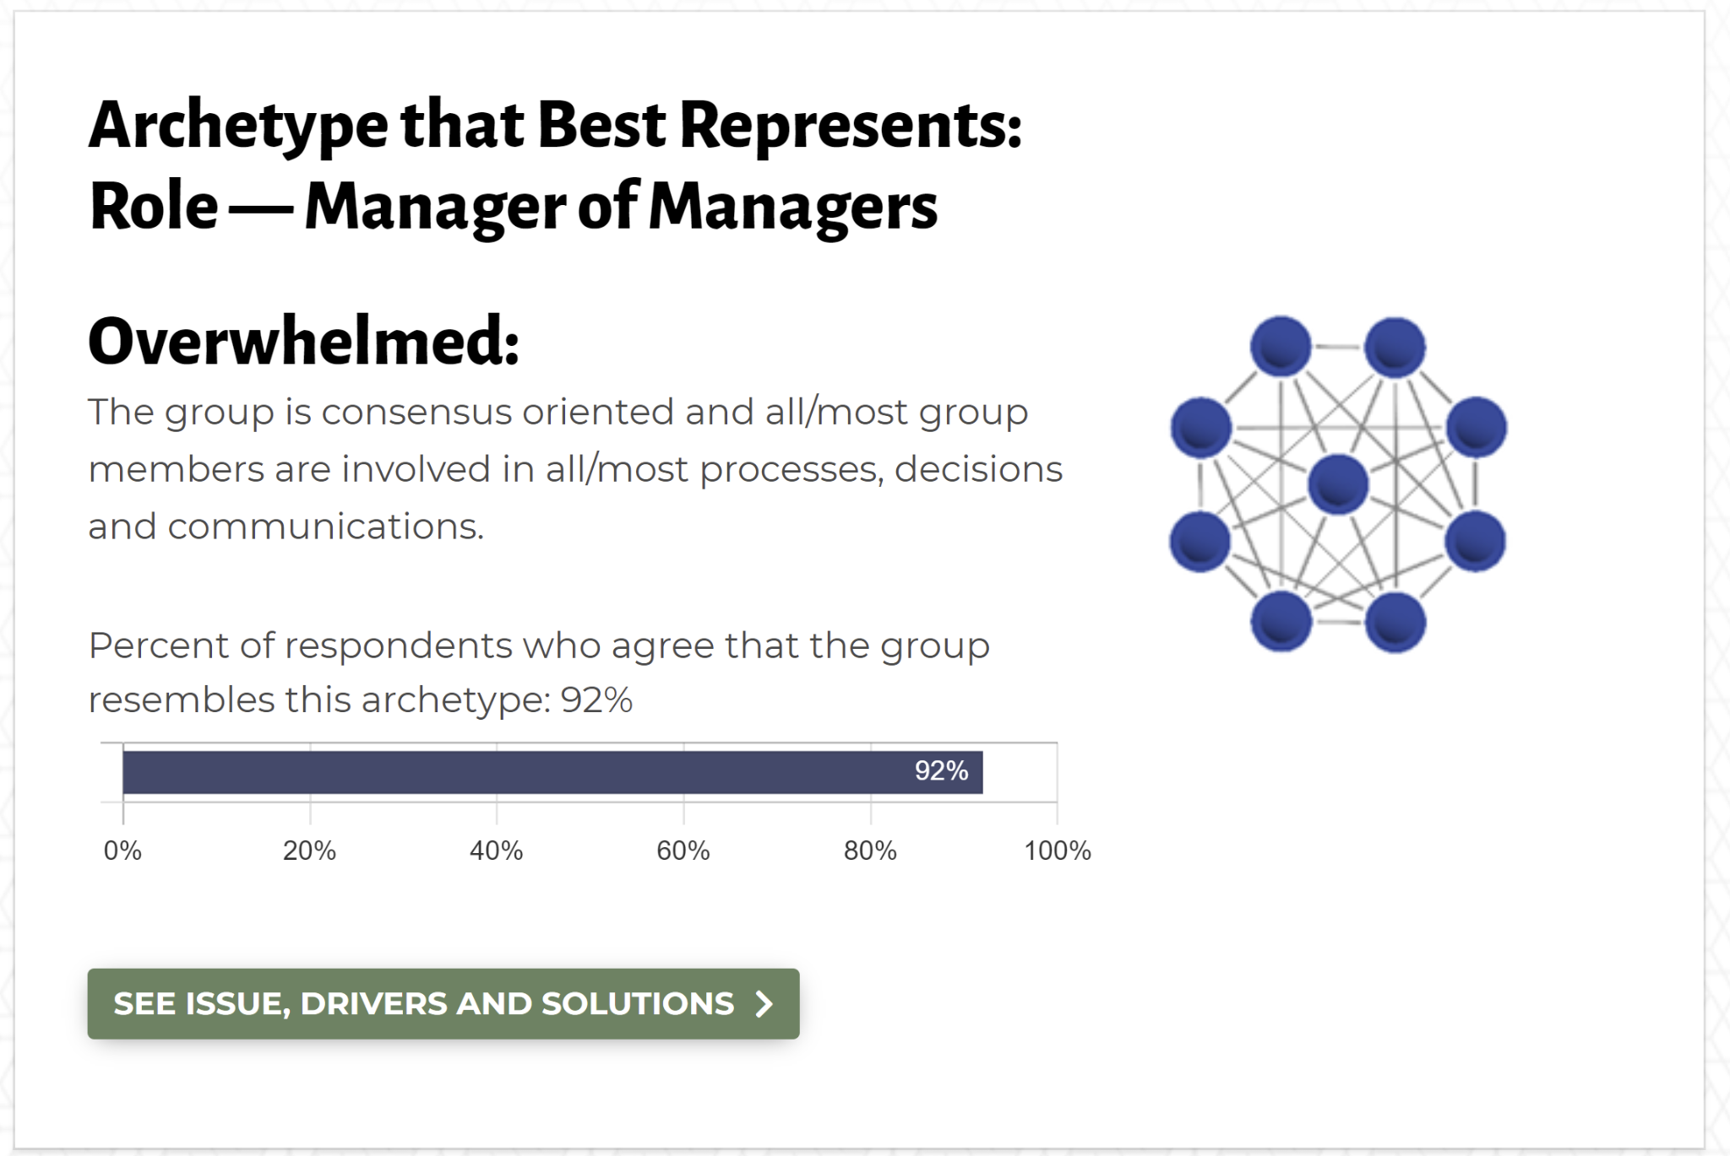

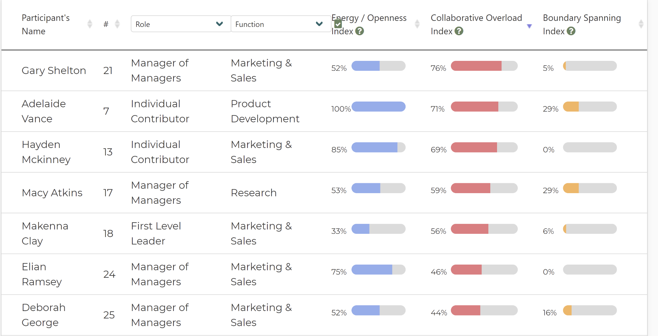

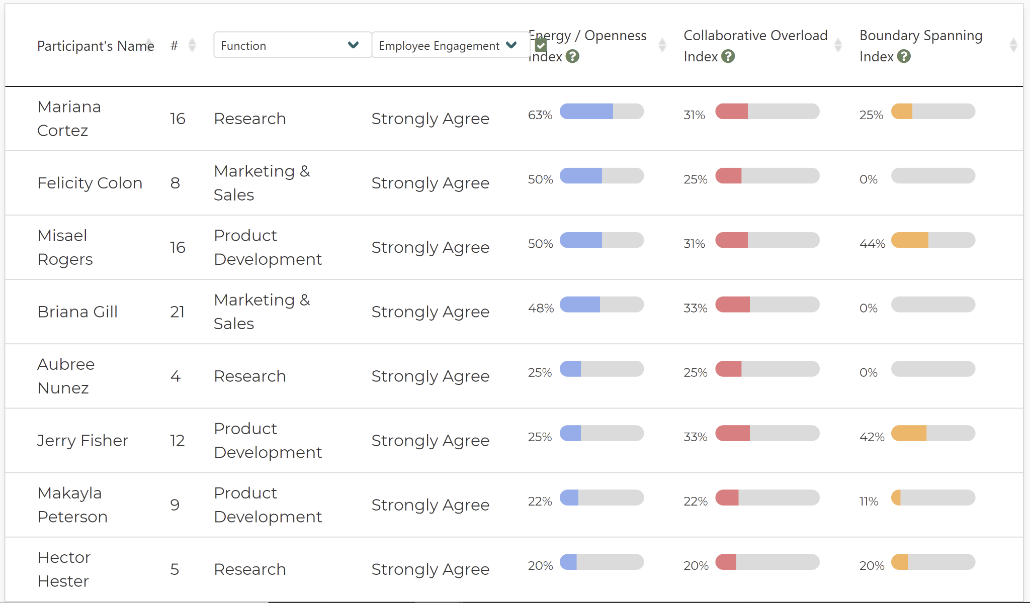





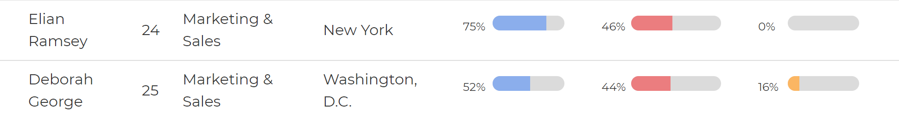







1. Marketing & Sales:

* Deborah George (52% energy, 16% boundary spanning)
* Ernest Reese (48% energy, 17% boundary spanning)

Product Development:

* Kadin Williams (62% energy, 62% boundary spanning)
* Adelaide Vance (100% energy, 29% boundary spanning)

Research:

* Marina Cortez (63% energy, 25% boundary spanning)
* Macy Atkins (53% energy, 29% boundary spanning)

When figuring out which six people to recommend engaging over the coming days, I decided that to have the largest effect of inter-function cooperation it makes the most sense to choose two highly energizing people from each function. Within each function there are a handful of highly energizing individuals, but not all of them also have a high number of connections and % boundary spanning into other functions. To decide who the top two from each function should be, I made sure the connections and % boundary spanning were high, but weighed the energizing percentage more heavily when debating between two individuals with similar boundary spanning.