Catalog - Shopping Cart

Sources: <https://www.pinterest.com/pin/333547916144932218/>

1. Box 1

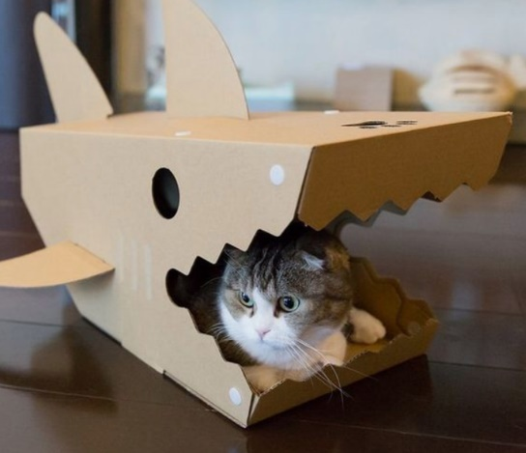

Measurement: 56cm x 45cm x 30cm

Shark shaped box with an easy access for smaller cats/kittens who like corners.

Easily transportable

Made of durable non-toxic box

2. Box 2

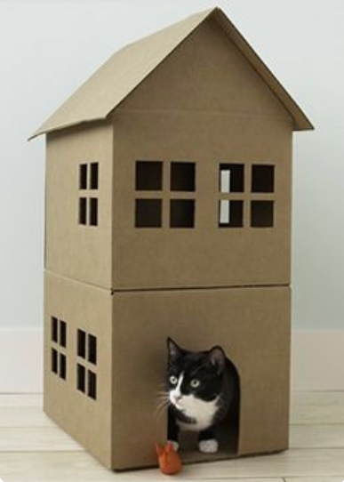

Measures 50 x 56 x 60 cm

Simple block design

Made of durable non-toxic box

3. Box 3

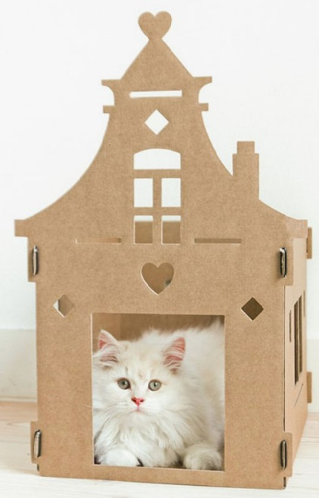

Measures 50 x 56 x 40 cm

Wide and spacious

Easily disassembled and collected

Made of durable non-toxic box

4. Box 4

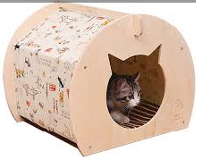

Measures 50 x 56 x 30 cm

The wide entrance shaped like a cat’s head permits easy in-and-out access for cats

Easily transportable

Made of durable non-toxic box

5. Box 5

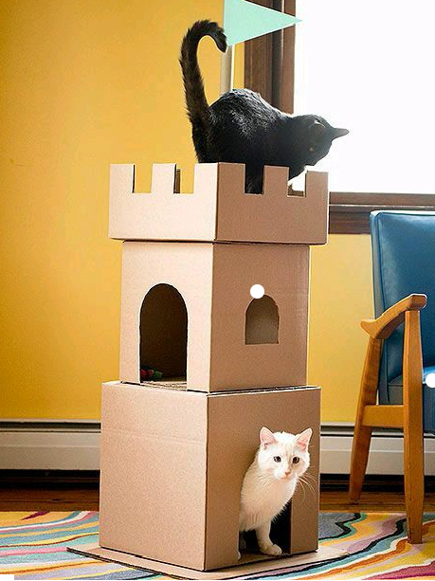

Measures 56.5cm x 48.5cm x 66.5cm

A DIY Cat Tower is amazing if you have more than one cat

Modern and sleek design

Made of durable non-toxic box

Home Page - News Articles

1. WHY CATS LOVE BOXES?

How many times have you bought your cat a new cat tower, only to have your cat immediately pounce into the box it came in? But why are cats so attracted to boxes? Well it seems that seeking out confined spaces is instinctual behavior for cats both in the wild and in domestication. A box to a cat is an area where it can both hide from predators as well as stalk prey. Cats love to hide and a box is a place of safety and security to it. Inside a box a cat feels that it cannot be snuck upon and feels very safe much like a human wrapped up in a blanket. Boxes also provide cats with a cozy place to sleep which is important considering cats sleep up to 20 hours a day.

https://www.youtube.com/watch?v=KDDM_XGNj2c

2. KEEP YOUR CAT ENTERTAINED FOR HOURS

With our new 50 box cat maze, you can now keep your freaky feline occupied for hours. This setup is designed to provide your cat with hours of entertainment and exercise. You can place bits of dried cat food within the maze to stimulate your cats mind and allow it to tap into its feline instincts to find its “prey” within the maze. Box set comes with instructions on how to set up. ORDER NOW!!

3.TREAT YOUR KITTY LIKE THE PRINCE/PRINCESS IT IS

Do you feel like normal cat boxes are too plain for your furry feline? Want something more majestic for your little royalties? Wait no more. Cat Boxes presents the new cat castle. A huge cat box for your little kitties, it comes with rooms and windows and hammocks, The entrance to this little cat is a drawbridge to really immerse your cat in the medieval cat lord role it really is it even has a water fountain in the middle for your cat to hydrate.

https://www.youtube.com/watch?v=v_DEtzX0Pc4

About Us

1. https://www.youtube.com/watch?v=CozFGY20X-E

2. Cat Boxing aims to provide your feline companions with the most purr-fect box to satisfy their innate desire to fit into impossible spaces. Our boxes cater to all cats with varying levels of challenge - from the classic shoe-box for those who just want to snuggle into a comfy fit, to the mind-blowingly small snack box for cats that seek to surpass space-time.