Network Dynamics are Associated with Reinforcement Learning

Models

Raphael Gerraty

## Behavioral Learning Model

We ran a generalized mixed effects logit model predicting proportion correct with block. Subjects demonstrated significant learning across the task.

## Generalized linear mixed model fit by maximum likelihood (Laplace  
## Approximation) [glmerMod]  
## Family: binomial ( logit )  
## Formula: correct ~ block_int + (block_int | subject)  
## Data: flex_behav  
## Weights: weights  
##   
## AIC BIC logLik deviance df.resid   
## 468.1 480.5 -229.1 458.1 83   
##   
## Scaled residuals:   
## Min 1Q Median 3Q Max   
## -1.6088 -0.4340 0.1505 0.5624 1.6471   
##   
## Random effects:  
## Groups Name Variance Std.Dev. Corr  
## subject (Intercept) 1.0237 1.0118   
## block_int 0.2195 0.4685 0.81  
## Number of obs: 88, groups: subject, 22  
##   
## Fixed effects:  
## Estimate Std. Error z value Pr(>|z|)   
## (Intercept) 1.1864 0.2250 5.272 1.35e-07 ***  
## block_int 0.2820 0.1136 2.482 0.0131 *   
## ---  
## Signif. codes: 0 '***' 0.001 '**' 0.01 '*' 0.05 '.' 0.1 ' ' 1  
##   
## Correlation of Fixed Effects:  
## (Intr)  
## block_int 0.748

## Effect of Flexibility on Reinforcement Learning

### Striatal flexibility- REML

We fit a mixed effects generalized linear model using a REML approximation to associate individual learning performance with striatal flexibility across blocks, using lme4.

## Generalized linear mixed model fit by maximum likelihood (Laplace  
## Approximation) [glmerMod]  
## Family: binomial ( logit )  
## Formula: correct ~ str_flex + (str_flex || subject)  
## Data: flex_behav  
## Weights: weights  
##   
## AIC BIC logLik deviance df.resid   
## 494.8 504.7 -243.4 486.8 84   
##   
## Scaled residuals:   
## Min 1Q Median 3Q Max   
## -2.63858 -0.73581 -0.02002 0.85468 2.43378   
##   
## Random effects:  
## Groups Name Variance Std.Dev.   
## subject (Intercept) 2.796e-08 0.0001672  
## subject.1 str_flex 6.196e+01 7.8715162  
## Number of obs: 88, groups: subject, 22  
##   
## Fixed effects:  
## Estimate Std. Error z value Pr(>|z|)   
## (Intercept) 0.04581 0.23683 0.193 0.84662   
## str_flex 9.45132 2.74667 3.441 0.00058 ***  
## ---  
## Signif. codes: 0 '***' 0.001 '**' 0.01 '*' 0.05 '.' 0.1 ' ' 1  
##   
## Correlation of Fixed Effects:  
## (Intr)  
## str_flex -0.772

## Generalized linear mixed model fit by maximum likelihood (Laplace  
## Approximation) [glmerMod]  
## Family: binomial ( logit )  
## Formula: correct ~ str_flex + str_flex_mean + (str_flex || subject)  
## Data: flex_behav  
## Weights: weights  
##   
## AIC BIC logLik deviance df.resid   
## 496.3 508.6 -243.1 486.3 83   
##   
## Scaled residuals:   
## Min 1Q Median 3Q Max   
## -2.52483 -0.74572 -0.05168 0.81802 2.43855   
##   
## Random effects:  
## Groups Name Variance Std.Dev.  
## subject (Intercept) 0.00 0.000   
## subject.1 str_flex 66.28 8.141   
## Number of obs: 88, groups: subject, 22  
##   
## Fixed effects:  
## Estimate Std. Error z value Pr(>|z|)   
## (Intercept) 1.236 1.671 0.740 0.459478   
## str_flex 9.792 2.819 3.473 0.000514 ***  
## str_flex_mean -11.137 15.454 -0.721 0.471150   
## ---  
## Signif. codes: 0 '***' 0.001 '**' 0.01 '*' 0.05 '.' 0.1 ' ' 1  
##   
## Correlation of Fixed Effects:  
## (Intr) str_fl  
## str_flex 0.053   
## str_flex_mn -0.990 -0.162

### Striatal flexibility- Bayesian model

For appropriate posterior inference, we fit the same model using Hamiltonian Monte Carlo to generate a full posterior distribution for the effect of striatal flexibility on learning performance. We used the 'brms' package to build Stan models.

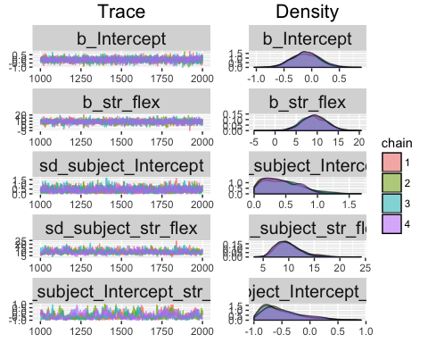

## Family: binomial (logit)   
## Formula: numcorr ~ str_flex + (str_flex | subject)   
## Data: flex_behav (Number of observations: 88)   
## Samples: 4 chains, each with iter = 2000; warmup = 1000; thin = 1;   
## total post-warmup samples = 4000  
## WAIC: Not computed  
##   
## Random Effects:   
## ~subject (Number of levels: 22)   
## Estimate Est.Error l-95% CI u-95% CI Eff.Sample  
## sd(Intercept) 0.43 0.29 0.02 1.06 1092  
## sd(str_flex) 9.92 2.49 6.10 16.00 573  
## cor(Intercept,str_flex) -0.48 0.36 -0.93 0.39 197  
## Rhat  
## sd(Intercept) 1.01  
## sd(str_flex) 1.01  
## cor(Intercept,str_flex) 1.02  
##   
## Fixed Effects:   
## Estimate Est.Error l-95% CI u-95% CI Eff.Sample Rhat  
## Intercept -0.11 0.25 -0.60 0.40 4000 1  
## str_flex 9.26 2.94 3.53 14.99 1943 1  
##   
## Samples were drawn using sampling(NUTS). For each parameter, Eff.Sample   
## is a crude measure of effective sample size, and Rhat is the potential   
## scale reduction factor on split chains (at convergence, Rhat = 1).

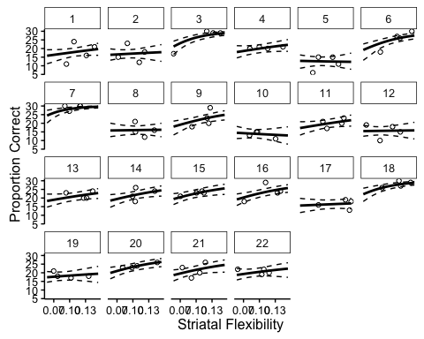

### Whole-brain flexibility

Because a global measure of flexibility has also been shown to relate to a number of cogitive processes (Bassett et al 2011, Braun et al 2015), we fit another mixed-effects model with this whole-brain metric as a predictor.

## Generalized linear mixed model fit by maximum likelihood (Laplace  
## Approximation) [glmerMod]  
## Family: binomial ( logit )  
## Formula: correct ~ wb_flex + (wb_flex || subject)  
## Data: flex_behav  
## Weights: weights  
##   
## AIC BIC logLik deviance df.resid   
## 511.5 521.4 -251.8 503.5 84   
##   
## Scaled residuals:   
## Min 1Q Median 3Q Max   
## -2.67954 -0.71005 -0.01157 0.81079 2.72652   
##   
## Random effects:  
## Groups Name Variance Std.Dev.  
## subject (Intercept) 0.00 0.000   
## subject.1 wb_flex 64.94 8.058   
## Number of obs: 88, groups: subject, 22  
##   
## Fixed effects:  
## Estimate Std. Error z value Pr(>|z|)   
## (Intercept) -0.1104 0.3506 -0.315 0.75287   
## wb_flex 11.8486 3.9126 3.028 0.00246 **  
## ---  
## Signif. codes: 0 '***' 0.001 '**' 0.01 '*' 0.05 '.' 0.1 ' ' 1  
##   
## Correlation of Fixed Effects:  
## (Intr)  
## wb_flex -0.889